LAB-4.3

**Task Description#1**

* Zero-shot: Prompt AI to write a function that checks whether a given year is a leap year.

**Expected Output#1**

* AI-generated function with no examples provided

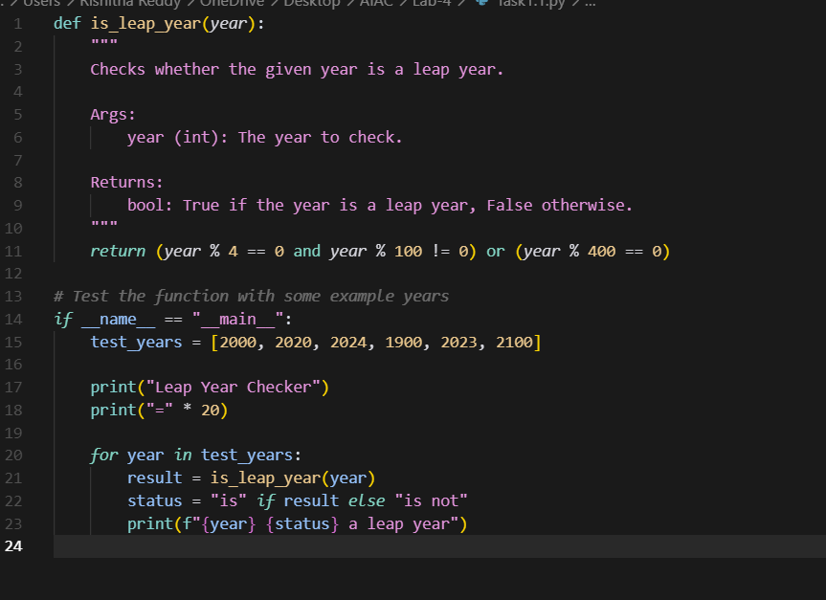

OUTPUT:

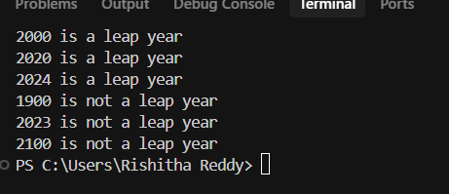

**Task Description#2**

* One-shot: Give one input-output example to guide AI in writing a function that converts centimeters to inches.

**Expected Output#2**

* Function with correct conversion logic
* 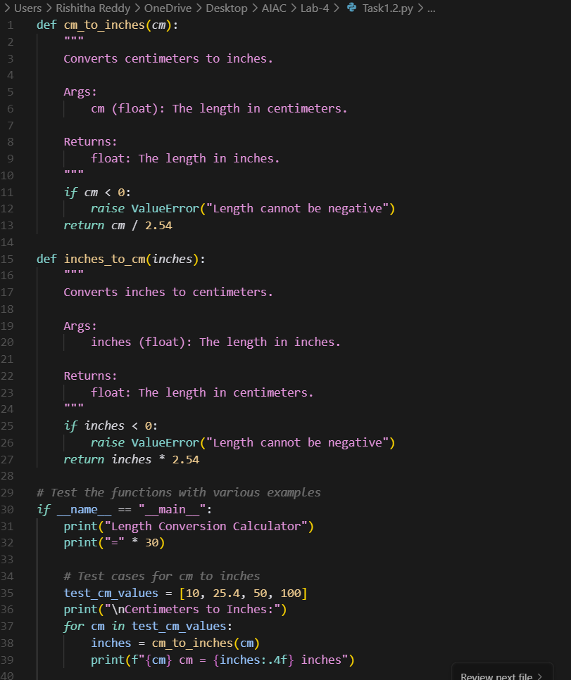

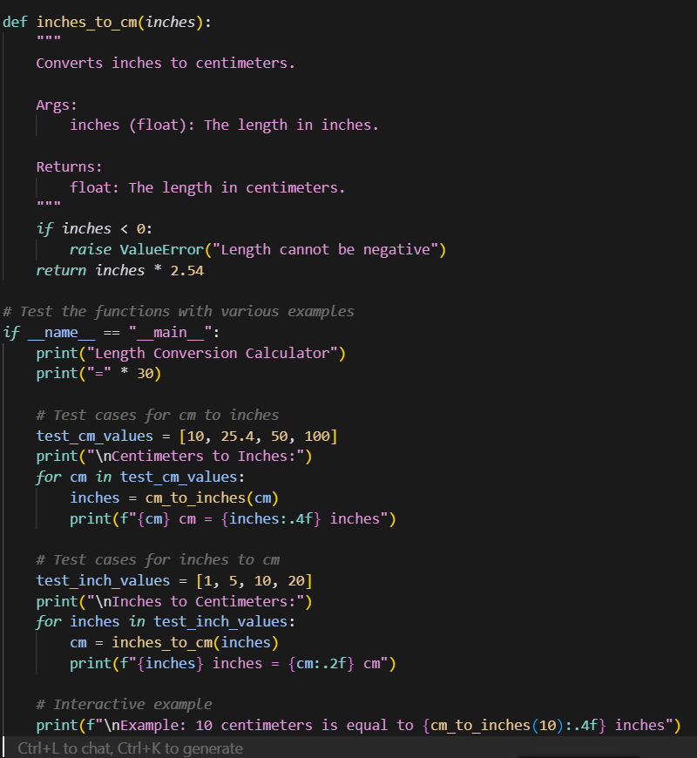

**OUTPUT:**

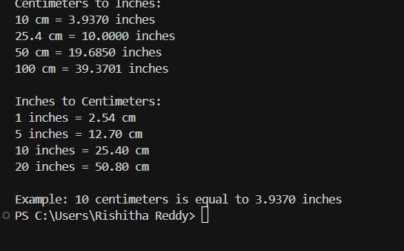

**Task Description#3**

* **Few-shot: Provide 2–3 examples to generate a function that formats full names as “Last, First”.**

**Expected Output#3**

**Well-structured function respecting the examples**

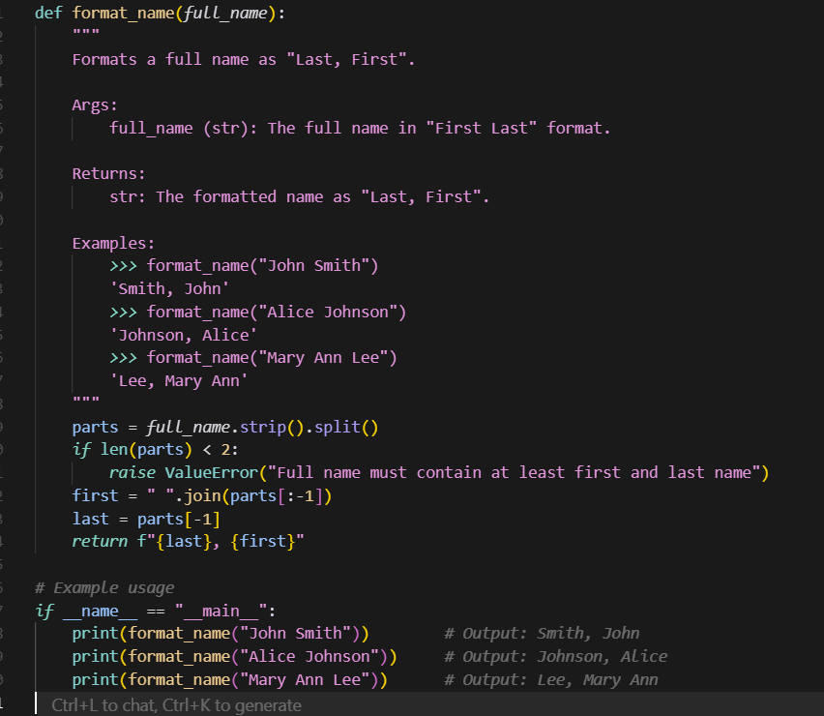

OUTPUT:

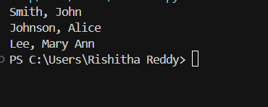

**Task Description#4**

* Compare zero-shot and few-shot prompts for writing a function that counts the number of vowels in a string.

**Expected Output#4**

* Functional output and comparative reflection
* 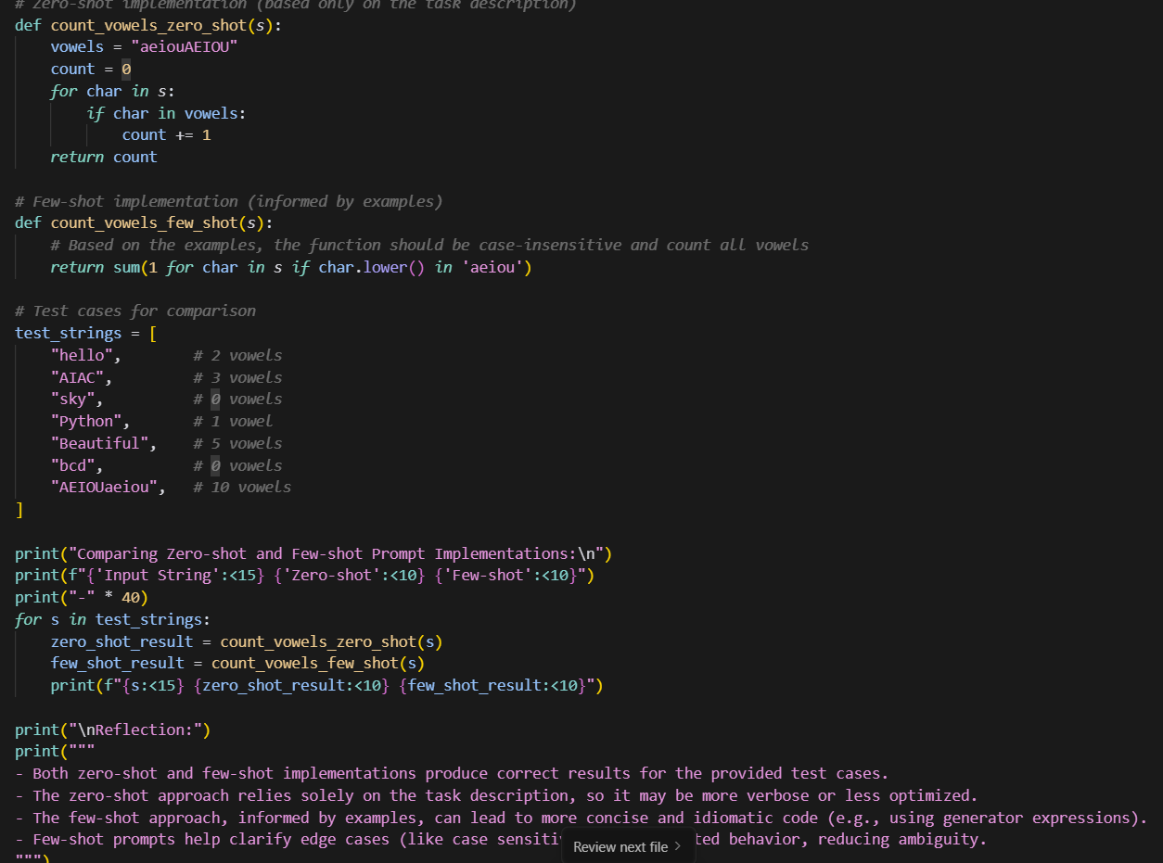
* **OUTPUT:**
* 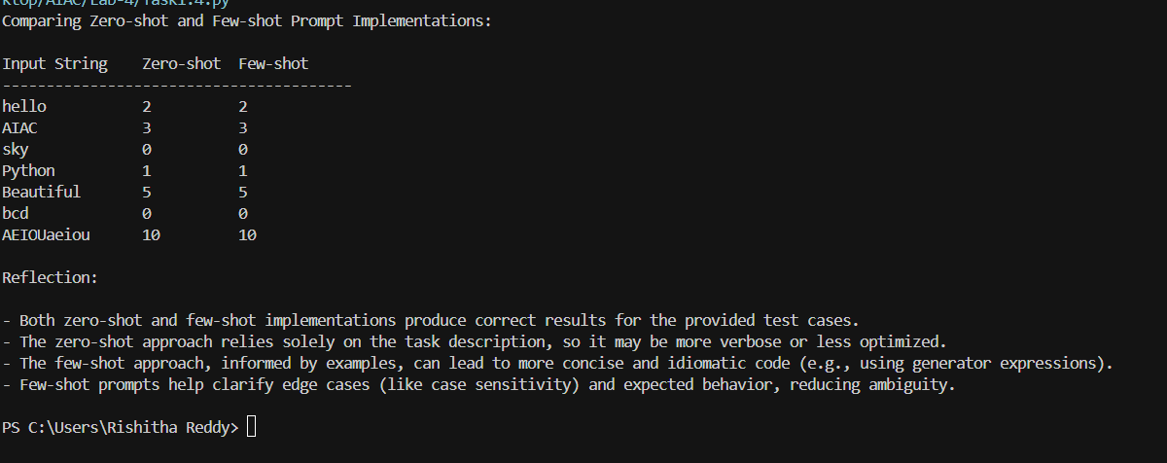

**Task Description#5**

* **Use few-shot prompting to generate a function that reads a .txt file and returns the number of lines.**

**Expected Output#5**

* **Working file-processing function with AI-guided logic**
* 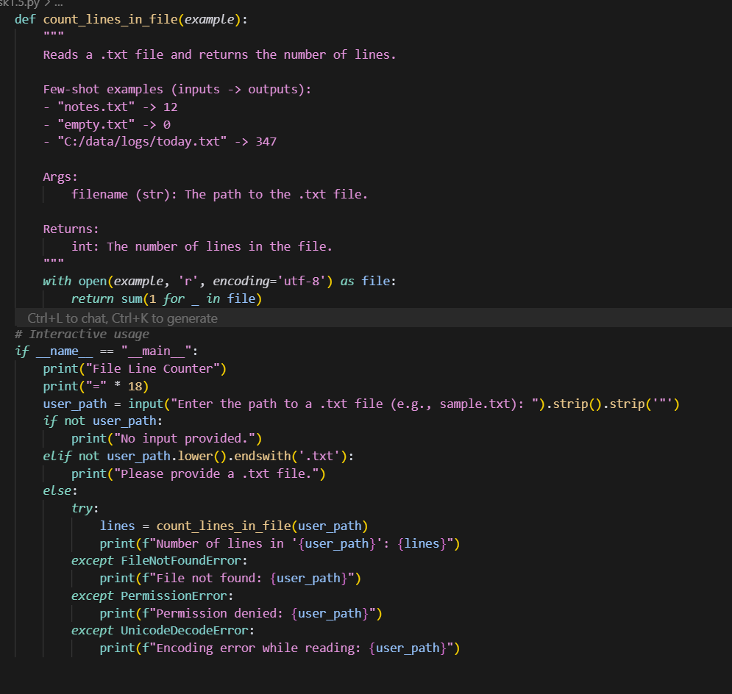

**OUPTUP:**

