# AI ASSIGNMENT-5.4

K SRIMANI

2403A51275

BATCH-12

**TASK 1**

**PROMPT:**

Create a Python script to collect name, age, and email, and add comments on how to protect or anonymize the data (e.g. hash, encrypt, remove PII).

**RESPONSE:**

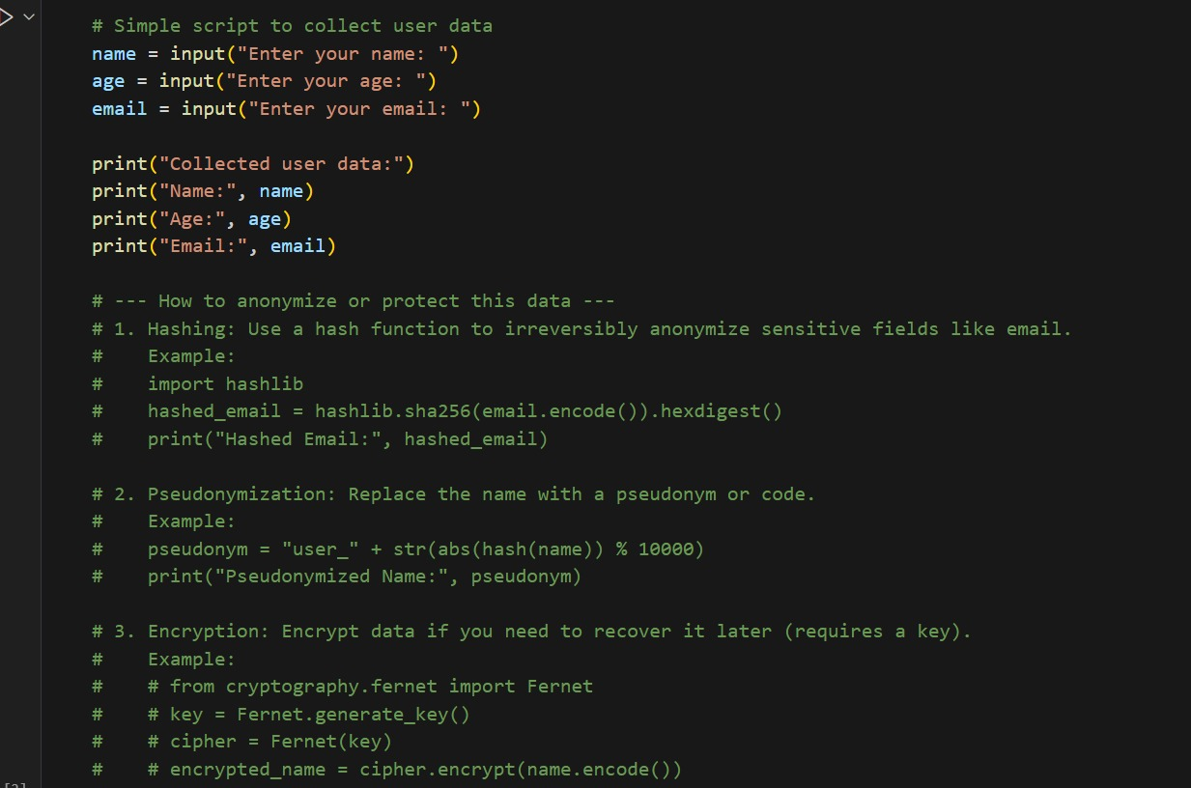

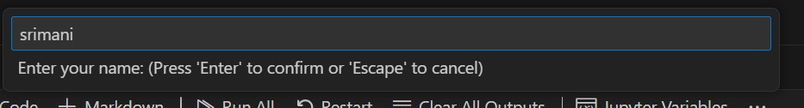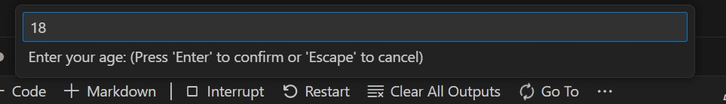

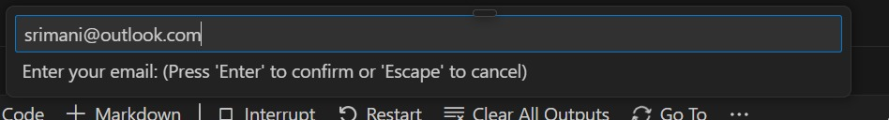

**OUTPUT:**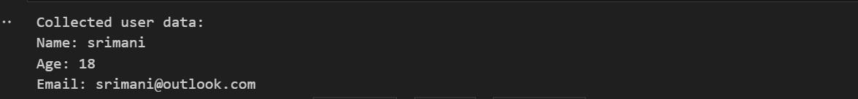

**TASK 2**

**PROMPT:**Write a Python function for sentiment analysis using a basic model or library. Then, add comments on how to identify and handle potential biases in the training data.

**RESPONSE**:

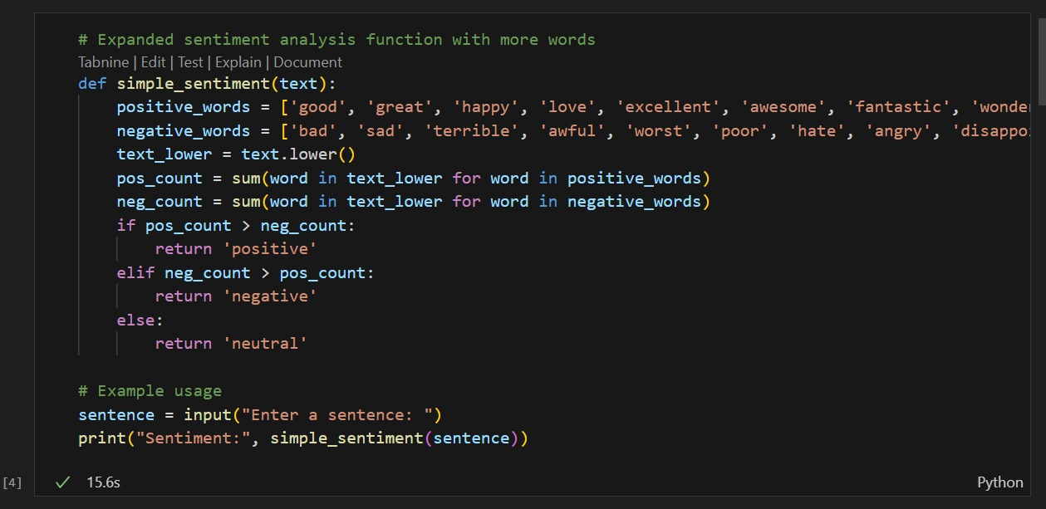

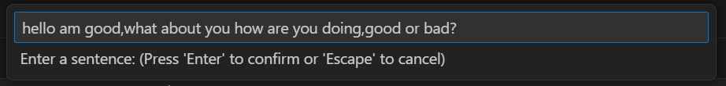

**OUTPUT:**



**TASK 3**

**PROMPT:**

Write a Python program that recommends products based on user browsing or purchase history. Add comments to ensure ethical guidelines are followed, such as transparency.

**RESPONSE:**

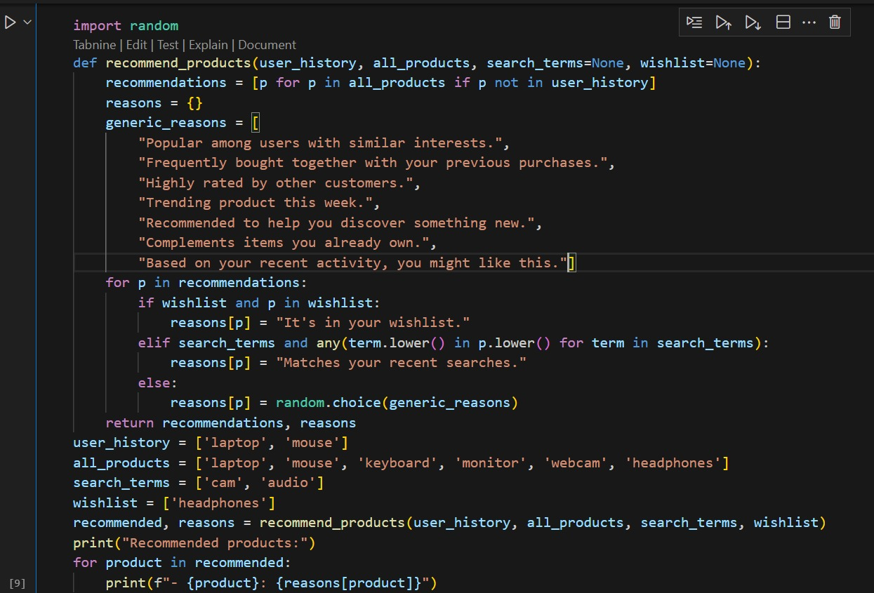

**RESPONSE:**

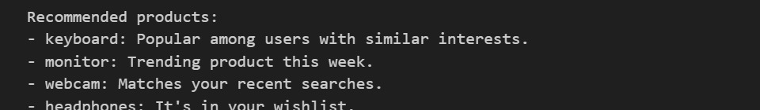

**TASK 4**

**PROMPT:**

Generate logging functionality in a Python web application using the logging module. Add comments to ensure that sensitive information.

**RESPONSE:**

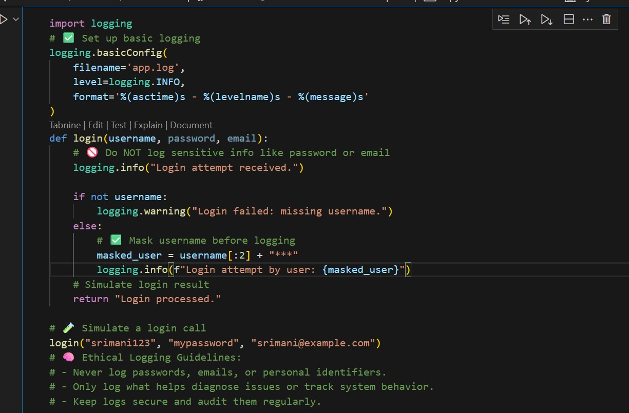

**OUPUT:**

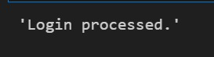



**TASK 5**

**PROMPT:**

Create a simple machine learning model in Python (e.g., for classification or regression) using scikit-learn. Add documentation/comments on how to use the model responsibly, including model explainability, accuracy limitations, and avoiding misuse or overgeneralization.

**RESPONSE:**

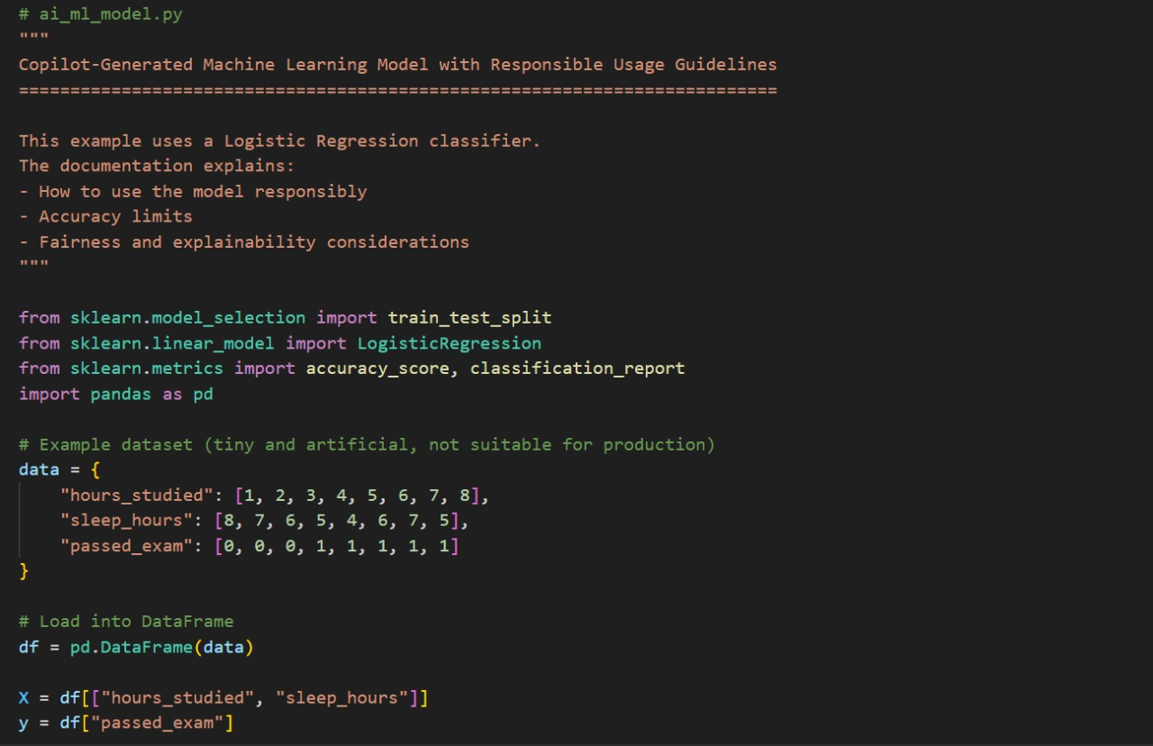

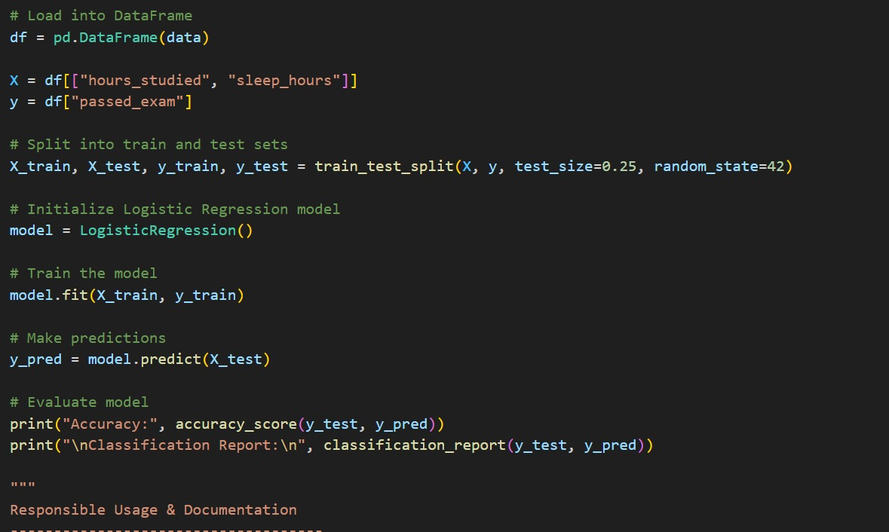

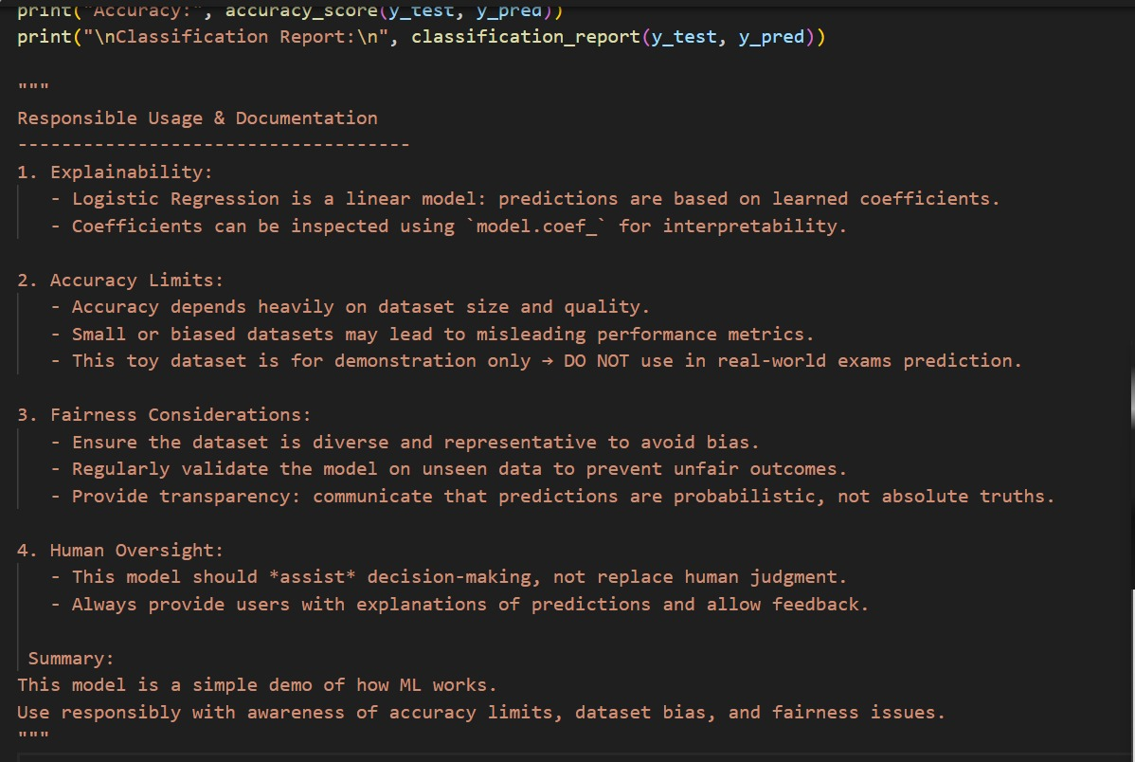

**OUTPUT:**

