# AI ASSISTED CODING

## LAB TEST-1

SRIMANI KOTA

2403A51275

BATCH-12

**QUESTION-1**



**PROMPT:**

Write a python code which has a function that converts an given amount from one currency to another using exchange rates stored in a dictionary.

**FEW SHOT PROMPT GIVEN:**

Few-shot examples to guide the model

Example 1:

convert_currency(100, 'USD', 'INR', {'USD': 1, 'INR': 83.2}) ➞ 8320.0

Example 2:

convert_currency(500, 'EUR', 'USD', {'EUR': 1, 'USD': 1.1}) ➞ 550.0

**CODE:**

**OUTPUT:**

**QUESTION-2**



**PROMPT:**

Write a Python program that extracts all email addresses from a block of text using regular expressions.

**CODE:**

**QUESTION-3**



**PROMPT:**

Given a database that contains movies grouped in different genres FEW SHOT : list 3 movies from the action genre the expected output will be " mad max :Fury Road ,John Wick, Gladiator" .If the query is "Name 2 comedy movies", the output should be "The hangover , superbad".

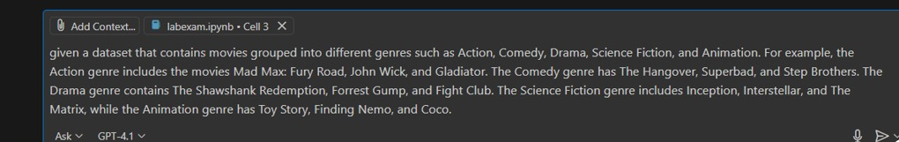

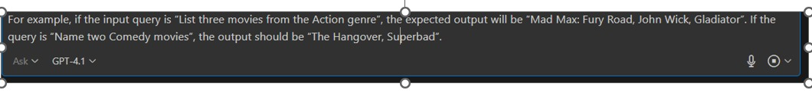

**CODE:**

**OUTPUT:**



**QUESTION-4**



**PROMPT:**

Give a code that reads a csv file having student data which calculates total and average of their marks in 3 different subjects.

**CODE:**

**OUTPUT:**  
