

Header

6 inches

3 inches

3 inches

12 inches

body

12 inches

4 inches

4 inches

4 inches

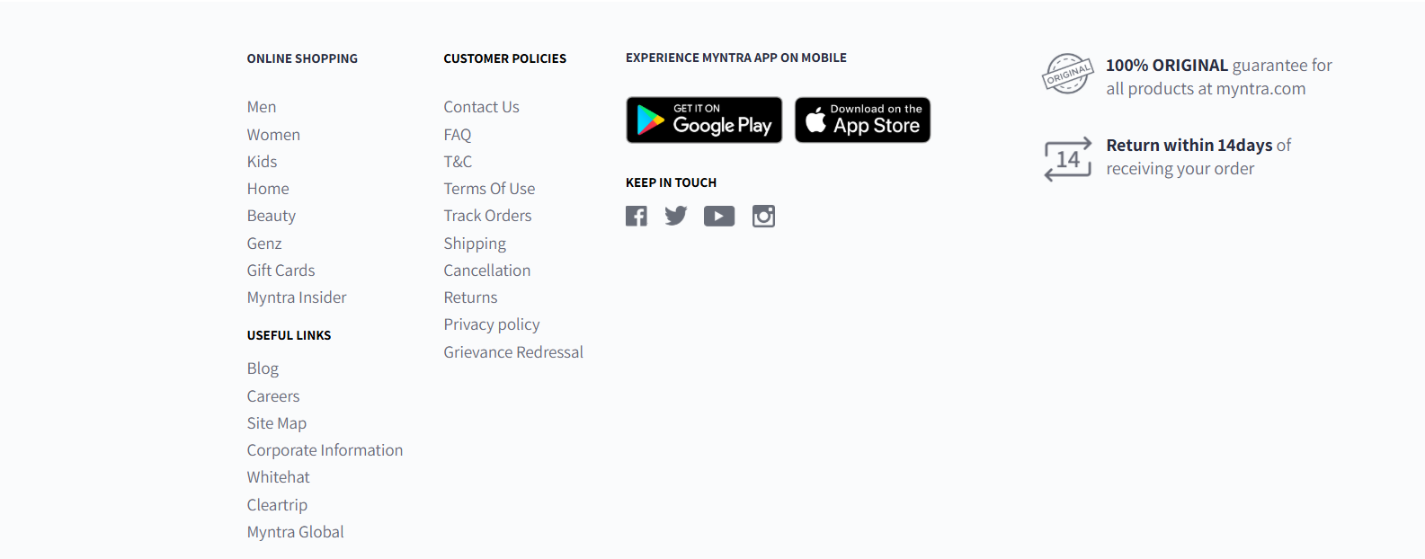

Footer

2 inches

12 inches

8 inches

2 inches