Heart Disease MLOps
Final Report

Student: Sriman Narayan Bharadwaj R
Course: MLOps Assignment 01 (2026)
Repository: https://github.com/srimannarayanbharadwaj/MLOps-Assignment
Date: 12-07-2026

1. Executive Summary
This project builds an end-to-end MLOps pipeline for the UCI Cleveland Heart Disease dataset. The workflow covers data ingestion, exploratory analysis, model training, experiment tracking, packaging, automated testing, containerized serving, Kubernetes deployment, and basic monitoring. Two models were compared using stratified 5-fold cross-validation: Logistic Regression and Random Forest. Logistic Regression was selected for deployment because it achieved the best ROC-AUC (0.9188) while remaining simple to explain and efficient to serve in production.

2. Project Setup

2.1 Environment
- Python version: 3.12 (used because MLflow UI failed on Python 3.14).
- Virtual environment: .venv312
- Core libraries: pandas, scikit-learn, mlflow, fastapi, uvicorn, pytest, prometheus-client

2.2 Repository Structure
heart-disease-mlops/
data/raw, data/processed
src/ # download, cleaning, EDA, training, API
tests/ # unit tests
models/ # packaged pipeline
.github/workflows/ # CI pipeline
k8s/ # deployment manifests
screenshots/ # evidence from each phase
report/ # final report and generated metrics

2.3 Reproduction Commands
python -m venv .venv312
.\.venv312\Scripts\Activate.ps1
pip install -r requirements.txt
python -m src.data_download
python -m src.eda
python -m src.train
python -m src.package_model

3. Phase 1 — Data and EDA

3.1 Dataset
- Source: UCI Heart Disease dataset, Cleveland subset
- Rows after cleaning: 303
- Features: 13 clinical attributes plus binary target
- Missing values appeared as '?' in ca and thal and were handled in preprocessing
- Target rule: 0 = no disease, values 1+ collapsed to 1 = disease

3.2 Class Balance
- No disease (0): 164
- Disease (1): 139
The classes are moderately imbalanced. Accuracy alone can be misleading because a model could appear strong by predicting the majority class more often. For this medical screening task, recall, precision, and ROC-AUC are more informative because they reflect how well the model catches actual disease cases and ranks risk correctly.
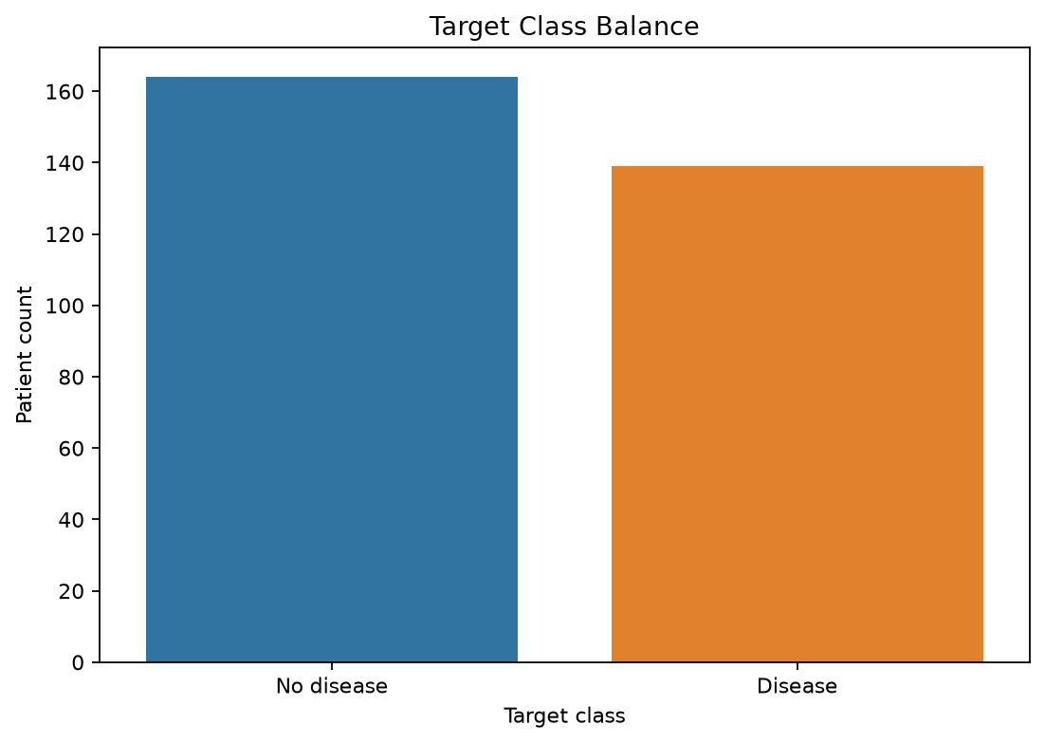
Figure 1: Class balance

3.3 Feature Distributions
The numeric histograms show that age is roughly bell-shaped, while cholesterol and blood pressure have wider spreads with some extreme values. Oldpeak and thalach also vary noticeably across patients. Because the numeric features use different scales, StandardScaler was applied before model training.
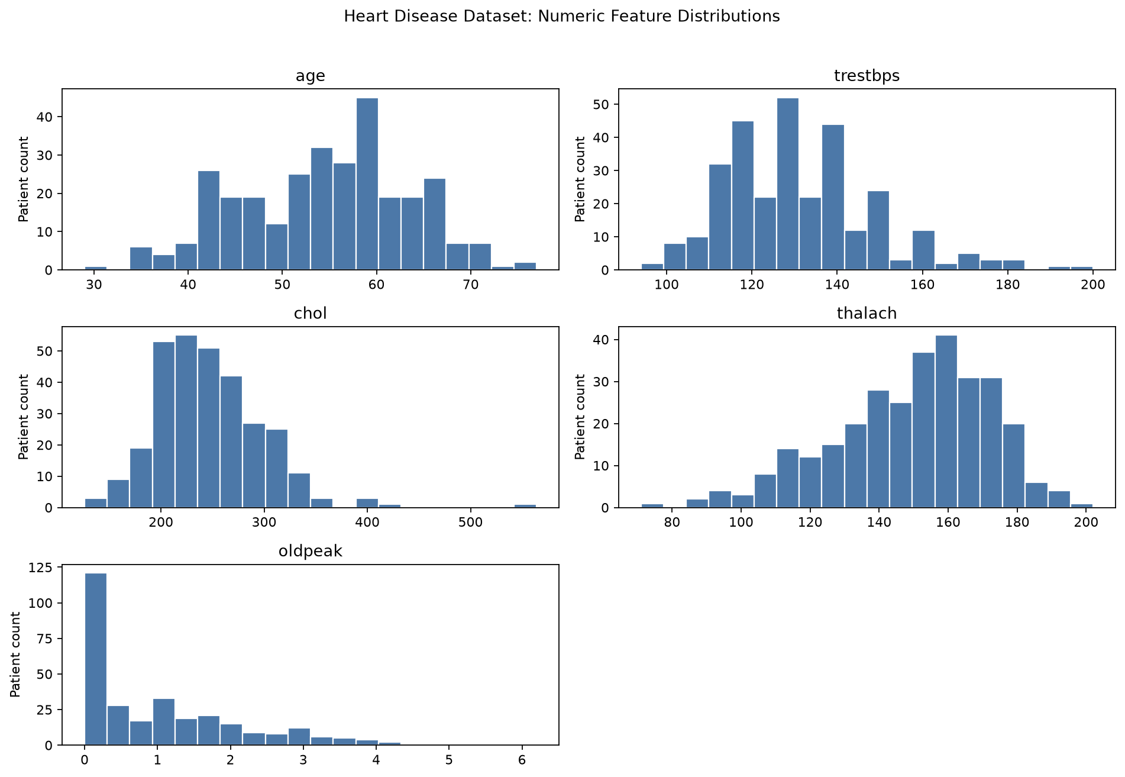
Figure 2: Numeric feature histograms

3.4 Correlation Heatmap
The heatmap shows moderate relationships between several clinical variables and the target. Features such as cp, thalach, and oldpeak stand out as useful predictors. Some input variables are also correlated with each other, which is expected in medical data. Tree models can tolerate this naturally, while Logistic Regression still performed well after scaling and one-hot encoding.
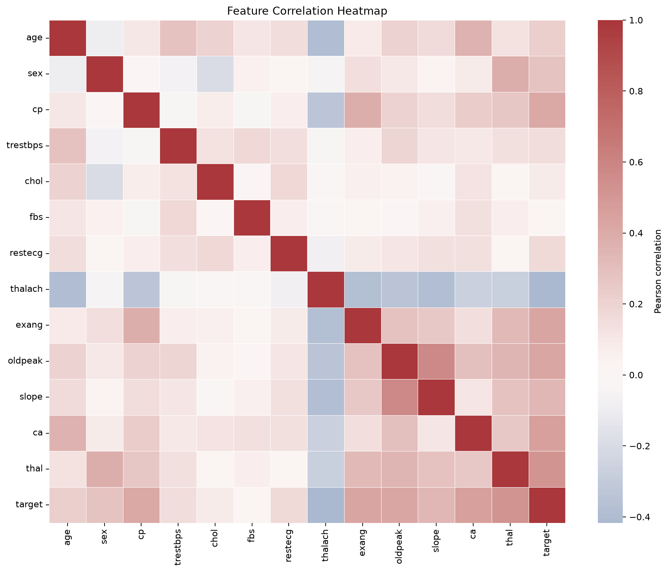
Figure 3: Correlation heatmap

4. Phase 2 — Feature Engineering and Modeling

4.1 Preprocessing Pipeline
- Numeric features: age, trestbps, chol, thalach, oldpeak -> StandardScaler
- Categorical features: sex, cp, fbs, restecg, exang, slope, ca, thal -> OneHotEncoder
- Combined with ColumnTransformer inside a sklearn Pipeline

4.2 Cross-Validation Results
Model | Accuracy | Precision | Recall | ROC-AUC
Logistic Regression | 0.8447 | 0.8475 | 0.8050 | 0.9188
Random Forest | 0.8416 | 0.8388 | 0.8127 | 0.9163
Evaluation used StratifiedKFold with 5 folds.

4.3 Model Selection Justification
Logistic Regression was selected as the production model because it achieved the highest ROC-AUC (0.9188), indicating stronger overall ranking ability across thresholds. Random Forest had slightly better recall (0.8127 vs 0.8050), which matters clinically because missed disease cases can be more serious than false alarms. However, the recall difference is small, and Logistic Regression is easier to interpret and faster to deploy in an API service.

5. Phase 3 — Experiment Tracking (MLflow)
Each training run was logged in MLflow with model parameters, cross-validation metrics, confusion matrix images, CSV summaries, and the full sklearn pipeline. MLflow made it easy to compare Logistic Regression and Random Forest side by side without manually opening multiple output files.
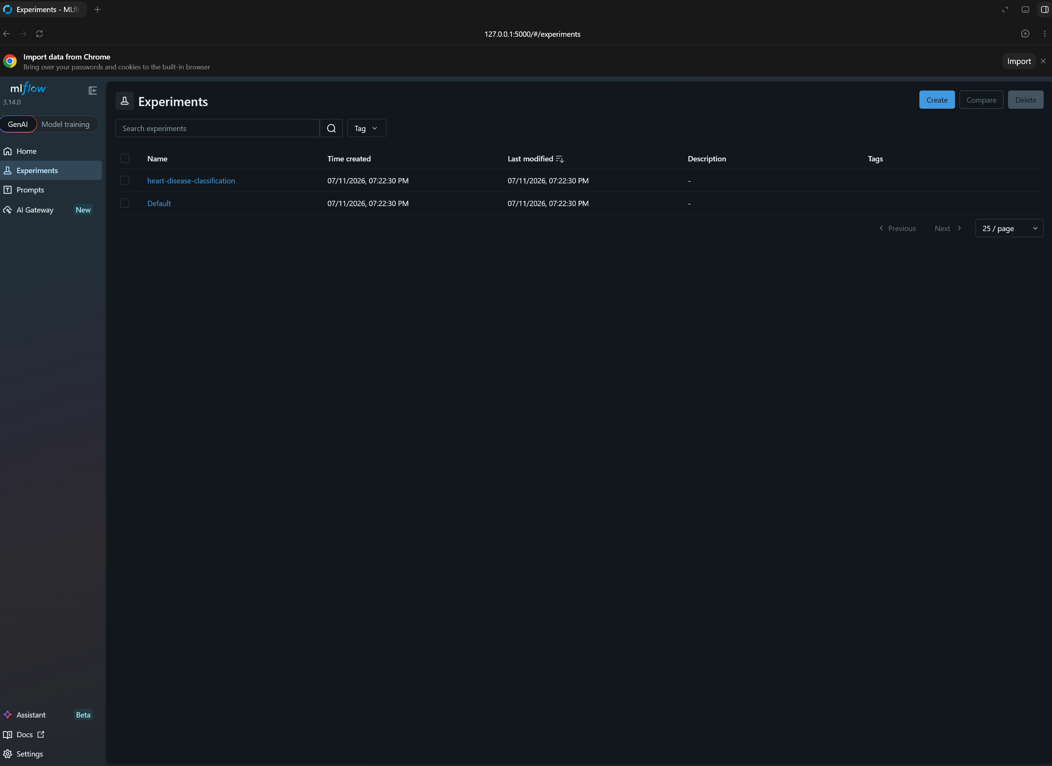
Figure 4: MLflow experiments page
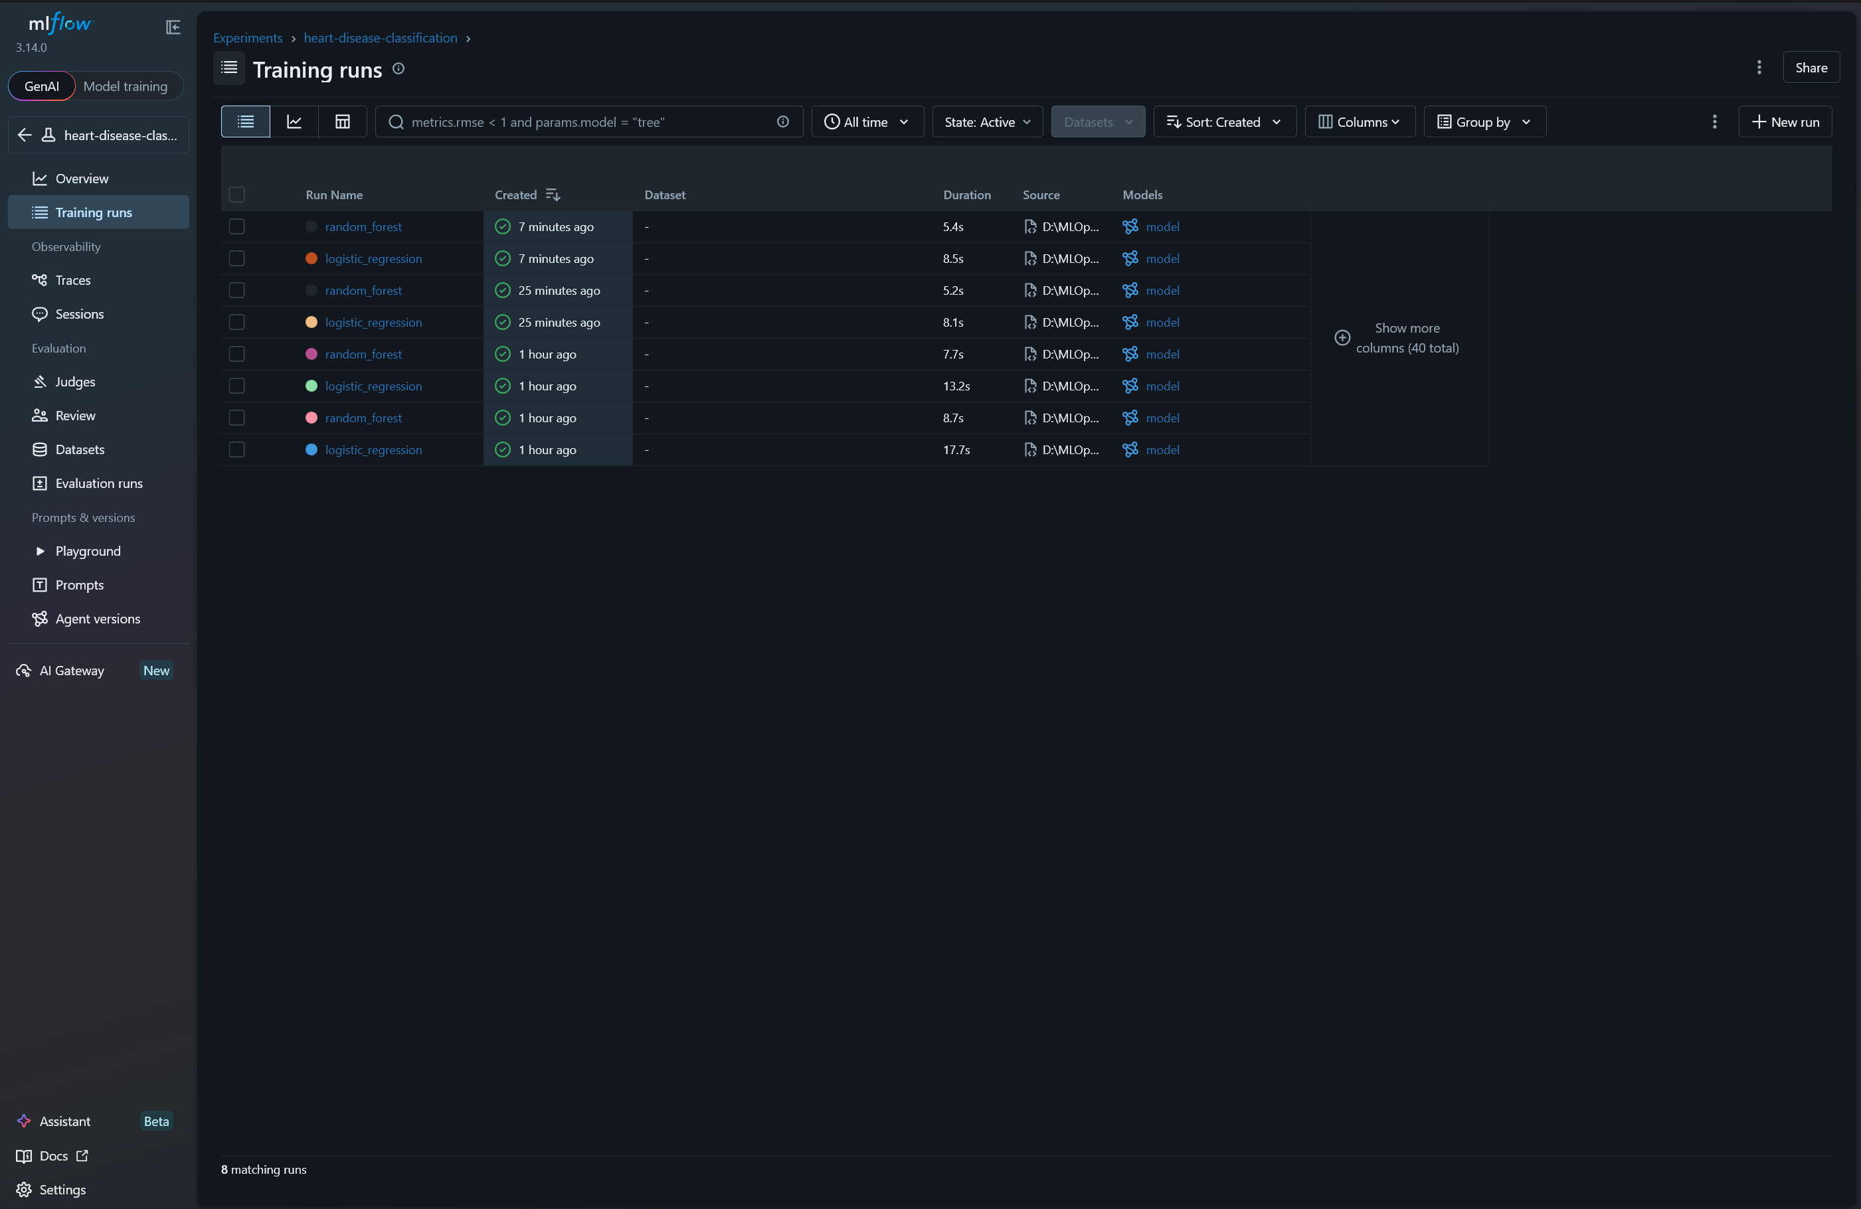
Figure 5: MLflow training run comparison
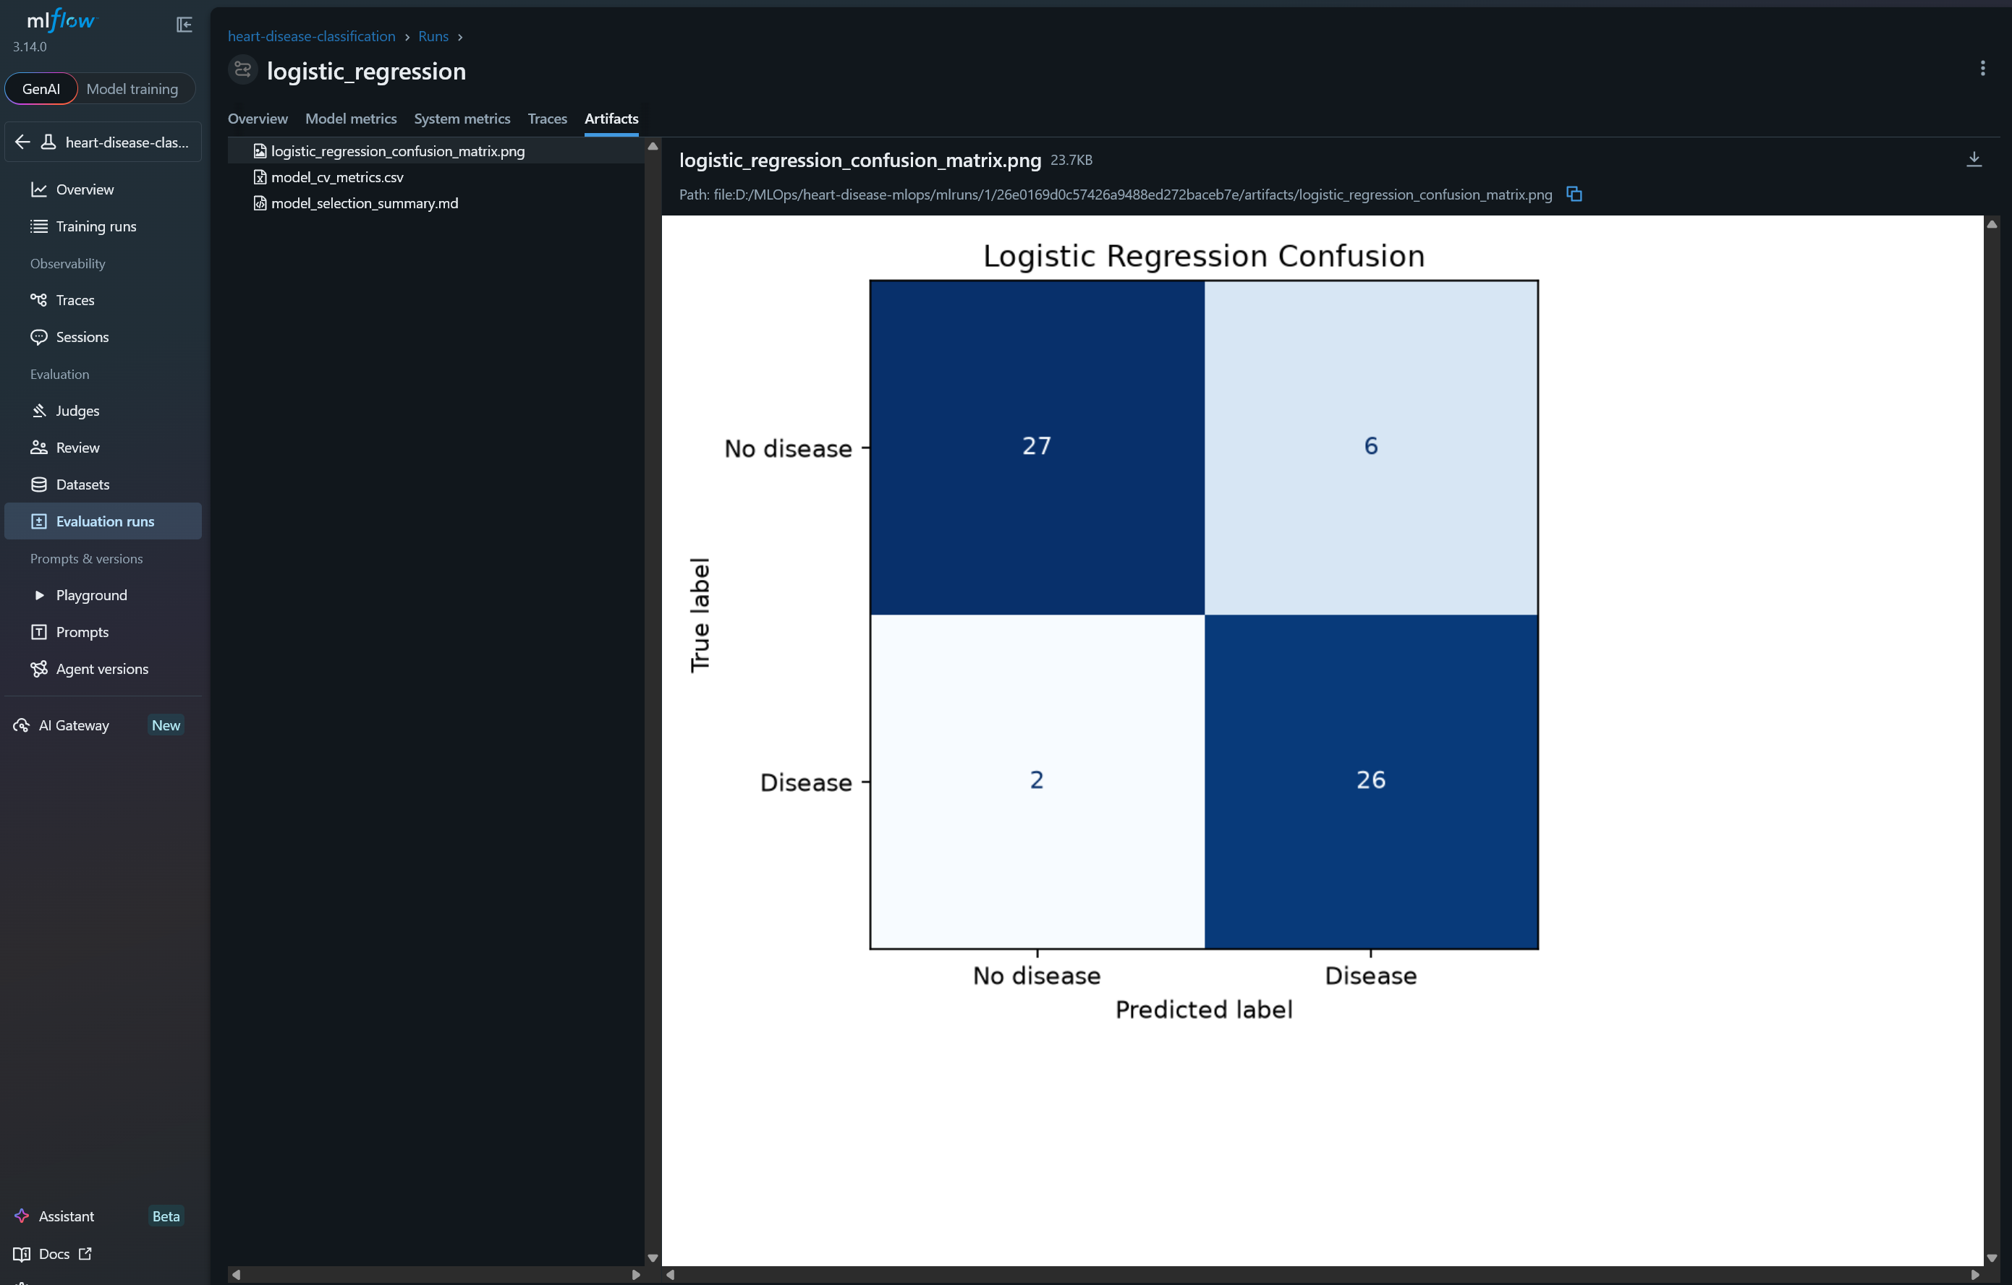
Figure 6: Logistic Regression run artifacts

6. Phase 4 — Packaging
- models/heart_disease_pipeline.joblib — preprocessing + model pipeline
- models/model_metadata.json — feature lists, training rows, CV metrics
- models/sample_input.json — sample inference payload
- requirements.txt — pinned dependencies for reproducibility
A fresh clone can reproduce the packaged artifact by installing requirements and running python -m src.package_model.

7. Phase 5 — Unit Tests and CI/CD
- tests/test_data.py validates null handling and target binarization
- tests/test_model.py checks prediction shape and probability validity
- tests/test_api.py checks /health and /metrics endpoints
GitHub Actions runs lint, pytest, and the training/package workflow in order. This prevents broken cleaning logic or model code from being merged silently.
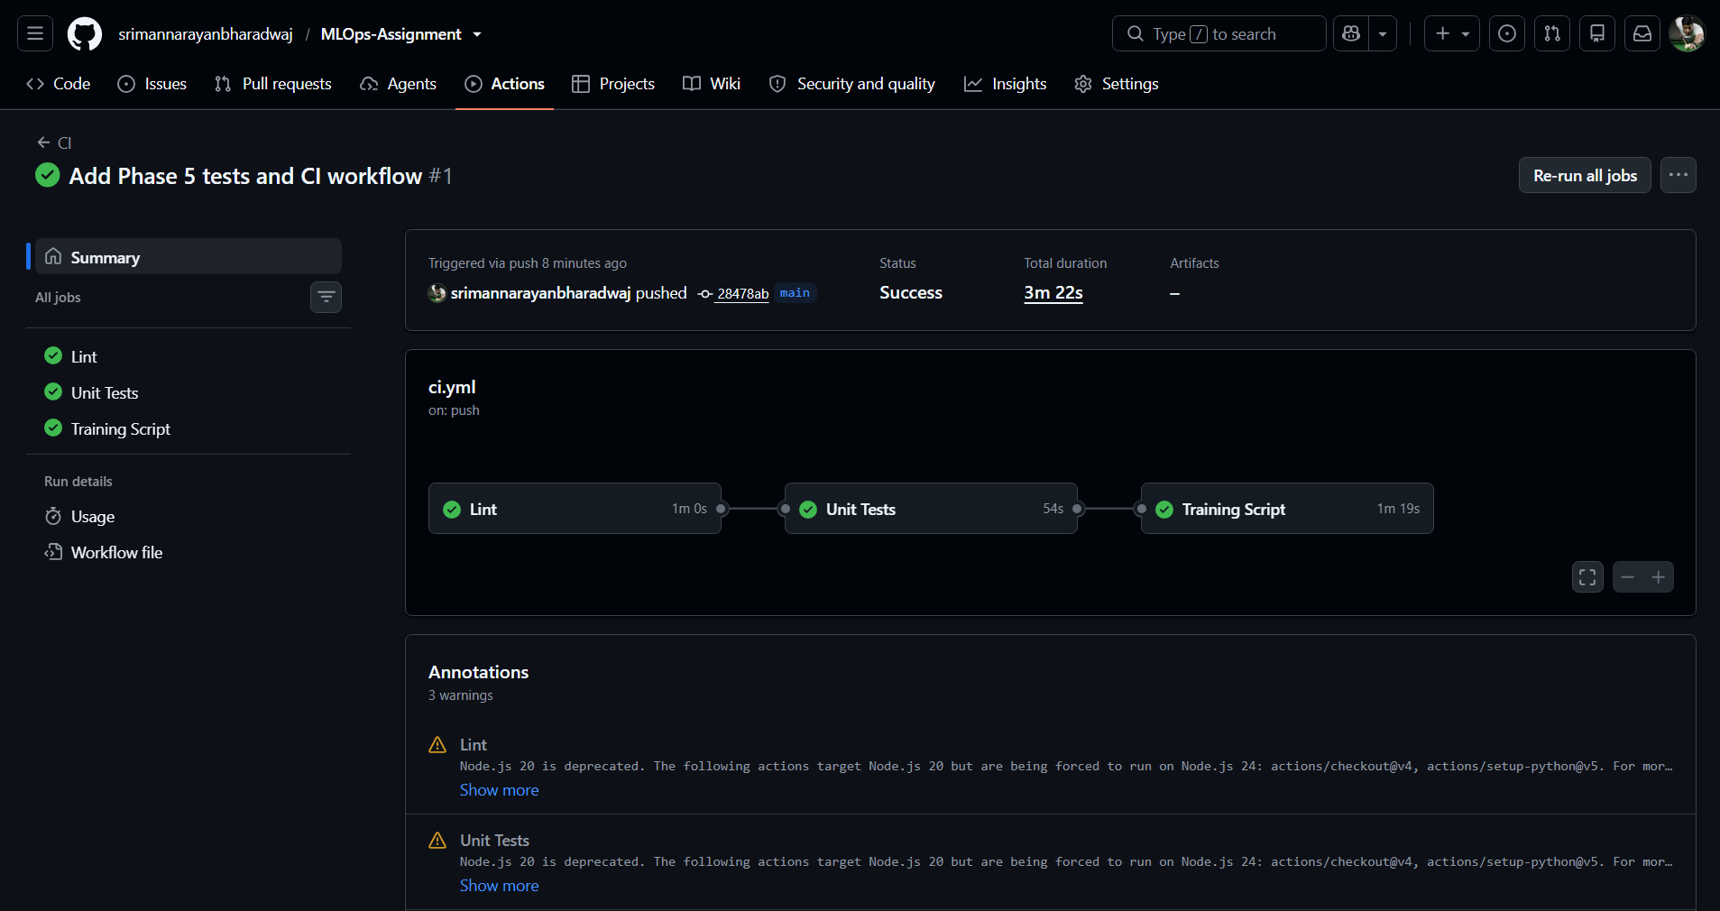
Figure 7: Successful GitHub Actions workflow

8. Phase 6 — Containerization (Docker + FastAPI)
- GET /health — service and model status
- POST /predict — prediction, confidence, and risk label
- GET /metrics — Prometheus metrics
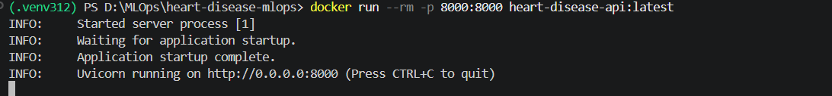
Figure 8: Docker container running
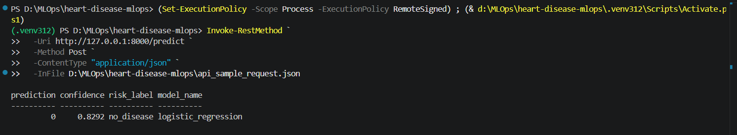
Figure 9: Successful Docker /predict response
Sample response: {"prediction": 0, "confidence": 0.8292, "risk_label": "no_disease", "model_name": "logistic_regression"}

9. Phase 7 — Kubernetes Deployment (Minikube)
The Docker image was deployed to a local Minikube cluster using Kubernetes Deployment and Service manifests. Readiness and liveness probes use /health.
minikube start
docker build -t heart-disease-api:latest .
minikube image load heart-disease-api:latest
kubectl apply -f k8s/
kubectl port-forward service/heart-disease-api 8080:8000
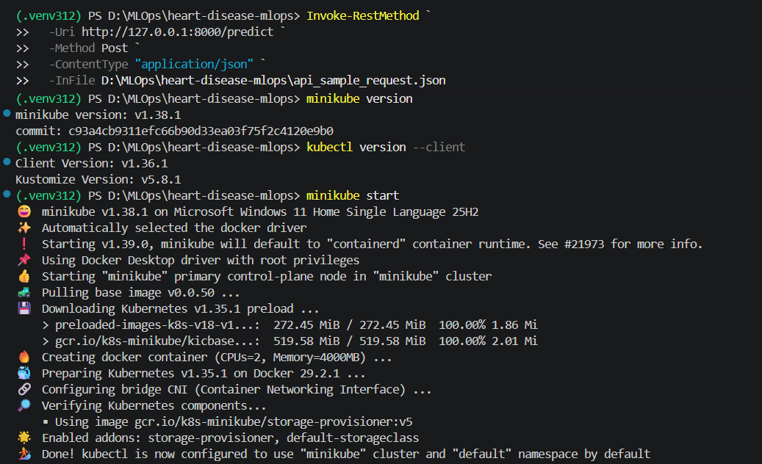
Figure 10: Minikube started successfully
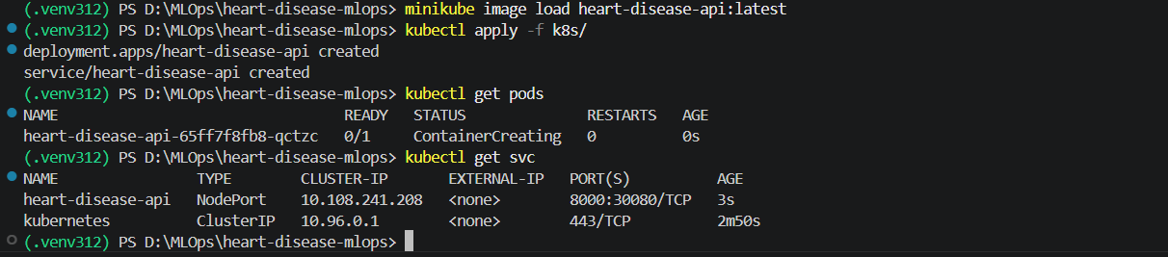
Figure 11: Kubernetes deployment and service created
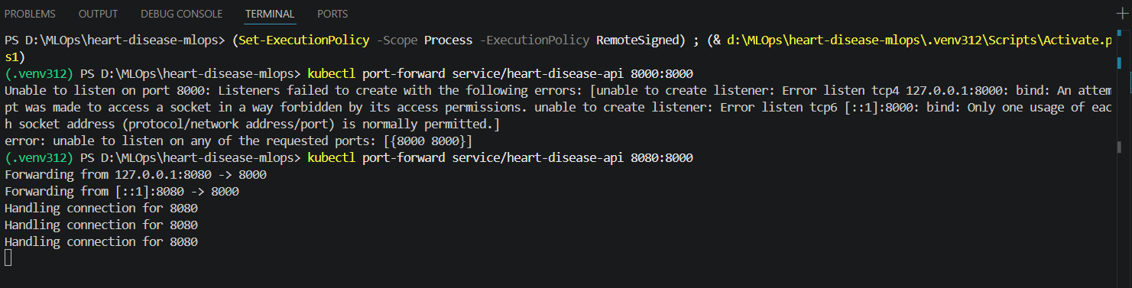
Figure 12: Port-forward to the Kubernetes service
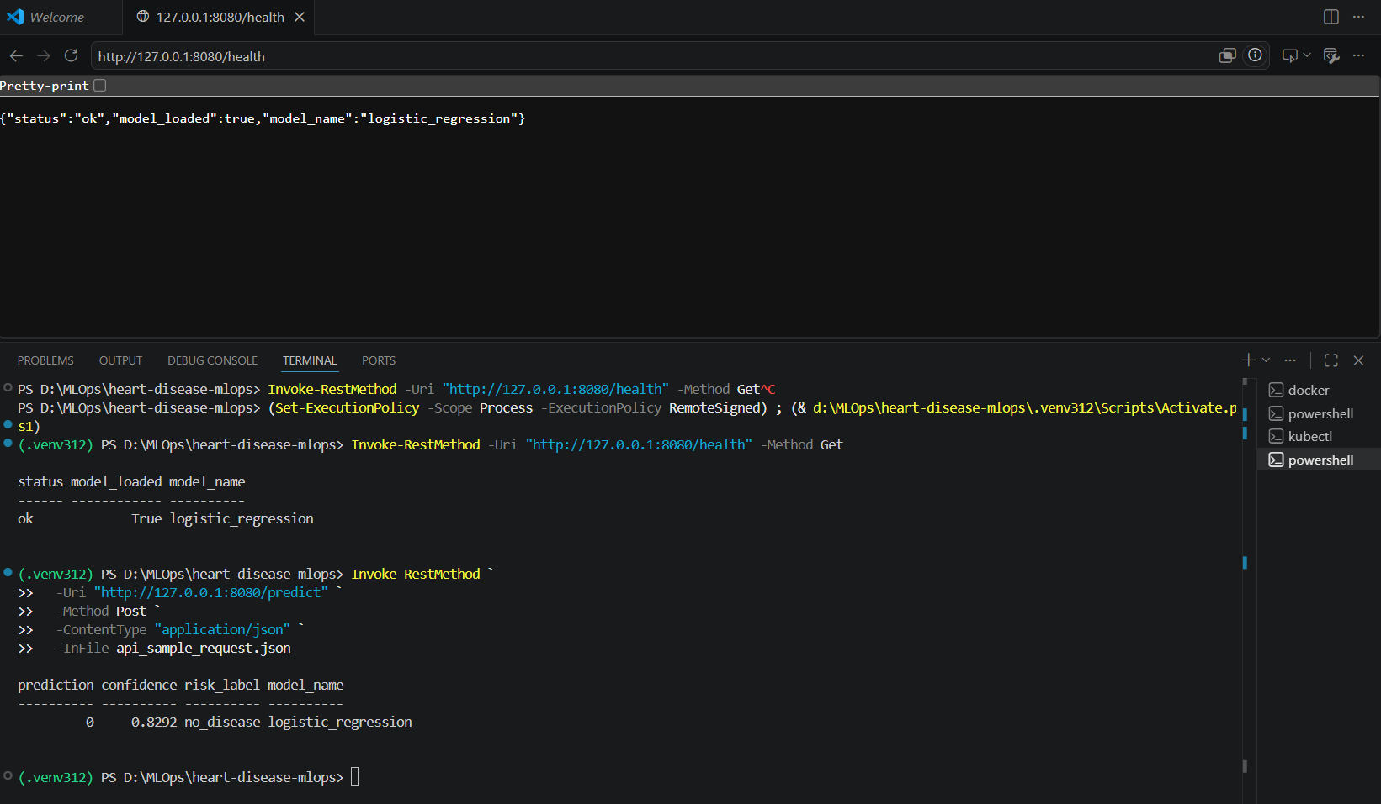
Figure 13: Successful /health response from Kubernetes deployment

10. Phase 8 — Monitoring
The FastAPI service includes request logging middleware and a Prometheus /metrics endpoint. Logs capture timestamp, endpoint, method, status code, and latency. In production, these signals would help diagnose slow endpoints or rising error rates.
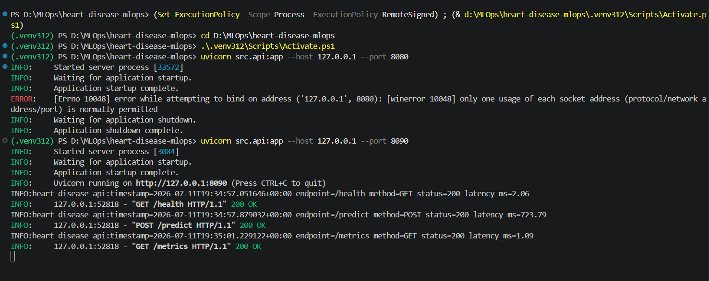
Figure 14: Request logging output
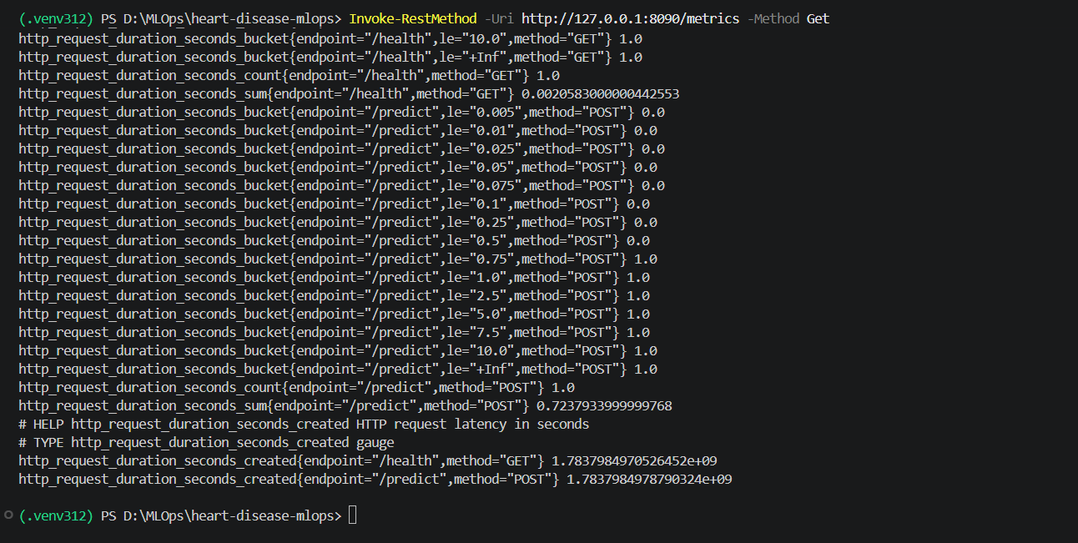
Figure 15: Prometheus /metrics endpoint

11. System Architecture
Pipeline flow: UCI CSV -> data_download.py -> cleaned dataset -> EDA and train.py -> MLflow tracking and generated metrics -> package_model.py -> joblib pipeline -> FastAPI -> Docker image -> Minikube deployment -> /predict, /health, and /metrics endpoints. GitHub Actions and pytest validate the pipeline automatically on each push.
UCI CSV
-> src/data_download.py
-> data/processed/heart_cleveland_clean.csv
-> src/eda.py + src/train.py
-> MLflow + report/generated metrics
-> src/package_model.py
-> models/heart_disease_pipeline.joblib
-> src/api.py (FastAPI)
-> Docker image
-> Kubernetes deployment (Minikube)
-> /predict, /health, /metrics
GitHub Actions + pytest validate each stage automatically.

12. Challenges and Lessons Learned
- Python 3.14 caused MLflow UI failures; Python 3.12 resolved the issue.
- Docker and Minikube port conflicts required alternate ports or stopping old tunnels.
- Pinned requirements improved reproducibility across machines.
- MLflow significantly simplified experiment comparison and artifact management.

13. Conclusion
This assignment delivered a complete MLOps workflow from raw medical data to a monitored production-style API. The final Logistic Regression pipeline achieved strong cross-validated performance and was packaged, tested, containerized, and deployed on Kubernetes with logging and metrics support.

Appendix A — Repository Link
https://github.com/srimannarayanbharadwaj/MLOps-Assignment

Appendix B — Video Demonstration
Add the recorded end-to-end walkthrough video link or filename here before final submission.

