Filters and Interceptors are two mechanisms in Java and Spring frameworks used for intercepting and processing requests/responses. While they share some similarities, they differ in their purpose, scope, and implementation. Here’s a detailed comparison:

1. What is a Filter?
A Filter is part of the Servlet API. It is used to preprocess and postprocess HTTP requests and responses in a web application.

Key Characteristics
- Part of the Servlet specification.
- Operates at the servlet container level.
- Can be applied to a wide range of web resources (e.g., servlets, JSPs, static resources).
- Executes before the request reaches a servlet and after the servlet generates a response.

Typical Use Cases
- Authentication and authorization checks.
- Logging and auditing.
- Request/response compression (e.g., GZip).
- Modifying request headers or parameters.
- Managing CORS (Cross-Origin Resource Sharing).

Implementation Example
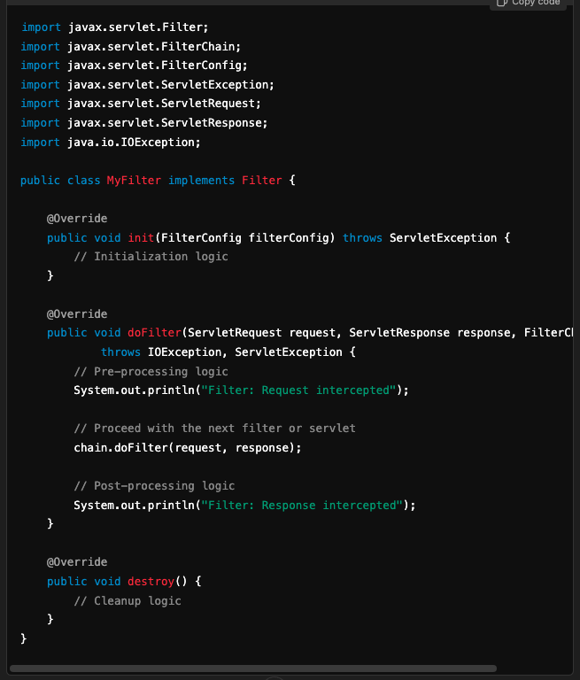

Registration in Spring Boot
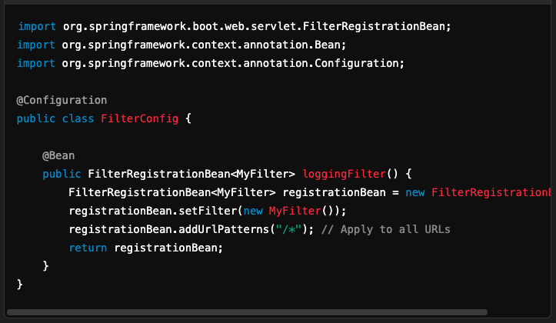

2. What is an Interceptor?
An Interceptor is specific to the Spring framework. It is used to intercept requests in the context of a HandlerMapping in a Spring MVC application.

Key Characteristics
- Part of the Spring framework.
- Operates at the Spring MVC layer.
- Can only intercept requests mapped to controllers.
- Provides finer-grained control over pre-processing and post-processing of requests, including modifying the handler.

Typical Use Cases
- Pre-processing requests for authentication/authorization.
- Logging and debugging at the application level.
- Adding custom headers to responses.
- Implementing application-specific logic (e.g., locale resolution).

Implementation Example
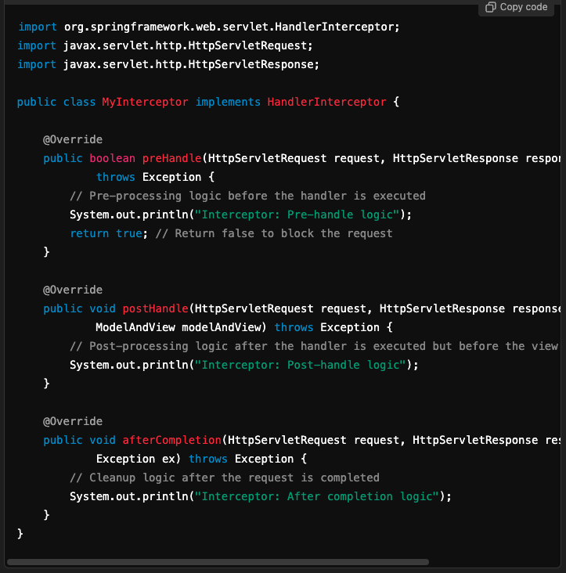
Registration in Spring
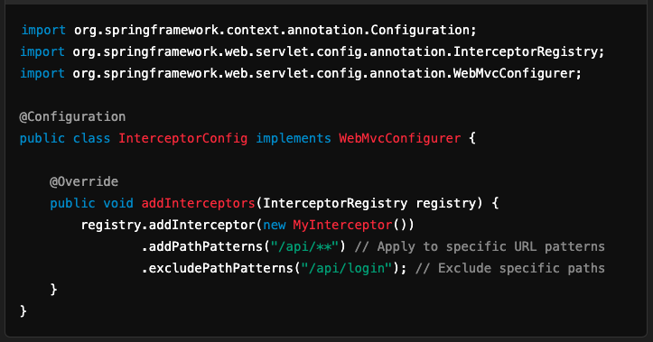

3. Key Differences Between Filter and Interceptor
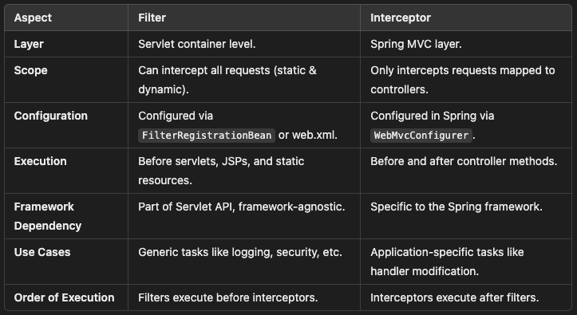

4. When to Use What?
- Use Filters:
  - For cross-cutting concerns that apply to all types of requests, including static resources.
  - For tasks that must occur before any servlet-specific or Spring-specific logic (e.g., CORS, request compression).
- Use Interceptors:
  - For Spring MVC-specific logic that needs access to controllers, models, or specific URL patterns.
  - For tasks like modifying the handler, resolving locale, or customizing response headers in the MVC context.

5. Example Workflow
- Request Flow:
  - Filter → DispatcherServlet → Interceptor (preHandle) → Controller → Interceptor (postHandle) → View Renderer → Interceptor (afterCompletion) → Filter.
- Response Flow:
  - In reverse order through the same components.

Conclusion
Both Filters and Interceptors play vital roles in processing requests and responses in web applications. Filters are ideal for low-level, framework-agnostic concerns, while Interceptors excel in Spring-specific, application-layer concerns. Choose based on the task's scope and requirements.

