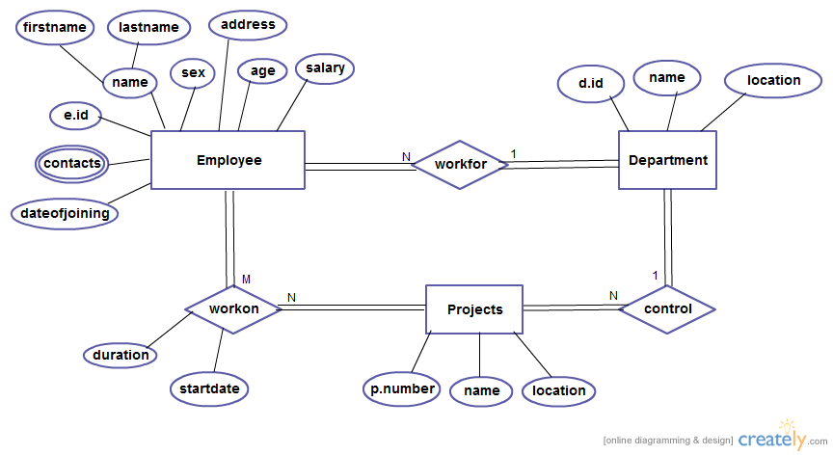

EMP_DEPT_PROJ_DDL_DML.sql

EMP_DEPT_PROJ_DQL.sql

SQL query to find first 5 employee based on highest salary?
SELECT * FROM employee e1 WHERE (SELECT COUNT(*) FROM employee e2 WHERE e1.salary < e2.salary) < 5 ORDER BY e1.salary DESC;

