Protocol Buffers (Protobuf) is a language-neutral, platform-neutral method for serializing structured data. It was developed by Google and is widely used for data exchange between systems, especially in distributed computing environments.

Key Features of Protobuf:
- Compact and Efficient: Protobuf generates smaller data sizes than formats like XML or JSON, making it ideal for systems with bandwidth or storage constraints.
- Cross-Language Support: You define your data structure in a .proto file, and Protobuf generates code for multiple languages (e.g., Java, Python, C++).
- Schema Evolution: Protobuf allows you to add or update fields in your schema without breaking compatibility with older versions.
- Speed: It is highly optimized for serialization (converting data into bytes) and deserialization (converting bytes back to data).

Example:
Here’s a simple Protobuf schema (example.proto):
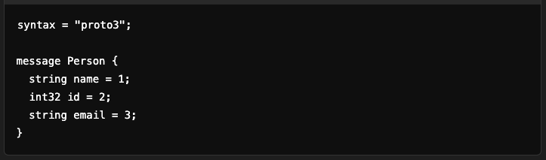
- message: Defines a structured data type (like a class in object-oriented programming).
- Each field has a name, a type, and a unique number (used in the binary format).

Workflow:
- Write the .proto schema.
- Use the Protobuf compiler (protoc) to generate code in your desired programming language.
- Use the generated code to serialize and deserialize data.

Use Cases:
- Communication between microservices (e.g., with gRPC).
- Storing structured data efficiently.
- Data transfer between systems or devices.

Here’s a detailed example of how Protobuf works, from schema definition to usage in code.

1. Define the .proto Schema
Create a file called person.proto with the following content:
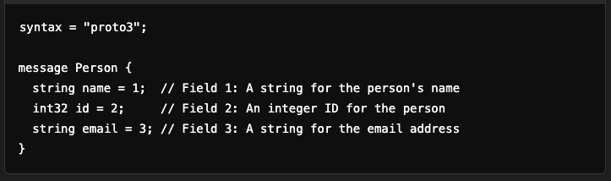

2. Compile the Schema
Use the Protobuf compiler (protoc) to generate code for your desired programming language.
This generates a .py or .java file that contains the Person class.

3. Use the Generated Code

Python Example:
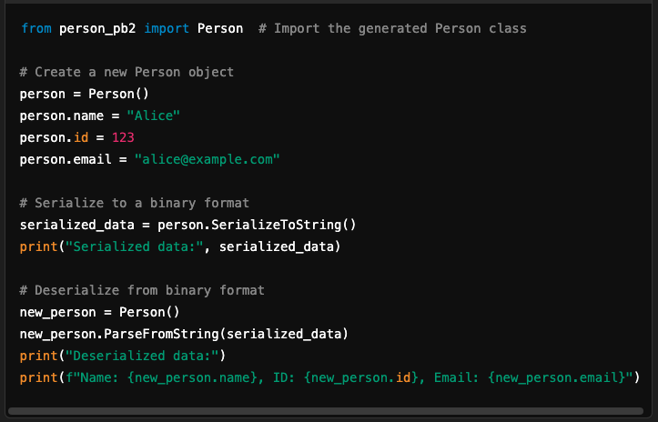

Java Example:
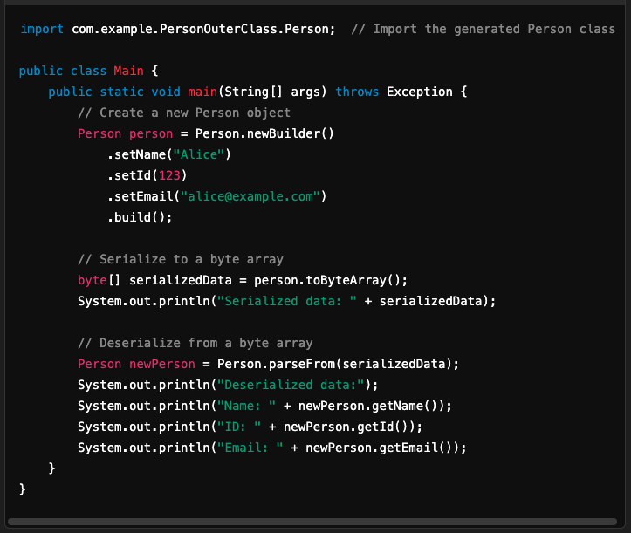

4. Output Example
For Python, the output might look like:
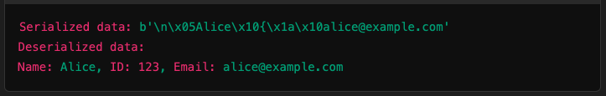
For Java, the output is similar but represented as a byte array.

Summary
- Define the data structure in a .proto file.
- Compile it to generate language-specific classes.
- Use these classes in your application to serialize/deserialize data.

