GraphQL is a query language for APIs and a runtime for executing those queries, developed by Facebook in 2015. It provides a more flexible and efficient alternative to traditional REST APIs by allowing clients to specify exactly the data they need and receive it in a single request.

Key Features of GraphQL
- Client-Specified Queries:
  - Clients can request only the data they need, avoiding over-fetching or under-fetching.
- Single Endpoint:
  - Unlike REST, which has multiple endpoints for different resources, GraphQL typically uses a single endpoint for all operations.
- Strongly-Typed Schema:
  - The API is defined using a schema that specifies the types of data available and the relationships between them.
- Real-Time Updates:
  - Supports subscriptions for real-time communication between the client and server.
- Introspection:
  - Clients can query the schema to learn about available data and operations.

How GraphQL Works
- Schema:
  - The server defines a schema using a type system that describes the shape of the data and the operations (queries, mutations, subscriptions) available.
  - Example Schema:
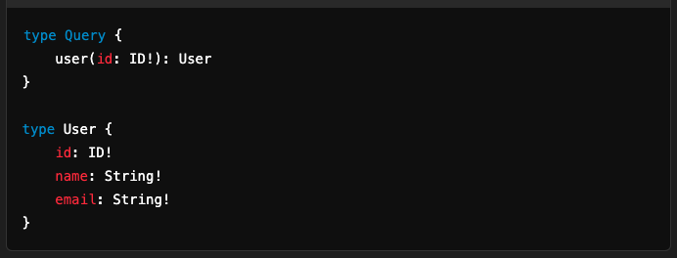
- Querying:
  - Clients send queries to the server specifying the data they need.
  - Example Query:
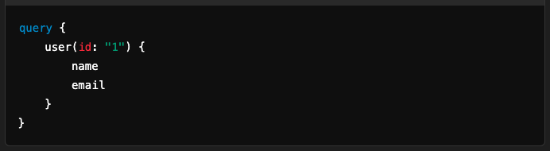
  - Example Response:
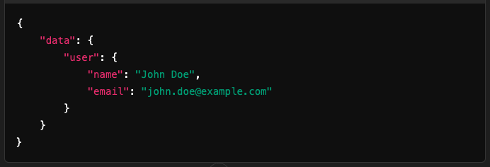
- Mutations:
  - Used to modify data on the server (create, update, delete).
  - Example Mutation:
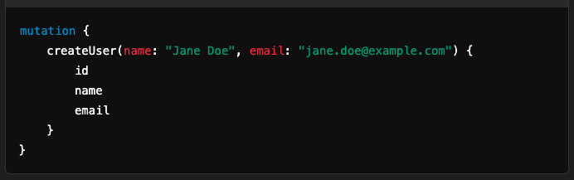
  - Example Response:
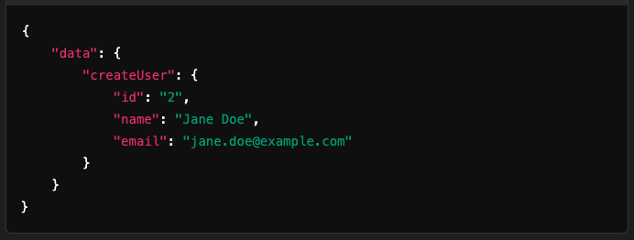

- Subscriptions:
  - Enables real-time data updates via WebSockets.
  - Example Subscription:
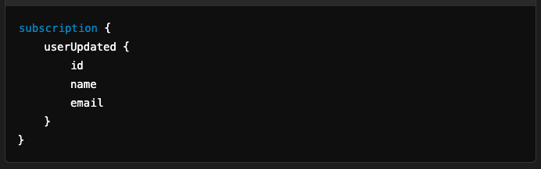

GraphQL vs REST
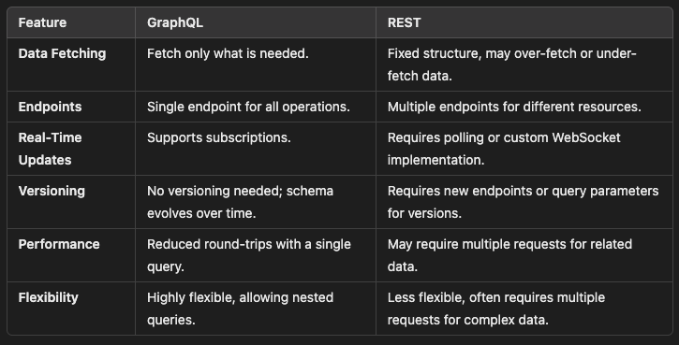

Advantages of GraphQL
- Efficient Data Fetching:
  - Clients receive only the data they request.
- Single Request:
  - Combines multiple resources in a single request.
- Strongly-Typed Schema:
  - Prevents errors and provides better documentation and tooling.
- Self-Documentation:
  - Introspection allows clients to explore the API schema dynamically.
- Real-Time Support:
  - Built-in support for subscriptions.

Challenges with GraphQL
- Complexity:
  - Requires more setup and a well-designed schema.
- Overhead:
  - Complex queries can lead to performance issues on the server.
- Caching:
  - REST benefits from HTTP caching; caching in GraphQL requires custom implementation.
- Learning Curve:
  - New concepts like schema design and query language need to be learned.

When to Use GraphQL
- When the API has complex relationships or hierarchies.
- When clients need different data views.
- For real-time applications that require updates.
- To optimize performance in mobile or low-bandwidth environments.

GraphQL Workflow
- Define Schema:
  - The server defines a schema describing the available data and operations.
- Write Queries:
  - Clients write queries or mutations to interact with the API.
- Send Request:
  - Queries or mutations are sent to the server via HTTP POST.
- Process Request:
  - The server parses the query, executes it, and returns the response.
- Client Processes Response:
  - The client uses the response data to update the UI or state.

GraphQL provides a modern approach to API design and is particularly useful for applications with dynamic, real-time, and nested data needs.

