HTTP/2 is a major revision of the HTTP protocol, designed to improve performance, reduce latency, and enhance resource utilization over HTTP/1.1. The flow of HTTP/2 involves key features like multiplexing, stream prioritization, header compression, and server push. Below is a breakdown of how HTTP/2 works:

Key Features of HTTP/2
- Binary Protocol:
  - HTTP/2 uses a binary format instead of the text-based format of HTTP/1.1, making it more compact and easier to parse.
- Multiplexing:
  - Multiple streams of data (requests and responses) can be sent over a single TCP connection simultaneously, eliminating head-of-line (HOL) blocking in HTTP/1.1.
- Stream Prioritization:
  - Streams can be assigned weights and dependencies, allowing the server to prioritize which resources to send first.
- Header Compression:
  - HTTP/2 compresses headers using HPACK, reducing the overhead of large headers sent repeatedly.
- Server Push:
  - The server can proactively send resources (like CSS or JavaScript files) to the client without waiting for an explicit request.

HTTP/2 Flow
- Connection Setup:
  - The client establishes a TCP connection to the server.
  - Optionally, an SSL/TLS handshake occurs if the connection uses HTTPS.
  - HTTP/2 negotiation happens during the connection phase:
    - ALPN (Application-Layer Protocol Negotiation) is used to negotiate HTTP/2 over TLS.
    - The server and client agree to use HTTP/2.
- Stream Creation:
  - HTTP/2 breaks communication into streams.
  - Each stream is identified by a unique stream ID.
  - Streams are bidirectional and can carry requests or responses.
- Multiplexing:
  - Multiple streams are sent simultaneously over a single TCP connection.
  - Each stream is divided into frames (e.g., header frames, data frames, etc.).
  - Frames are interleaved and reassembled by the recipient.
- Header Compression:
  - The client and server exchange headers using HPACK compression to reduce overhead.
  - Repeated headers (e.g., User-Agent) are sent as references to previously transmitted data.
- Stream Prioritization:
  - Streams can be prioritized using weights (1–256) and dependencies.
  - The server uses this information to decide the order of resource delivery.
- Server Push:
  - The server can push additional resources to the client without an explicit request.
  - For example, if a client requests an HTML file, the server can push associated CSS and JavaScript files proactively.
- Data Transmission:
  - The client sends a request as a series of frames (e.g., header and data frames).
  - The server processes the request and sends the response as frames, which the client reassembles.
- Stream Termination:
  - Once the response is complete, the stream is closed.
  - Streams can also be terminated explicitly by either the client or server.

HTTP/2 Frame Types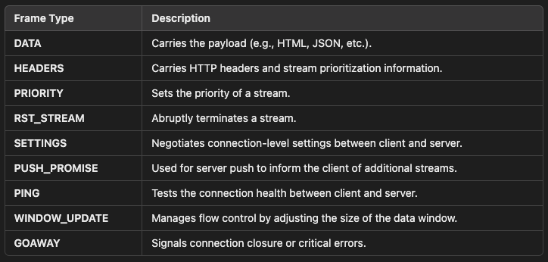

HTTP/2 Flow Diagram
1. Connection Establishment:
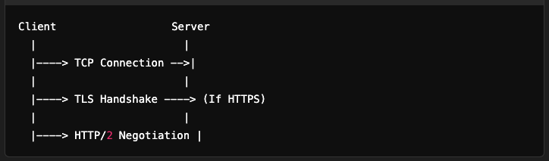

2. Request and Response:
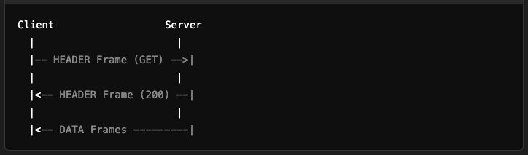
3. Server Push:
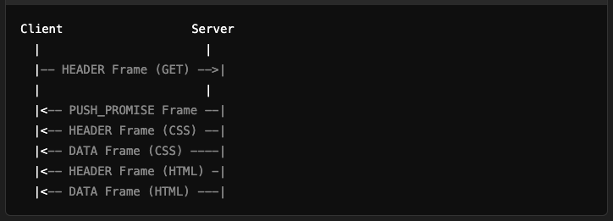

Advantages of HTTP/2
- Improved Performance:
  - Reduces latency through multiplexing and server push.
- Lower Overhead:
  - Header compression reduces redundant data.
- Efficient Resource Use:
  - A single connection serves multiple requests and responses.
- Better Flow Control:
  - Fine-grained control over data transmission through stream prioritization.

Challenges
- Complexity:
  - More complex to implement compared to HTTP/1.1.
- Head-of-Line Blocking (TCP-level):
  - Still exists at the TCP layer; if a packet is lost, all streams sharing the connection are affected.
- Compatibility:
  - Not all clients and servers fully support HTTP/2 features.

Conclusion
HTTP/2 is a significant evolution of the HTTP protocol, addressing many limitations of HTTP/1.1. Its core features like multiplexing, server push, and header compression make it faster, more efficient, and suitable for modern web applications.

