In Java, both Runnable and Callable are functional interfaces used to represent tasks that can be executed by a thread or executor service. However, they have key differences in functionality:

1. Return Type
- Runnable: Does not return a result. Its run() method is void.
- Callable: Returns a result. Its call() method returns a generic type T.

2. Exception Handling
- Runnable: The run() method does not throw checked exceptions.
- Callable: The call() method can throw checked exceptions.

3. Method Signature
Runnable:
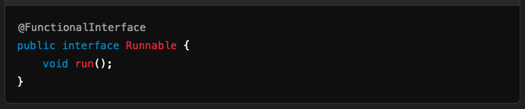
Callable:
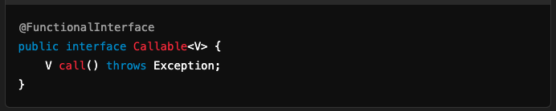

4. Use Cases
- Runnable:
  - When you don't need a return value or to throw checked exceptions.
  - Suitable for simple tasks executed in threads.
- Callable:
  - When you need a task to return a result or throw checked exceptions.
  - Works with ExecutorService to submit tasks and get results via Future.

5. Working with Threads
Runnable: Can be directly used with Thread.
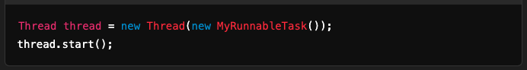
Callable: Cannot be directly used with Thread. Typically used with ExecutorService.
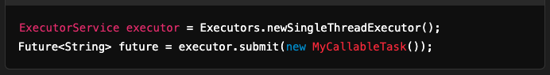

Examples

Runnable Example:
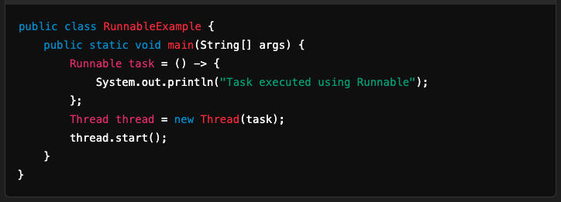

Callable Example:
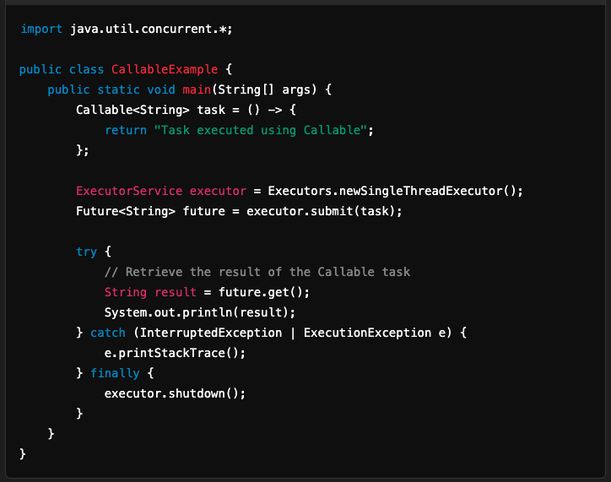

Comparison Table

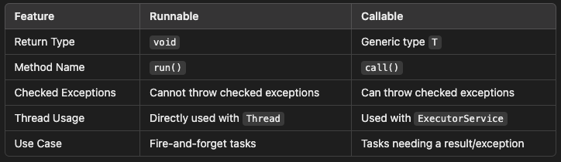

Summary
- Use Runnable for simple, fire-and-forget tasks.
- Use Callable when you need to return a result or handle exceptions.

