NGINX and HAProxy are both popular tools used for load balancing, reverse proxying, and improving the scalability and performance of web services. They differ in their architectures, features, and best use cases.

1. Overview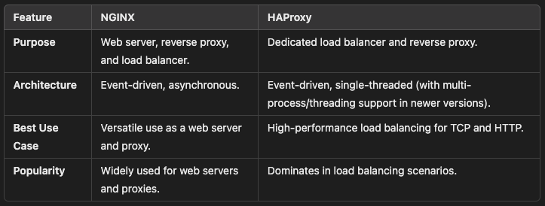

2. Features Comparison

2.1 Reverse Proxy
- NGINX: Optimized for handling static content, dynamic reverse proxying, and caching.
- HAProxy: Focused on routing and balancing TCP/HTTP traffic efficiently.

2.2 Load Balancing
- NGINX: Supports HTTP, HTTPS, TCP, and UDP load balancing.
- HAProxy: More advanced load balancing algorithms and health checks for TCP/HTTP.

2.3 Configuration
- NGINX: Configuration is file-based and uses declarative syntax.
- HAProxy: Uses a more detailed and flexible configuration file but can be complex for beginners.

2.4 Performance
- NGINX: Excels in handling large amounts of concurrent HTTP connections.
- HAProxy: Slightly faster and more efficient for raw TCP/HTTP load balancing under heavy traffic.

2.5 Security
- Both support:
  - SSL/TLS termination.
  - Rate limiting.
  - IP whitelisting/blacklisting.

2.6 Monitoring
- NGINX: Provides basic metrics; integrates well with tools like Prometheus.
- HAProxy: Offers detailed metrics and a robust stats page for monitoring and troubleshooting.

2.7 Scalability
- Both tools are highly scalable, but HAProxy has better performance in distributed and high-load environments due to its focus on raw traffic handling.

3. Typical Use Cases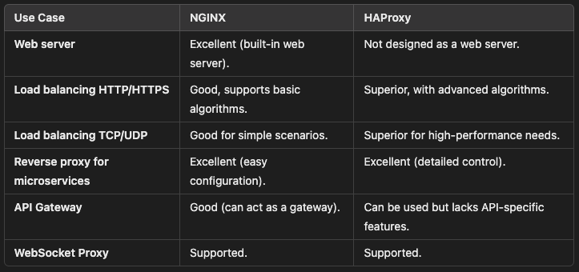

4. Configuration Examples

4.1 NGINX: Load Balancing Example
File: /etc/nginx/nginx.conf
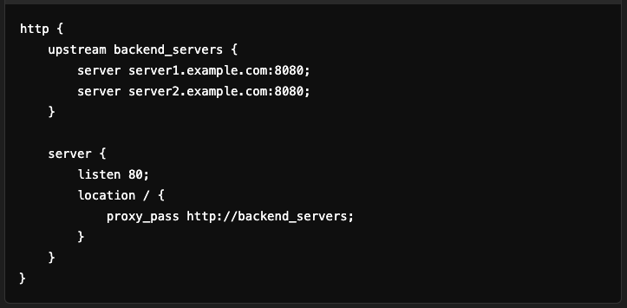
Features:
- Balances HTTP traffic between two servers.
- Can add caching, compression, or SSL termination.

4.2 HAProxy: Load Balancing Example
File: /etc/haproxy/haproxy.cfg
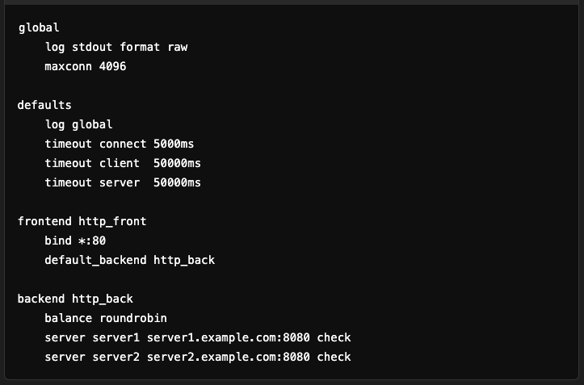
Features:
- Supports advanced algorithms like leastconn, source, and hashing.
- Performs health checks to ensure only healthy servers receive traffic.

5. When to Use Which?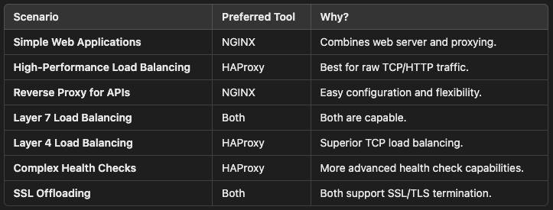

6. Combining NGINX and HAProxy
You can combine NGINX and HAProxy for advanced setups:
- HAProxy: Used as a Layer 4 load balancer to handle raw traffic.
- NGINX: Acts as a Layer 7 reverse proxy for HTTP traffic.
Example Architecture:
Client --> HAProxy (TCP Load Balancing) --> NGINX (HTTP Reverse Proxy) --> Application Servers

7. Monitoring and Debugging
- NGINX:
  - Use tools like nginx_status or Prometheus exporters.
  - Enable metrics:
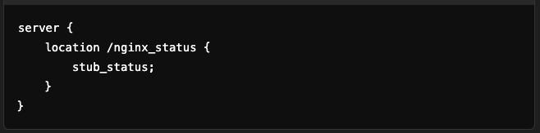
- HAProxy:
  - Enable stats page:


8. Conclusion
- Use NGINX if you need a versatile web server and reverse proxy with good performance.
- Use HAProxy for high-performance, low-latency load balancing in complex distributed systems.
Both tools excel in their domains and can even be used together for an optimized infrastructure.

