Base64 Encoding
Base64 is a binary-to-text encoding scheme that converts binary data into a string format using a set of 64 characters. It is commonly used to encode data that needs to be transmitted over text-based protocols like email or JSON.

How Base64 Works
- Input: Takes binary data (e.g., a file or string).
- Conversion:
  - Splits the binary data into 6-bit groups (since 2^6 = 64).
  - Maps each group to a corresponding character in a predefined set of 64 characters:

- Output: Produces a Base64-encoded string.

Example
- Input: "Hello"
- Binary: 01001000 01100101 01101100 01101100 01101111
- Base64: "SGVsbG8="

Common Use Cases
- Embedding binary files (e.g., images) in text-based formats like HTML or JSON.
- Encoding authentication credentials in HTTP headers (Basic Auth).
- Ensuring data remains intact during transfer over systems that only handle text.

Limitations
- Increases data size by approximately 33% (binary data is padded and converted to text).

SHA Encoding (Hashing)
SHA (Secure Hash Algorithm) is a family of cryptographic hash functions designed to ensure data integrity. Unlike Base64, which encodes data, SHA performs hashing, which is a one-way transformation of data into a fixed-length hash value.

Key Features of SHA
- One-Way Function: You cannot reverse a hash to get the original data.
- Fixed Output Size: The output hash size is fixed regardless of the input size.
  - SHA-1: 160 bits (20 bytes).
  - SHA-256: 256 bits (32 bytes).
  - SHA-512: 512 bits (64 bytes).
- Collision Resistance: Hard to find two inputs that produce the same hash (improved in newer versions like SHA-256 and SHA-512).

Example
- Input: "Hello"
- SHA-256 Output: 185f8db32271fe25f561a6fc938b2e264306ec304eda518007d1764826381969

Common Use Cases
- Data Integrity:
  - Verifying that a file or message hasn’t been tampered with.
  - Example: Comparing hash values of downloaded files.
- Digital Signatures:
  - Hashes are used in cryptographic operations to create unique, verifiable signatures.
- Password Storage:
  - Instead of storing passwords directly, systems store their hash values.
- Blockchain:
  - Hashes ensure data immutability in blockchain systems.

Differences Between Base64 and SHA
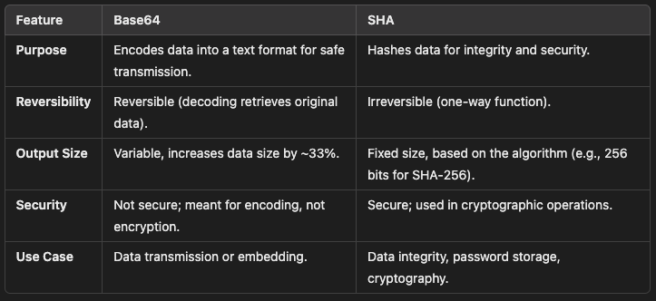

Conclusion
- Use Base64 for encoding binary data into a text-safe format for transmission.
- Use SHA for creating a cryptographic hash of data to ensure integrity and security.

