Difference Between Promises and async/await in JavaScript
Both Promises and async/await are used to handle asynchronous operations in JavaScript. While they are closely related, they differ in syntax, readability, and usage.

1. Promises
Promises provide a way to handle asynchronous operations by chaining .then(), .catch(), and .finally() methods.

Example with Promises:
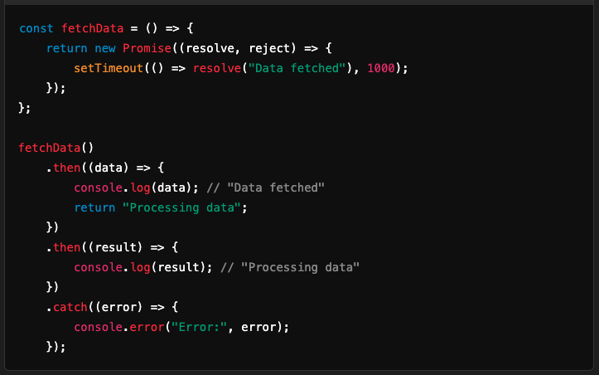

2. async/await
async/await is syntactic sugar over Promises that allows asynchronous code to be written in a more synchronous and readable manner. It eliminates the need for chaining and provides easier error handling using try-catch.

Example with async/await:
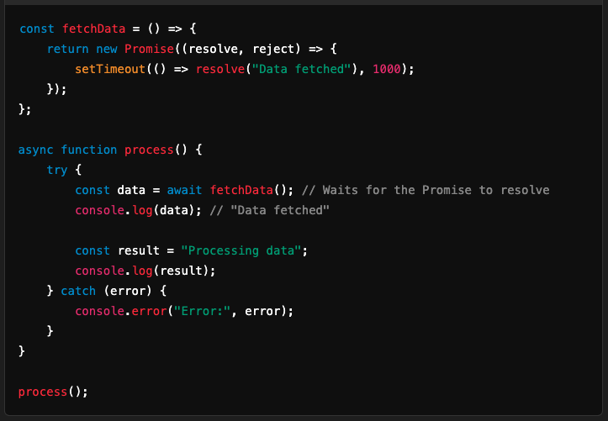

Key Differences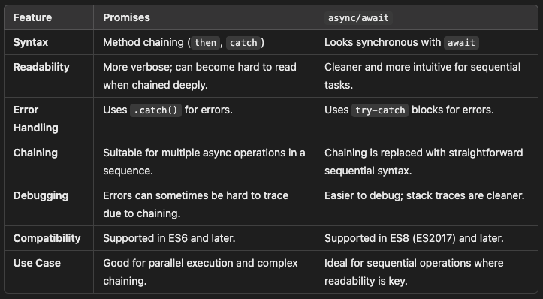

3. Error Handling Comparison

With Promises:
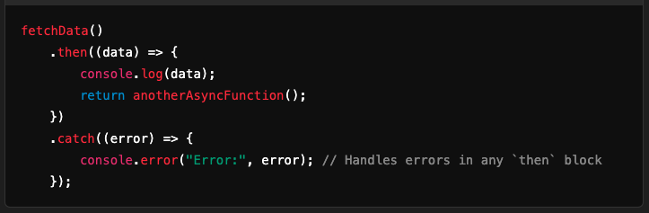

With async/await:
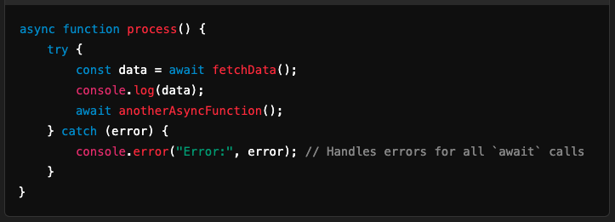

4. Parallel vs Sequential Execution

Parallel Execution with Promises:


Parallel Execution with async/await:
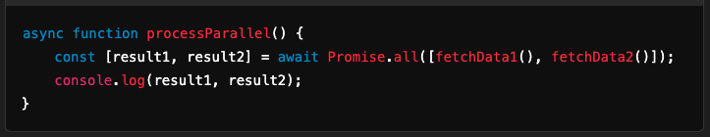

Sequential Execution:
Both approaches handle sequential execution similarly:
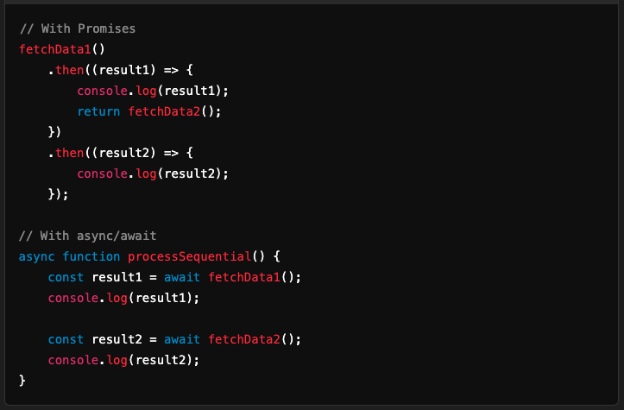

Which One Should You Use?
- Use Promises:
  - When performing independent asynchronous operations that can run in parallel.
  - For straightforward chaining of asynchronous tasks.
- Use async/await:
  - When working with sequential asynchronous tasks.
  - When you need better readability and simpler error handling.
Both Promises and async/await are powerful tools for handling asynchronous code. Choose the one that best fits the complexity and requirements of your specific task.

