In JavaScript, a Promise is an object that represents the eventual completion (or failure) of an asynchronous operation and its resulting value. Promises provide a cleaner and more readable way to handle asynchronous code, replacing the traditional callback-based approach.

States of a Promise
A Promise can be in one of three states:
- Pending:
  - The initial state.
  - Neither fulfilled nor rejected.
- Fulfilled:
  - The operation was completed successfully.
  - The promise has a resulting value.
- Rejected:
  - The operation failed.
  - The promise has a reason (error).
Once a Promise transitions from the "pending" state to either "fulfilled" or "rejected," it becomes settled, and its state cannot change.

Creating a Promise
A Promise is created using the Promise constructor, which takes a function (executor) with two arguments:
- resolve: Marks the promise as fulfilled and provides a value.
- reject: Marks the promise as rejected and provides a reason (error).

Example:
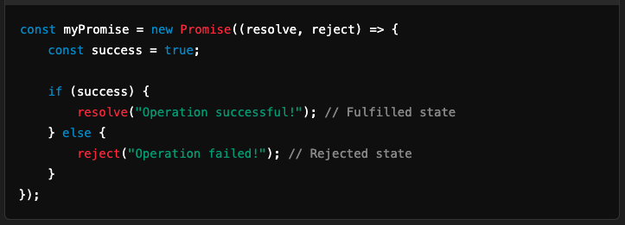

Using Promises

1. then() Method
- Used to handle the fulfillment of a Promise.
- Takes a callback function as its argument.

2. catch() Method
- Used to handle the rejection of a Promise.
- Takes a callback function as its argument.

3. finally() Method
- Executes a callback after the Promise is settled, regardless of whether it was fulfilled or rejected.

Example:
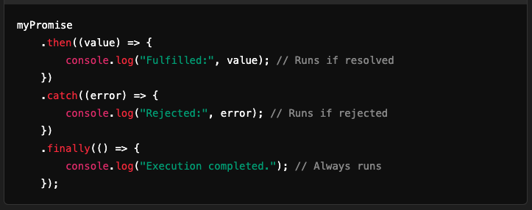

Promise Chaining
You can chain multiple .then() calls to perform a series of asynchronous operations.

Example:
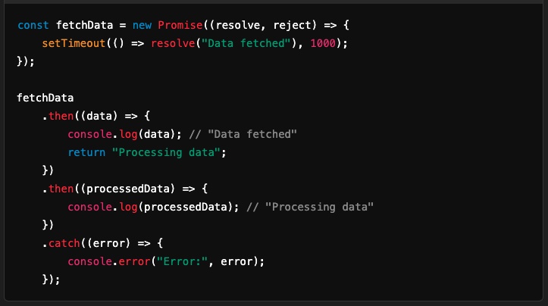

Static Methods in Promise

1. Promise.resolve(value)
- Creates a resolved Promise with the given value.

2. Promise.reject(reason)
- Creates a rejected Promise with the given reason.

3. Promise.all(iterable)
- Resolves when all Promises in the iterable are resolved.
- Rejects if any Promise is rejected.
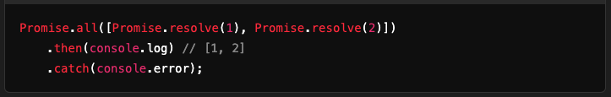

4. Promise.race(iterable)
- Resolves or rejects as soon as any Promise in the iterable settles.
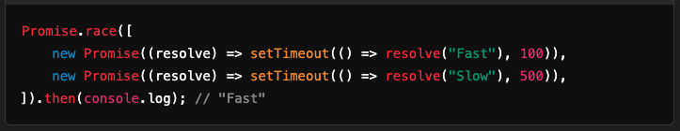

5. Promise.allSettled(iterable)
- Waits for all Promises to settle and returns their results (fulfilled or rejected).
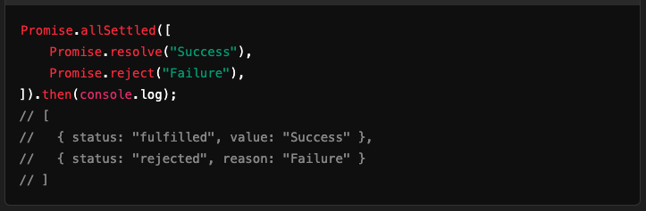

Key Benefits of Promises
- Better Readability:
  - Promises simplify handling asynchronous code compared to nested callbacks.
- Avoid Callback Hell:
  - Promises reduce deeply nested callbacks, making the code more maintainable.
- Chaining:
  - Promises allow chaining multiple asynchronous operations in sequence.

Alternative: async/await
- Introduced in ES2017 (ES8), async/await provides a cleaner way to work with Promises, making asynchronous code look synchronous.

Example:
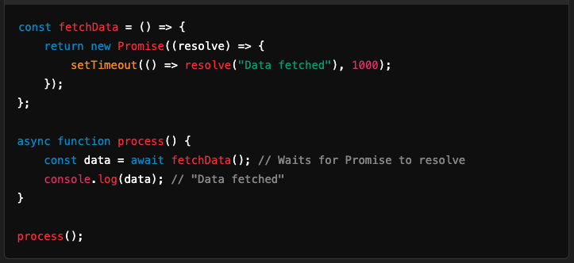

Promises are foundational for modern JavaScript programming, especially when dealing with asynchronous tasks like fetching data or reading files.

