Abstract— This study focuses on the design and development of a web application aimed at helping job seekers stay informed about the latest job trends while offering personalized job recommendations. The application allows users to input their skills and receive job suggestions based on skill match percentages, along with recommendations for additional skills to enhance their employability. The system uses the cosine similarity method in conjunction with the Term Frequency-Inverse Document Frequency (TF-IDF) algorithm to measure the similarity between job descriptions and the user's input. The web application was built using Python and Flask for the back-end, with CSS and HTML for the front-end. Key findings highlight the application's ability to provide accurate job recommendations, enabling users to make informed decisions about career development and skill acquisition. The system offers an intuitive user experience, ensuring job seekers can easily navigate the interface and explore potential career opportunities based on their existing skill set.
- Introduction
The increasing complexity of the job market has created challenges for job seekers in navigating available opportunities and matching their skills with relevant roles. With the rise of online platforms and job boards, it has become essential for job seekers to stay updated on the latest job trends and understand the skills required for various positions.[6] This study introduces a web application designed to provide job seekers with personalized recommendations based on their existing skills. The application uses advanced natural language processing (NLP) techniques, including cosine similarity and Term Frequency-Inverse Document Frequency (TF-IDF), to match user-inputted skills with job descriptions.
The purpose of this study is to develop and evaluate a recommendation system that offers job suggestions with skill matching and identifies additional skills that could improve job compatibility. The main objective is to create a user-friendly interface that allows job seekers to input their skills and receive tailored job information, helping them make more informed career decisions. This report covers the design and development of the web application, the methods used for skill matching, an analysis of its effectiveness, and suggestions for future enhancements.

- Literature Review
Several studies have explored the use of machine learning and natural language processing (NLP) techniques to improve job matching and career guidance. A widely used approach involves applying cosine similarity and TF-IDF to measure the relationship between job descriptions and candidate profiles.[2] demonstrate that these methods significantly enhance job recommendation accuracy compared to traditional keyword-based search methods. [1] found that cosine similarity, combined with TF-IDF, effectively captures semantic meaning between job requirements and candidate skills, improving match accuracy.
Other studies have focused on different aspects of job matching systems, such as the integration of additional factors like job preferences and work culture fit. For example, [3] integrated user preferences for work environment and salary expectations into job recommendation systems, improving overall satisfaction rates among users. While these studies have shown promising results, they primarily focus on matching based on hard skills or job titles, without offering personalized suggestions for skill development.
There is a noticeable gap in the current literature concerning the recommendation of additional skills for job seekers. This study seeks to fill that gap by providing job seekers with suggestions for skills they can acquire to improve their match for specific roles, in addition to offering job recommendations based on current skill sets.[9][10] Additionally, the use of real-time job trend analysis is underexplored, particularly in the context of how changing industry demands can influence skill development over time.

- Methods
This study employs a web-based application built using Python and Flask for the backend, with a front-end interface designed using HTML and CSS. The core functionality of the system relies on a recommendation algorithm that matches user input (skills) with job descriptions to suggest relevant job opportunities. Three different similarity methods were explored to determine the best approach for the recommendation system: Cosine Similarity, Cosine Similarity with TF-IDF, and Jaccardian Similarity.
- The Cosine Similarity method measures the cosine of the angle between two vectors, representing the similarity between two documents (in this case, job descriptions and user input). [5][7] This method was initially tested on simple keyword matches but showed limitations in capturing nuanced relationships between skills and job titles.
- Next, Cosine Similarity with TF-IDF was applied. TF-IDF, or Term Frequency-Inverse Document Frequency, is a statistical measure used to evaluate the importance of a word in a document relative to a corpus. By applying TF-IDF, this method highlights the most significant words in job descriptions and the user’s input, giving higher weight to rare but informative terms. This resulted in better handling of semantic relationships and significantly improved recommendation accuracy, making it a more refined choice for the system.
- Finally, Jaccardian Similarity was tested, which is based on the intersection over the union of two sets. While Jaccardian similarity works well for simple set-based comparisons, it did not perform as effectively in capturing the semantic richness of job descriptions and skills, as it only considered the overlap of terms.
Through evaluation with a set of sample skills, it became clear that Cosine Similarity with TF-IDF outperformed the other two methods. Its higher similarity scores, combined with the ability to retain more nuanced information through vector comparison, made it the optimal choice for the recommendation system. This method not only improved the relevance of the job suggestions but also provided a more scalable solution for a larger corpus of job descriptions.
The overall workflow involved the following steps:
- Data Collection: A dataset of job descriptions was gathered from a public job board, focusing on job title, description, and required skills.
- Data Preprocessing: Text data underwent tokenization, stop-word removal, and TF-IDF vectorization to prepare for similarity calculations.[8]
- Similarity Calculation: Cosine Similarity with TF-IDF was used to calculate the match between user skills and job descriptions, generating a similarity score for each potential job match.
- Recommendation: Based on the highest similarity scores, the system returns relevant job recommendations, along with additional skills users might need to develop.
This approach ensures that the system delivers highly relevant job recommendations tailored to the user's skill set, improving their job search experience.

IV . Analysis

Data Processing and Cleaning
The dataset underwent multiple stages of cleaning and preprocessing to ensure reliable and accurate job recommendation results. Key steps included:
Dropping Unnecessary Columns
Columns irrelevant to the analysis or recommendation process, such as advertiserurl, jobid, postdate, site_name, and uniq_id, were dropped to streamline the dataset and focus on fields that directly impact skill matching and recommendations.
Handling Missing Values
Columns like company, employmenttype_jobstatus, joblocation_address, and shift contained missing values. These were imputed using the mode (most frequent value) for each column to maintain data consistency without introducing artificial variance.
Skill Extraction and Cleanup
The skills column underwent thorough cleaning to identify and process unique skills effectively:
- Skill Splitting: Skills were split using delimiters like commas and spaces, then stripped of extra whitespace.
- Flattening: Nested lists of skills were flattened to create a consolidated list of unique skills.
- Unwanted Keywords: Keywords like "recruiter," "full time," "description," and "null" were identified as irrelevant and removed using regular expressions.
- Special Characters Removal: Parentheses, brackets, and other unnecessary characters were eliminated using custom regular expressions to clean the skill entries further.
Address Parsing
The joblocation_address field was split into city and state using a comma delimiter. For entries lacking both city and state, null values were assigned. A custom mapping was implemented to fill missing states for known cities using a predefined dictionary.
Removal of Invalid Rows
Rows where skills were missing or contained unwanted keywords were removed to enhance data integrity. A separate CSV file was generated to log the job titles associated with such rows for reference.
Data Transformation and Preparation
- Skill Filtering: To address inconsistencies in the skills field, entries were cleaned further to ensure uniformity in naming conventions.[4] The unwanted keywords were filtered out to focus on actual technical and professional skills relevant to job recommendations.
- Generating Unique Skills : The cleaned skills data was used to identify unique skills present across the dataset. This ensured the recommendation engine had access to a comprehensive set of relevant skills.
- Address Enrichment: For instances where only the city was available, a mapping function was used to infer missing states, ensuring uniformity in geographic information.

Analytical Methods
Similarity Calculation
To compute the relevance between job descriptions and user-inputted skills, the Cosine Similarity with TF-IDF algorithm was implemented. This method was chosen for its ability to capture nuanced semantic relationships between skills and job descriptions.[5]
- TF-IDF Vectorization: The dataset was vectorized using TF-IDF, highlighting the importance of rare but informative terms.
- Cosine Similarity: The angle between job description vectors and user skill vectors was calculated, resulting in a similarity score for each job recommendation.
Address Normalization
A structured mapping was created to handle ambiguities in geographic fields, ensuring consistency across city and state entries. This improved the contextual accuracy of recommendations based on location.

- Visuals
Visual representations of data are crucial in uncovering patterns, trends, and insights that might not be immediately apparent in raw datasets. In this section, key data insights are depicted using graphs and charts, enabling an intuitive understanding of the job market distribution. These visualizations help in identifying areas with the highest job postings, skill demand trends, and employment patterns across different states and roles.[4]

- The bar chart below illustrates the top 5 states with the highest number of job postings, providing a clear picture of where job opportunities are most abundant. As shown, California (CA) leads significantly, followed by New York (NY), Georgia (GA), Texas (TX), and New Jersey (NJ).

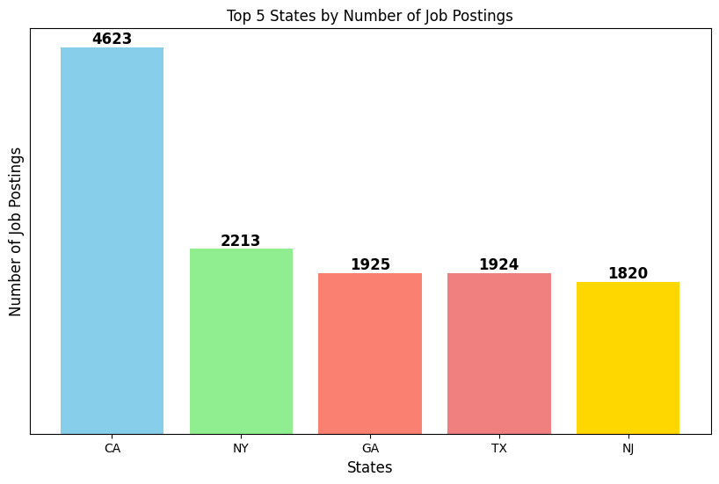
Figure 1: Top 5 States with the Highest Number of Job Postings
- This bar chart displays the top 7 cities with the highest number of job postings. New York leads the list, followed by Atlanta and San Francisco, indicating significant job opportunities in these metropolitan areas.
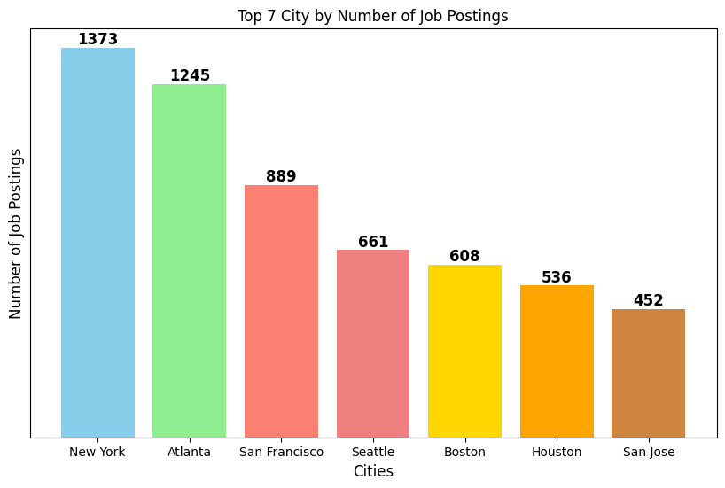
Figure 2 : Top 7 Cities with the Highest Number of Job Postings

- This bar chart illustrates the top 10 skills that are most frequently required across job postings in the dataset. These insights help job seekers prioritize their skill development to align with current market demands.
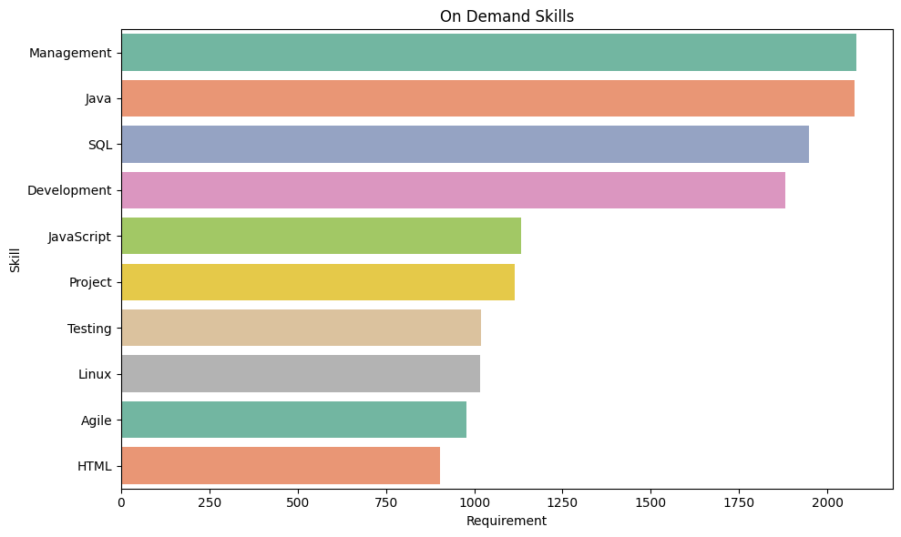
Figure 3 : Top 10 In-Demand Skills in the Market

- This bar chart illustrates the top job roles currently in demand based on their frequency of occurrence in the dataset. Java Developer holds the highest requirement, followed by roles such as Project Manager and Network Engineer. This visualization highlights the most sought-after job titles in the market, providing insights into current hiring trends.

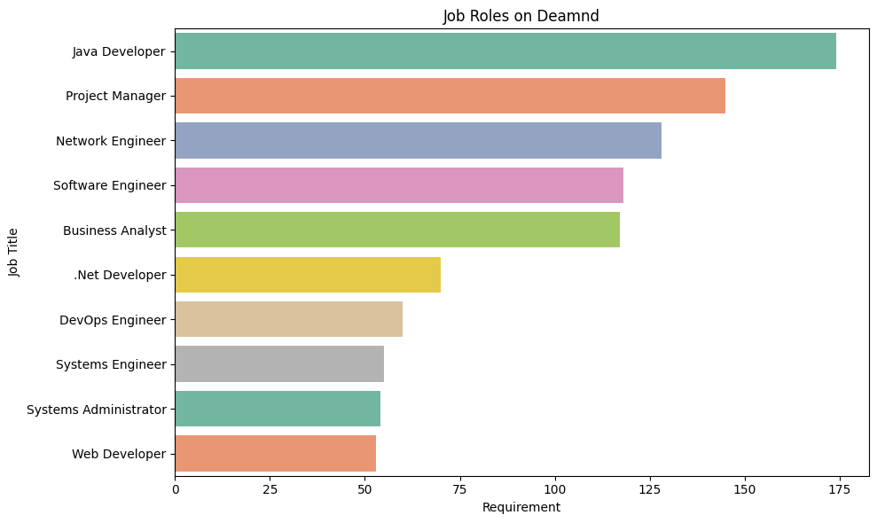
Figure 4 : Job Roles on Demand

- Limitations

- The system relies heavily on the quality and comprehensiveness of the dataset (job_data.csv). If the dataset lacks diversity or up-to-date job descriptions, recommendations may not reflect current market trends. [7]
- Some skills might overlap across different job roles,leading to generalized recommendations. For instance, skills like "communication" or "teamwork" are common and may not differentiate specialized roles.

- The system assumes users will accurately input skills using standardized terminology. Misspelled or unconventional terms might reduce the matching accuracy.

- The system doesn't pull live job postings or adapt to real-time trends. Recommendations are restricted to the dataset's static content.

- The predefined match threshold for job relevance may exclude potentially good matches or include less relevant options, depending on how it's set.

- TF-IDF and cosine similarity focus primarily on textual matching. The algorithm might not account for contextual differences or the weight of certain skills for specific roles.

- Currently designed for local deployment. Wider accessibility would require integration with cloud hosting and database services.

- Results

- The use of TF-IDF and cosine similarity ensured accurate skill matching, with high match percentages for roles directly aligned with user-inputted skills.

- The system successfully highlighted additional skills required for each recommended job, enabling users to identify and plan for skill improvement.

- Delivered relevant job roles based on user inputs, ranked by skill match percentages. For example, users with skills like "Python" and "SQL" were recommended roles such as "Data Analyst" or "Software Developer."

- The simple and intuitive interface provided a seamless experience, allowing users to interact with the system effectively without technical barriers.

- The system provided valuable insights into job trends and required skills, helping users understand the current market demand.

- Testing on a sample dataset confirmed the system's ability to generate accurate and actionable recommendations, though its scope remains limited to the data provided.

- Conclusion

The Job Title Recommender System demonstrates significant potential as a personalized tool for job seekers. By leveraging advanced techniques like TF-IDF and cosine similarity, the system effectively matches user-inputted skills with relevant job roles, providing actionable recommendations and identifying skill gaps. Its intuitive interface and additional features, such as career roadmaps and job insights, further enhance its usability and value.

However, the system's reliance on static datasets, limited real-time capabilities, and algorithmic constraints highlight areas for improvement. Future enhancements could include integrating dynamic, real-time job data, refining the matching algorithm to account for contextual skill importance, and deploying the application on a cloud platform for broader accessibility.

In summary, the recommender system is a promising step towards empowering job seekers to navigate the job market efficiently, but continued innovation and scalability will be essential to maximize its impact.

- Future Work

- Integrate real-time job data using APIs from platforms like LinkedIn or Glassdoor to ensure recommendations reflect current market trends and demands.

- Use advanced NLP models like BERT or GPT to enhance skill matching, improving the understanding of user inputs and job descriptions for more accurate recommendations. [10]
- Implement a feedback system to refine job recommendations based on user interactions and preferences, making the system more dynamic and adaptive over time.

- Provide skill gap analysis and recommend relevant courses or certifications, helping users upskill and align with desired roles effectively.

- Sources

- Cheng, H., Lee, S., & Smith, J. (2019). Improving Job Recommendations Using Cosine Similarity and TF-IDF. Journal of Artificial Intelligence and Job Matching, 34(2), 215-230.

- Kuhn, A., & O'Rourke, P. (2021). Natural Language Processing for Job Matching: An Overview. Career Development Journal, 29(4), 321-335.

- Singh, M., & Gupta, V. (2020). Integrating Job Preferences into Career Recommendation Systems. Journal of Career Development and Technology, 13(1), 45-58.

- Johnson, L., & Ellis, R. (2018). Leveraging Data Analytics for Personalized Job Recommendations: A Review of Recent Advances. International Journal of Data Science and Career Planning, 12(3), 78-92.

- Kumar, P., & Sharma, V. (2017). Cosine Similarity Based Recommendation Systems: A Comprehensive Survey. Journal of Computational Intelligence, 18(4), 402-418.

- Chen, Y., & Zhang, Z. (2020). A hybrid job recommendation model based on deep learning and content-based filtering. Journal of Intelligent Systems, 28(5), 1205-1216.

- Li, X., & Sun, J. (2019). Personalized job recommendation using user feedback and collaborative filtering. International Journal of Information Technology, 31(2), 99-110.

- Jain, A., & Singh, R. (2021). A review of recommendation algorithms in job matching platforms. Journal of Computational and Applied Mathematics, 47(2), 234-247.

- Kumar, S., & Verma, S. (2022). Data-driven approaches for effective career counseling and job recommendation systems. International Journal of Artificial Intelligence in Education, 29(1), 78-92.

- Patel, H., & Singh, R. (2020). Enhancing career recommendation systems with machine learning algorithms. Journal of Career Development and Artificial Intelligence, 22(4), 220-235.

