CO4 – AT1 DATA INTERPRETATION
Given • Model • Comparison Table • Selection • Graph • Conclusion
1. Real-Time Detection System
Given: A surveillance system must work under strict latency constraints while maintaining acceptable accuracy.
Model: Viola-Jones, YOLO, and Deep Learning.
Method | Accuracy | Speed
Viola-Jones | 78% | Fast
YOLO | 92% | Moderate
Deep Learning | 95% | Slow
Comparison: Viola-Jones is fastest but less accurate. Deep Learning is most accurate but slow. YOLO gives a good balance.
Selection: YOLO.
Conclusion: YOLO is suitable for real-time surveillance because it provides 92% accuracy with moderate speed.
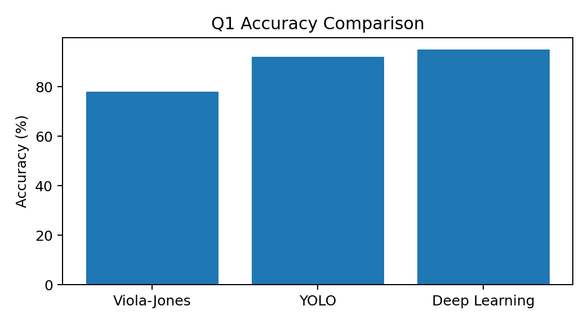
2. Robust Object Detection
Given: Compare object-detection performance in normal, occluded, and low-light conditions.
Model: Viola-Jones, YOLO, and Deep Learning.
Method | Normal | Occlusion | Low Light
Viola-Jones | 80% | 60% | 55%
YOLO | 90% | 75% | 70%
Deep Learning | 95% | 85% | 80%
Comparison: Deep Learning has the highest performance in all three conditions. YOLO is second and Viola-Jones is lowest.
Selection: Deep Learning.
Conclusion: Deep Learning provides the best overall robustness, with the trade-off of higher computational needs.
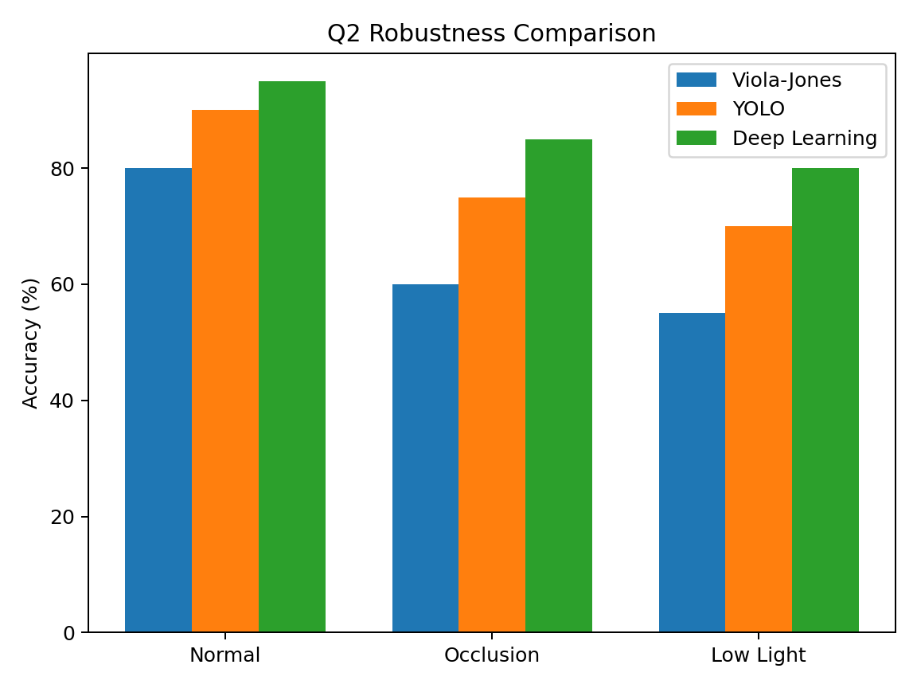
3. Optical Flow Analysis
Given: Two optical-flow methods are available for motion tracking in dynamic scenes.
Model: Method A – stable vectors but misses small motions. Method B – detects fine motion but produces noisy vectors.
Factor | Method A | Method B
Stability | High | Low
Fine-motion detection | Low | High
Noise sensitivity | Low | High
Tracking | Stable | Noisy
Comparison: Method A is more stable and less sensitive to noise. Method B detects small motion better but is noisy.
Selection: Method A for reliable dynamic-scene tracking.
Conclusion: Method A is preferred when stable and reliable tracking is more important than detecting very small motions.
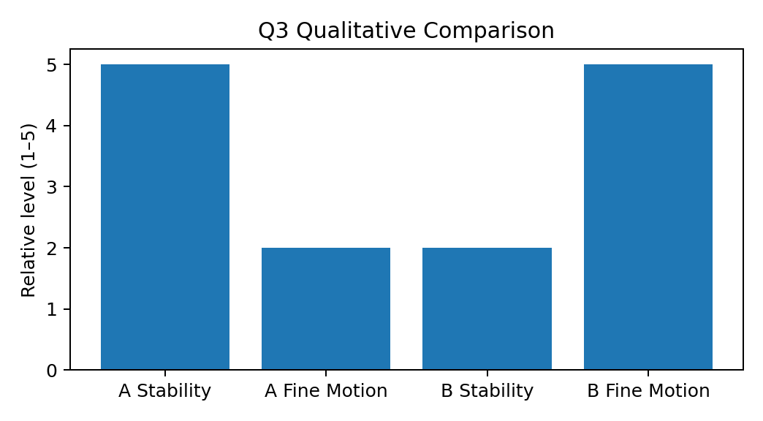
4. Model Generalization and Overfitting
Given: Compare training and testing accuracy to identify overfitting and generalization.
Model: Model A and Model B.
Model | Training | Testing | Gap
A | 98% | 70% | 28%
B | 90% | 88% | 2%
Comparison: Model A has a large 28% gap, indicating overfitting. Model B has only a 2% gap, indicating better generalization.
Selection: Model B.
Conclusion: Model B is more reliable for real-world deployment because training and testing performance are close.
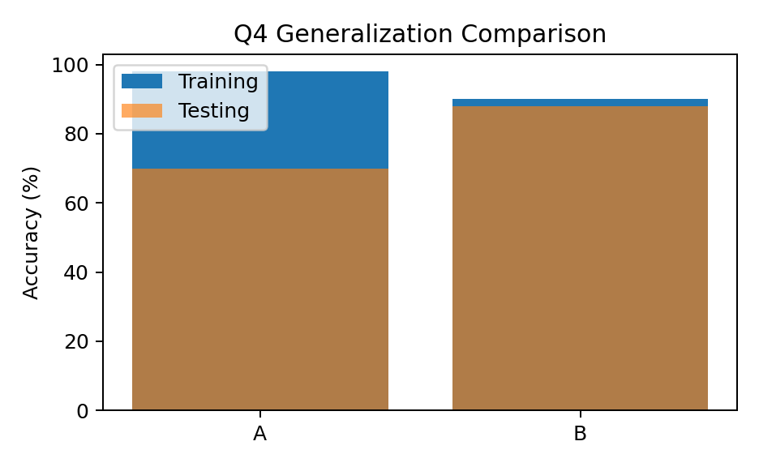
5. System Performance under Constraints
Given: Compare accuracy, latency, and cost for a real-time application.
Model: Model A, Model B, and Model C.
Model | Accuracy | Latency | Cost
A | 88% | 50 ms | Low
B | 92% | 80 ms | Moderate
C | 95% | 120 ms | High
Comparison: A is fastest and cheapest. C has the highest accuracy but is slow and expensive. B gives a balanced performance.
Selection: Model B.
Conclusion: Model B provides the best balance between accuracy, latency, and cost for a real-time application.
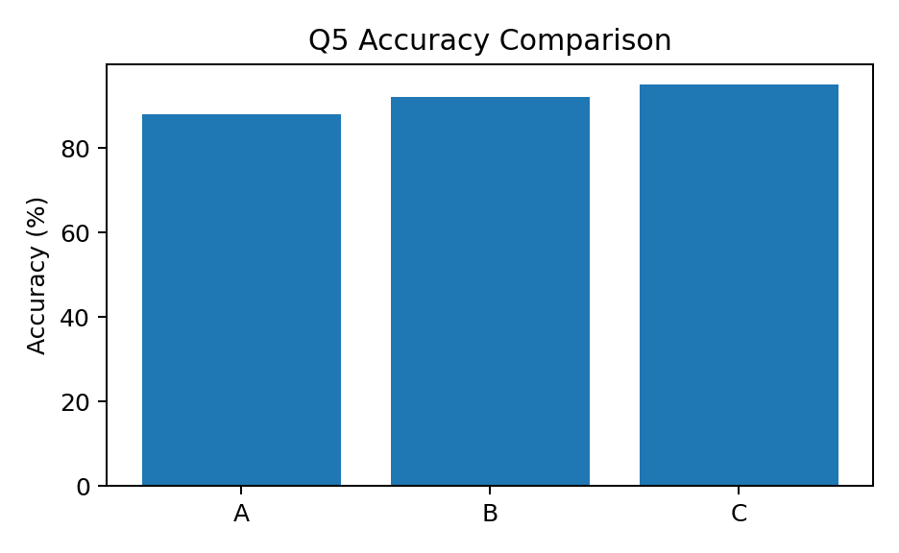
Final Selection
Question | Selection
1 | YOLO
2 | Deep Learning
3 | Method A
4 | Model B
5 | Model B

