COMPARATIVE ANALYSIS
Computer Vision Assessment
Object Detection Performance Comparison
Motion Estimation Error Analysis
Depth Estimation Comparison

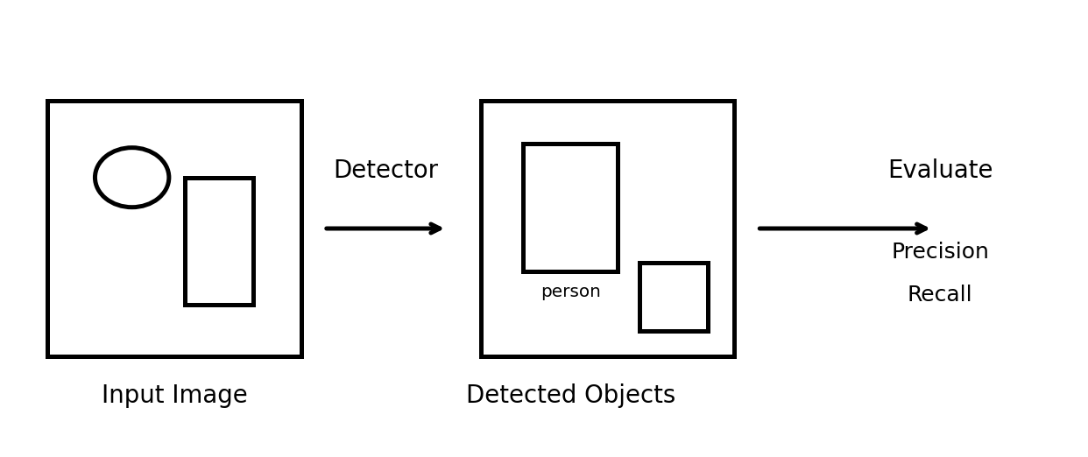
Figure 1: Computer vision pipeline from image input to object detection.
Introduction
Computer vision uses image and video information to understand objects, motion, and 3D structure. Object detection identifies objects and their locations, motion estimation measures displacement between frames, and depth estimation determines how far objects are from the camera. These three tasks are important parts of practical computer vision systems. citeturn0search1turn0search8
The following analysis calculates the requested numerical measures and compares the methods using the given data.

1. Object Detection Performance Comparison
Question:
Two object detection models, Viola–Jones and YOLO, produce the following results. Model A has 80 True Positives, 20 False Positives, and 30 False Negatives. Model B has 90 True Positives, 15 False Positives, and 20 False Negatives.
(a) Calculate Precision and Recall
Precision measures how many detected positive objects are actually correct.
Precision = TP / (TP + FP)
Model A — Viola–Jones:
Precision = 80 / (80 + 20) = 80 / 100 = 0.80 = 80%
Recall measures how many of the actual positive objects were successfully detected.
Recall = TP / (TP + FN)
Recall = 80 / (80 + 30) = 80 / 110 = 0.7273 ≈ 72.73%
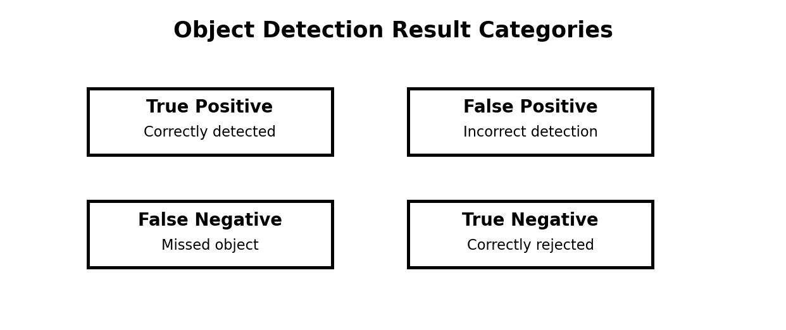
Figure 2: True/false positive and negative categories used in detection evaluation.

1. Object Detection Performance Comparison — Continued
Model B — YOLO:
Precision = 90 / (90 + 15) = 90 / 105 = 0.8571 ≈ 85.71%
Recall = 90 / (90 + 20) = 90 / 110 = 0.8182 ≈ 81.82%
(b) Comparison of Results
Model | TP | FP | FN | Precision | Recall
Model A — Viola–Jones | 80 | 20 | 30 | 80.00% | 72.73%
Model B — YOLO | 90 | 15 | 20 | 85.71% | 81.82%

Interpretation:
Model B has higher precision than Model A. This means YOLO produces a smaller proportion of incorrect detections among its positive detections. Model B also has higher recall, meaning it successfully detects a larger proportion of the actual objects.
Conclusion:
YOLO provides better overall object detection performance for the given data because it has both higher precision (85.71%) and higher recall (81.82%). Therefore, it is the better model in this comparison.
A useful visual interpretation is that a strong detector should produce many true positives while keeping false positives and false negatives low.

2. Motion Estimation Error Analysis
Question:
Two motion estimation techniques produce displacement errors in pixels for three consecutive frames. Method A has errors 2, 3, and 2 pixels. Method B has errors 3, 5, and 4 pixels.
Motion estimation determines how image content moves between frames; it is commonly used for motion analysis and tracking. citeturn0search0turn0search10
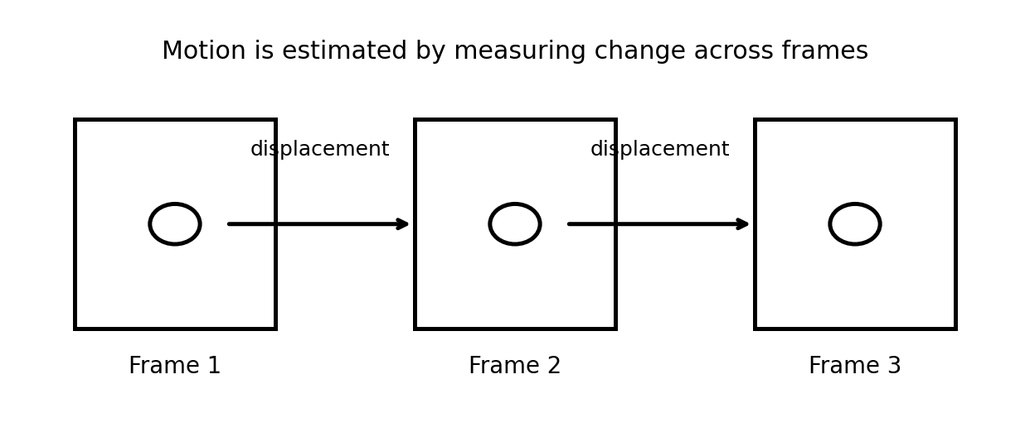
Figure 3: Frame-to-frame displacement used in motion estimation.
(a) Calculate the Average Displacement Error
Average Error = Sum of Displacement Errors / Number of Frames
Method A:
Average Error = (2 + 3 + 2) / 3 = 7 / 3 = 2.33 pixels
Method B:
Average Error = (3 + 5 + 4) / 3 = 12 / 3 = 4.00 pixels

2. Motion Estimation Error Analysis — Continued
Comparison table:
Method | Frame 1 | Frame 2 | Frame 3 | Average Error
Method A | 2 px | 3 px | 2 px | 2.33 px
Method B | 3 px | 5 px | 4 px | 4.00 px

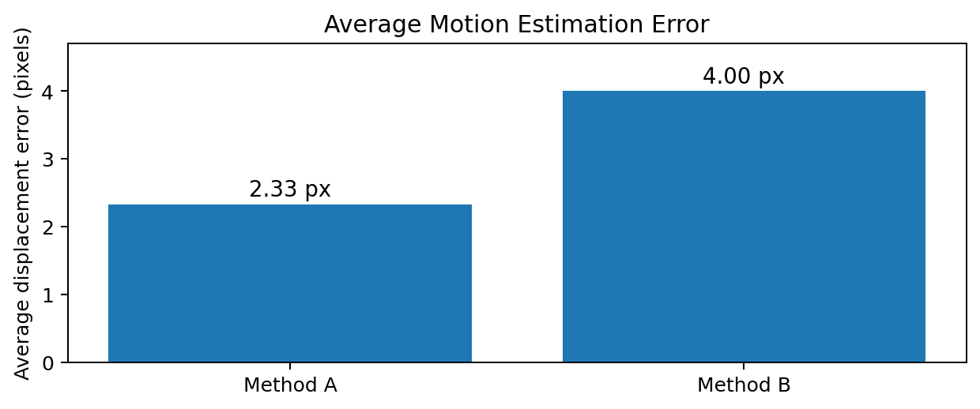
Figure 4: Average displacement error for the two motion estimation methods.
(b) Which method is more accurate?
Method A is more accurate because its average displacement error is only 2.33 pixels, whereas Method B has an average error of 4.00 pixels.
(c) Justification
For motion estimation, a smaller error means the estimated displacement is closer to the actual displacement. Method A has lower error in Frame 1, Frame 2, and Frame 3. Its average error is also lower.
4.00 − 2.33 = 1.67 pixels
Therefore, Method A reduces the average displacement error by approximately 1.67 pixels compared with Method B. Hence, Method A provides the more accurate and consistent motion estimation for the supplied data.

3. Depth Estimation Comparison
Question:
A stereo vision system and a Structure-from-Motion (SfM) system estimate the depth of three objects. Actual depths are 2 m, 3 m, and 4 m. Stereo Vision estimates 2.0 m, 3.0 m, and 4.0 m, while SfM estimates 2.5 m, 3.8 m, and 5.0 m.
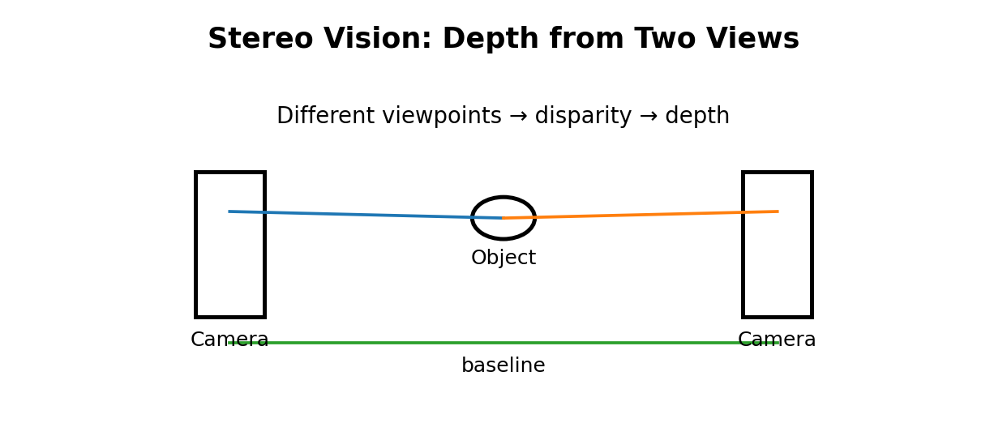
Figure 5: Stereo vision uses two viewpoints to recover depth from image correspondence.
Stereo vision estimates depth using two views of the scene; the separation between the cameras and image correspondence provide geometric information about distance. citeturn0search5turn0search6
(a) Absolute Error for Each Object
Absolute Error = |Estimated Depth − Actual Depth|
Object | Actual Depth | Stereo Estimate | Stereo Error | SfM Estimate | SfM Error
1 | 2.0 m | 2.0 m | 0.0 m | 2.5 m | 0.5 m
2 | 3.0 m | 3.0 m | 0.0 m | 3.8 m | 0.8 m
3 | 4.0 m | 4.0 m | 0.0 m | 5.0 m | 1.0 m

3. Depth Estimation Comparison — Continued
(b) Average Absolute Error
For Stereo Vision:
Average Error = (0 + 0 + 0) / 3 = 0 m
For Structure-from-Motion (SfM):
Average Error = (0.5 + 0.8 + 1.0) / 3
= 2.3 / 3 = 0.7667 m ≈ 0.77 m
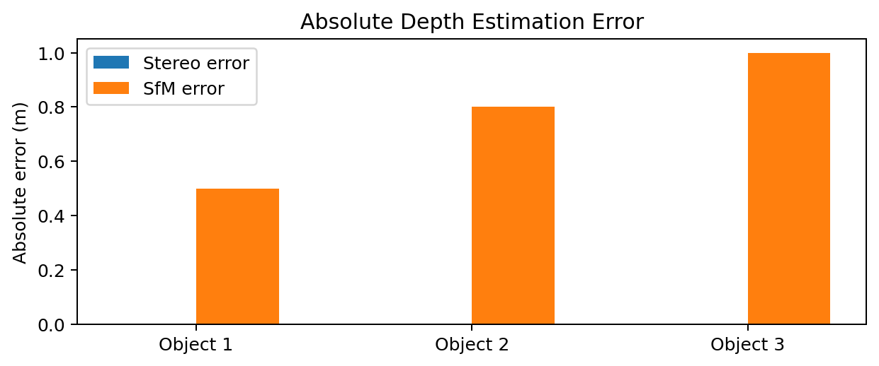
Figure 6: Absolute depth-estimation error for Stereo Vision and SfM.
(c) Comparison and Final Conclusion
Stereo Vision provides the more accurate depth estimation for the supplied data. Its average absolute error is 0 m, while SfM has an average absolute error of approximately 0.77 m.
The object-wise results also support the conclusion: Stereo Vision has zero error for all three objects, whereas SfM has errors of 0.5 m, 0.8 m, and 1.0 m.
Final Answer:
Stereo Vision: Average Absolute Error = 0 m
SfM: Average Absolute Error ≈ 0.77 m
Therefore, Stereo Vision is the better depth-estimation method for this particular dataset because its estimated depths exactly match the given actual depths. Depth estimation is a core computer-vision task for obtaining 3D scene information from visual observations. citeturn0search1turn0search8

