COMPUTER VISION – ASSESSMENT TOOL 1
EXPERIMENT RECORD
Course Code: ITA05 | CO3 – Precision | 5 Experiments × 10 Marks
The experiments below are prepared directly from Annexure A of the uploaded assessment document. The source asks for systematic implementation, documented outputs, and analysis. fileciteturn0file0L41-L47

1. Feature Descriptor Comparison (SIFT vs Harris)
AIM
To compare Harris Corner Detection and SIFT feature extraction on the same image and study feature quality, robustness, repeatability, and suitability for image matching.
PROCEDURE
1. Read the input image and convert it to grayscale.
2. Apply Harris Corner Detection to locate strong corner points.
3. Apply SIFT to detect keypoints and compute feature descriptors.
4. Draw the detected Harris corners and SIFT keypoints on the input image.
5. Compare the number and distribution of detected features.
CODE
import cv2
img = cv2.imread("input.png")
gray = cv2.cvtColor(img, cv2.COLOR_BGR2GRAY)
# Harris
harris = cv2.cornerHarris(gray.astype("float32"), 2, 3, 0.04)
# SIFT
sift = cv2.SIFT_create()
keypoints, descriptors = sift.detectAndCompute(gray, None)
print("SIFT keypoints:", len(keypoints))
INPUT AND OUTPUT
Input Image
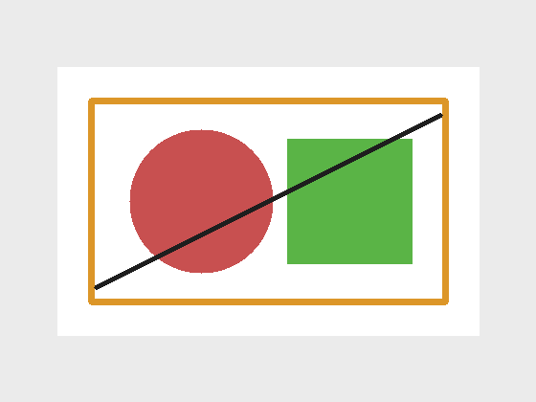
Harris Output
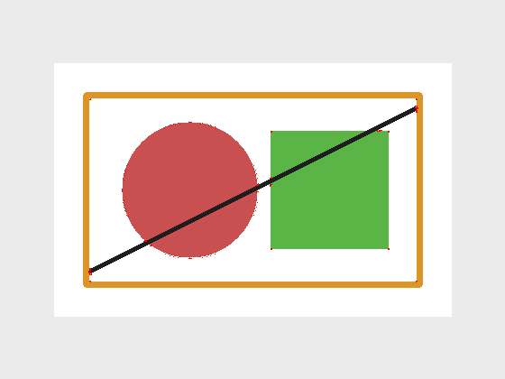
SIFT Output
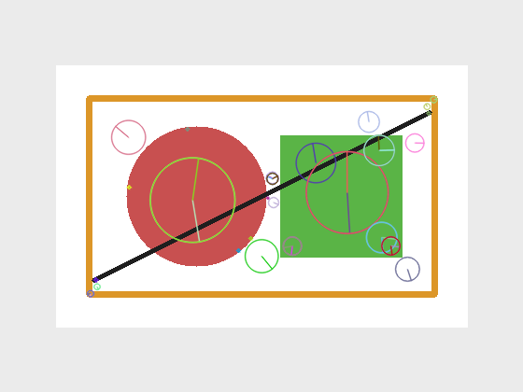
RESULT / OBSERVATION
Harris highlights strong corner locations, while SIFT provides scale- and rotation-tolerant keypoints with descriptors, making SIFT more suitable for feature matching applications.
Assessment reference: fileciteturn0file0L42-L47

2. Image Enhancement for Feature Detection
AIM
To evaluate how histogram equalization and contrast enhancement affect feature visibility and feature detection performance.
PROCEDURE
1. Read the image and convert it to grayscale.
2. Reduce contrast to simulate a low-visibility image.
3. Apply histogram equalization to improve intensity distribution.
4. Detect corner features on the enhanced image.
5. Compare the low-contrast and enhanced outputs.
CODE
import cv2
img = cv2.imread("input.png")
gray = cv2.cvtColor(img, cv2.COLOR_BGR2GRAY)
low = cv2.convertScaleAbs(gray, alpha=0.45, beta=30)
enhanced = cv2.equalizeHist(low)
corners = cv2.goodFeaturesToTrack(
enhanced, maxCorners=80,
qualityLevel=0.01, minDistance=8
)
print("Detected corners:", 0 if corners is None else len(corners))
INPUT AND OUTPUT
Input Image

Low-Contrast Image
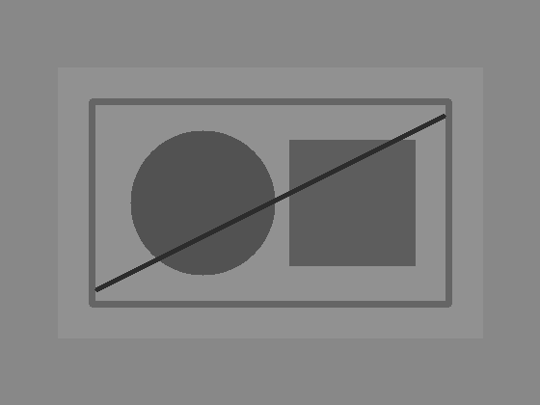
Enhanced + Feature Detection
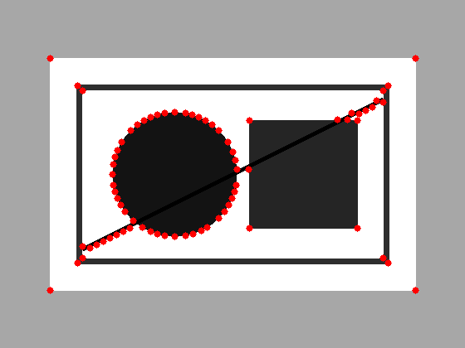
RESULT / OBSERVATION
Histogram equalization improves contrast and makes feature points more visible, which can improve the reliability of subsequent feature detection.
Assessment reference: fileciteturn0file0L48-L54

3. Multi-Scale Feature Detection Analysis
AIM
To study feature detection at different image scales and analyze the effect of resolution changes on feature stability, accuracy, and computational performance.
PROCEDURE
1. Read the input image.
2. Create resized versions at 0.5×, 1× and 1.5× scales.
3. Convert each image to grayscale.
4. Detect strong corner features at each scale.
5. Compare the feature distribution and image resolution at the three scales.
CODE
import cv2
img = cv2.imread("input.png")
for scale in [0.5, 1.0, 1.5]:
resized = cv2.resize(img, None, fx=scale, fy=scale)
gray = cv2.cvtColor(resized, cv2.COLOR_BGR2GRAY)
corners = cv2.goodFeaturesToTrack(
gray, maxCorners=60,
qualityLevel=0.01, minDistance=10
)
print(scale, "x scale:",
0 if corners is None else len(corners), "features")
INPUT AND OUTPUT
Input Image

0.5× Scale
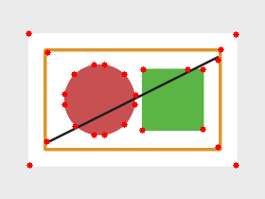
1× Scale
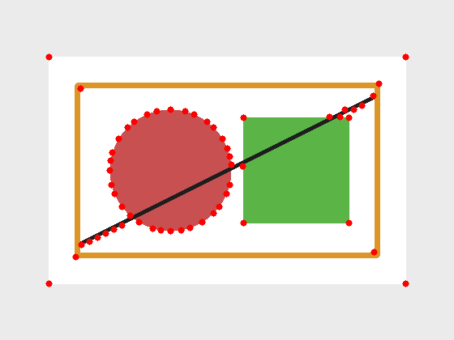
1.5× Scale
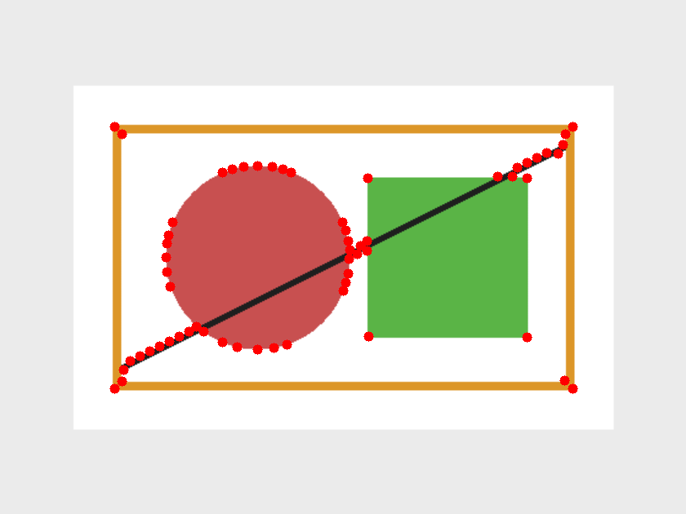
RESULT / OBSERVATION
Feature locations can change with image scale. A multi-scale experiment helps identify which features remain stable and how image size affects computational cost.
Assessment reference: fileciteturn0file0L55-L60

4. Comparative Analysis of Image Filtering Techniques
AIM
To compare Mean, Gaussian, and Median filters for noise reduction while preserving important image features.
PROCEDURE
1. Read the input image and convert it to grayscale.
2. Add salt-and-pepper noise to create a noisy image.
3. Apply Mean filtering using a 5×5 kernel.
4. Apply Gaussian filtering using a 5×5 kernel.
5. Apply Median filtering using a 5×5 neighbourhood.
6. Compare noise removal and edge preservation.
CODE
import cv2
img = cv2.imread("input.png", 0)
mean = cv2.blur(img, (5,5))
gaussian = cv2.GaussianBlur(img, (5,5), 0)
median = cv2.medianBlur(img, 5)
cv2.imwrite("mean.png", mean)
cv2.imwrite("gaussian.png", gaussian)
cv2.imwrite("median.png", median)
INPUT AND OUTPUT
Input Image

Noisy Input
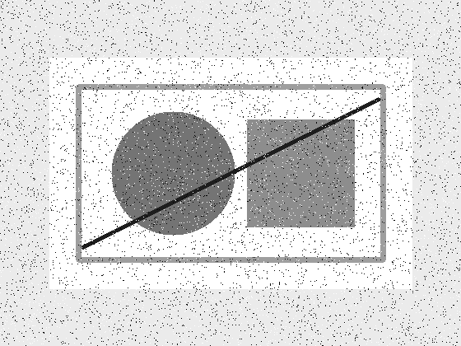
Mean Filter
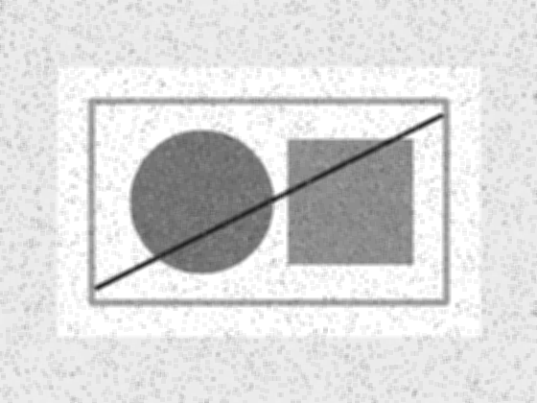
Gaussian Filter
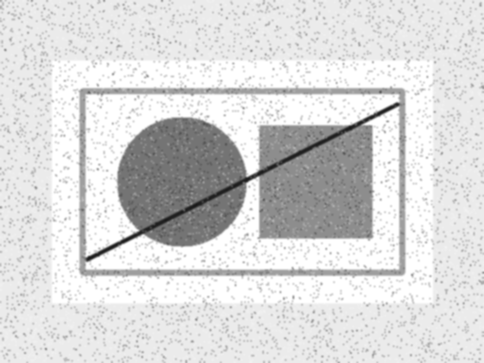
Median Filter
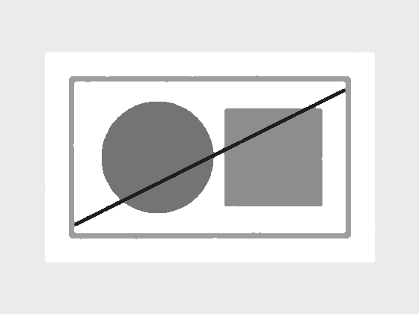
RESULT / OBSERVATION
All three filters reduce noise. Mean filtering smooths strongly, Gaussian filtering gives weighted smoothing, and Median filtering is particularly effective for impulse/salt-and-pepper noise while preserving edges.
Assessment reference: fileciteturn0file0L61-L66

5. Complete Object Detection Workflow
AIM
To implement a complete object detection workflow using preprocessing, edge detection, feature extraction, and shape/bounding-box detection.
PROCEDURE
1. Read the input image.
2. Convert it to grayscale and apply Gaussian preprocessing.
3. Detect object boundaries using Canny edge detection.
4. Extract contours from the edge image.
5. Draw bounding boxes around significant detected regions.
6. Observe the final object detection output.
CODE
import cv2
img = cv2.imread("input.png")
gray = cv2.cvtColor(img, cv2.COLOR_BGR2GRAY)
blur = cv2.GaussianBlur(gray, (5,5), 0)
edges = cv2.Canny(blur, 50, 150)
contours, _ = cv2.findContours(
edges, cv2.RETR_EXTERNAL,
cv2.CHAIN_APPROX_SIMPLE
)
for c in contours:
if cv2.contourArea(c) > 500:
x,y,w,h = cv2.boundingRect(c)
cv2.rectangle(img, (x,y),
(x+w,y+h), (0,0,255), 3)
cv2.imwrite("detected.png", img)
INPUT AND OUTPUT
Input Image

Canny Edge Output
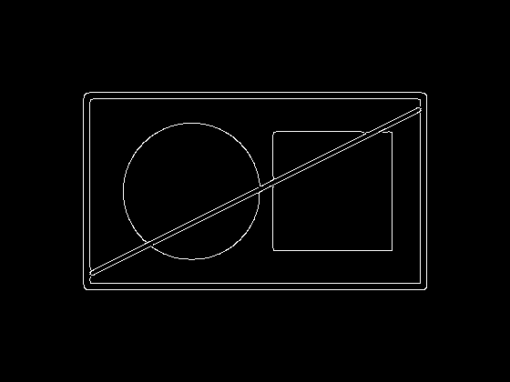
Final Detection Output
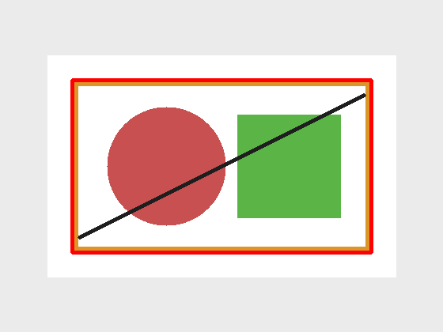
RESULT / OBSERVATION
The workflow combines preprocessing, edge detection, contour/feature extraction and shape localization to produce a final object-detection result. The uploaded assessment specifically requires outputs at every stage and analysis of effectiveness under different image conditions.
Assessment reference: fileciteturn0file0L67-L73

Note for Submission
The input image and output figures in this document are demonstration images generated using OpenCV so that the experiment record contains the required visual evidence. If your faculty requires a specific dataset/image, replace the input image and rerun the same code; keep the procedure and output structure.
The uploaded assessment emphasizes clear documentation with diagrams, code, and results. fileciteturn0file0L174-L184

