WHATSNEXT VISION MOTORS
VEHICLE ORDER MANAGEMENT SYSTEM USING SALESFORCE
PROJECT DOCUMENTATION

Prepared By: M DEVIKA 24CSR052
Department: Computer Science and Engineering

USER STORY

The Vehicle Order Management System at WhatsNext Vision Motors is built on Salesforce CRM to improve customer experience and operational efficiency. As an administrator, the user should be able to manage vehicles, stock levels, dealers, and customer orders from one centralized platform, so that every record stays organized, accurate, and easy to access.
As a customer, the user should be able to place a vehicle order and have it automatically assigned to the nearest dealer based on the customer's location. The system blocks orders for out-of-stock vehicles and updates stock after every valid order. Customers also receive scheduled email reminders for their booked test drives.
As an order administrator, the user should be able to rely on automated workflows and Apex jobs to process orders without manual effort. Batch jobs update vehicle stock, and Scheduled Apex runs the order processing automatically. Order statuses are updated dynamically, which improves order accuracy and overall operational efficiency.

1. INTRODUCTION

1.1 Project Overview
WhatsNext Vision Motors is revolutionizing its customer experience and operational efficiency with a cutting-edge Salesforce CRM implementation. The project streamlines the vehicle ordering process by managing vehicles, dealers, customers, test drives, and orders in a single centralized system.
The solution uses Salesforce custom objects, fields, relationships, Apex triggers, trigger handler classes, batch jobs, scheduled Apex, and record-triggered Flows. Apex triggers validate stock before an order is accepted, batch jobs update stock, and scheduled Apex automates order processing.
Each order is automatically assigned to the nearest dealer based on the customer's location, and orders for out-of-stock vehicles are prevented. Automated workflows update order statuses dynamically and send scheduled email reminders for test drives.

1.2 Purpose
The purpose of this project is to enhance customer satisfaction, improve order accuracy, and boost operational efficiency by automating vehicle order handling, dealer assignment, stock control, and test drive reminders on the Salesforce platform.

1.3 Objectives
- Create and manage vehicle, dealer, customer, test drive, and vehicle order records in Salesforce.
- Maintain accurate vehicle stock information and link it to order details.
- Prevent orders for out-of-stock vehicles using Apex trigger validation.
- Update vehicle stock automatically after a valid order is placed.
- Use Apex triggers and handler classes to separate trigger execution from business logic.
- Process orders in bulk through batch jobs and automate them with Scheduled Apex.
- Update order statuses dynamically, marking orders Confirmed when stock is available and Pending when it is not.
- Auto-assign orders to the nearest dealer and send scheduled test drive reminders to improve customer experience.

2. PROJECT OVERVIEW AND SCOPE

2.1 Business Background
Customers expect a quick and reliable way to order vehicles, and dealers need accurate stock and order data to serve them. When orders are accepted for unavailable vehicles or assigned to distant dealers, it leads to delays, dissatisfaction, and extra manual work. The Salesforce CRM solution removes these problems by applying business rules automatically at every step of the order process.

2.2 Project Scope
The project scope covers Salesforce environment setup, custom object and field creation, relationship configuration, tabs and app setup, Apex trigger and handler development, stock validation and stock updates, nearest-dealer assignment, a record-triggered Flow for test drive reminders, Batch Apex, Scheduled Apex, and testing.

2.3 Functional Requirements
- Maintain vehicle details and available stock quantity.
- Maintain dealer information and dealer locations.
- Create and manage vehicle order and test drive records.
- Prevent orders when the requested quantity exceeds the available stock.
- Update vehicle stock automatically after a valid order.
- Update order statuses dynamically through batch and scheduled processing.
- Assign each order to the nearest dealer and send scheduled email reminders for test drives.

2.4 Non-Functional Requirements
- Data consistency: stock and order records must always stay accurate and in sync.
- Maintainability: business logic is organized into handler classes for easy updates.
- Usability: all records are accessible through the Salesforce Lightning interface.
- Reliability: automation is tested for both valid and invalid order scenarios.

3. PHASE 1: REQUIREMENT ANALYSIS AND PLANNING

3.1 Understanding Business Requirements
The business requires an organized way to track vehicle inventory, dealer details, customer orders, and test drives. Key rules include preventing orders for out-of-stock vehicles, assigning each order to the nearest dealer, updating order statuses automatically, and sending timely test drive reminders to customers by email.

3.2 Data Model
The core objects include Vehicle (Vehicle__c), Vehicle Order (Vehicle_Order__c), Dealer, and Vehicle Test Drive. The Vehicle Order object has a lookup relationship to the Vehicle object, and orders are also linked to a dealer chosen by customer location. The Vehicle Test Drive object stores the details used by the reminder Flow.

4. PHASE 2: SALESFORCE SETUP AND DATA MANAGEMENT

4.1 Salesforce Environment Setup
The project is built in Salesforce Lightning Experience. Salesforce Setup and Object Manager are used to create the custom objects, define fields, configure relationships, and organize the application for easy navigation.
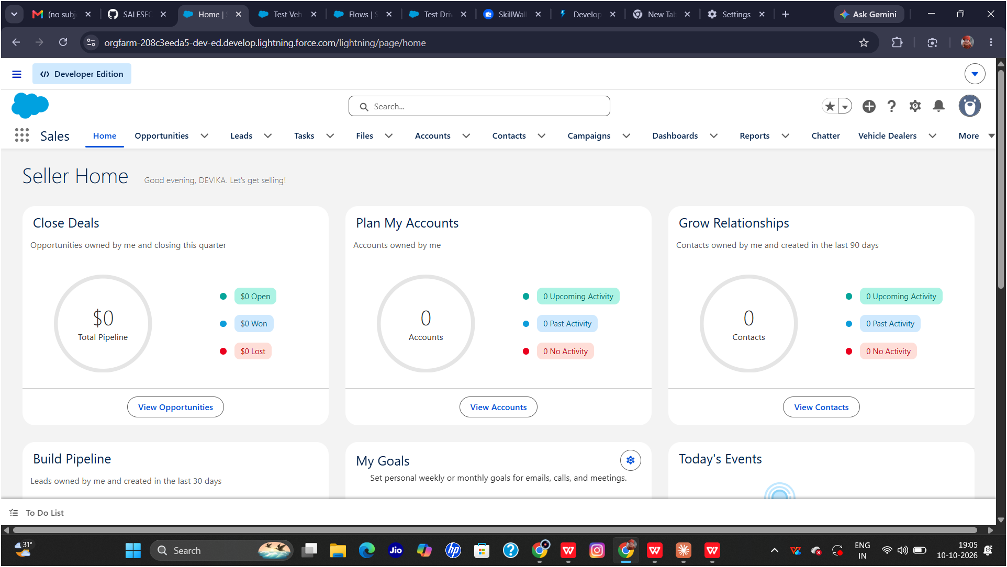

4.2 Custom Objects

Vehicle Object (Vehicle__c)
The Vehicle object stores vehicle details such as the vehicle name, model, and the stock quantity that the order validation and stock update logic depend on.
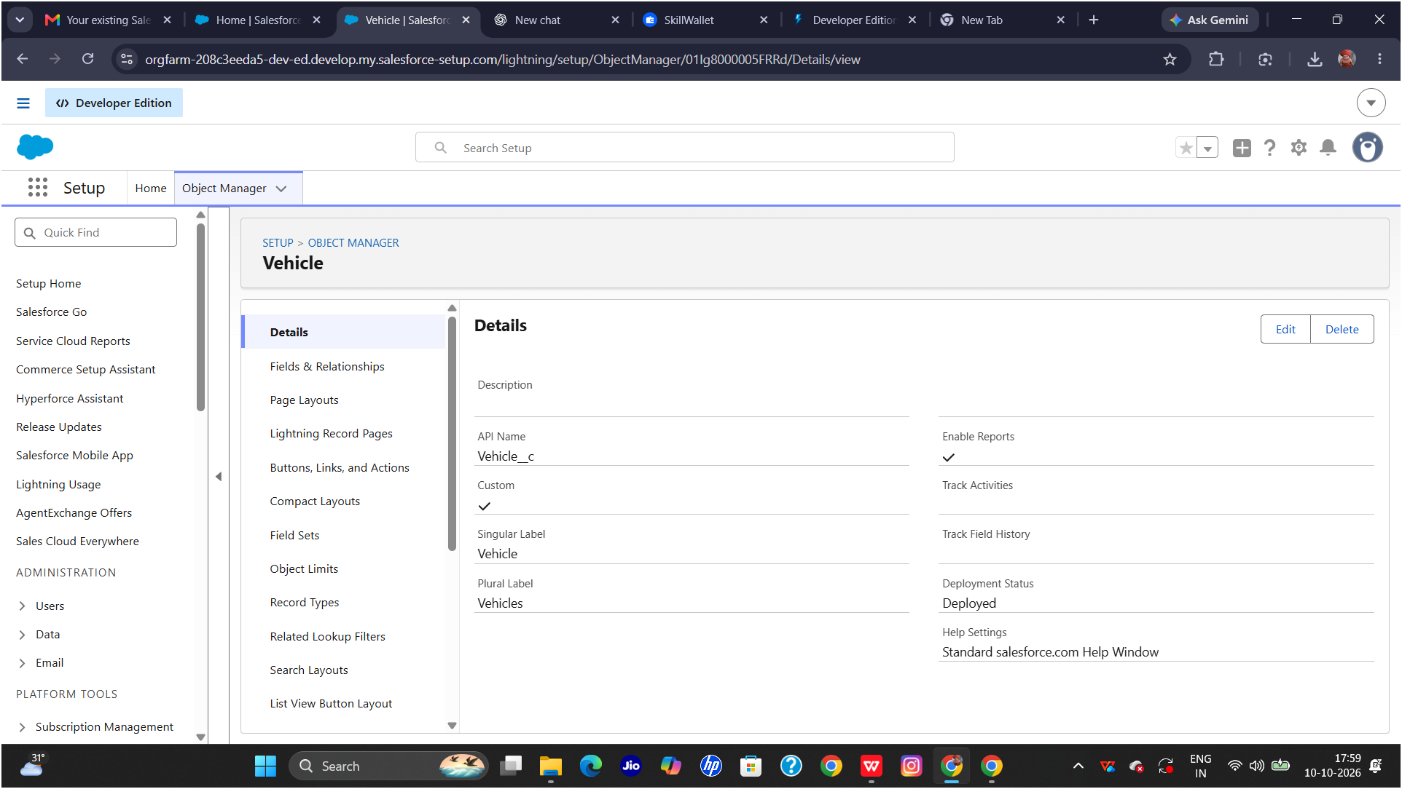

Vehicle Order Object (Vehicle_Order__c)
The Vehicle Order object stores each customer's order details, including the requested quantity, order status, and customer location. It references the ordered vehicle through the Vehicle__c relationship field.
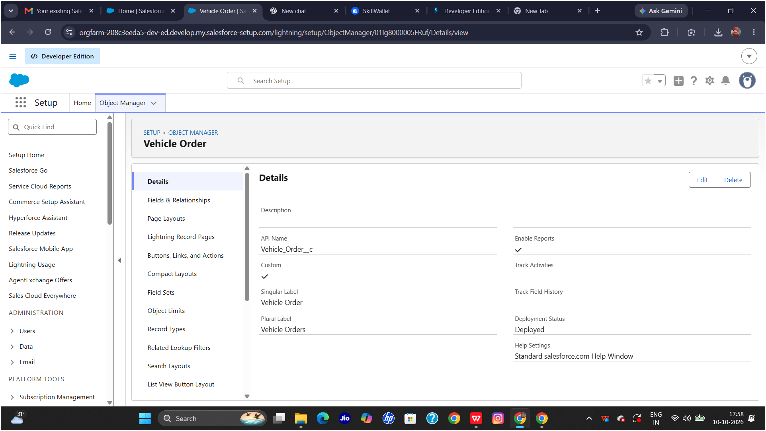

Dealer Object
The Dealer object stores dealer information such as the dealer name and location. This data is used to find the nearest dealer for each customer order.
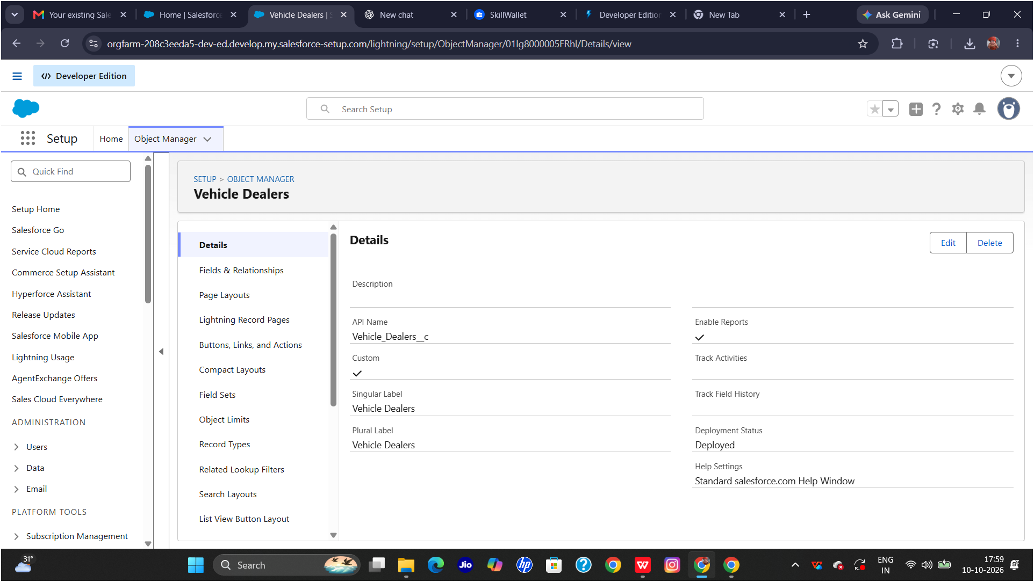

4.3 Custom Fields
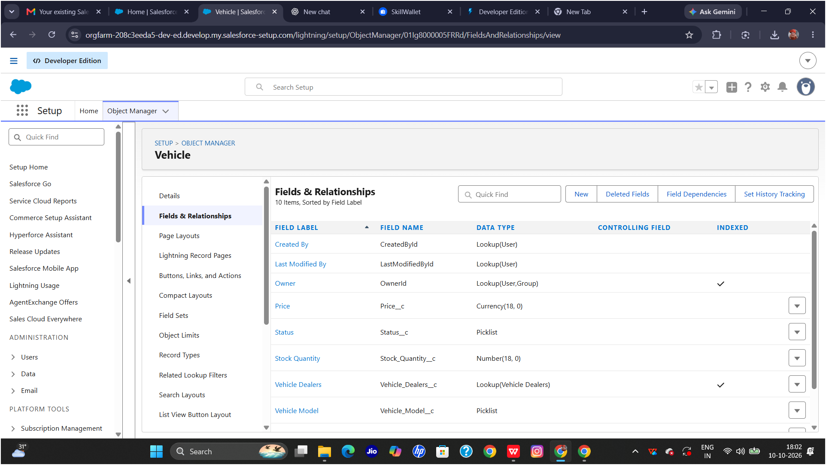
Custom fields capture the data needed for ordering and stock control. Important fields include the stock quantity on Vehicle__c, the Vehicle relationship and order status on Vehicle_Order__c, and the customer location used for dealer assignment.

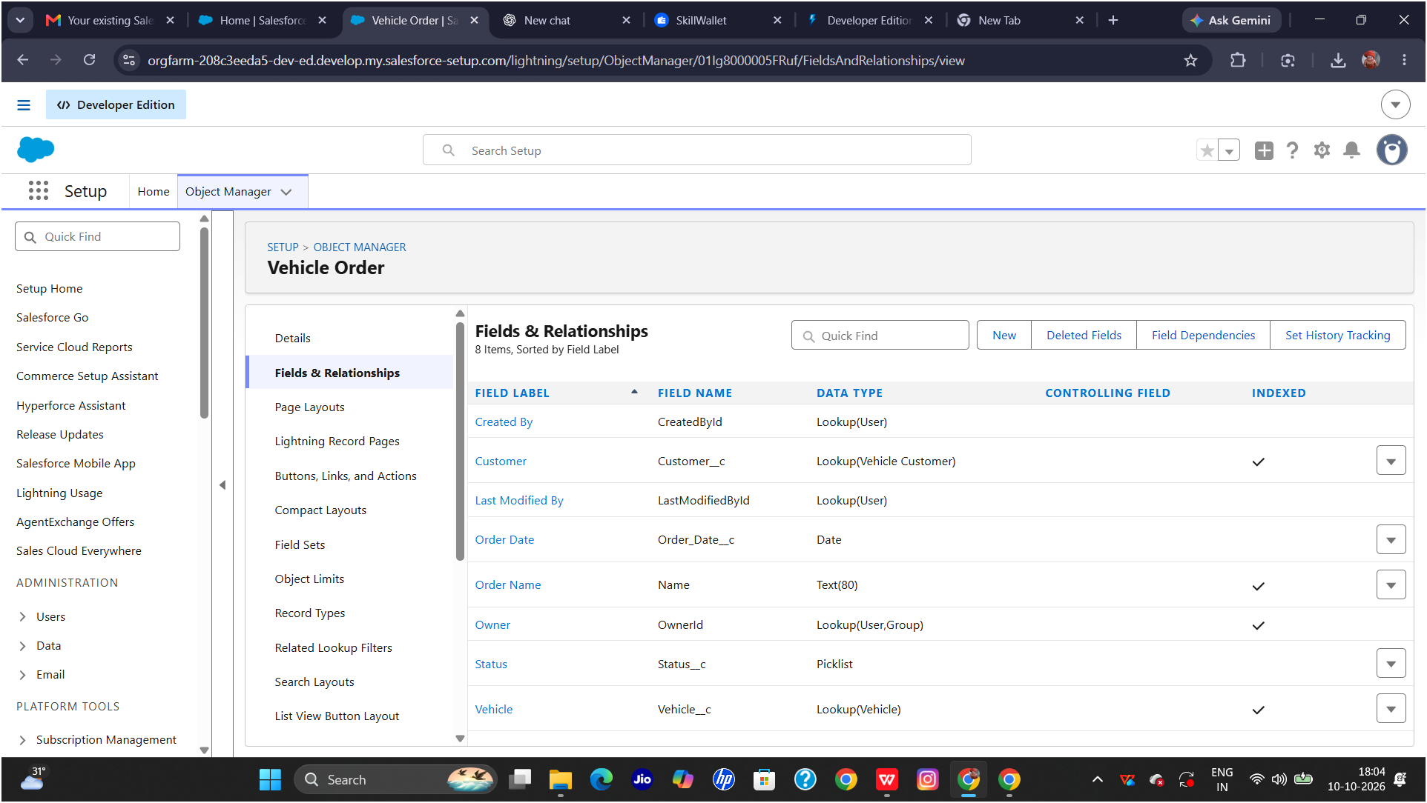

4.4 Relationships
Each Vehicle Order record is related to a vehicle through the Vehicle__c lookup field, and to a dealer based on location. These relationships let the automation find the correct vehicle to check or update stock and the correct dealer to receive the order.
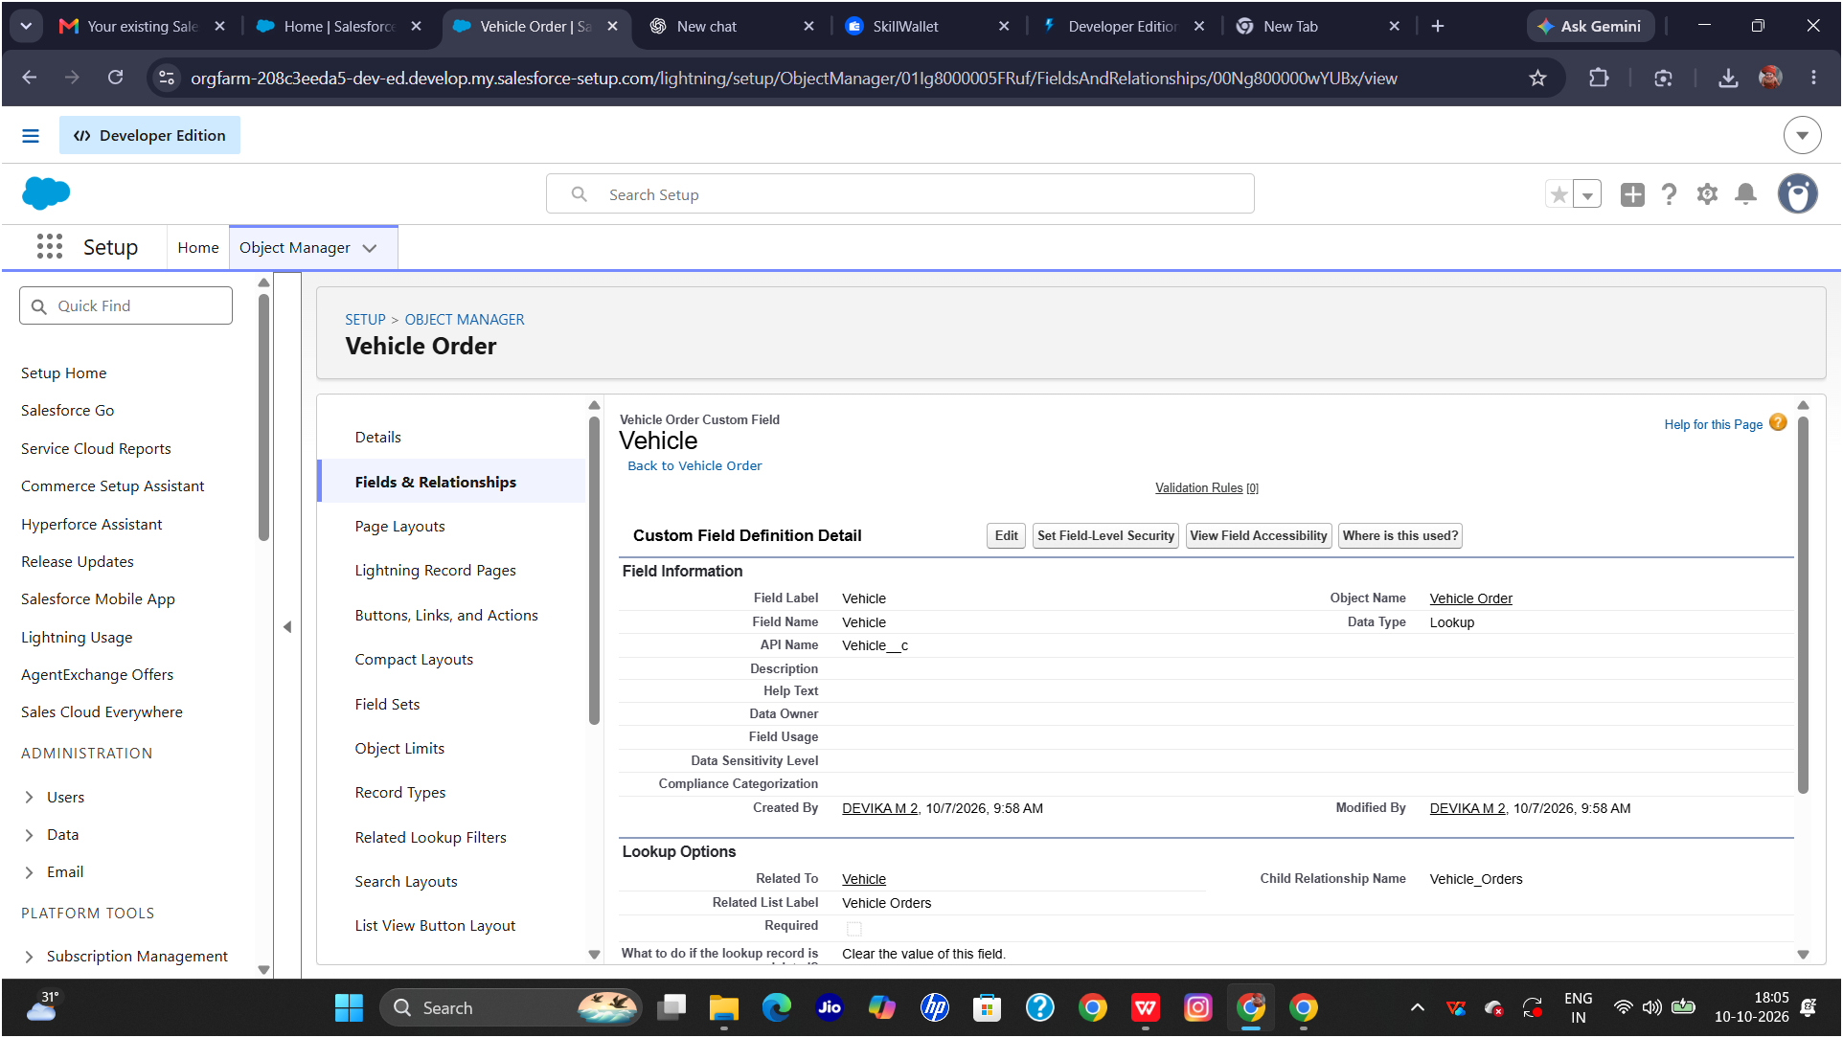

4.5 Tabs and App Manager
Custom tabs and the Salesforce app provide easy navigation to the Vehicle, Dealer, Vehicle Order, and Vehicle Test Drive records used in the project.
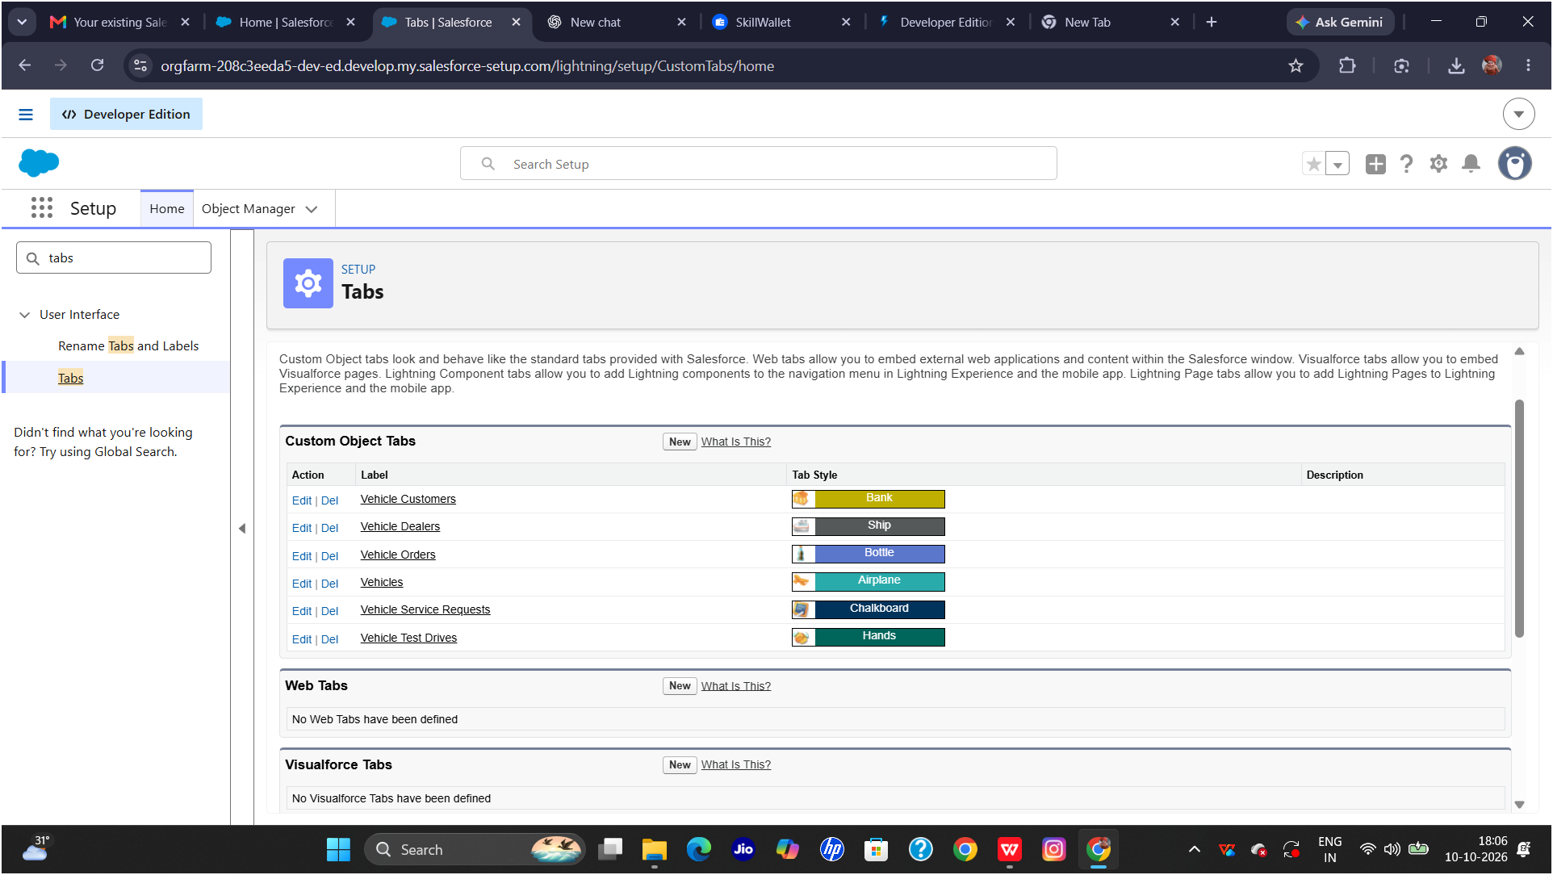
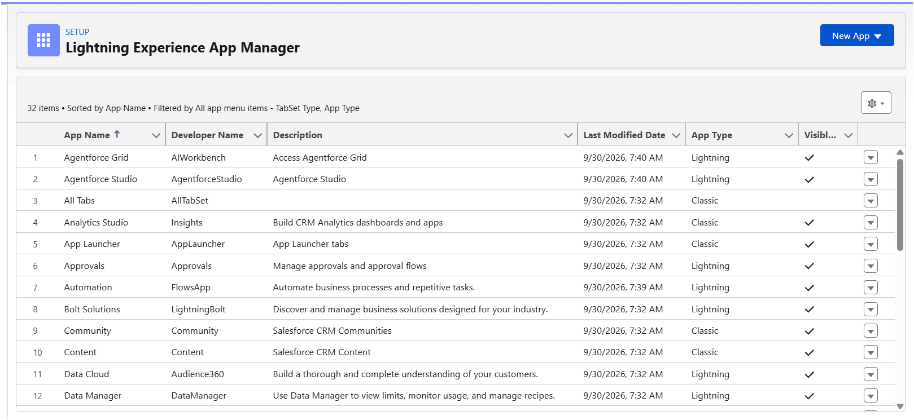

5. PHASE 3: AUTOMATION AND APEX DEVELOPMENT

5.1 Automation Overview
Automation in this project is handled by Apex triggers, a trigger handler class, a record-triggered Flow, Batch Apex, and Scheduled Apex. The trigger handler keeps the trigger simple and places all business logic in a separate class, which makes the code cleaner and easier to maintain.

5.2 Vehicle Order Trigger
The Vehicle Order trigger runs when order records are inserted or updated and calls the handler class. Stock is validated before the order is saved, and stock is updated after a valid order is saved.
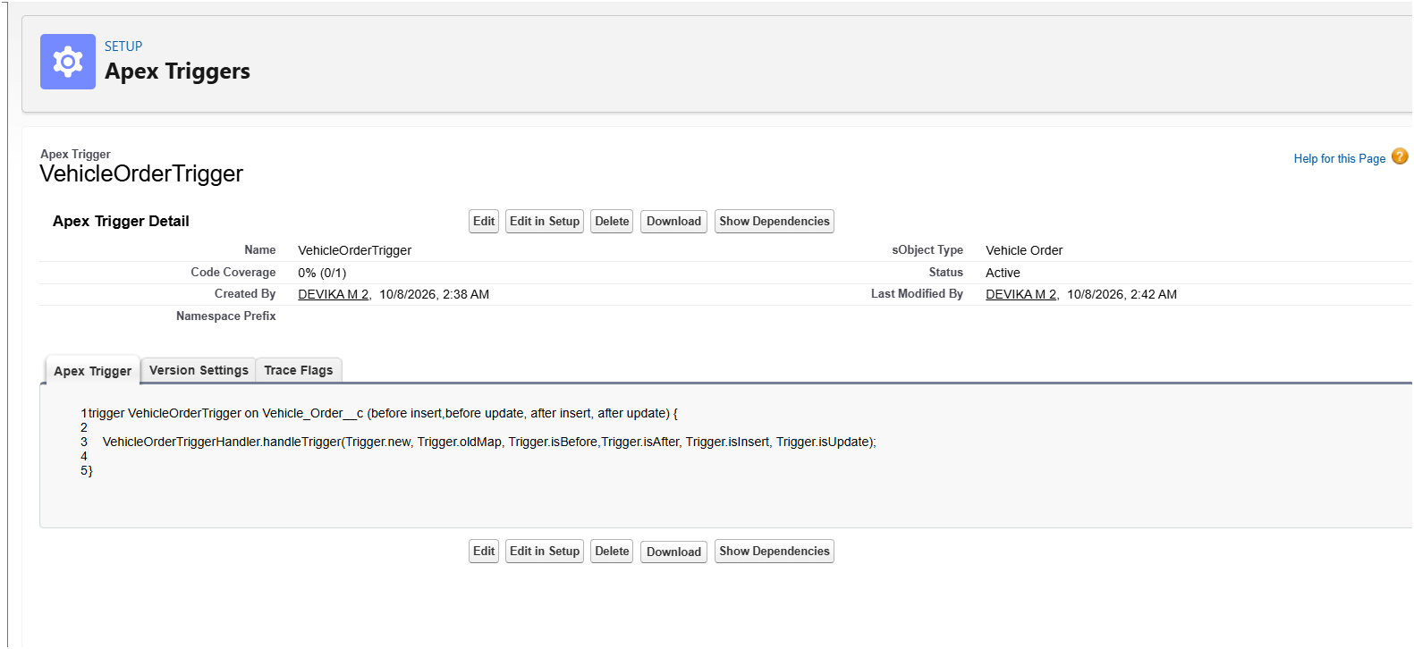

5.3 VehicleOrderTriggerHandler
The VehicleOrderTriggerHandler class contains the core logic of the system. Its before-insert and before-update methods check stock availability and block invalid orders, while its after-insert and after-update methods reduce the vehicle's stock after a valid order
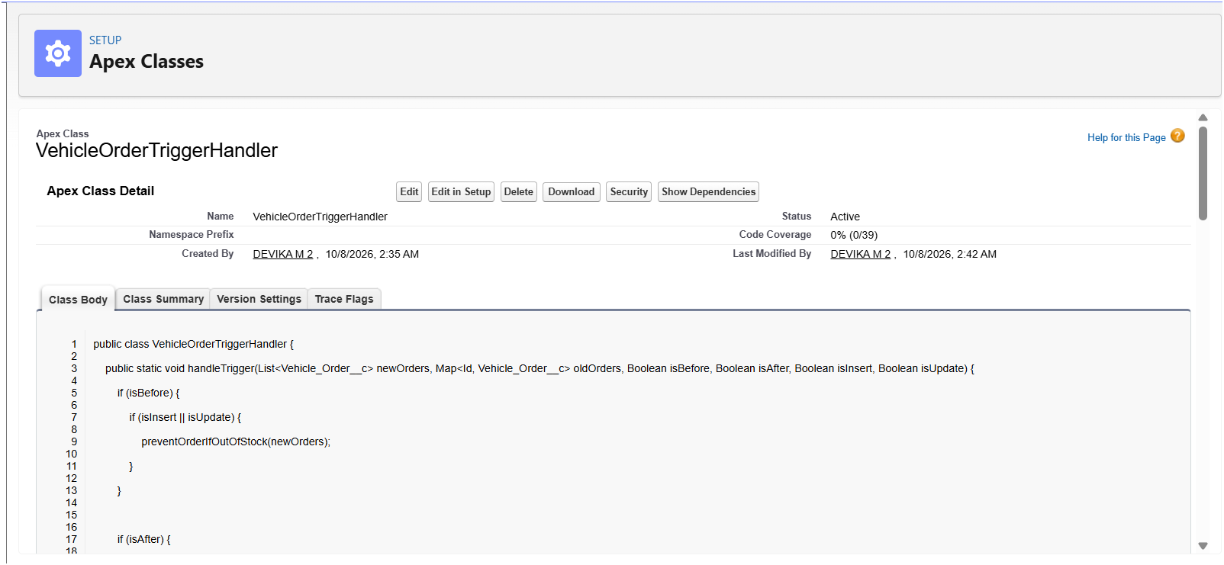

5.4 Stock Validation
The stock validation logic compares the requested quantity with the available stock of the selected vehicle. If the stock is not enough, the order is stopped and an error message is shown, so out-of-stock vehicles can never be ordered.
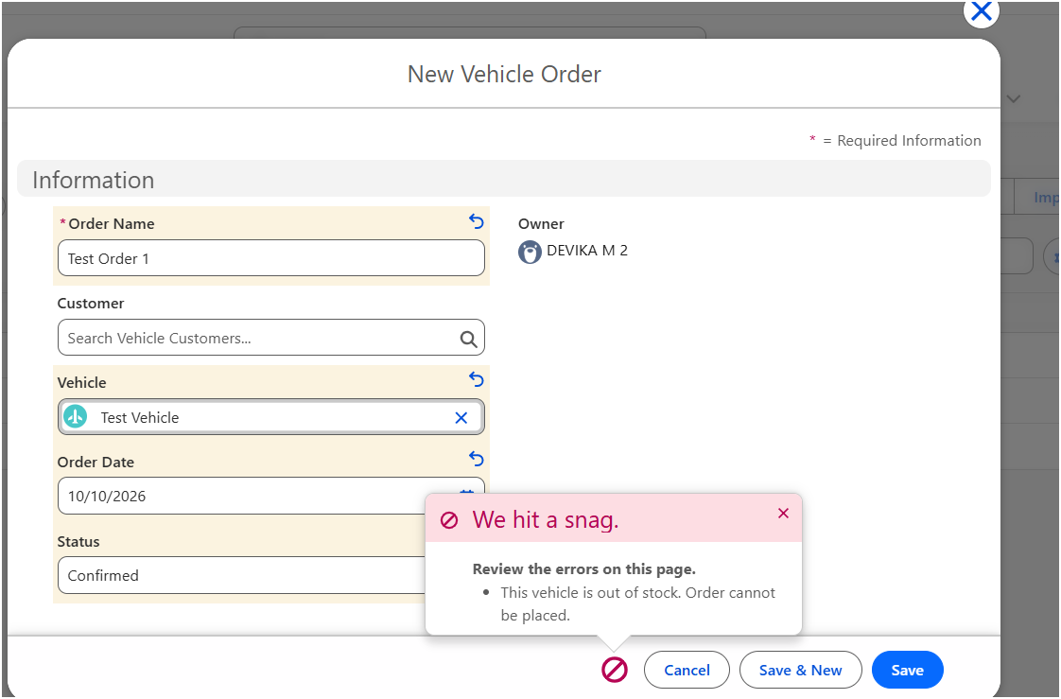

5.5 Vehicle Stock Update
After a valid order is placed, the handler reduces the vehicle's stock quantity by the ordered amount. The before-and-after stock values confirm that the automation keeps the inventory accurate.
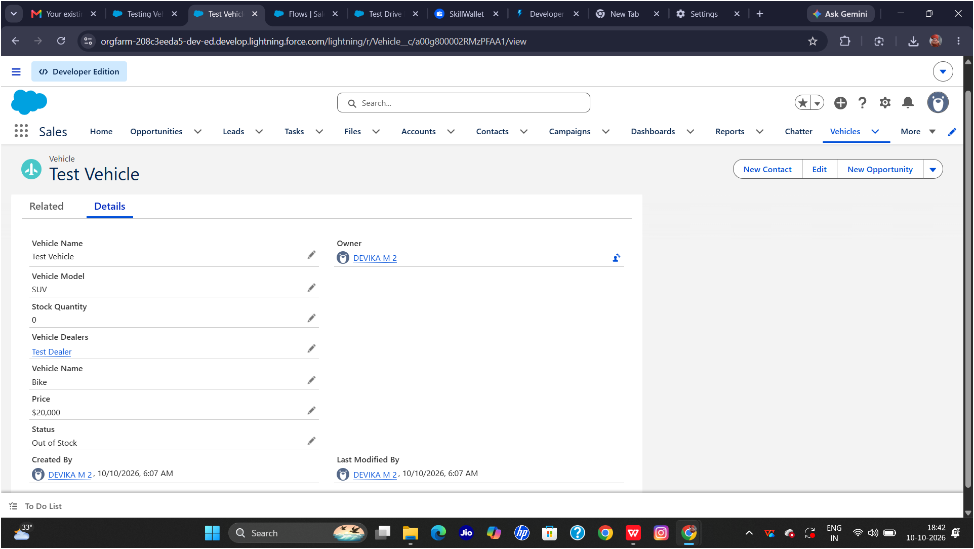
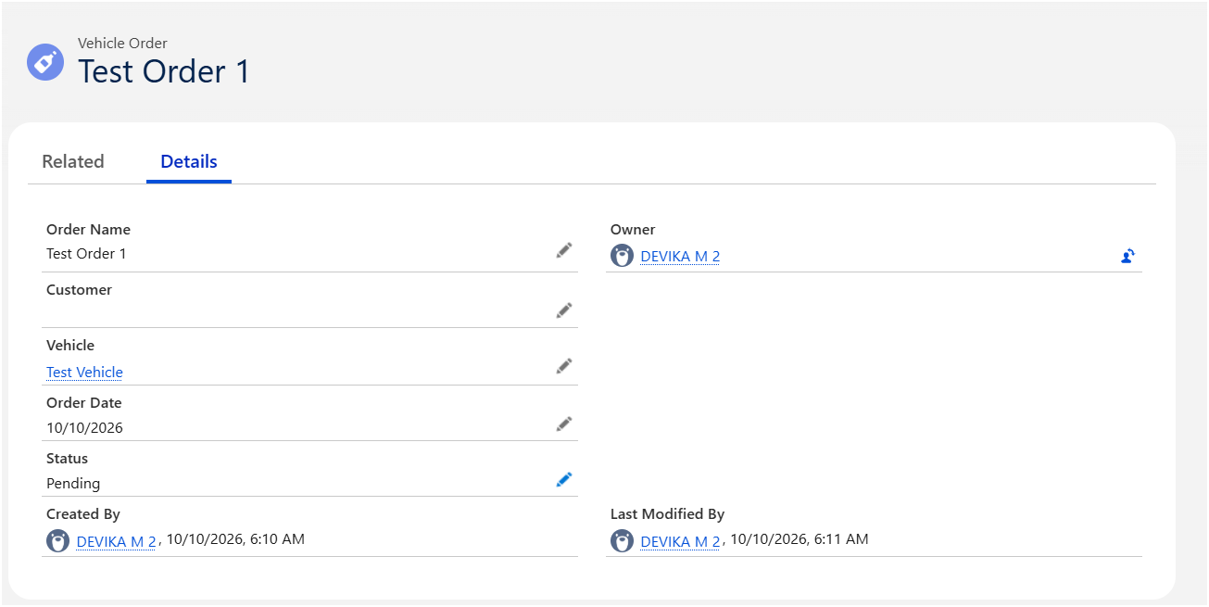

5.5 Test Drive Remainder Flow Configuration
A record-triggered Flow is configured on the Vehicle Test Drive object. It uses scheduled paths to run before the test drive date, retrieves the customer's information, and then runs the Send Test Drive Reminder action to email the customer.
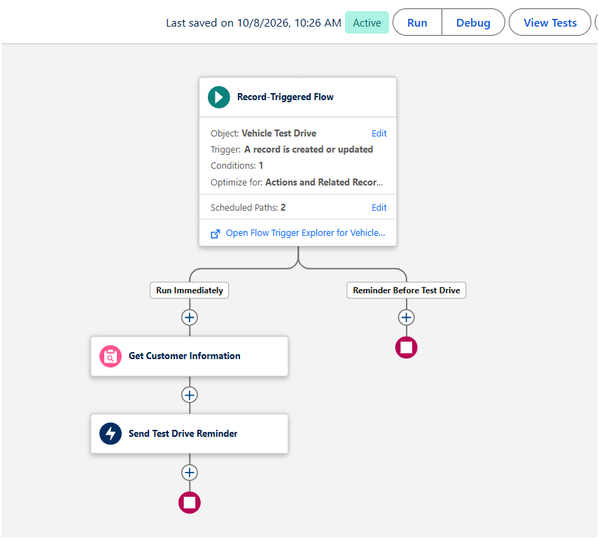

6. PHASE 4: BATCH APEX AND SCHEDULED PROCESSING

6.1 Batch Apex
Batch Apex processes large numbers of vehicle order records in manageable groups. The batch job checks vehicle stock and updates stock and order status: orders with available stock are marked Confirmed, and orders without available stock are marked Pending.
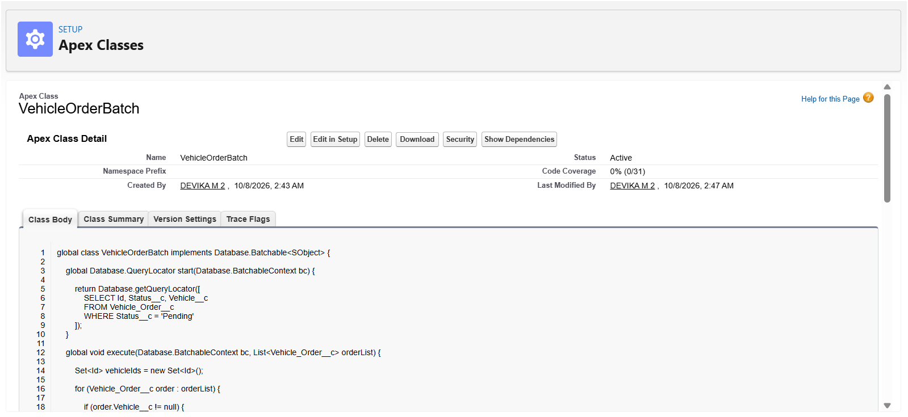

6.2 Scheduled Apex
Scheduled Apex runs the batch job automatically at a set time. The scheduler class implements Salesforce's Schedulable interface and starts the batch class, so order processing happens daily without any manual work.
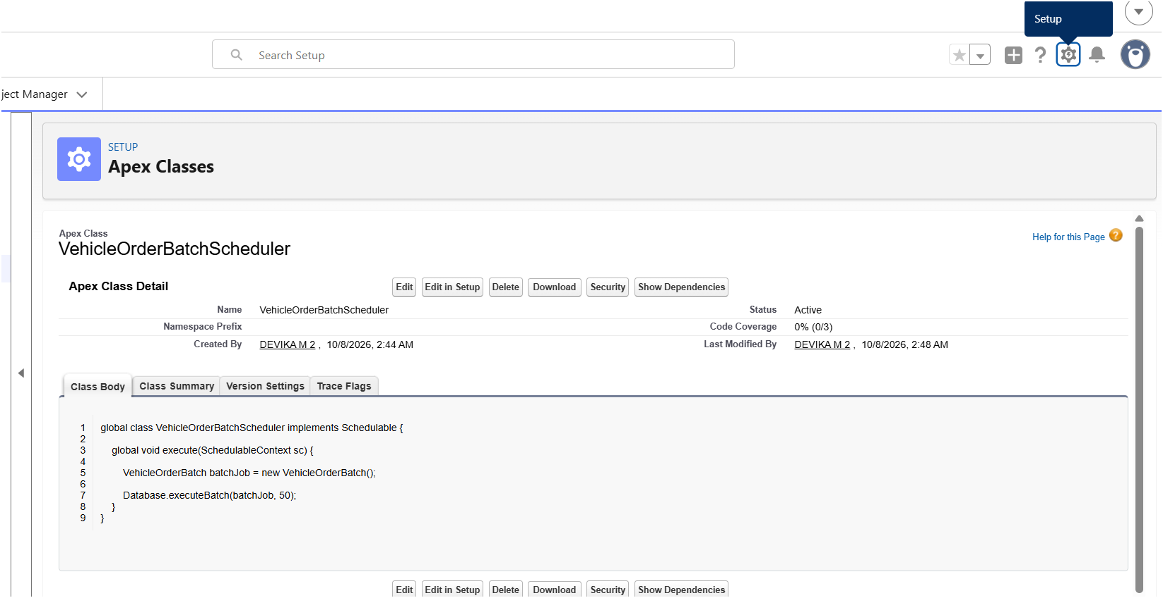
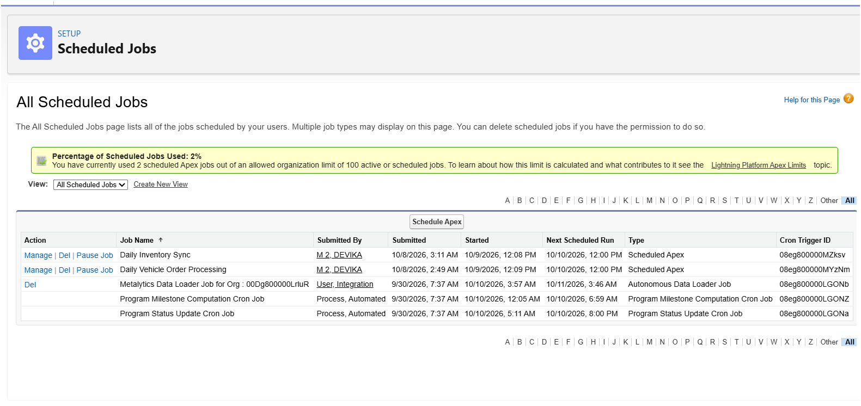

7. PHASE 5: TESTING AND VALIDATION

7.1 Testing Overview
Testing verifies that the trigger, handler, Flow, batch job, and scheduler work correctly for both valid and invalid order scenarios.

7.2 Test Cases

Test Case | Input / Action | Expected Result
TC-01: Valid vehicle order | Create an order with a quantity within the available stock. | Order is accepted and the vehicle stock is reduced.
TC-02: Out-of-stock order | Attempt an order with a quantity greater than the available stock. | Order is blocked and an error message is shown.
TC-03: Dealer assignment | Create an order with customer location details. | The order is assigned to the nearest dealer.
TC-04: Batch processing | Run the batch job on pending orders. | Stock is updated; orders become Confirmed or Pending based on stock.
TC-05: Scheduled execution | Run or wait for the scheduled Apex job. | The scheduler starts the batch process successfully.
TC-06: Test drive reminder | Create a test drive record with a future date. | A reminder email is sent to the customer on the scheduled path.
These test cases confirm that the system meets its key business rules.

8. RESULTS AND CONCLUSION
The Vehicle Order Management System shows how Salesforce CRM can transform vehicle ordering for WhatsNext Vision Motors. Custom objects and fields organize business data, while the Apex trigger and VehicleOrderTriggerHandler validate stock and keep inventory accurate.
With nearest-dealer assignment, dynamic status updates, Batch Apex, Scheduled Apex, and automated test drive email reminders, the project enhances customer satisfaction, improves order accuracy, and boosts overall operational efficiency.

9. FUTURE ENHANCEMENTS
- Add service request management for customers after vehicle purchase.
- Send test drive and order updates through SMS and WhatsApp along with email.
- Build a customer portal using Experience Cloud for order tracking.
- Configure low-stock alerts and automatic replenishment notifications.
- Create reports and dashboards for vehicle stock, dealer performance, and order status.
- Improve Apex test coverage for bulk records, edge cases, and error handling.
- Monitor scheduled batch jobs and handle failed jobs with alerts.
- Review object permissions and access controls for different user roles.

