SMART INDIA HACKATHON 2026 @ KONGU ENGINEERING COLLEGE
(7th & 8th September 2026)
Department: Computer Science and Engineering  Project category: Software  PS ID: SIH26003  Team ID / Name: MemoMate_KEC | Team leader:  Srimathi D (Roll No: 22CSR180)  Team members:  Srimathi D (Roll No: 22CSR180)  Team Member 2 (Roll No: 22CSR181)  Team Member 3 (Roll No: 22CSR182)  Team Member 4 (Roll No: 22CSR183)  Team Member 5 (Roll No: 22CSR184)  Mentor/Co-mentors:  Dr. R. Malathi; Associate Professor, Dept of CSE, KEC  Prof. P. Suresh; Assistant Professor, Dept of CSE, KEC

PROTOTYPE SCREENSHOTS & IMPLEMENTATION MODULES
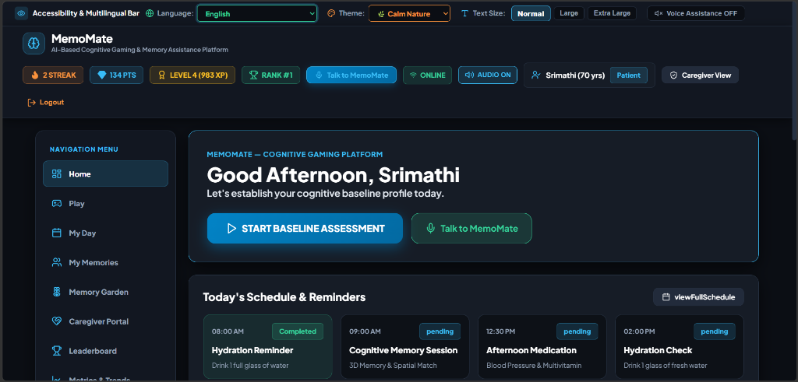
Figure 1: MemoMate Personalized User Dashboard & Daily Schedule Interface
Description: Features personalized greeting ('Good Afternoon, Srimathi'), direct baseline assessment launch button, AI voice assistant entry point, accessibility toolbar (English/Hindi/Tamil/Assamese, themes, text sizing), active gamification counters (2-day streak, 134 gems, Level 4 / 983 XP, Rank #1), patient metadata badge, and daily schedule reminders (hydration, memory session, afternoon medication).
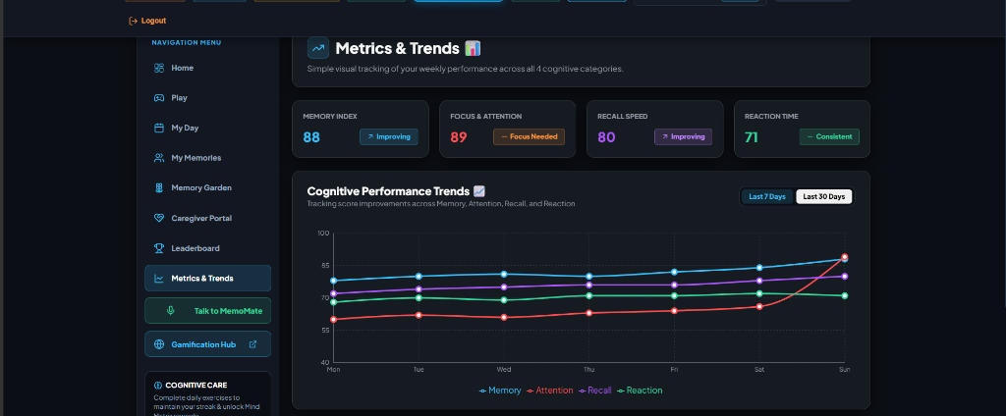
Figure 2: Cognitive Metrics & 30-Day Trend Analytics Dashboard
Description: Displays quantitative cognitive domain index scores (Memory Index: 88, Focus & Attention: 89, Recall Speed: 80, Reaction Time: 71) alongside dynamic status indicators ('Improving', 'Focus Needed', 'Consistent'). A 30-day SVG line graph tracks score trajectories across all four cognitive categories to evaluate patient improvement.
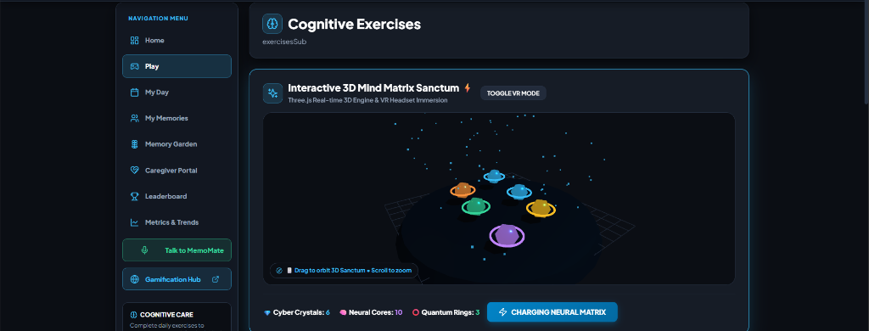
Figure 3: Interactive 3D Mind Matrix Sanctum Engine (Three.js WebGL)
Description: Features an interactive WebGL 3D cognitive stimulation scene powered by Three.js. Supports orbit rotation, zoom, VR headset immersion mode, particle systems, orbiting target spheres, and real-time inventory tracking (6 Cyber Crystals, 10 Neural Cores, 3 Quantum Rings) with neural matrix charging feedback.
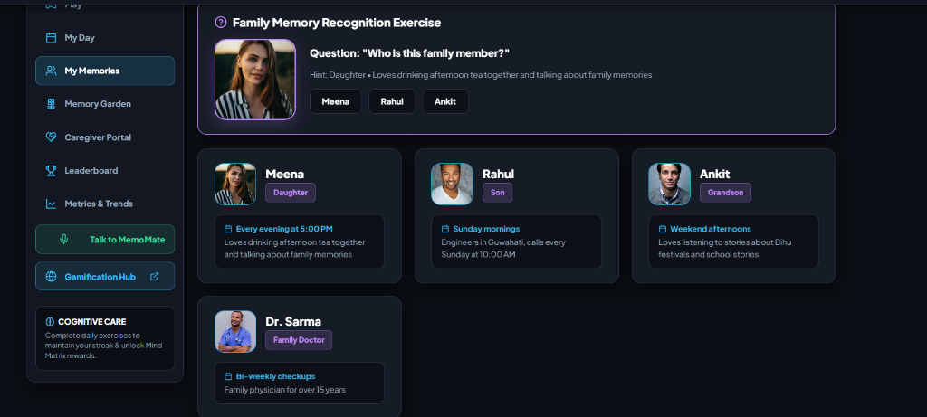
Figure 4: Family Memory Recognition & Reminiscence Exercise Module
Description: Presents photo-based family recognition prompts ('Who is this family member?') with portrait imagery, hints ('Daughter • Loves drinking afternoon tea together...'), and multi-choice selections (Meena, Rahul, Ankit). Detailed profile cards show relationship tags, visiting schedules, and doctor contacts to reinforce familiar identities.
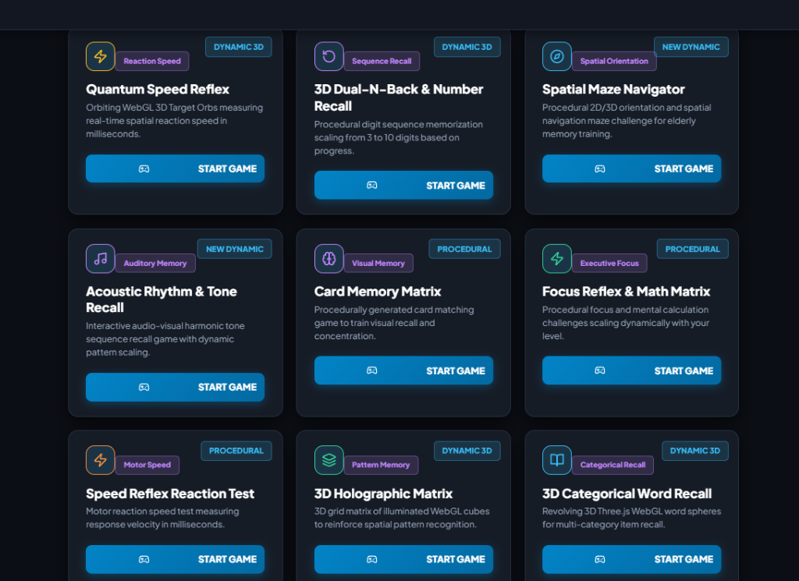
Figure 5: MemoMate Cognitive Gaming Hub Suite
Description: Showcases the 9-game cognitive suite including Quantum Speed Reflex, 3D Dual-N-Back & Number Recall, Spatial Maze Navigator, Acoustic Rhythm & Tone Recall, Card Memory Matrix, Focus Reflex & Math Matrix, Speed Reflex Reaction Test, 3D Holographic Matrix, and 3D Categorical Word Recall with procedural scaling tags and direct play controls.

