SMART INDIA HACKATHON 2026 @ KONGU ENGINEERING COLLEGE
(7th & 8th September 2026)
Department: Computer Science and Engineering  Project category: Software  PS ID: SIH26003  Team ID: MemoMate | Team leader:  Sriman Kumar V: 24CSR301  Team members:  Sriman Kumar V: 24CSR301  Srimathi D: 22CSR180  Mentor/Co-mentors:  Dr. M. Geetha M.E., Ph.D.: Associate Professor; Department of Computer Science and Engineering, Kongu Engineering College

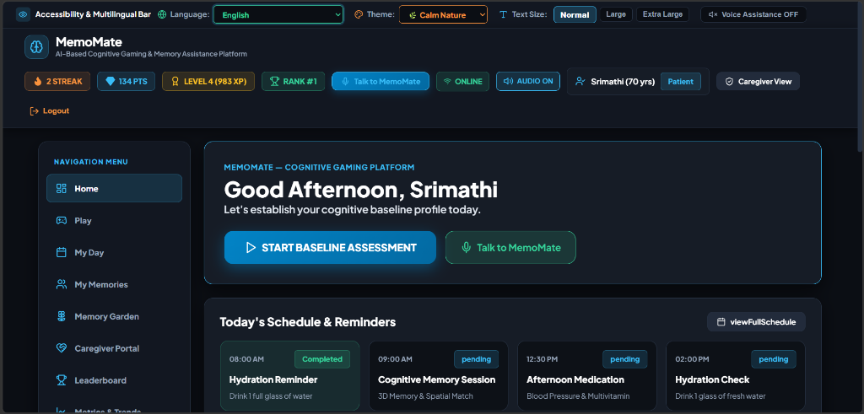
Figure 1: MemoMate Personalized User Dashboard & Daily Reminders Interface
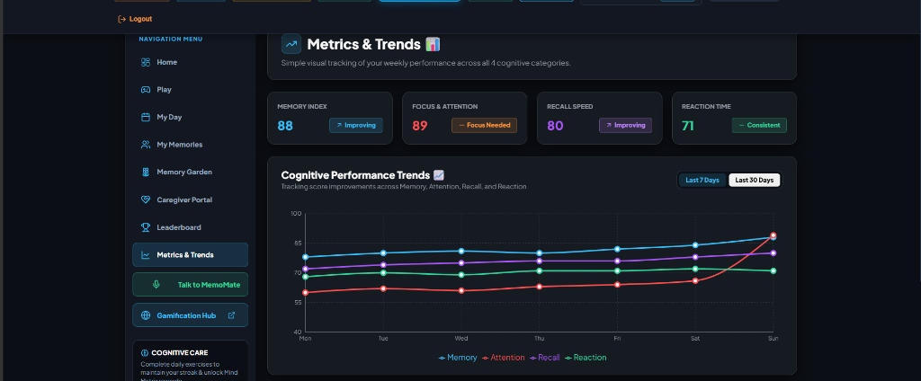
Figure 2: Cognitive Metrics & 30-Day Performance Analytics Dashboard
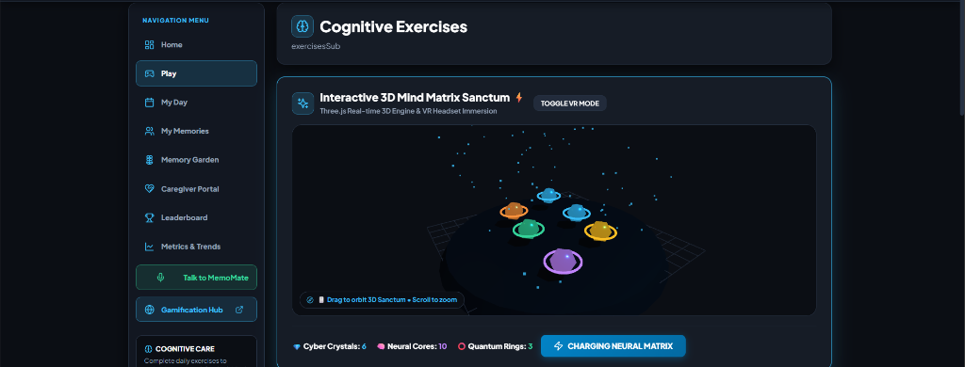
Figure 3: Interactive 3D Mind Matrix Sanctum Module (Three.js WebGL Engine)
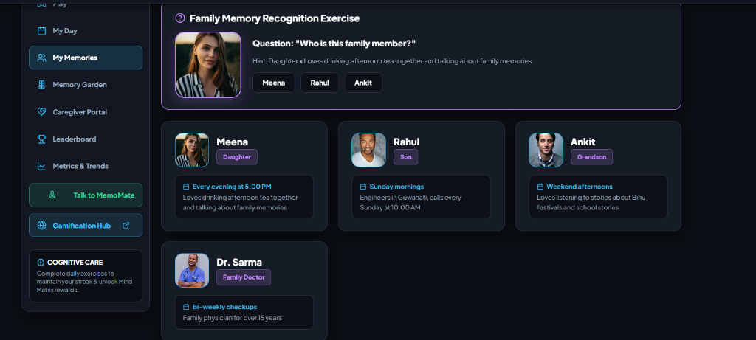
Figure 4: Family Memory Recognition & Reminiscence Exercise Module
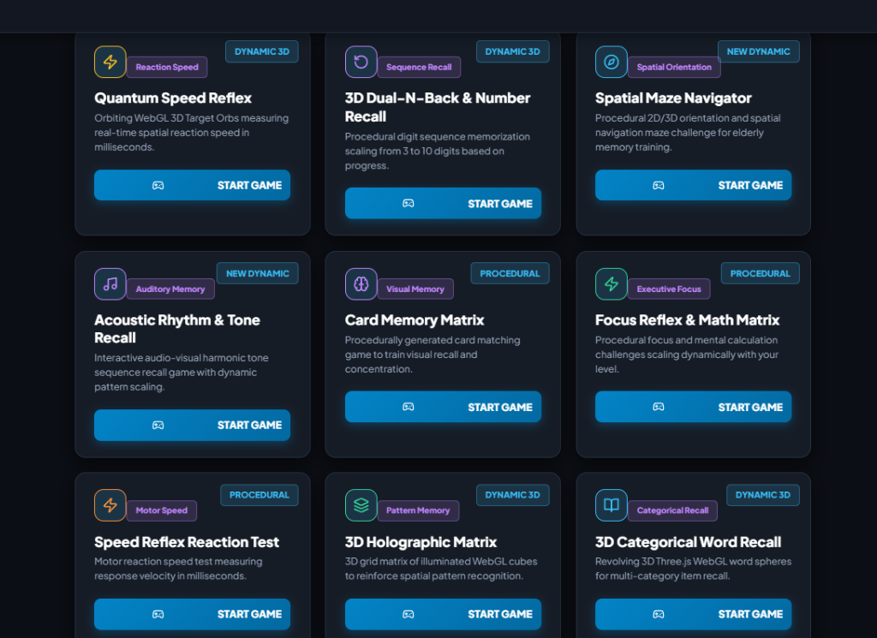
Figure 5: MemoMate Cognitive Gaming Hub Suite (9 Interactive Games)

