MainframeOps AI
Job Analysis Agent — Feature Guide
────────────────────────────
Version 1.0.0 | September 2026

Feature Guide | Job Analysis Agent

Table of Contents
1. Notices 2
2. What's New 2
3. Introduction 3
4. Job Analysis Agent Workflow 5
5. Standalone Deployment Workflow 13
6. Acronyms 16

1. Notices
This document describes the features and capabilities of MainframeOps AI. All job names, dataset names, execution results, return codes, system identifiers, and organizational references used in this document are illustrative examples only. Any resemblance to real production environments, systems, or data is coincidental.
MainframeOps AI is not an IBM product and is not affiliated with, endorsed by, or connected to International Business Machines Corporation or any other company. No IBM trademarks, product names, APIs, or proprietary content are reproduced in this document.
TO THE FULL EXTENT PERMITTED BY APPLICABLE LAW, THE INFORMATION IN THIS DOCUMENT IS PROVIDED "AS IS" WITHOUT ANY WARRANTY, EXPRESS OR IMPLIED. Examples presented are illustrative only. Actual results will vary based on configurations and conditions.

License terms
This document is published as a portfolio sample under open terms. It may be reproduced or referenced for evaluation purposes. No part of this document may be presented as a real vendor product specification.

Privacy
No personal data is collected or processed by MainframeOps AI in the context of this documentation. All user identifiers and organizational references in examples are illustrative only.

2. What's New
Learn about what is new and changed in the MainframeOps AI Job Analysis Agent Feature Guide.

2.1 Version 1.0.0
This is the initial release of the MainframeOps AI Job Analysis Agent Feature Guide. Version 1.0.0 introduces the core Job Analysis Agent capability, enabling operations teams to investigate batch-job failures, inspect datasets, and generate operational reports using natural-language interaction.

2.2 Version 2.0.0
The following feature enhancements are added in version 2.0.0:
- Operational report generation adds support for producing formatted failure summaries, trend reports, and step-level execution breakdowns from a single natural-language request.
- Dataset and JCL analysis adds the ability to inspect dataset allocation, authorization controls, and JCL step definitions associated with a failed job, directly from the agent conversation.
- Dataset inspection introduces an agent-driven workflow for browsing, filtering, and exporting dataset contents without leaving the chat interface.
- Standalone deployment introduces a self-contained workflow package for executing the full Job Analysis Agent workflow on premises, without requiring a cloud connectivity component.
The following sections are added in version 2.0.0: Operational report generation, Dataset and JCL analysis, Dataset inspection, and Standalone deployment workflow.

3. Introduction
This guide describes the Job Analysis Agent workflow in MainframeOps AI. The Job Analysis Agent enables mainframe operations teams to investigate batch-job failures, analyze Job Control Language (JCL), inspect datasets, understand execution results, and generate operational reports using natural-language interaction.
The Job Analysis Agent provides automated job investigation, step-level failure analysis, dataset authorization checking, and AI-generated execution summaries to support incident triage, root-cause analysis, and operational reporting.
Prerequisites validation: Validates the agent environment and confirms that all required connectivity and authorization components are in place before analysis begins.
Batch job analysis: Enables natural-language investigation of failed batch jobs, including step-level failure diagnosis, return code interpretation, and likely cause identification.
Dataset inspection: Provides an agent-driven workflow for browsing and inspecting datasets associated with failed jobs, including authorization and allocation detail.

3.1 Scope and assumptions
The Job Analysis Agent capability covers:
- Natural-language investigation of batch-job failures, including step-level analysis and return code interpretation.
- Dataset inspection for jobs that fail due to authorization, allocation, or access issues.
- JCL analysis, including step definition review and EXEC/DD statement inspection.
- Operational report generation for failure summaries and execution trends.
This guide assumes the following conditions:
- Read access to the job execution log repository and spool output is available.
- The MainframeOps AI platform is configured with Job Analysis Agent and MCP tool access.
- The user has appropriate authorization to query job history and dataset attributes.

3.2 Target audience
This guide is designed for:
- Operations specialists responsible for triaging batch-job failures, analyzing execution results, and coordinating incident resolution for mainframe workloads.
- System programmers who manage job scheduling, JCL libraries, dataset authorizations, and the supporting mainframe infrastructure.
- Analysts who use operational reports and execution summaries to evaluate job failure trends, identify recurring causes, and assess batch workload health.

3.3 Key concepts and terminology
MainframeOps AI provides capabilities for end-to-end batch-job investigation, root-cause analysis, dataset inspection, and report generation. These capabilities analyze job execution history, identify failure patterns, and deliver AI-generated summaries to support operations and incident management.
The following list describes key concepts:
MainframeOps AI
MainframeOps AI is an enterprise AI-agent platform that assists mainframe operations teams in investigating batch-job failures, analyzing JCL, inspecting datasets, and generating operational reports through conversational interaction.
Job Analysis Agent
The Job Analysis Agent is the primary AI agent within MainframeOps AI. It accepts natural-language requests about batch-job executions and orchestrates the retrieval, analysis, and presentation of job data, step results, and related datasets.
Execution record
A stored record of a specific batch-job run, including the submission timestamp, return code, step-level results, spool output, and associated dataset activity.
Return code
A numeric value produced by a batch job or step at the conclusion of processing. Return codes indicate execution status: 0000 indicates success, 0004 indicates a warning, 0008 indicates a recoverable error, and 0012 or higher typically indicates a failure requiring investigation.
Failed step
The specific job step within a JCL job that produced the highest return code or terminated abnormally, causing the overall job to fail.
MCP tool
A Model Context Protocol tool invoked by the Job Analysis Agent to retrieve job history, inspect dataset attributes, fetch JCL members, and submit analytical jobs on behalf of the user.
JCL generation
Automated creation of Job Control Language by the agent, used to submit inspection or report-generation jobs based on the analysis context and user-confirmed parameters.

4. Job Analysis Agent Workflow
The Job Analysis Agent orchestrates multiple Model Context Protocol (MCP) tools to complete batch-job investigation, dataset inspection, and report-generation tasks. The user interacts with the agent through natural language. The agent determines the required tools, collects necessary parameters, and presents results in a structured, readable format.
The workflow phases are:
- Prerequisites validation: Verifies the required configuration, agent connectivity, dataset access permissions, and environment readiness before any investigation activity begins.
- Batch job analysis: Investigates failed batch-job executions, identifies the failed step, retrieves return codes, and produces an AI-generated root-cause summary.
- Dataset inspection: Inspects datasets associated with a failed job, including authorization profiles, allocation attributes, and access history relevant to the failure.

4.1 Prerequisites validation
Validates the agent environment and confirms that all required components are in place before investigation begins.
Overview
Completing this phase ensures the environment is fully prepared and prevents investigation failures before batch-job analysis begins.
Key capabilities
- Verifies connectivity to the job history repository and spool access service.
- Validates dataset read authorization for the requesting user identity.
- Confirms that the required MCP tool endpoints are available and responding.
- Generates a validation summary indicating overall agent readiness.
Outcome
Successful validation confirms that the MainframeOps AI environment is ready for batch-job analysis and dataset inspection.

4.2 Batch job analysis
The batch job analysis capability enables operations teams to investigate failed batch-job executions using natural-language requests. The following analysis types are available as independent tasks:
- Payroll job failure analysis
- Operational report generation
- Dataset and JCL analysis
Each analysis type is available as an independent workflow. The agent processes user requests in a guided, conversational interaction, presenting execution results, step details, and AI-generated summaries at each stage.
4.2.1 Payroll Job Failure Analysis
The payroll job failure analysis investigates failed payroll batch-job executions and identifies the root cause of each failure using an agent-driven workflow. The agent retrieves execution history, collects confirmation from the user, and submits diagnostic jobs on the user's behalf. The following analysis tasks are available independently:
- Payroll job step-level failure analysis
- Authorization and dataset access investigation
Key capabilities
- Retrieves all recent executions for the requested job and presents a selection to the user.
- Identifies the failed step, return code, and likely cause for the selected execution.
- Inspects datasets referenced in the failed step and surfaces authorization or allocation issues.
- Generates and presents an AI-produced execution summary with remediation recommendations.
Outcome
The agent identifies the failed step, return code, and likely root cause for the selected execution. An execution summary report is available for incident documentation and post-investigation review.
Walkthrough: Payroll Job Failure Analysis
This walkthrough demonstrates a complete failure investigation for the PAYROLL01 job, covering environment selection, prerequisite validation, execution selection, step-level analysis, and report generation.
Phase 1: Start the investigation
Open the Job Analysis module and enter a natural-language request in the chat input:
Analyze the failed PAYROLL01 job.
The Job Analysis Agent welcomes the user, describes its capabilities, and accepts the prompt. The agent then presents the environment selection panel.
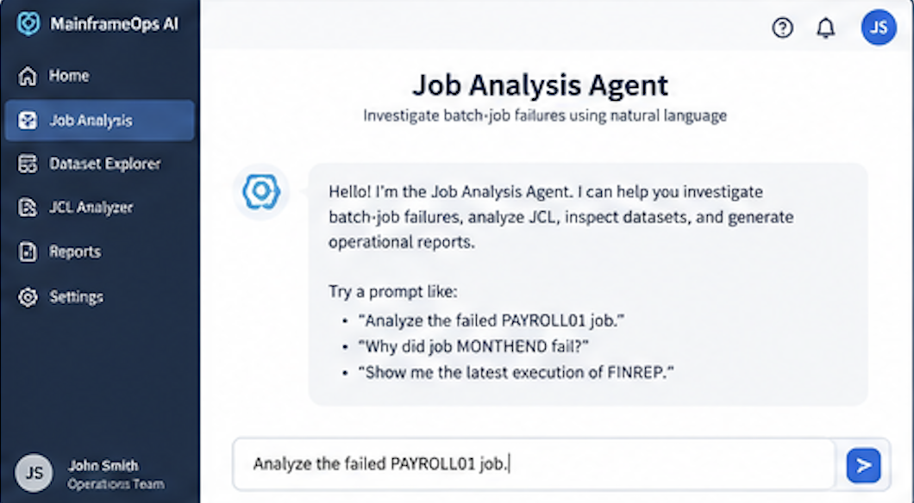
Figure 1. Job Analysis Agent — starter prompt
Purpose of this step:
Establishes the investigation intent. The agent confirms it can investigate batch-job failures, analyze JCL, inspect datasets, and generate operational reports.
Phase 2: Select the environment
The agent presents the Select Environment panel. The available mainframe environments are listed with their system ID, location, and online status. Select Production (MF01) and click Continue.
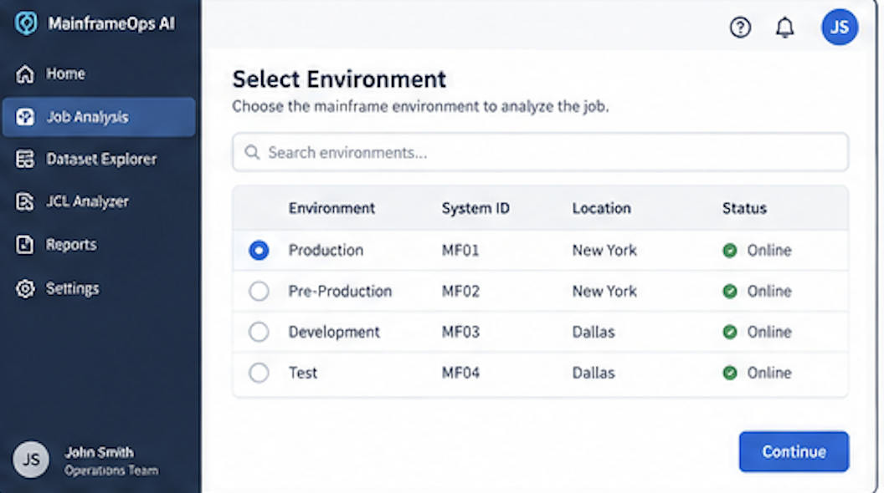
Figure 2. Select Environment
Purpose of this step:
Establishes the target mainframe environment. Locking the environment before analysis ensures all subsequent job history queries and dataset lookups run against the correct system. In this example, the Production environment (MF01, New York) is selected.
Phase 3: Validate prerequisites
After the environment is selected, the agent automatically runs the prerequisite validation check. Each required component is verified and its status is displayed. Click Continue when all checks pass.
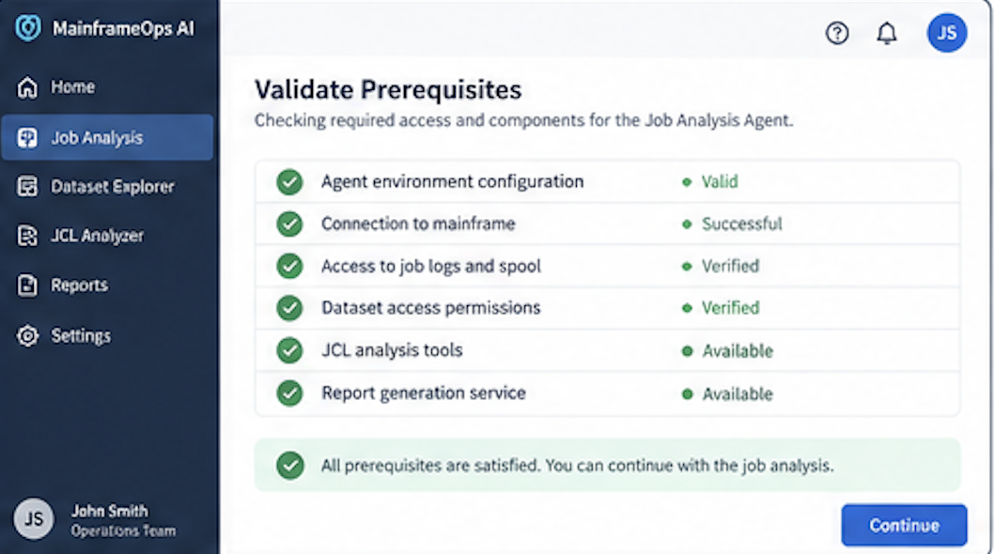
Figure 3. Validate Prerequisites — all checks passed
Purpose of this step:
Prevents investigation failures by confirming that all required services are accessible before any analysis activity begins. The six checks cover agent configuration, mainframe connectivity, job log access, dataset permissions, JCL tooling, and report generation.
Phase 4: Identify the job
The agent presents the Job Identification panel, displaying all jobs that match the requested name. The list shows job name, type, owner, last execution date, and status. Select PAYROLL01 (2026-09-08 01:30, Failed) and click Continue.
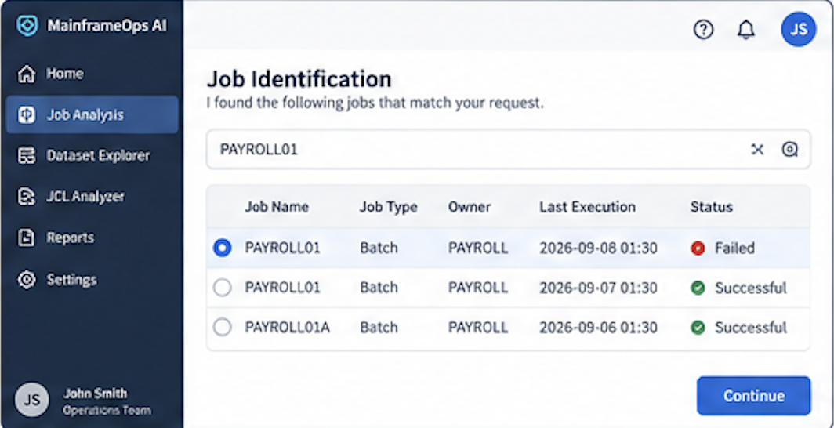
Figure 4. Job Identification — PAYROLL01 search results
Purpose of this step:
Disambiguates the job when multiple jobs or variants share the same name. The user confirms the exact job record before the agent proceeds, preventing analysis of the wrong execution.
Phase 5: Select the execution
The Select Job Execution panel lists recent executions for PAYROLL01, showing date/time, status, return code, and duration. Select the 2026-09-08 01:30 execution (Failed, RC 0008, duration 00:12:43) and click Continue.
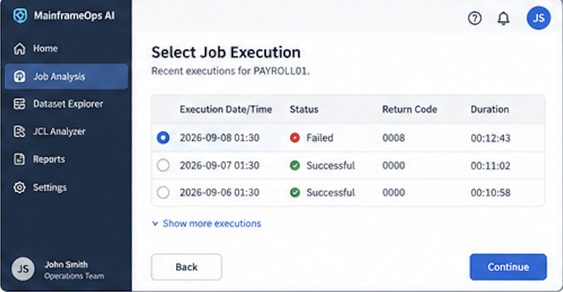
Figure 5. Select Job Execution — PAYROLL01 recent executions
Purpose of this step:
Confirms the exact execution to analyze. Showing execution history with return codes and duration allows the user to distinguish the failed run from successful prior runs before the agent begins deep analysis.
Phase 6: Analyze the job execution
The agent runs the analysis pipeline and displays a live progress view. Each stage completes in sequence: retrieving job log and spool output, analyzing execution steps, checking dataset access and authorization, analyzing JCL and step definitions, identifying the likely cause, and preparing results.
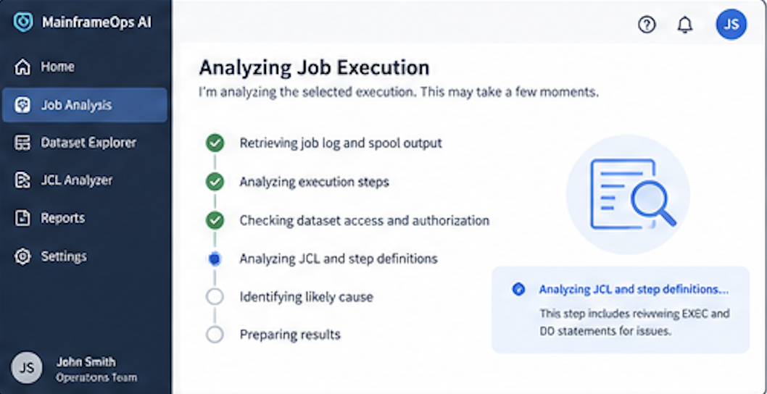
Figure 6. Analyzing Job Execution — analysis pipeline in progress
Purpose of this step:
Provides transparency into the agent's analysis pipeline. Each completed stage is marked with a green check; the active stage is highlighted with its detail tooltip. This allows the operations team to monitor progress without manual intervention.
Phase 7: Review the analysis results
When analysis completes, the Job Analysis Results screen opens on the Summary tab. A red alert banner confirms the failure. The summary table shows all key findings in a single view.
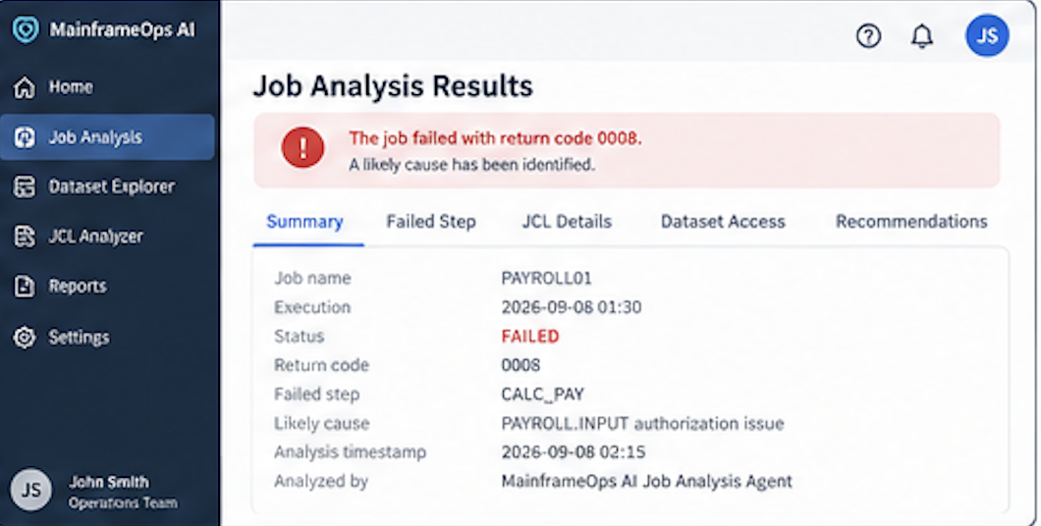
Figure 7. Job Analysis Results — Summary tab
Purpose of this step:
Delivers the complete analysis in a single tabbed view. The Summary tab consolidates job name, execution time, return code, failed step, likely cause, and analysis metadata. Additional tabs (Failed Step, JCL Details, Dataset Access, Recommendations) provide deeper drill-down without leaving the results screen.
Phase 8: Review the failed step details
Select the Failed Step tab to view step-level detail for CALC_PAY. The panel shows step name, step number, return code, step status (ABEND), and execution time. A step log excerpt displays the raw system messages that confirm the authorization failure.
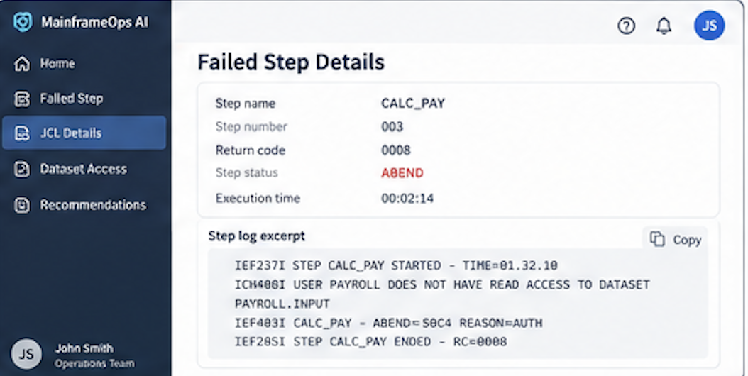
Figure 8. Failed Step Details — CALC_PAY step log excerpt
Purpose of this step:
Surfaces the raw system messages that confirm the root cause. The ICH408I message explicitly states that user PAYROLL does not have READ access to PAYROLL.INPUT, and the IEF403I message records the resulting ABEND with reason AUTH. This eliminates the need to browse the spool manually.
Phase 9: Generate and download the investigation report
Select the report type (Failure Investigation Report), choose the output format (PDF), and confirm the sections to include: Executive summary, Job and execution details, Failed step analysis, JCL and dataset information, and Recommendations. Click Generate Report. When the report is ready, click Download to save PAYROLL01_20260908_Report.pdf (2.4 MB) to your local workspace.
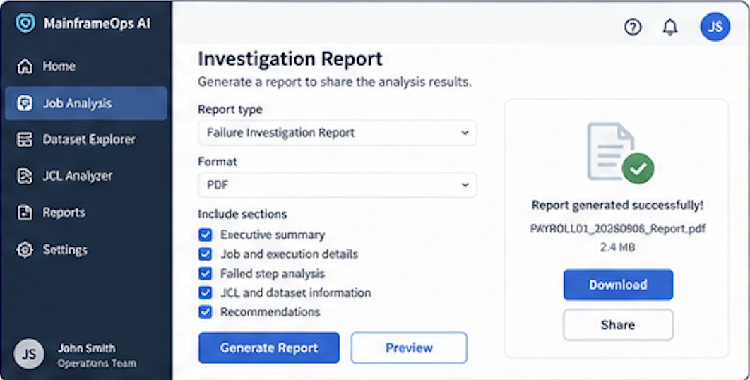
Figure 9. Investigation Report — report generated successfully
Purpose of this step:
Packages the complete investigation as a shareable PDF suitable for incident tickets, operations reviews, or post-incident documentation. The report includes all five sections selected and can also be shared directly from the results screen.
4.2.2 Operational Report Generation
The operational report generation capability produces formatted failure summaries, trend reports, and step-level execution breakdowns from a single natural-language request. The agent collects the report scope, retrieves execution history, and assembles an AI-generated report delivered directly in the chat session.
Key capabilities
- Generates failure summary reports for individual jobs or groups of jobs across a user-specified date range.
- Produces step-level execution breakdowns showing which steps failed, their return codes, and likely causes.
- Exports reports as downloadable CSV files for use in external incident management systems.
- Identifies recurring failure patterns and presents trend information across multiple executions.
4.2.3 Dataset and JCL Analysis
The dataset and JCL analysis capability enables the agent to inspect dataset allocation attributes, authorization profiles, and the JCL step definitions associated with a failed job. This analysis is conducted directly from the agent conversation and does not require the user to access the mainframe interactively.
Key capabilities
- Retrieves allocation attributes (space, device type, record format) for datasets referenced in the failed step.
- Displays authorization access levels for the job's executing identity against each referenced dataset.
- Displays the JCL EXEC and DD statements for the failed step, annotated with the agent's analysis findings.
- Identifies discrepancies between the job's expected input dataset and its actual allocated state.
Dataset name | DD name | Access required | Authorization status
PROD.PAYROLL.LOADLIB | STEPLIB | READ | PERMITTED
PAYROLL.INPUT | INPUT | READ | DENIED — PAYRJOB1 missing READ
PAYROLL.CALC.OUTPUT | OUTPUT | WRITE | PERMITTED

4.3 Dataset inspection
The dataset inspection capability provides an agent-driven workflow for browsing dataset contents, reviewing allocation attributes, and inspecting member lists. The agent retrieves dataset information on demand and presents it in a readable format within the chat interface.
Key capabilities
- Browses partitioned dataset member lists and retrieves member content on request.
- Displays dataset allocation attributes including space type, primary and secondary quantities, record format, and logical record length.
- Exports dataset contents and member lists as local files for offline review.
- Supports sequential and partitioned dataset types.
Outcome
Operations teams can inspect datasets without requiring direct mainframe access or a separate dataset management tool. The agent presents dataset detail inline and supports export for longer-term review.

5. Standalone deployment workflow
The Job Analysis Agent workflow can be executed entirely on premises without requiring a cloud connectivity component or a hosted service. The workflow is provided as a self-contained deployment package with the skills required to execute the end-to-end job analysis process.
The standalone deployment package defines the analysis workflow, skills, specification files, and supporting configuration that enable the AI assistant to guide the investigation process through conversational interaction.
The standalone workflow supports the following analysis capabilities:
- Batch job failure analysis
- Operational report generation
- Dataset and JCL analysis
- Dataset inspection and export
Prerequisites
Before running the standalone workflow, configure the required MCP server connections for the AI assistant. The MCP configuration file (.mopsai/mcp.json) defines the server connections used during analysis. The following MCP servers are required:
- jobanalysis-server: Provides job analysis capabilities, including execution history retrieval, step-level failure analysis, dataset authorization inspection, and report generation.
- common: Provides shared services used by the analysis workflow, including file transfer and asynchronous process handling.
Example MCP Server Configuration (.mopsai/mcp.json)
{
"mcpServers": {
"jobanalysis-server": {
"type": "streamable-http",
"url": "http://<YOUR-SERVER-HOST>:<PORT>",
"headers": {
"agentSessionId": "xxxxxxxx-xxxx-xxxx-xxxx-xxxxxxxxxxxx",
"correlationId": "<YOUR-CORRELATION-ID>",
"Accept": "text/event-stream, application/json"
},
"timeout": 300
},
"common": {
"type": "streamable-http",
"url": "http://<YOUR-SERVER-HOST>:<PORT>",
"headers": {
"agentSessionId": "xxxxxxxx-xxxx-xxxx-xxxx-xxxxxxxxxxxx",
"correlationId": "<YOUR-CORRELATION-ID>",
"Accept": "text/event-stream, application/json"
},
"timeout": 300
}
}
}
In addition to the MCP server configuration, the following environment requirements must be met:
- Access to the mainframe LPAR that hosts the job history repository.
- Read permission for the job execution log store and dataset catalog.
- Write permission for local output directories used by the report export function.
- Required agent runtime libraries accessible on the target LPAR.
- Prerequisites are validated automatically when the analysis workflow starts.
Project structure
The mainframeops-ai-standalone package contains the workflow specifications, runtime skills, and supporting configuration required to execute the analysis workflow:
mainframeops-ai-standalone/
├── job-analysis/
│ ├── config.properties
│ ├── .mopsai/
│ │ └── skills/
│ │ ├── analysis-apply-change/
│ │ │ └── SKILL.md
│ │ └── report-transfer-chunks/
│ │ ├── fetch_report_chunks.py
│ │ └── SKILL.md
│ └── workflow/
│ └── specs/
│ ├── prerequisite-check/
│ │ └── spec.md
│ ├── execution-selection/
│ │ └── spec.md
│ ├── step-analysis/
│ │ └── spec.md
│ ├── dataset-inspection/
│ │ └── spec.md
│ ├── report-generation/
│ │ └── spec.md
│ └── long-running-process-handling/
│ └── spec.md
└── dataset-inspection/
├── config.properties
└── workflow/
└── specs/
├── prerequisite-check/
│ └── spec.md
└── dataset-browse/
└── spec.md
Specification components
Job analysis workflow:
- prerequisite-check: Validates connectivity to the job history repository, confirms dataset access authorization, and blocks workflow execution if validation fails.
- execution-selection: Retrieves all recent executions for the requested job, presents a selection list to the user, and routes to the analysis workflow for the confirmed execution.
- step-analysis: Retrieves step-level execution detail, identifies the failed step, correlates return codes with dataset access events, and generates a root-cause summary.
- dataset-inspection: Discovers datasets referenced in the failed step, retrieves allocation attributes and authorization profiles, and presents the findings in a structured table.
- report-generation: Assembles the execution summary report, formats the output as a structured document, and exports it to the local workspace.
- long-running-process-handling: Waits synchronously for up to 90 seconds before switching to asynchronous status polling; supports manual status polling on request; handles terminal statuses and returns to the main workflow menu.
Standalone workflow
The standalone workflow coordinates the following activities:
- Specify the job name and analysis scope using natural language.
- Select the execution to analyze from the retrieved execution list.
- Review the step-level failure analysis and root-cause summary.
- Inspect datasets and JCL associated with the failed step.
- Generate and download the execution summary report.
The workflow combines automated retrieval and analysis with user-driven selection and confirmation at defined decision points.

6. Acronyms
This section explains the acronyms used in this guide.
Acronym | Full form | Definition
ABEND | Abnormal End | A system condition that occurs when a program or job step terminates unexpectedly before completing its normal processing.
AI | Artificial Intelligence | The simulation of human intelligence processes by computer systems, including learning, reasoning, and problem-solving.
API | Application Programming Interface | A defined set of rules and protocols that enables software components to communicate and exchange data.
CSV | Comma-Separated Values | A plain-text file format that stores tabular data with values separated by commas, widely used for data exchange.
DD | Data Definition | A JCL statement that identifies a dataset and its attributes for use by a job step.
EXEC | Execute | A JCL statement that specifies the program or cataloged procedure to be executed in a job step.
JCL | Job Control Language | A scripting language used on mainframe systems to instruct the operating system how to run a batch job, including program execution and dataset allocation.
JSON | JavaScript Object Notation | A lightweight, human-readable data interchange format commonly used for configuration files and API payloads.
LPAR | Logical Partition | An independent partition of a mainframe system that runs its own operating system instance and workloads.
MCP | Model Context Protocol | An open protocol that standardizes how AI models interact with external tools, data sources, and services.
PDF | Portable Document Format | A file format that presents documents in a fixed layout independent of software, hardware, or operating system.
PDS | Partitioned Dataset | A mainframe dataset organized as a directory of named members, each containing a separate sequential data stream.
RC | Return Code | A numeric value returned by a job step to indicate completion status: 0000 (success), 0004 (warning), 0008 (error), 0012 or higher (failure).
SIEM | Security Information and Event Management | A platform that collects, correlates, and analyzes security event data from across an IT environment.
SLA | Service Level Agreement | A formal agreement that defines the expected performance, availability, and response time standards for a service or system.
SMF | System Management Facilities | A mainframe component that collects and records system activity data, used for performance monitoring and audit reporting.

