# Name: SRIMAY KUMAR ,Enrol. No.: E23CSEU0565,G5-B19

**AI Project Milestone – 2**

### 1: Crop Recommendation System Using Machine Learning.

This research focuses on improving crop selection for farmers by using machine learning (ML) algorithms to examine soil and environmental variables such as pH, N, P, K, temperature, and rain. The study analyses ML approaches such as Decision Trees, Random Forest, and XGBoost, and finds that XGBoost is the most accurate, achieving 99.31%. Data is gathered from the Kaggle website and analysed using feature extraction to improve model performance. The system's main goal is to increase agricultural productivity by delivering data-driven crop suggestions for diverse soil conditions in India. **SOURCE LINK:**

[**https://ijsrcseit.com/paper/CSEIT2173129.pdf**](https://ijsrcseit.com/paper/CSEIT2173129.pdf)

### 2: Crop Recommendation System.

This research uses an Arduino-based IoT setup and machine learning models (Naïve Bayes, SVM, and K-Means) to select crops based on real-time

environmental data such as soil pH, moisture, and temperature. The algorithm gives farmers top crop recommendations and collects feedback via a mobile app to improve predictions over time. With 92-96% accuracy throughout its components, this system promises to boost farming efficiency and yield in Sri Lanka by continuously self-optimizing based on collected data and user

feedback. **SOURCE LINK:**

[**https://www.researchgate.net/publication/346627389_Crop_Recommendati**](https://www.researchgate.net/publication/346627389_Crop_Recommendation_System)[**on_System**](https://www.researchgate.net/publication/346627389_Crop_Recommendation_System)

### 3: Crop recommendation system for precision agriculture

This website focuses on precision agriculture, with the goal of recommending suitable crops after considering soil quality, weather, and geographical data. It uses a dataset with parameters such as soil type, climate, and nutrient content to train an ensemble of machine learning models, including Decision Tree,

Naive Bayes, SVM, Logistic Regression, Random Forest, and XGBoost, with Random Forest being particularly accurate. The system uses majority voting to provide reliable forecasts. Crop suggestions are highly accurate, according to performance measures, assisting farmers in picking crops that maximize production and sustainability. **SOURCE LINK:**

[**https://www.semanticscholar.org/paper/Crop-recommendation-system-**](https://www.semanticscholar.org/paper/Crop-recommendation-system-for-precision-Pudumalar-Ramanujam/a64c8a9185d5ebed4dc7bdb1f26293d7bee82c5c)[**forprecision-Pudumalar-**](https://www.semanticscholar.org/paper/Crop-recommendation-system-for-precision-Pudumalar-Ramanujam/a64c8a9185d5ebed4dc7bdb1f26293d7bee82c5c)

[**Ramanujam/a64c8a9185d5ebed4dc7bdb1f26293d7bee82c5c**](https://www.semanticscholar.org/paper/Crop-recommendation-system-for-precision-Pudumalar-Ramanujam/a64c8a9185d5ebed4dc7bdb1f26293d7bee82c5c)

# ESHA SHRIVASTAV, Enrol. No. : E23CSEU0502 -G5 B17

**AI Project Milestone – 2**

## 1: Enhancing crop recommendation systems with explainable artificial intelligence: a study on

**agricultural decision-making**

Crop Recommendation Systems are invaluable tools for farmers, assisting them in making informed decisions about crop selection to optimize yields. These systems leverage a wealth of data, including soil characteristics, historical crop performance, and prevailing weather patterns, to provide personalized

recommendations. In response to the growing demand for transparency and

interpretability in agricultural decision-making, this study introduces XAI-CROP an innovative algorithm that harnesses eXplainable artificial intelligence (XAI) principles. The fundamental objective of XAI- CROP is to empower farmers with comprehensible insights into the recommendation process, surpassing the opaque nature of conventional machine learning models. The study rigorously compares XAI-CROP with prominent machine learning models, including

Gradient Boosting (GB), Decision Tree (DT), Random Forest (RF), Gaussian Naiive Bayes (GNB), and Multimodal Naiive Bayes (MNB). Performance

evaluation employs three essential metrics: Mean Squared Error (MSE), Mean Absolute Error (MAE), and R-squared (R2). The empirical results unequivocally establish the superior performance of XAI-CROP. It achieves an impressively

low MSE of 0.9412, indicating highly accurate crop yield predictions. Moreover, with an MAE of 0.9874, XAI-CROP consistently maintains errors below the

critical threshold of 1, reinforcing its reliability. The robust R2 value of 0.94152 underscores XAI-CROP’s ability to explain 94.15% of the data’s variability,

highlighting its interpretability and explanatory power.

**SOURCE LINK:** [**https://link.springer.com/article/10.1007/s00521-023-09391-2**](https://link.springer.com/article/10.1007/s00521-023-09391-2)

## 2: IOT-BASED crop recommendation system

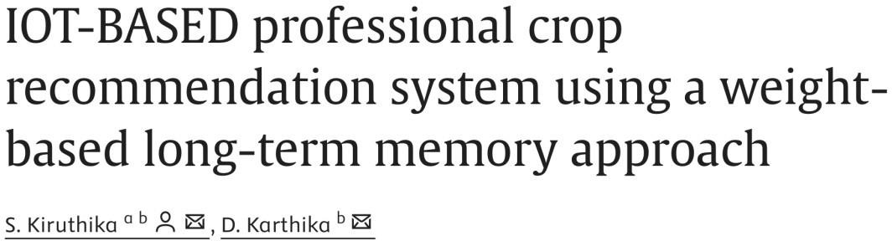

For the vast majority of Indians, [agriculture](https://www.sciencedirect.com/topics/agricultural-and-biological-sciences/agricultural-science) is their main source of income, and it plays a vital role in the country's economy. The most prevalent issue Indian farmers have is that they do not choose their crops based on the requirements of the soil, which has a significant negative impact on their productivity.

Precision agriculture can help solve this problem. This method considers three parameters: soil characteristics, soil types, and crop yield data collection. A suitable crop to cultivate is suggested to the farmer based on these parameters.

However, India must develop and civilizes the agro industry's technological

engagement and usability. Due to the inability to select acceptable features, the existing system's accuracy is low, and it takes longer to process the given

climate dataset. This paper proposes a method based on

IDCSO (Improved Distribution-based Chicken [Swarm](https://www.sciencedirect.com/topics/agricultural-and-biological-sciences/swarms) Optimization) with WLSTM (Weight-based Long Short-Term Memory) for crop predictions and

recommendations in order to address the aforementioned issues with the help of the [Internet of Things](https://www.sciencedirect.com/topics/engineering/internet-of-things) (IoT). The [primary phases](https://www.sciencedirect.com/topics/engineering/primary-alpha-phase) are pre-processing, attribute selection using the IDCSO algorithm, and crop prediction using the WLSTM

method. First, climate data are collected, then crop production data. For this study, the climate data includes a number of variables responsible for the rainfall at a given location and the [agricultural yield](https://www.sciencedirect.com/topics/earth-and-planetary-sciences/yield-agricultural) in that region. Then,

preprocessing is performed to enhance the quality of the input. To provide precise prediction results with shorter [execution times,](https://www.sciencedirect.com/topics/engineering/execution-time) the IDCSO algorithm is utilized to choose the most helpful features. The most pertinent features from the provided dataset are chosen using the optimal fitness values. The required crop predictions are then performed using the WLSTM approach. Farmers can

get instant crop recommendations by entering their preferred climate and crop attributes. The experimental findings show that in terms of precision, recall, and execution time, the suggested IDCSO-WLSTM technique performs better

than its forerunner.

**SOURCE LINK:**

[**https://www.sciencedirect.com/science/article/pii/S2665917423000582**](https://www.sciencedirect.com/science/article/pii/S2665917423000582)

## 3: Crop recommendation system for precision agriculture

Agriculture in India plays a predominant role in economy and employment. The common problem existing among the Indian farmers are they don't choose the right crop based on their soil requirements. Data mining is the practice of examining and deriving purposeful information from the data. Data mining finds its application in various fields like finance, retail, medicine, agriculture

etc. Data mining in agriculture is used for analyzing the various biotic and abiotic factors. Due to this they face a serious setback in productivity. This problem of the farmers has been addressed through precision agriculture.

Precision agriculture is a modern farming technique that uses research data of soil characteristics, soil types, crop yield data collection and suggests the farmers the right crop based on their site-specific parameters. This reduces the wrong choice on a crop and increase in productivity. In this paper, this problem is solved by proposing a recommendation system through an ensemble model with majority voting technique using Random tree, CHAID, K-Nearest Neighbor and Naive Bayes as learners to recommend a crop for the site specific

parameters with high accuracy and efficiency.

**SOURCE LINK:** [**https://ieeexplore.ieee.org/document/7951740/authors -**](https://ieeexplore.ieee.org/document/7951740/authors#authors)[**authors**](https://ieeexplore.ieee.org/document/7951740/authors#authors)

ARUSHI SHAH, Enrl. No.: E23CSEU0562, G5-B21

Research Paper 1

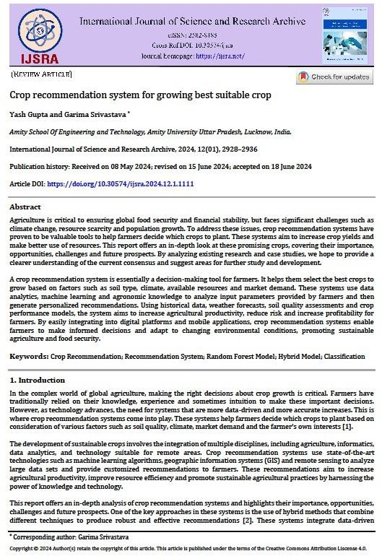

**Abstract-**

The research paper focuses on a crop recommendation system that uses machine learning, particularly a Random Forest algorithm, to optimize crop selection. It integrates soil, climate, and environmental data to provide personalized recommendations to farmers, enhancing agricultural productivity. The methodology combines data analytics with expert knowledge, enabling real-time adaptability and scalability. Performance metrics highlight improvements in accuracy, customization, and user satisfaction. The system promotes sustainable agriculture by helping farmers make data-driven decisions tailored to specific conditions.

Research Paper 2

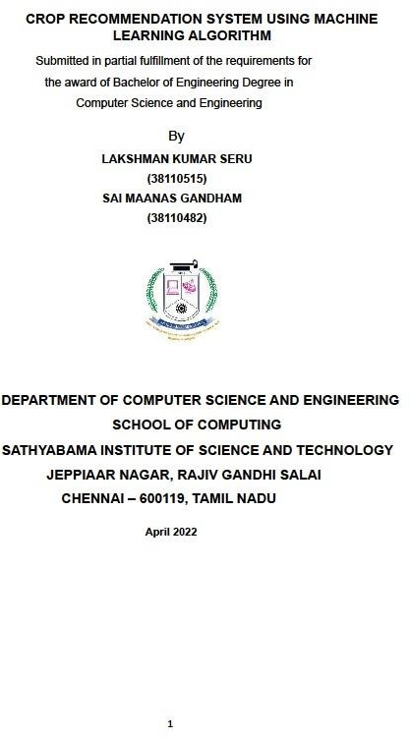

**Abstract-**

The research focuses on a crop recommendation system for South Indian states, utilizing a hybrid machine learning model. The dataset includes parameters such as soil type, rainfall, groundwater, temperature, fertilizers, and pesticides. The system applies ensemble classifiers like Random Forest and Decision Tree to recommend optimal crops, aiming to maximize yield. Key performance metrics include improved crop quality identification via ranking and cost prediction for fertilizers, offering personalized recommendations to enhance agricultural productivity.

Research Paper 3

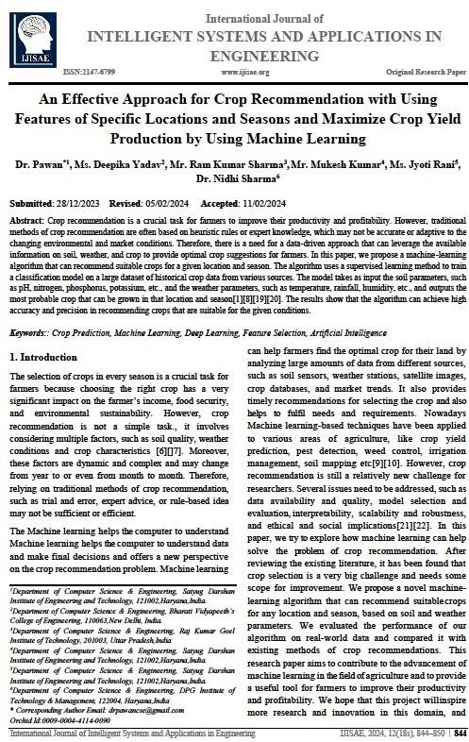

**Abstract-**

This research paper focuses on crop recommendation using machine learning. It utilizes datasets that include soil parameters (pH, nitrogen, etc.) and weather conditions (temperature, rainfall) to train a supervised learning model. Various machine learning algorithms, including Random Forest and Decision Trees, were evaluated. Random Forest achieved the highest accuracy of 98.18%. The model helps farmers select optimal crops based on location-specific factors, aiming to maximize yield, profitability, and sustainability while reducing environmental impact