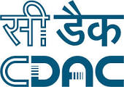

***System Requirement Specification***   
***For***   
***SMDP-C2SD Web Portal***

|  |  |  |
| --- | --- | --- |
| Project No: CDACD/SMDP-C2SD/07/17 | | |
| Document No: SMDP-C2SD/2017/SRS/1.0 | | |
| Author Name: Chandan Kumar Goyal | | |
| Distribution Type: | | |
| Approved By Name  Signature | Designation | Date of Approval |
| Shri D. Sasmala | Joint Director, C-DAC Delhi |  |
| Smt Sunita Verma | Scientist 'F', MeitY |  |
| Released By: | | |
| Release Date: | | |
| Copy No. : 1 | | |

1

***Revision History***

|  |  |  |  |  |
| --- | --- | --- | --- | --- |
| **Version** | **Date of release** | **Pages Affected** | **Reason of change** | **Signature** |
| 1.0 | 04.09.2017 | 14 | New |  |
|  |  |  |  |  |
|  |  |  |  |  |
|  |  |  |  |  |
|  |  |  |  |  |
|  |  |  |  |  |
|  |  |  |  |  |
|  |  |  |  |  |
|  |  |  |  |  |

2

***Table Of Contents***

|  |  |
| --- | --- |
| **1. Project Code**  **2. Project Title**  **3. Project Scope**  **4. Introduction**  4.1 Background  4.2 Problem  4.3 Solution  4.4 Intended Audience & Reading Suggestions  **5. Overall Description**  5.1 Product Perspective  5.2 Product Function  5.3 User Classes & Characteristics  5.4 Operating Environment  5.5 Design & Implementation Constraints 5.6 Software Standard Follows  5.7 Software Quality Attributes  5.8 Deliverables  5.9 Acceptance Criteria | **4**  **4**  **4**  **5**  5  5  5  6  **7**  7  7  9  9  9  9  10  10  10 |

**6. System Architecture**   
6.1 Overall Architecture 11 6.2 Online Application Architecture 11

**7. System / Process Flow Diagrams**   
7.1 Design Package Submission Flow 12

**8. Schedule & Milestones**

|  |  |
| --- | --- |
| 8.1 PERT Chart | 13 |

3

***System Requirement Specification***

**1. Project Code**

CDACD/SMDP-C2SD/07/17

**2. Project Title**

Design and Development of Web Portal for Design Submission Package to Chip Centre for Chips to Systems Design (C2SD)

**3. Project Scope**

|  |  |
| --- | --- |
| • • | "To develop design submission package for Chip Centre".  “To design, develop, operate & maintain a modern, user friendly & interactive |

website for Chips 2 Systems Design.”  
• “To design, develop, operate & maintain a web based application portal for facilitating the online submission of requirements, informations, progress and achievements pertaining to Chips 2 Systems Design.”  
• “To develop, operate & maintain a database of different types of reports submitted under Chips 2 Systems Design.”  
• “To develop a forum for discussion amongst the institutes for knowledge and information sharing.”  
• "To develop online registration forms for Short Term Courses and ZOPP workshop/IEPs etc. ".

4

**4. Introduction**

**4.1 Background :**

The Special Manpower Development Programme (SMDP) scheme initiated & sponsored by Ministry of Electronics & Information Technology (MeitY) provides help, resources & budget for the development of expertise & facilities in the premiere institutions of the country for the training & development of manpower in the field of VLSI & embedded systems. The currently running Special Manpower Development Programme for Chips to System Design (SMDP-C2SD) is the third leg of this flagship scheme involving more than 60 premiere institutions from across the country.

Today's world is an era of IoT (Internet of Things), according to which even things are being connected to the internet. So its important for such a flagship scheme with that much widespread presence to have a portal where the participants can publish information regarding their work from time to time easily and with less effort. And a common man can access it easily too with just having an internet connectivity, in today's world even with their respective mobiles only.

A web portal is a collection of web pages with sources of information related to a associated thing. This is the first & very common way of e-governance. A website is the most popular way of communication with the user and reaching them as well. It can also be used to convey the message to a common man.

**4.2 Problem :**

Presently, there is no online system for submission of design packages to Chip Center for fabrication, institutions have to go through the typical classical(manual) method of submitting their design packages. They have to manually fill out the necessary form and send it with requisite packages to the Chip Center to get it fabricated. Moreover, they have to send their technical as well as financial reports manually or by post to the sponsoring authority i.e., MeitY.

**4.3 Solution :**

A new nicely designed, well formatted, modern, dynamic, user friendly and interactive web portal for the institutions involved in the Special Manpower Development Programme for Chips to System Design (SMDP-C2SD) scheme, sponsored by Ministry of Electronics & Information Technology (MeitY), will be developed adhering to the Guidelines for Indian Government Websites (GIGW) with features incorporating accessibility for differently-abled persons, localization/ bi-lingual in Hindi as well, adaptability for devices with different screen size form factors and also facilitating

5

the institutions to submit online their designed packages for fabrication to the Chip Center. All the information, procedures, guidelines, etc. for submission of design packages will be available to the institutions in a suitable way. The web portal will be regularly updated to contain the latest information on the number of design packages submitted, designs fabricated, manpower generated, technical progress and financial status as well.

**4.4 Intended Audience & Reading Suggestions :**

This document is intended for developers, project manager and testers. This document explains the requirements of all the required modules. Developers should go through all the sections in the given order. Other audiences can read the sections that are most pertinent to them.

6

**5. Overall Description**

**5.1 Product Perspective :**

The main purpose of this component of the project is to develop a dynamic & interactive

web portal complying to Guidelines for Indian Government Websites (GIGW) with added features

like online registration, accessibility for visually impaired people, localization (bilingual - english &

hindi), adaptability for devices with different screen sizes, etc.

Benefits of compliance to Guidelines for Indian Government Websites (GIGW) will be to :-

• Improve the overall usability quotient and technical competence of the Indian Government

websites vis-à-vis International Standards.

• Facilitate Indian Government websites in achieving citizen-centricity while providing

anytime anywhere delivery of government information and services.

• Formulate policies for sustenance and effective maintenance of the Indian Government

websites through their life cycle.

• Achieve, in the long run, a certain degree of commonality and standardization across the

Indian Government websites.

• Enhance the Government-Citizen Relationship.

**5.2 Product Function :**

The main functionalities of the component will be as given below :-

• Newly designed & developed web portal for SMDP-C2SD with above mentioned features

incorporated.

• Links for the institutions to submit their developed designs for fabrication to the chip centre.

• Links for registration for attending various events to be conducted like IEP, ZOPP, Trainings

& Short Term Courses, etc.

• Links for online submission of project progress details like Expenditure details,

Development details, etc.

• Following menu items/ web pages &/or features will also be available on the newly

designed & developed web portal:-

a) **Home** – Index / home page of the portal which will have links to all the below

mentioned features / functions.

b) **About** – It will contain some content about the SMDP program and the C2SD

project. what are the objectives?, who are the participants?, etc.

7

c) **ZOPP/ IEP/ Conference/ Training** – It will again contain different links associated with the different kinds of workshops held or to be held like its announcement, registration for participation, etc.

d) **Manpower** – This will again contain links on manpower associated with the scheme working on the project and different types & levels of manpower generated/ trained under the scheme.

e) **VLSI Laboratory** – This will contain the details on various hardwares & softwares and EDA tools made available under the scheme for the manpower working as well as the manpower getting trained under the scheme.

f) **Reports** – The page will be having the different kind of technical as well as financial reports being submitted by the institutions from time to time.

**Design Submission** - A link for online submission of developed designs for g)   
fabrication to the chip centre.

h) **Contact Us** – This will have the content on contact related information of the program & the project like phone no., email id, contact address, etc.

i) **Online Registration** – A link for the applicants to register online for attending the various events to be conducted.

j) **Notification & Announcements** – This link will have all the latest notifications & announcements related to the program.

k) **News & Updates** – This link will have all the latest news & updates regarding happenings related to the program.

l) **Search** – With this one can search for a keyword in the whole website.

m) **Screen Reader Access** – This link will enable the website contents to be read out as sound accessible & useful for the visually impaired users.

n) **Accessibility Options** – This will help the users adjust the size of fonts on the website to increase or decrease as per their liking.

o) **Feedback** – With this feature, a user can reach the webmaster alongwith their views, suggestions, comments & feedbacks related to the website.

p) **Projects** – This link will have informations pertaining to the individual/ system projects the institution is currently working upon under the project and its outcomes.

q) **RTI** – This link is necessary to be provided to comply with the GIGW guidelines having information related to the RTI Act of the Nation.

**Public Grievances** – This link is necessary to be provided to comply with the r)   
GIGW guidelines and will redirect the user to National Public Grievances Portal where one can register their grievance complain.

s) **National Portal** - This link is necessary to be provided to comply with the GIGW guidelines and will redirect the user to National Portal of India where one can get all the different kind of details regarding the Nation.

8

**5.3 User Classes & Characteristics**

The above mentioned web portal will be used as:

|  |  |
| --- | --- |
| • • • • • | a source of information about the project  a broadcast medium to convey messages to people and participants  a communication channel between PIs, RCs, nodal agency, chip centre and MeitY  a link to submit the developed design package to Chip Center for fabrication  a link to register online for various events to be conducted like IEP, ZOPP, Trainings & Short |

Term Courses, etc.

**5.4 Operating Environment**

Operating System : Any   
Web Browser : Any   
Valid Internet Connection

**5.5 Design & Implementation Constraints**

The portal will be designed fully using latest advanced web designing technologies like bootstrap, html5, ajax, jquery, javascript, etc. with compliance to Guidelines for Indian Government Websites (GIGW) which any web browser can easily render even the mobile browsers too.

One implementation constraint will be applied for security purpose that the user must have valid email-id for registration into the system. The first time, user registers with the system, a link will be mailed, the user has to click on the link to complete his/her registration, without which he/she won't be able to use the online services related to Semiconductor Integrated Circuit Layout Design registration & opposition.

**5.6 Software Standard Follows**

Agile software development method will be followed in which requirements & solutions evolve through collaboration between self-organizing cross-functional teams promoting adaptive planning, evolutionary development, early delivery, continous improvement encouraging rapid & flexible response to change.

Agile software development uses iterative development as a basis but advocates a lighter and more people-centric viewpoint than traditional approaches. Agile processes fundamentally incorporate iteration and the continuous feedback that it provides to successively refine and deliver a software system.

9

Under Agile Software Development approach, 'Scrum', an iterative & incremental

methodology for managing product development, will be applied. It defines "a flexible, holistic

product development strategy where a development team works as a unit to reach a common

goal", challenges assumptions of the "traditional, sequential approach" to product development,

and enables teams to self-organize by encouraging physical co-location or close online

collaboration of all team members, as well as daily face-to-face communication among all team

members and disciplines in the project.

**5.7 Software Quality Attributes**

• **Robustness –** The developed system will be completely robust in nature and will cope &

operate during execution due to any kind of error or abnormality in input, calculation, etc.

• **Usability –** The developed system will be quite user friendly encouraging users to interact

to the system with ease and learn.

• **Availability** – The developed system will be available 24x7 subject to availability of valid

internet connection.

• **Adaptability –** The developed system will be adaptable to devices with different screen

sizes and form factors.

• **Maintainability –** The developed system will be quite easy to maintain by the developers

as complete documentation will be made & provided after finishing the development.

**5.8 Deliverables**

• Newly designed, formatted, dynamic, user friendly and interactive web portal with above

mentioned features incorporated.

• Web application for online submission of forms for fabrication of developed designs.

**5.9 Acceptance Criteria**

The developed system will be acceptable to the User Agency if the Implementing Agency

successfully delivers the above mentioned deliverables in running condition within the time period

specified in the document.

10

**6. System Architecture**

**6.1 Overall Architecture**

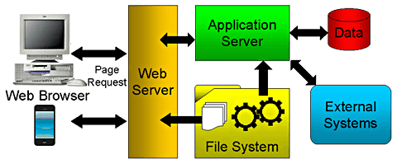

**6.2 Online Application Architecture**

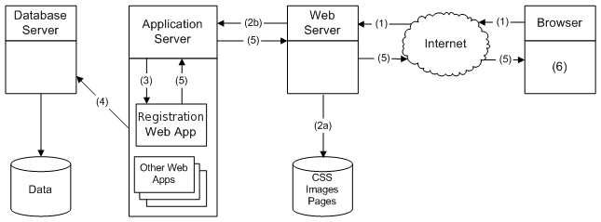

11

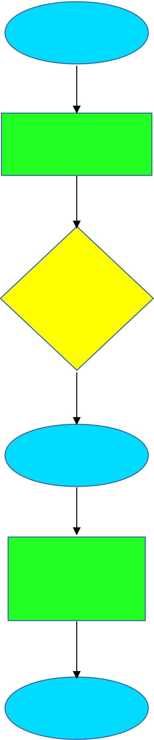

**7. System/ Process Flow Diagrams**

**7.1 Design Package Submission Flow**

Institutions

Design   
(ASIC/ SoC)

Design   
Submission   
Form

Chip Center

Fabrication   
&   
Packaging

MeitY

Resource Centres (RC) & Participating Institutions (PI)

Individual & System Project (Designed Product)

Institutions filling   
Design Submission Form & submits to   
The Chip Center

Chip Center fabricates the submitted Design & forwards to MeitY

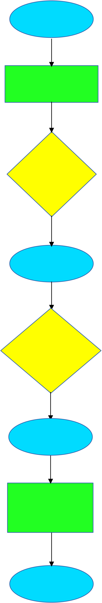

**7.2 India Chip Program**

Participants

Chip Design

Design   
Submission Form

MeitY

Designers from all over the country including   
individuals, educational   
institutions, organisations, etc.

Participants filling   
Design Submission   
Form

|  |  |
| --- | --- |
| Ten(10) Best  Designs | Ten best designs  selected by committee, formed by MeitY, and forwarded to Chip |

Center for fabrication

Chip Center

|  |  |
| --- | --- |
| Fabrication &  Packaging | Chip Center  fabricates  the provided |

Designs   
& forwards to MeitY

MeitY

13

**8. Schedule & Milestones**

**8.1 PERT Chart**

|  |  |  |  |  |  |  |
| --- | --- | --- | --- | --- | --- | --- |
| **Tasks Description** | **May-Jun 2017** | **Jul-Aug 2017** | **Sep-Oct 2017** | **Nov-Dec 2017** | **Jan-Dec 2018** | **Jan-Dec 2019** |
| Design the flow architecture & freeze the functionalities of the web Portal & Application. |  |  |  |  |  |  |
| UI Design & Development.  Database Design & Development. |  |  |  |  |  |  |
| Porting old necessary data.  Logic Development & Integration. |  |  |  |  |  |  |
| Security Audit & Testing.  Launch of newly developed portal |  |  |  |  |  |  |
| |  |  |  | | --- | --- | --- | | Maintenance, | Updation | & |   Upgradation. |  |  |  |  |  |  |
| |  |  |  | | --- | --- | --- | | Maintenance, | Updation | & |   Upgradation. |  |  |  |  |  |  |

14