Mongo DB Exercise 1

1) Create a Database called music.
use music
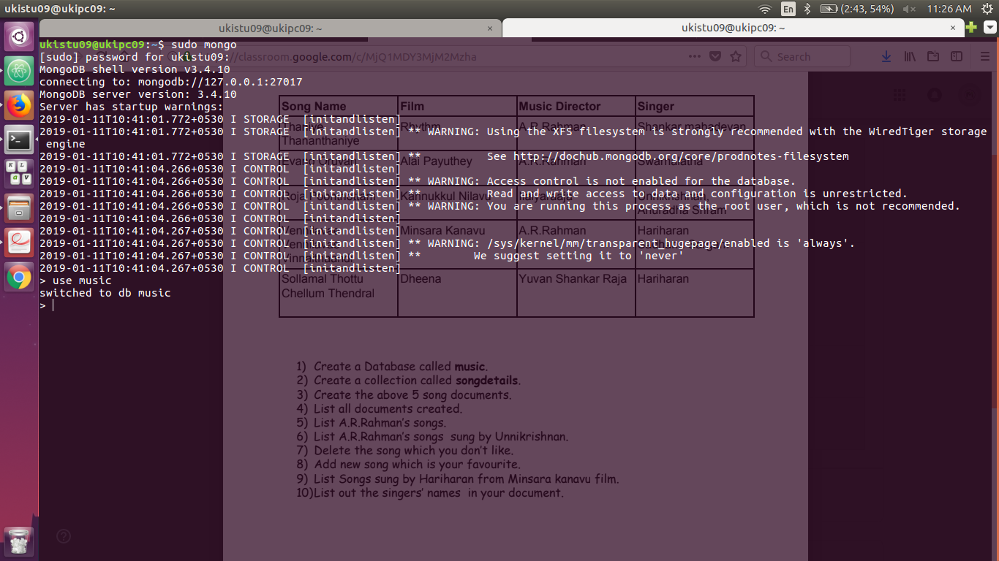

2) Create a collection called songdetails.
db.createCollection("Songdetails")
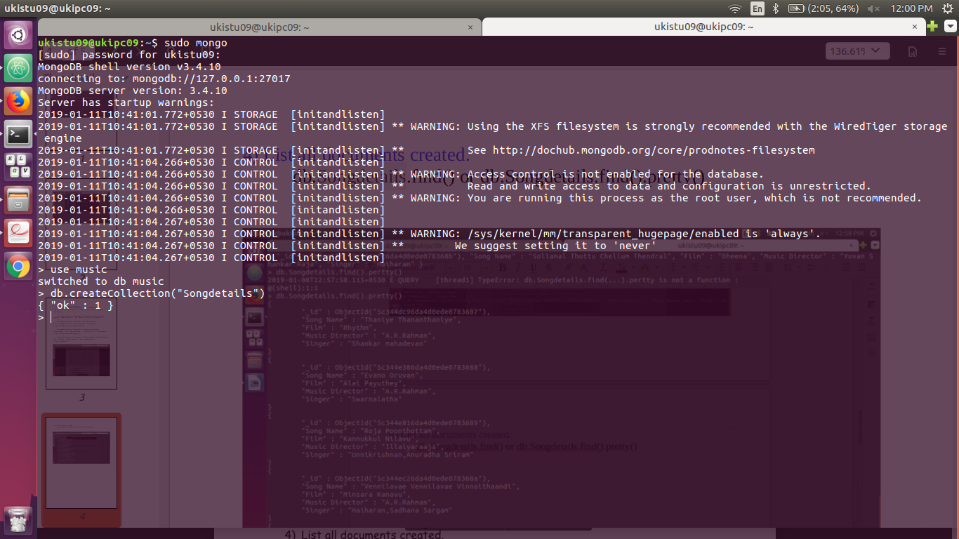
3) Create the above 5 song documents.
db.Songdetails.insert({"Song Name":"Thaniye Thananthaniye",
"Film":"Rhythm" , "Music Director" : "A.R.Rahman", "Singer":"Shankar
mahadevan"})
db.Songdetails.insert({"Song Name":"Evano Oruvan", "Film":"Alai
Payuthey" , "Music Director" : "A.R.Rahman", "Singer":"Swarnalatha"})
db.Songdetails.insert({"Song Name":"Roja Poonthottam",
"Film":"Kannukkul Nilavu" , "Music Director" : "Illaiyaraaja",
"Singer":"Unnikrishnan,Anuradha Sriram"})
db.Songdetails.insert({"Song Name":"Vennilavae Vennilavae
Vinnaithaandi", "Film":"Minsara Kanavu" , "Music Director" : "A.R.Rahman",
"Singer":"Hariharan,Sadhana Sargam"})
db.Songdetails.insert({"Song Name":"Sollamal Thottu Chellum Thendral",
"Film":"Dheena" , "Music Director" : "Yuvan Shankar Raja",
"Singer":"Hariharan"})

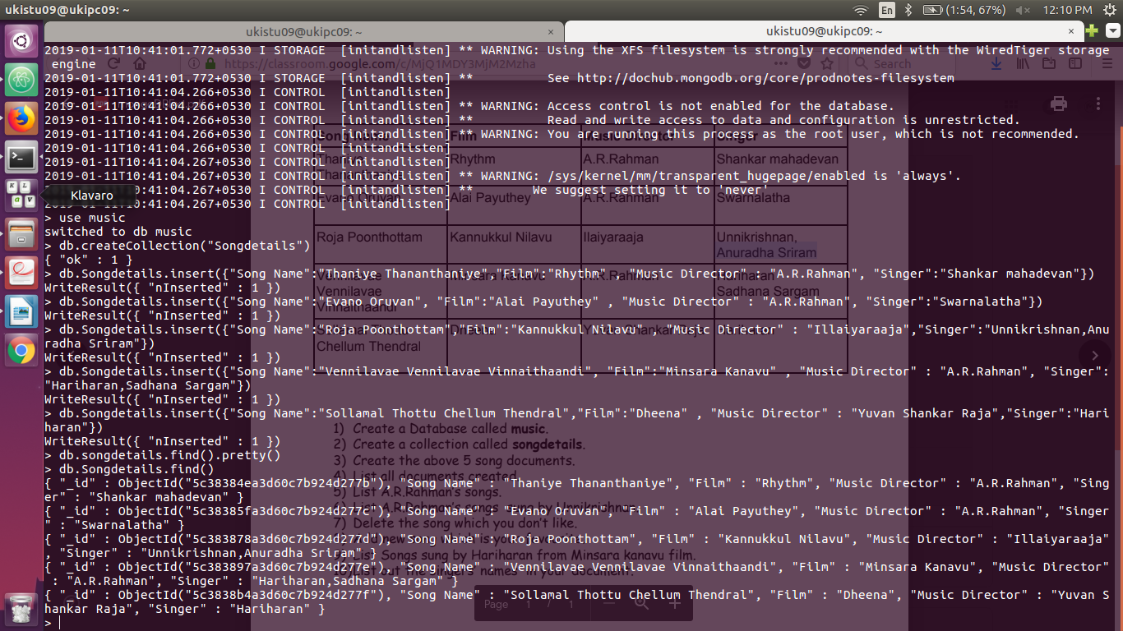
4) List all documents created.
db.Songdetails.find() or db.Songdetails.find().pretty()

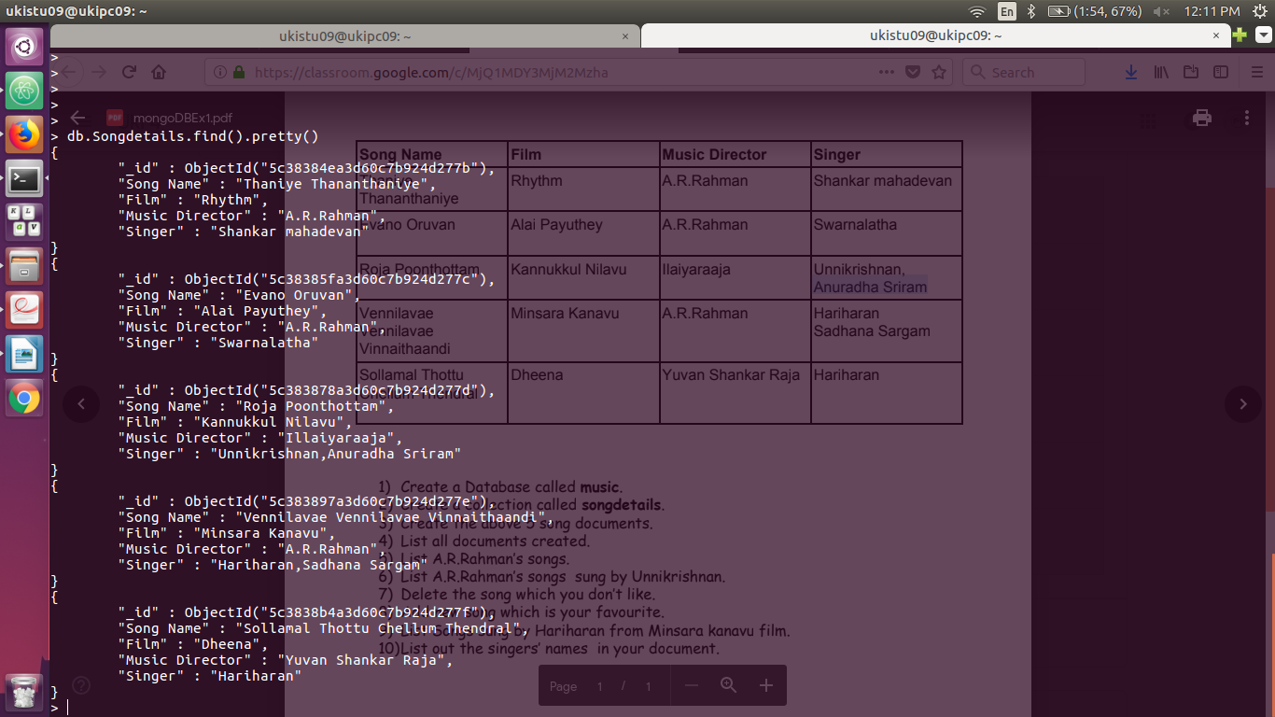
5) List A.R.Rahman’s songs.
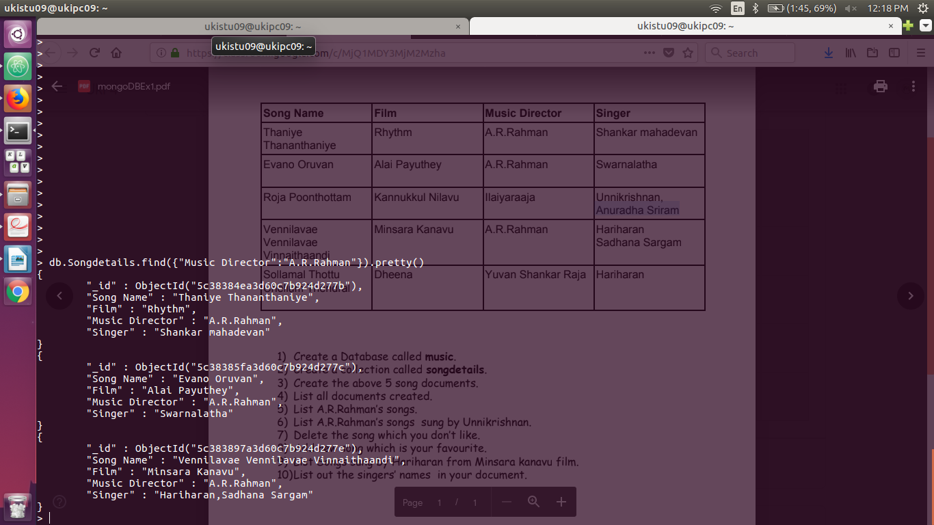
db.Songdetails.find({"Music Director":"A.R.Rahman"}).pretty()
6) List Illaiyaraaja’s songs sung by Unnikrishnan.
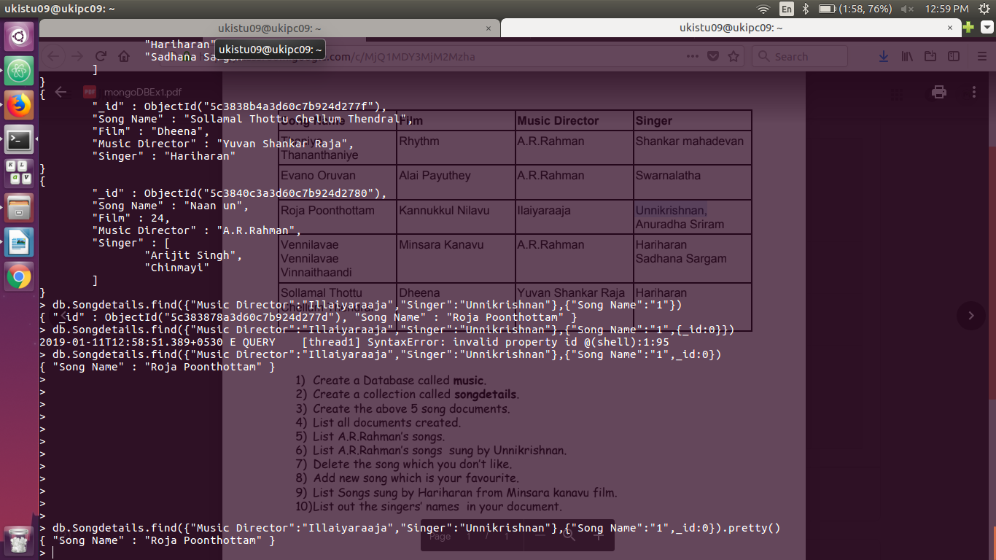
db.Songdetails.find({"Music Director":"Illaiyaraaja","Singer":"Unnikrishnan"},{"Song Name":"1",_id:0}).pretty()
7) Delete the song which you don’t like.
db.Songdetails.remove({"Film":"Alai Payuthey"})
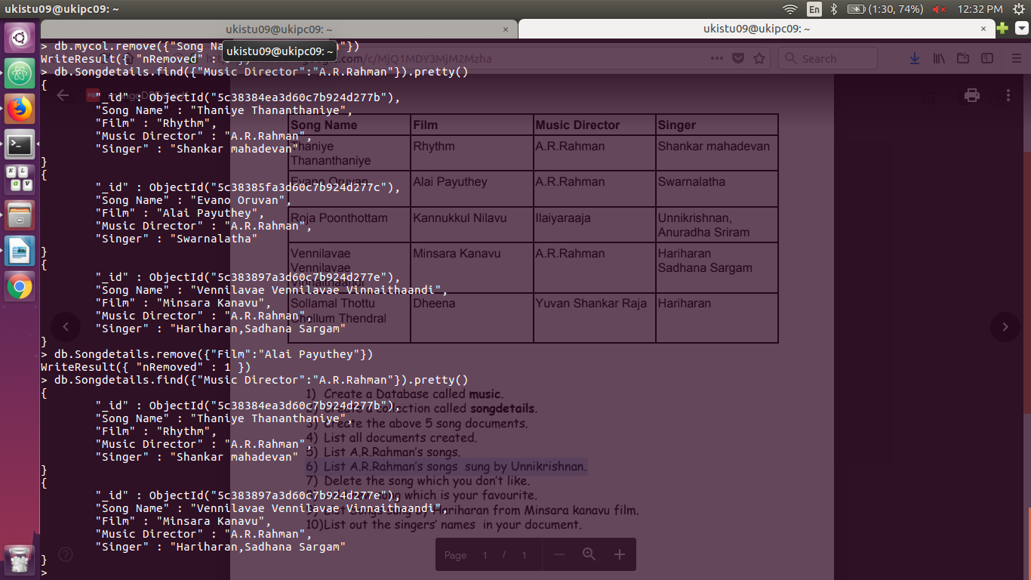
8) Add new song which is your favourite.
db.Songdetails.insert({"Song Name":"Naan un","Film":24 , "Music Director" : "A.R.Rahman", "Singer":"Arijit Singh,Chinmayi"})
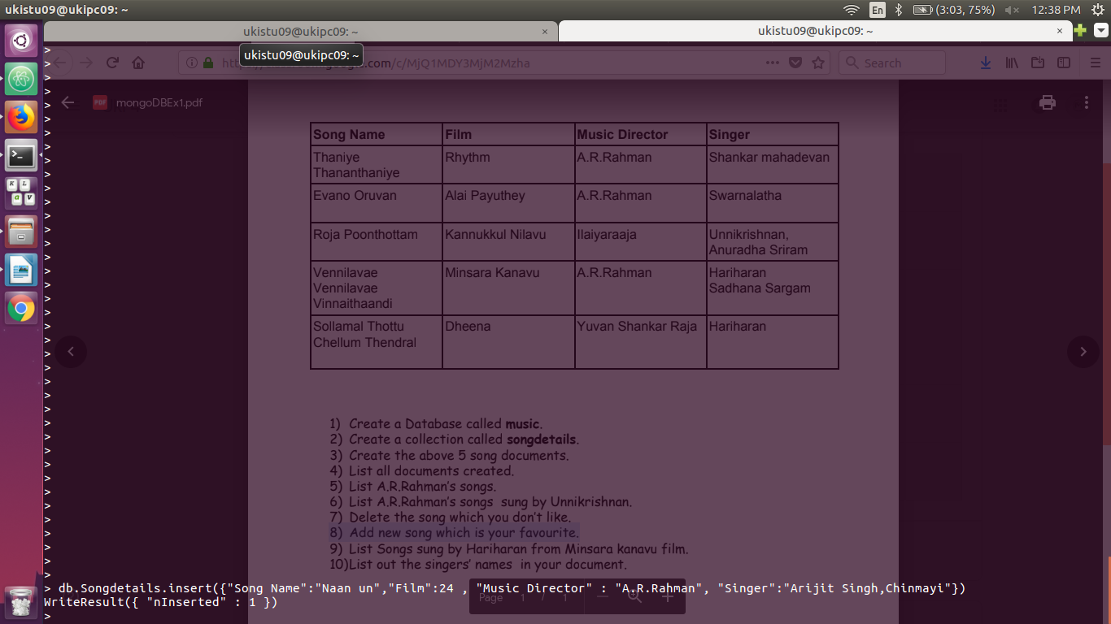
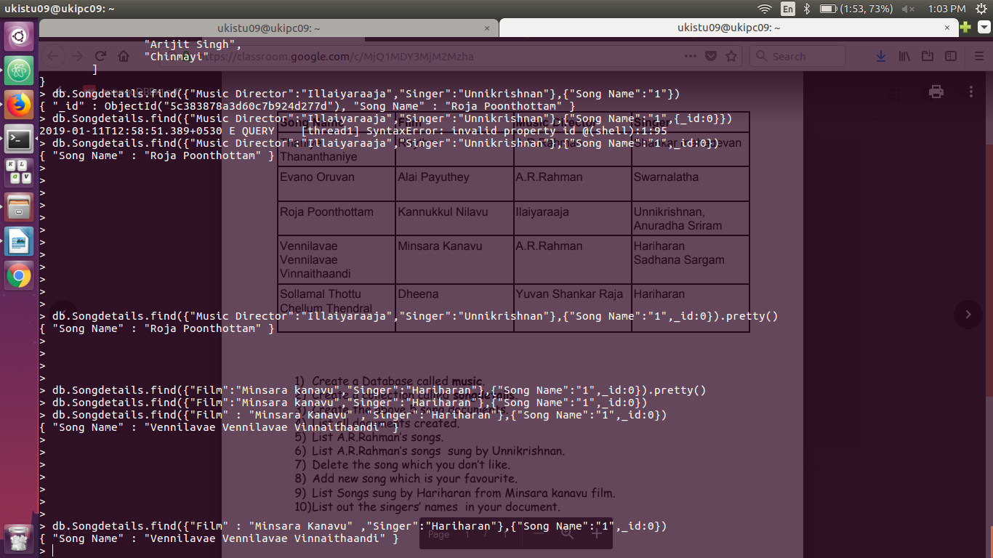
9) List Songs sung by Hariharan from Minsara kanavu film.
10)List out the singers’ names in your document.
db.Songdetails.find({},{"Singer":"1",_id:0}).pretty()

