MongoDB Exercise 2

1) Create a Database called student
use student
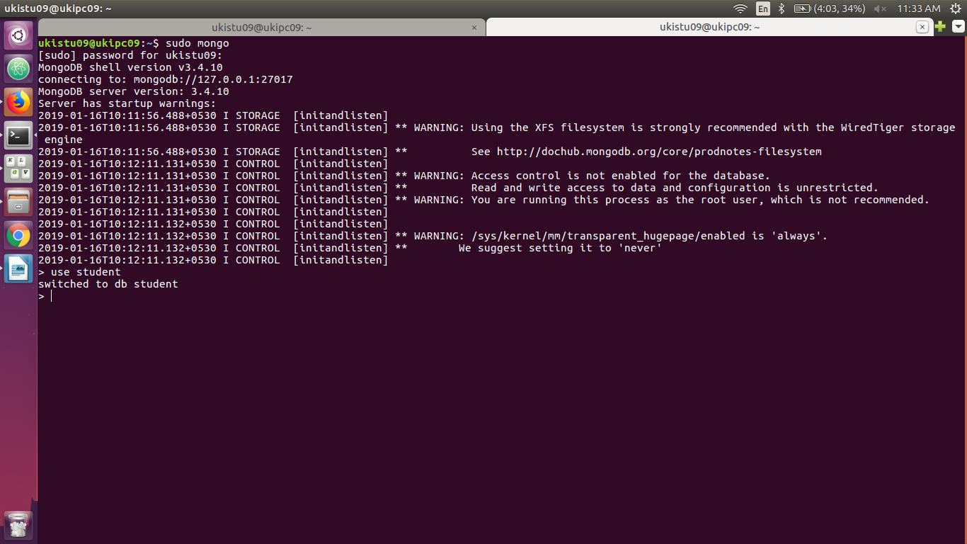

2) Create a collection called ​studentmarks
db.createCollection("studentmarks")
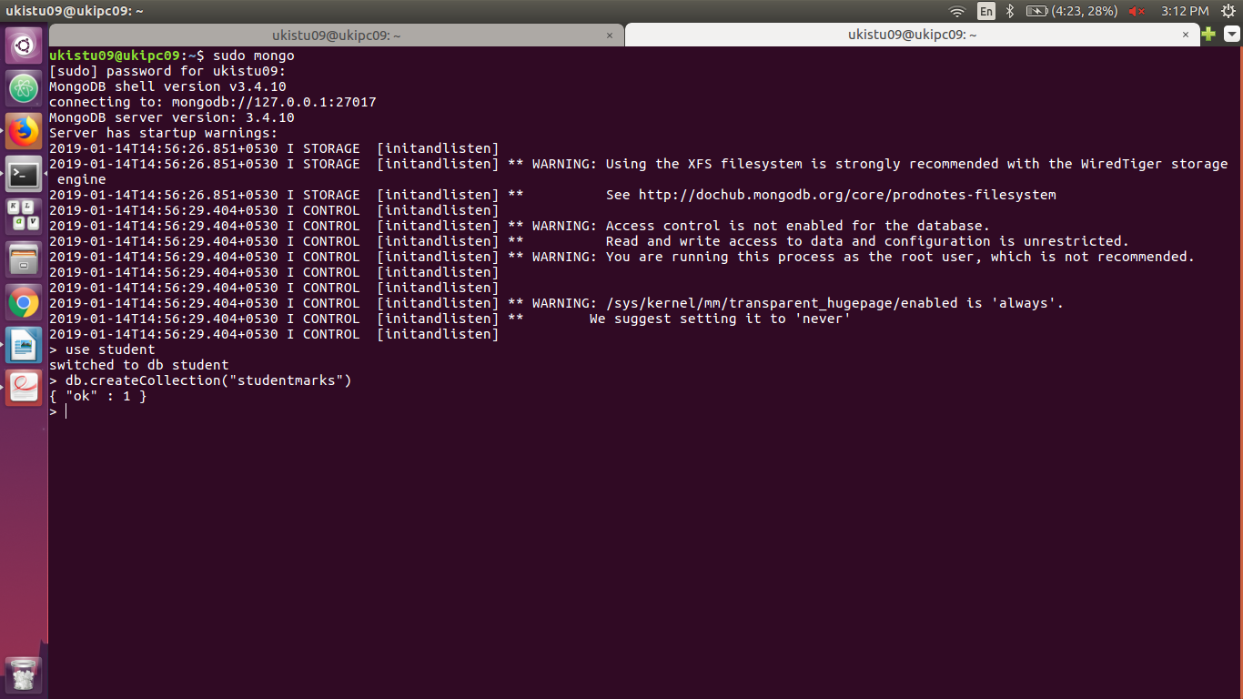

3) Create the documents listed in above table.
db.studentmarks.insert({name: "Mala",maths_marks:45,english_marks:53,science_marks:72})

db.studentmarks.insert({name: "Vanu", maths_marks:80,english_marks:75,science_marks:85})

db.studentmarks.insert({name: "Kala", maths_marks:32,english_marks:40,science_marks:53})

db.studentmarks.insert({name: "Aruli", maths_marks:78,english_marks:85,science_marks:80})

db.studentmarks.insert({name: "Shayu", maths_marks:80,english_marks:76,science_marks:65})

db.studentmarks.insert({name: "Kumaran", maths_marks:32,english_marks:73,science_marks:84})

db.studentmarks.insert({name: "Lucky", maths_marks:66,english_marks:90,science_marks:45})

db.studentmarks.insert({name: "Gva", maths_marks:71,english_marks:75,science_marks:56})

db.studentmarks.insert({name: "Raam", maths_marks:41,english_marks:65,science_marks:88})
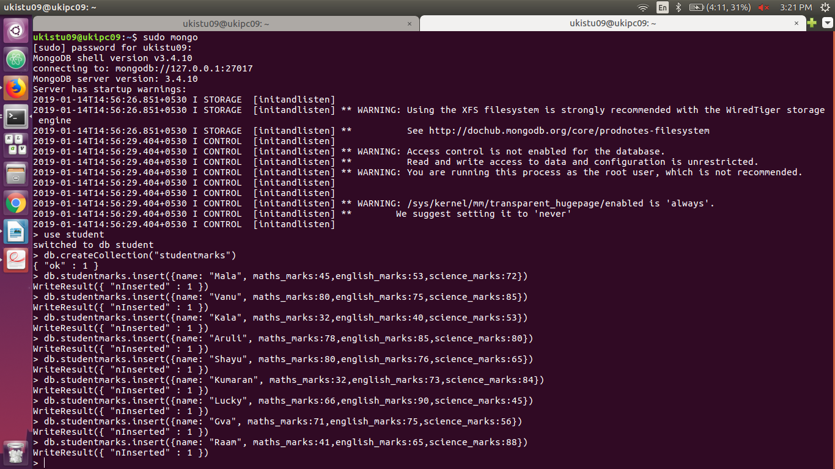

4) Increase the maths marks of Mala by 6 marks
db.studentmarks.update({name : "Mala"},{$inc:{maths_marks:6,}})
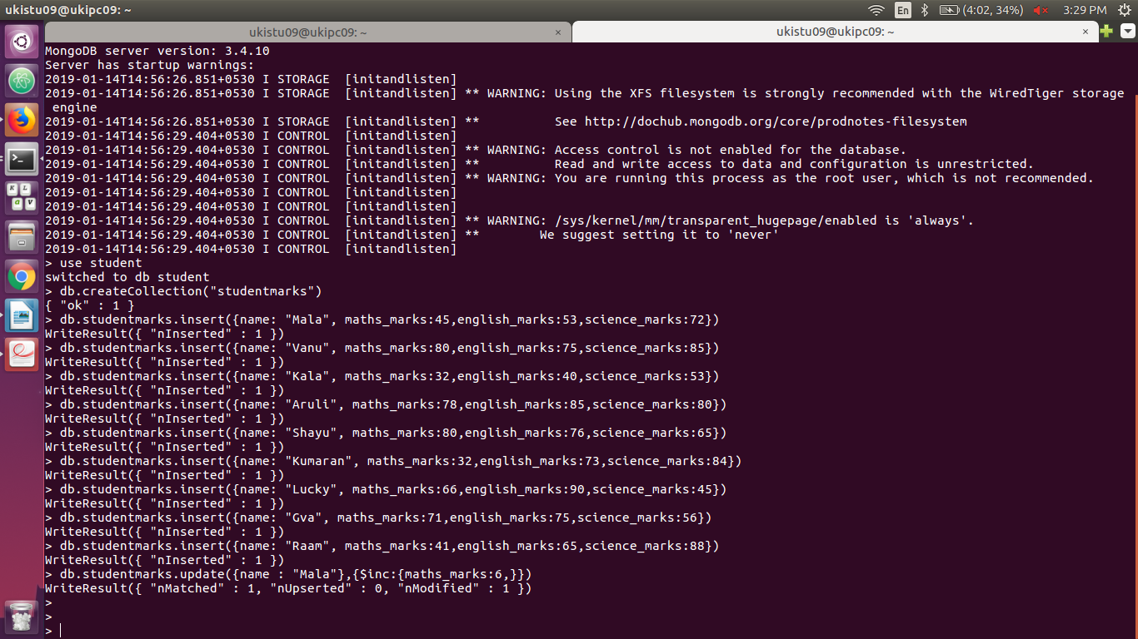

5) List the names of students who got more than 50 marks in Maths Subject.
db.studentmarks.find( { maths_marks: { $gt: 50 } } )
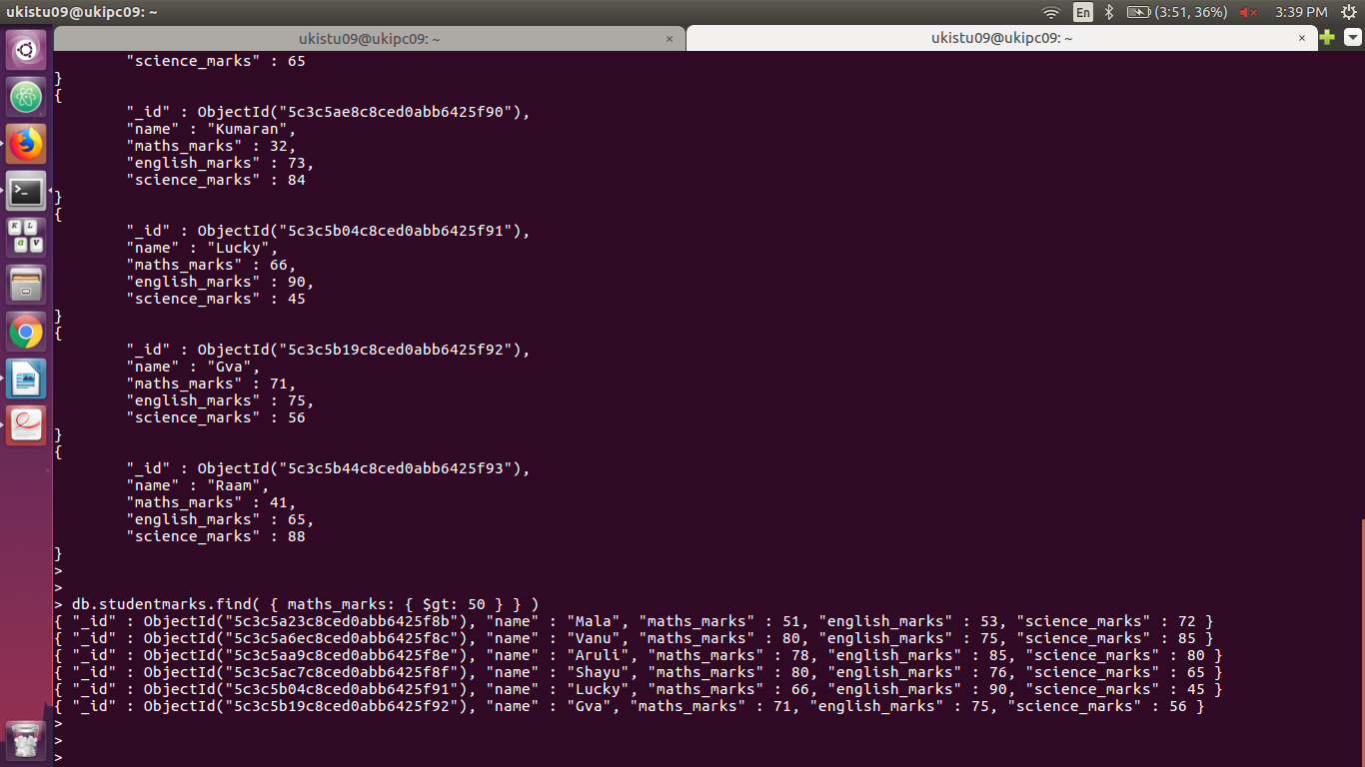

6)Add a new column(field) for Average for all students.
db.studentmarks.update({},{$set:{"Average":"null"}},{multi:true})
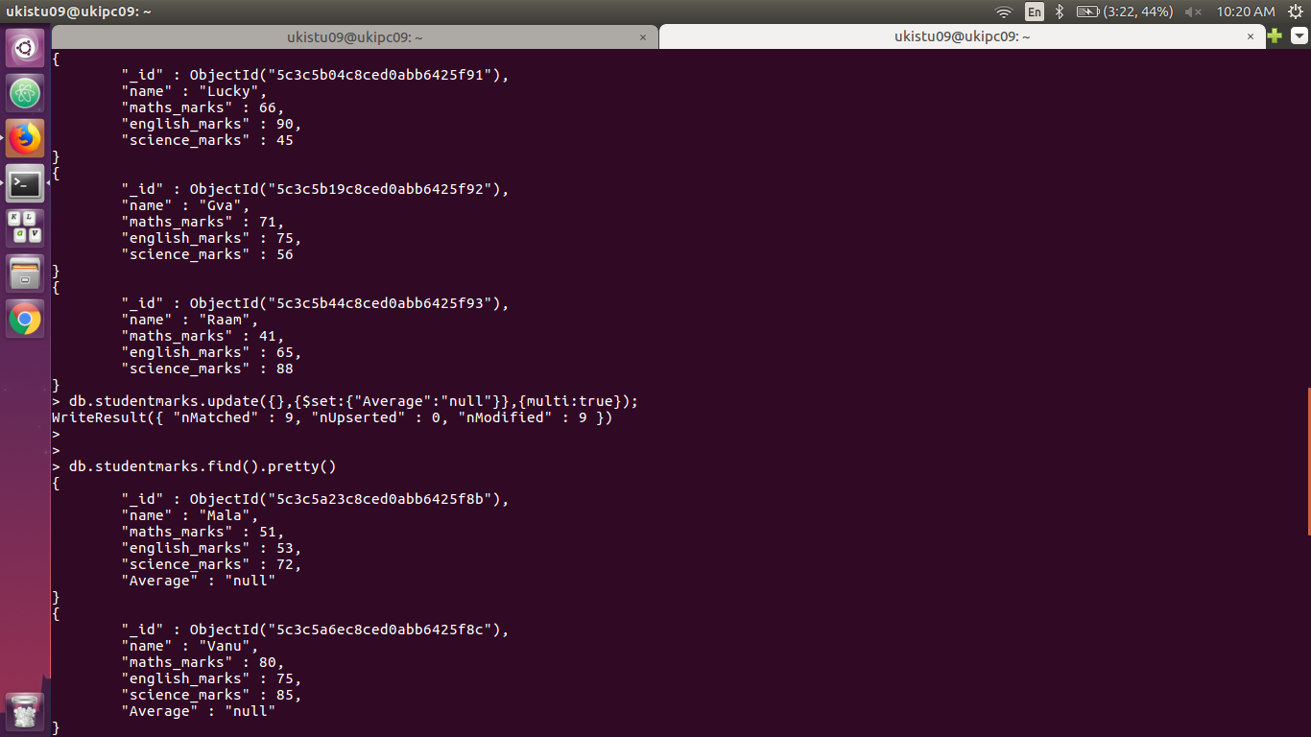

7) Update Marks_Science=75 to Lucky .
db.studentmarks.update({name:"Lucky"},{$set:{"science_marks":75}})

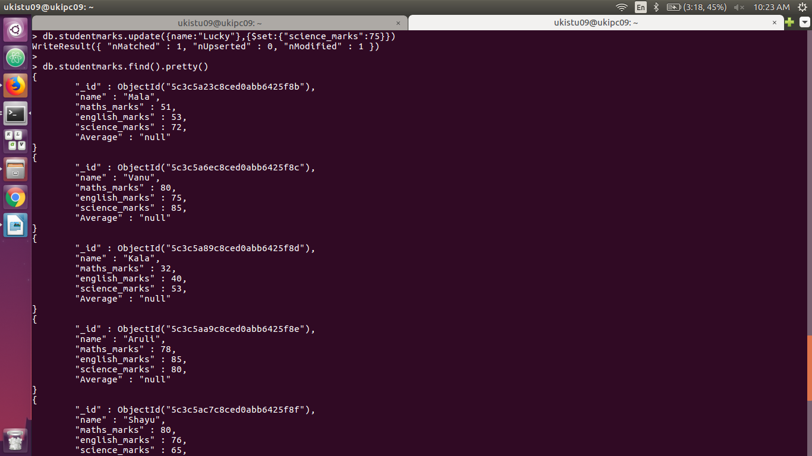

8) List the names who got more than 50 marks in all subjects.
db.studentmarks.find({$and:[{english_marks:{$gt:50}},{maths_marks:{$gt:50}},{science_marks:{$gt:50}}]},{name:1,_id:0})

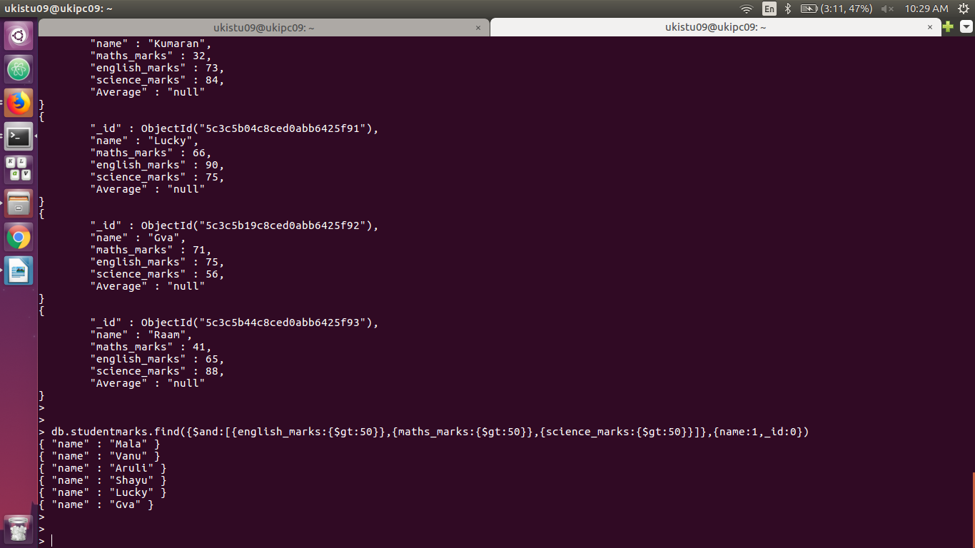

9) List the names who got less than 50 marks in Maths subject and more than 50 marks in English
db.studentmarks.find({$and:[{english_marks:{$gt:50}},{maths_marks:{$lt:50}},]},{name:1,_id:0})

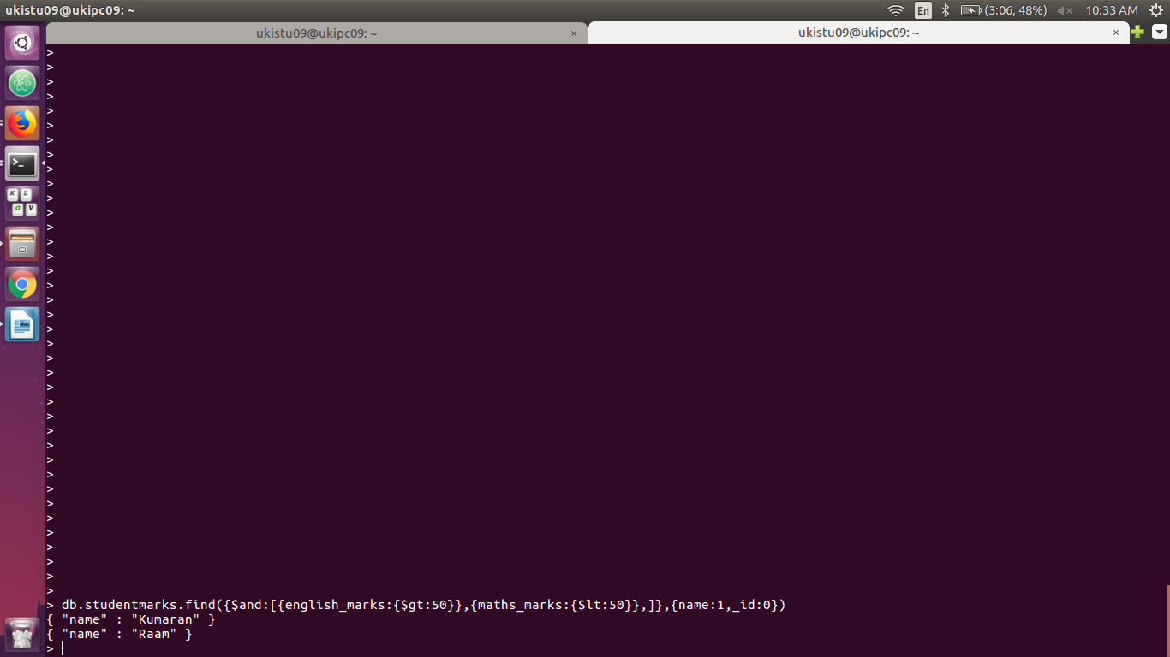

10) List the names who got less than 40 in both Maths and Science.
db.studentmarks.find({$and:[{science_marks:{$gt:40}},{maths_marks:{$lt:40}},]},{name:1,_id:0})
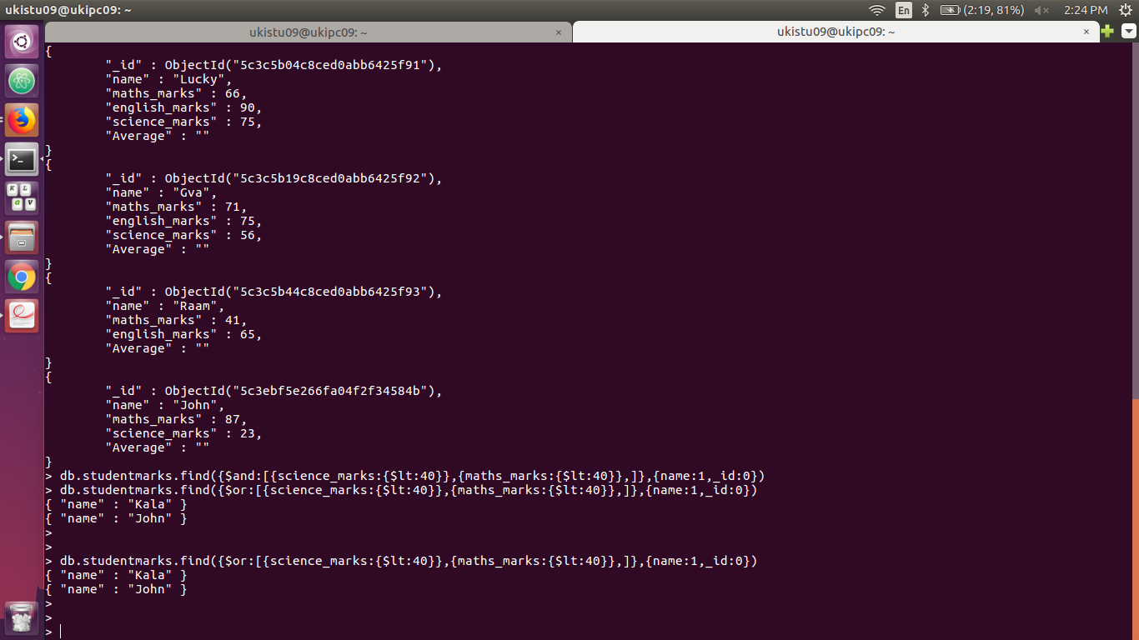

11) Remove Science column/field for Raam
db.studentmarks.update({name:"Raam"},{$unset:{science_marks:88}})
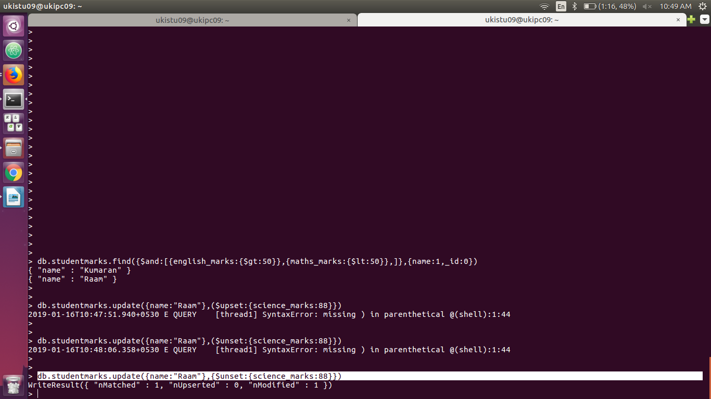

12) Update John’s Math mark as 87 and English mark as 23, if john not available upsert.
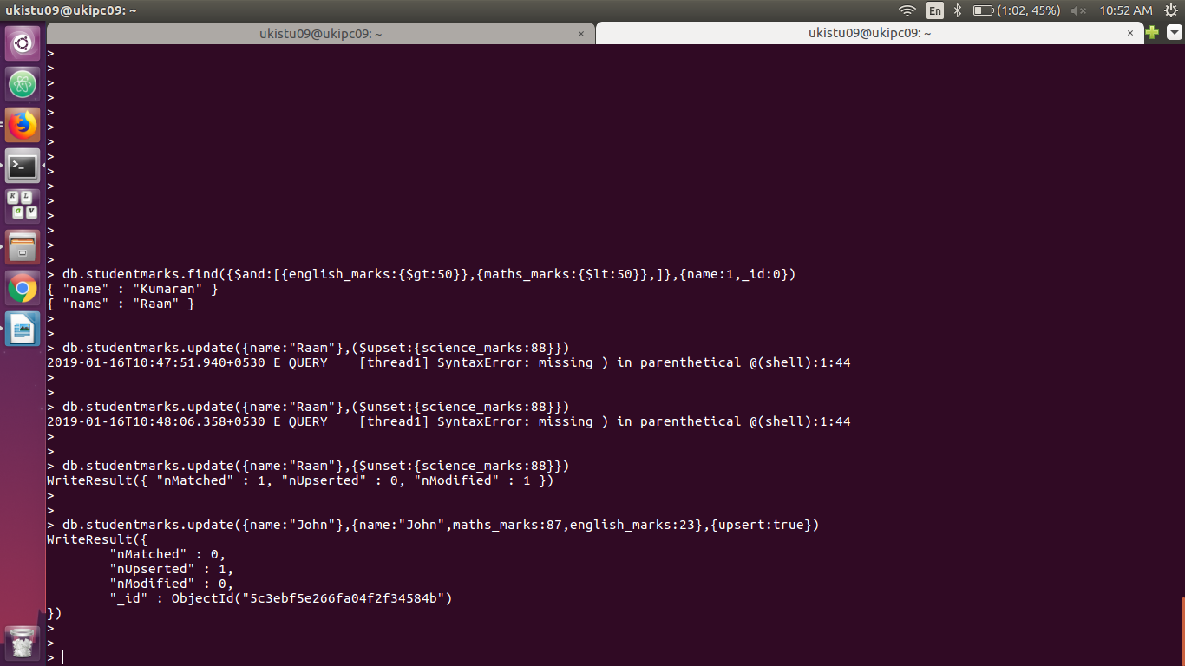
db.studentmarks.update({name:"John"},{name:"John",maths_marks:87,english_marks:23},{upsert:true})

13) Rename the english_marks column/field for John to science_marks
db.studentmarks.update({name:"John"},{$rename:{english_marks:"science_marks"}})
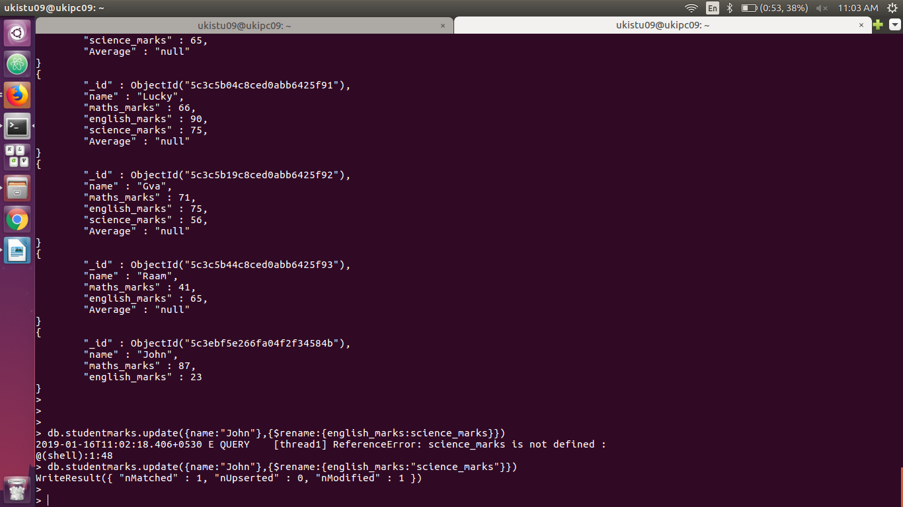

14) Remove Kumaran’s document from collection
db.studentmarks.remove({name:"Kumaran"})
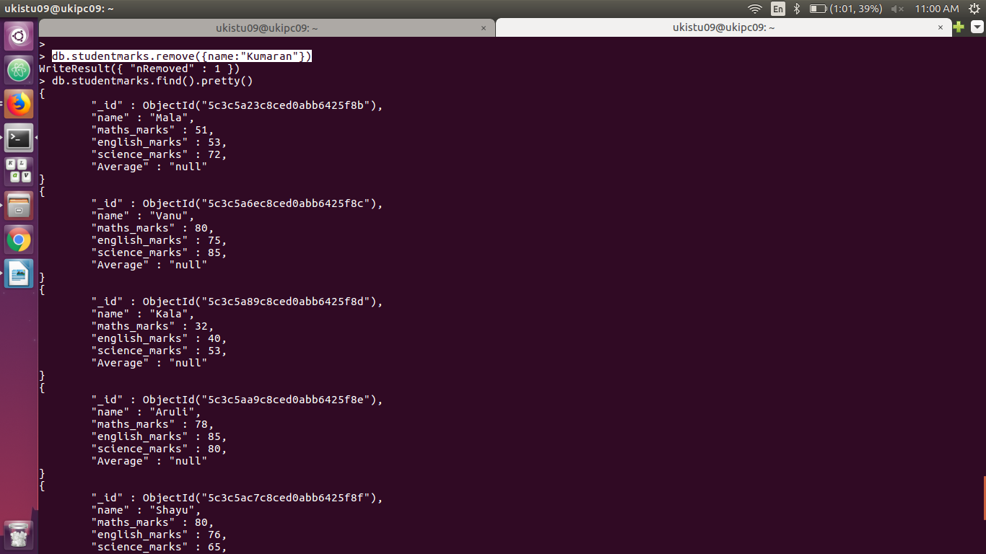

15) Find Kala’s or Aruli’s math_marks and science_marks
db.studentmarks.find({name:"Aruli"},{maths_marks:1,science_marks:1,_id:0})
