Home Workout Search Trends
India · Google Trends data · May 25 – Aug 25, 2026

1. Summary Table
All target queries confirmed against the uploaded CSV exports, with their exact search interest index, growth percentage, and the source report they came from.
Query | Search Interest (Index) | Increase % | Source Report
home workout without equipment | 62 | +250% | top-searches_1614
easy workout at home | 8 | +200% | top-searches_1614
online workout classes | 32 | +80% | top-searches_1615
home workout for women | 100 | +20% | top-searches_1617 / rising_1617
home workout for men | 100 | +10% | top-searches_1617__1 / rising_1617__1
home workout routine for men | 4 | Breakout | top-searches_1617__1 / rising_1617__1
full body workout at home | 7 | +160% | top-searches_1617__1 / rising_1617__1
chest workout | 11 | +160% | top-searches_1615
leg workout at home | 6 | -10% | top-searches_1658 (general)
abs workout at home | 9 | +3% | top-searches_1658 (general)

2. Search Interest — Snapshot Comparison
Index values (0-100) for each target query at the time each report was pulled. Values are only comparable within the same report/seed keyword, not across different reports.
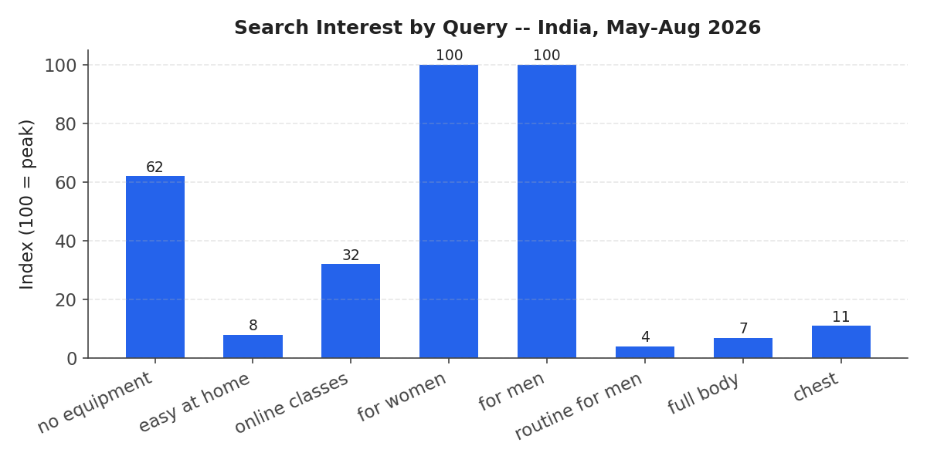

3. Growth % — Snapshot Comparison
"home workout routine for men" is excluded from this chart because Google Trends labels it "Breakout" — a non-numeric flag meaning growth too large to express as a percentage (typically 5,000%+), not zero or missing data.
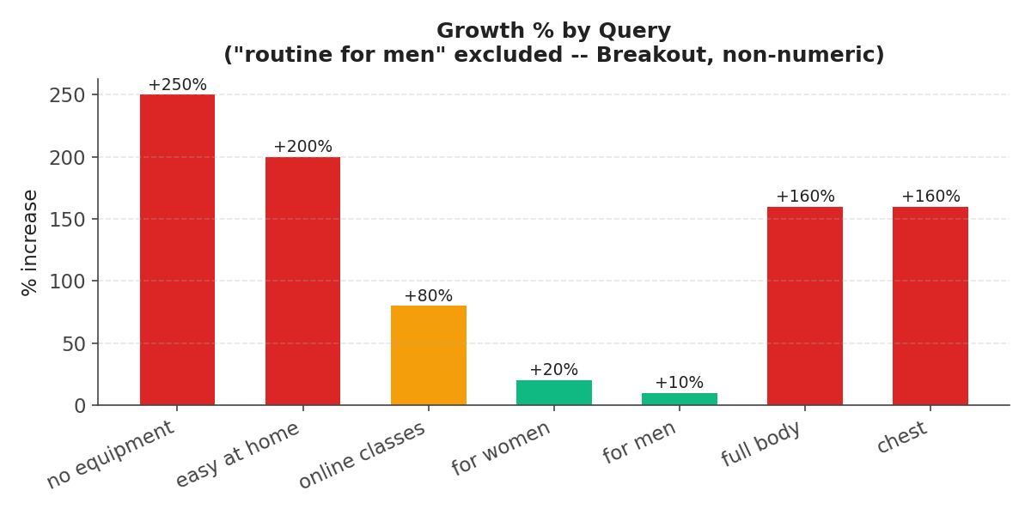

4. Body-Part Home Workouts — Growth %
Only "full body workout at home" actually reaches +160%. Leg, abs, and chest variants move in a much narrower band (roughly -10% to +3%) across the reports checked — they do not share the same growth spike.
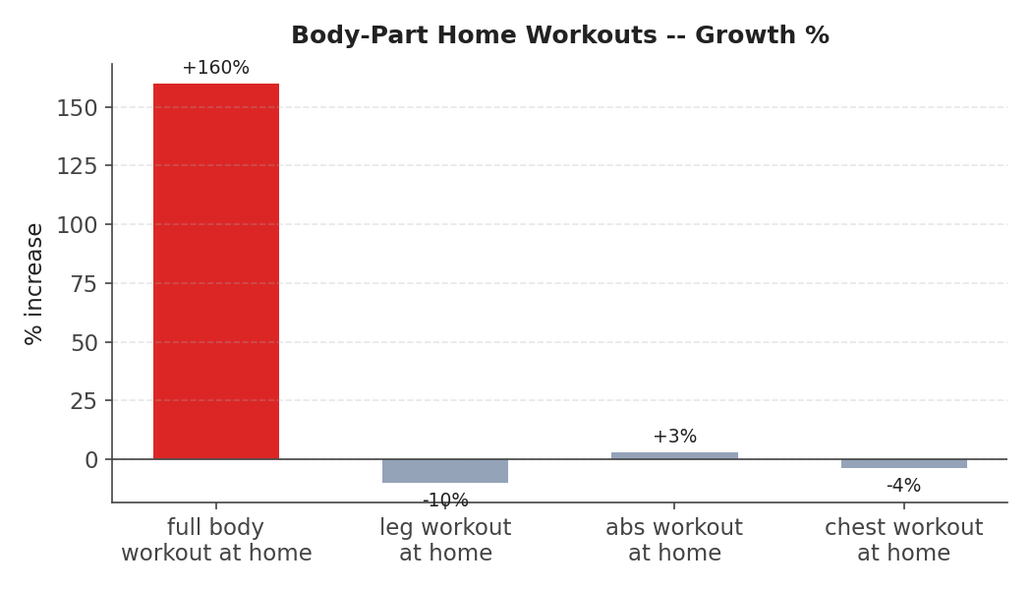

5. Daily Trend Lines (Parent Seed Keywords)
Google Trends only publishes a full daily time series for the seed keyword of each report — not for every related query listed under it. The four charts below show the actual day-by-day interest for the seed keywords that produced the numbers above.

5.1 "home workout" — parent of +250% and +200% queries
Covers "home workout without equipment" (+250%) and "easy workout at home" (+200%). This trend peaked at 100 on Aug 3, 2026 — the period driving both growth figures.
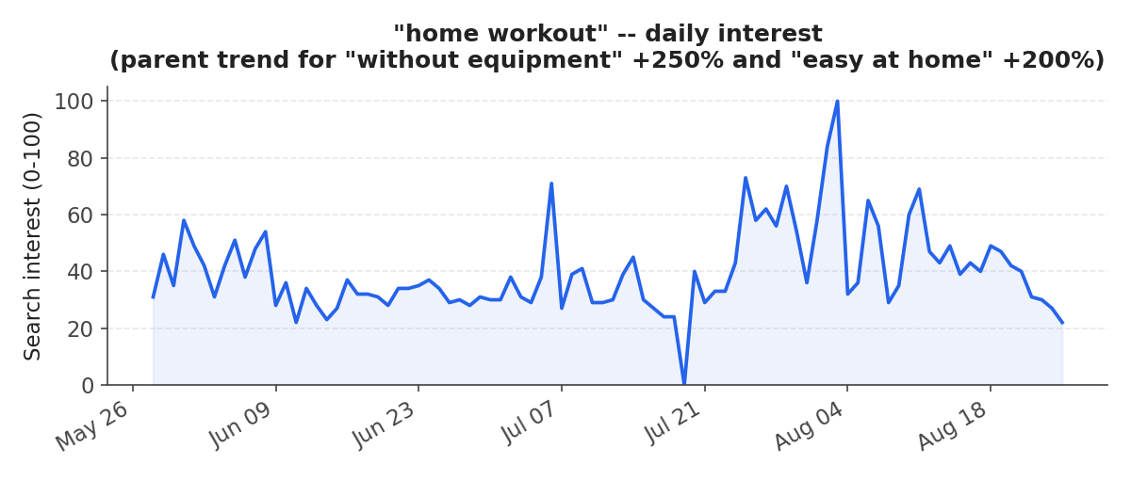

5.2 "online workout" — parent of +80% query
Covers "online workout classes" (+80%). Highly sporadic — long stretches at zero, a single peak of 100 on Jul 6, then a small tail in mid-August (11-15 range).
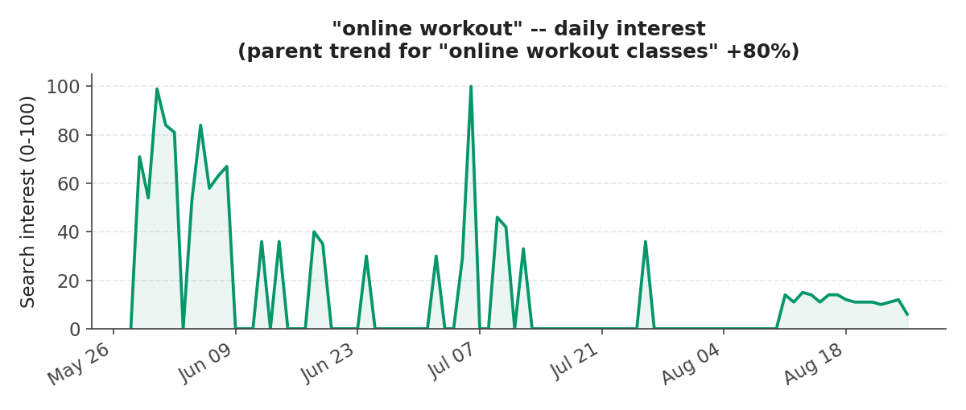

5.3 "home workout women" — parent of "home workout for women" (Index 100, +20%)
Registered activity on only one day across the entire 3-month window (Jun 2, value 100) — flat at zero every other day. The +20% figure rests on a single-day spike, not a sustained trend.
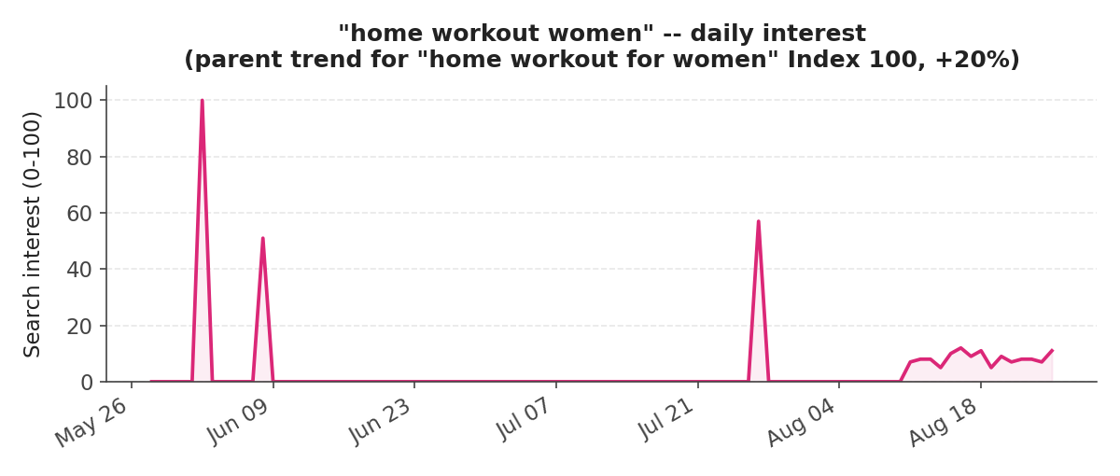

5.4 "home workout men" — parent of Index 100 / Breakout / +160% queries
Covers "home workout for men" (Index 100), "home workout routine for men" (Breakout), and "full body workout at home" (+160%) — all three trace back to a single-day spike on May 31 (value 100), flat everywhere else.
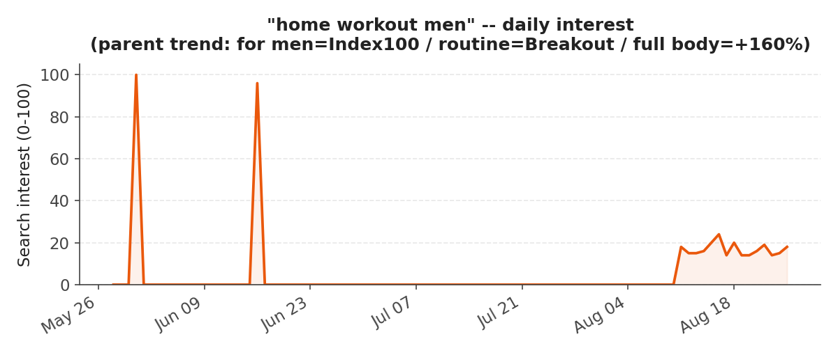

6. Key Caveats
- Percentages computed from near-zero baselines (single-day spikes) produce dramatic-looking numbers like +160%, +200%, +250%, and "Breakout" — these reflect a thin, spiky search pattern rather than steady sustained demand.
- "Home workout for women" and the men's-report queries are each driven by a single day of measurable search interest in an otherwise flat 90-day window.
- Leg, abs, and chest home-workout searches do not share the +160% spike seen in "full body workout at home" — treat body-part queries as distinct search patterns, not a uniform category.
- Figures should be read as directional signals from a short 3-month India-only sample, not as forecasts of durable search volume.

