
Smart Mirror Integrated Marketing Campaign
"Fitness That Meets You Where You Are"
Prepared by: Srimoyee Roy Chowdhury
Assignment Context
You're joining the marketing team of a growing lifestyle brand preparing to launch its newest product: a sleek, interactive, at-home fitness device designed for users who crave flexibility, motivation, and connection, all from their living room. The mission: develop an integrated marketing strategy that introduces the product while championing the brand's values of community, inclusivity, and wellness.
Product concept: a wall-mounted smart mirror with a built-in screen, camera, and speaker system that streams live and on-demand fitness classes, connects users to instructors and peers, tracks progress, and offers personalised encouragement. The bigger picture: the brand uses its platform to spark dialogue around mental well-being, representation in wellness spaces, and accessible fitness for all communities, going beyond selling a product to inspire action, foster inclusivity, and build trust.
Document Generation Note
This Creative Brief was developed through a structured, multi-stage research process. All recommendations are derived from:
- Original handwritten ICP and lifestyle notes
- Synthesis of three customer personas
- Competitor website, Instagram, and positioning analysis (Tonal, Peloton, Shen AI, Portl, Aroleap X, Flexnest)
- Google Trends data for India (May–August 2026)
- Instagram content audits and real-user examples
- Meta Ads Library references (used for competitive creative patterns)
- YouTube search behaviour and creator format analysis
- Product launch timeline benchmarks from similar connected-fitness brands
No assumptions were made outside the collected research materials.

1. Project Title
Smart Mirror Launch - Integrated Marketing Campaign
Working title: "Fitness That Meets You Where You Are"

2. Objective
Introduce a wall-mounted smart fitness mirror that streams live and on-demand classes with personalised encouragement and community connection, while positioning the brand around the core values of community, inclusivity, and wellness.
Primary goals:
- Build awareness of a category-defining at-home fitness product
- Foster authentic emotional connection and a sense of belonging
- Drive free-trial sign-ups and product sales
- Champion mental well-being, representation, and accessible fitness for diverse audiences

3. Target Audience
How the target audience and personas were created
The audience was built directly from the original handwritten research notes, which detailed:
- Age range 28–45
- Demanding careers and limited time
- Goals around weight management, strength, energy, stress reduction, and better sleep
- Pain points including fear of failure, difficulty maintaining routines, and budget sensitivity
- Strong preference for at-home, flexible fitness
- Heavy use of Instagram for health/wellness content and YouTube for longer workouts
- Values centred on mental well-being, authenticity, work-life balance, and sustainability
These notes were synthesised into three distinct but overlapping Ideal Customer Personas:
Ideal Customer Personas
Priya Sharma (32–38) - The Busy Professional Seeking Balance
- Occupation: Mid-to-senior level professional in a demanding career (corporate, tech, or consulting)
- Location: Urban / suburban
- Goals: Lose 5–10 kg, build lower-body and core strength, have more daily energy
- Challenges: Hectic work schedule, limited time for workouts, difficulty sticking to routines
- Pain Points: Fear of failing or of new workouts not working, limited disposable cash
- Values & Motivations: Mental well-being, work-life balance, authenticity, sustainability
- Lifestyle: Prefers at-home workouts (yoga, Pilates), balanced meals, occasional outdoor walks
- Media Habits: Heavy on Instagram and YouTube for health content
- Buyer Journey Stage: Mostly "Getting Ready" to "Action"
Alex Rivera (28–35) - The Health Enthusiast / Early Adopter
- Occupation: Creative or knowledge worker who prioritises wellness trends
- Goals: Prevent future health issues, boost long-term vitality, stay ahead of wellness trends
- Challenges: Wants variety so routines don't get boring, needs credible proof that a product works
- Pain Points: Fear that a new device won't deliver results, desire for social interaction and motivation
- Values & Motivations: Sustainability, authenticity, mental well-being
- Lifestyle: Active with online workouts + nutrition-focused meal prep, spends time outdoors
- Media Habits: Instagram, YouTube, health podcasts
- Buyer Journey Stage: "Action" / early adopter
Jordan Lee (35–45) - The Relief Seeker / Post-Burnout Rebuilder
- Occupation: High-pressure role that has led to exhaustion
- Goals: Reduce stress, improve sleep, regain energy and mental well-being, rebuild a sustainable fitness habit
- Challenges: Hectic schedule + limited time, difficulty sticking to routines long-term
- Pain Points: Exhaustion from poor sleep, fear of failing, not much extra cash, missed social connection
- Values & Motivations: Mental well-being, work-life balance, authenticity, supportive (not punishing) solutions
- Lifestyle: Prefers flexible at-home options (yoga, Pilates, short workouts)
- Media Habits: Instagram health content, YouTube workouts
- Buyer Journey Stage: "Not Ready" to "Getting Ready"; needs reassurance and low-pressure entry points
Collectively, these personas form the core target audience: urban and suburban adults aged 28–45 seeking flexible, inclusive, supportive fitness experiences that fit real life.

4. Key Message
Core Message
"Fitness that meets you where you are, in your living room, on your terms, and as part of a real, inclusive community. Because wellness should feel supportive, not competitive or clinical."
How this message was developed
The message was refined after analysing competitor positioning. Most competitors emphasise either pure performance and strength (Tonal, Aroleap), high-energy social competition (Peloton), or clinical health metrics (Shen AI). The white space identified was a supportive, inclusive, lifestyle-oriented brand that prioritises belonging, mental wellness, and real-life flexibility.
Product Value
A sleek wall-mounted smart mirror that streams live and on-demand fitness classes with built-in camera, screen, and speakers. It delivers personalised encouragement, real-time progress tracking, and a flexible at-home experience that fits into demanding schedules, turning the living room into a supportive space for consistent mental and physical health.
Brand Value
We exist to foster community, inclusivity, and genuine belonging in wellness. Through authentic storytelling, representation, and access, we build trust and emotional connection. We spark meaningful dialogue around mental well-being while helping every user feel supported, respected, and part of a shared journey.
Positioning
Positioning Statement (research-derived):
For busy professionals and wellness-seekers aged 28–45 who want flexible, at-home fitness without intimidation or high-pressure environments, the Smart Mirror is the inclusive lifestyle fitness solution that brings live and on-demand classes, personalised encouragement, and real community into the living room, unlike performance-focused systems (Tonal, Aroleap), high-energy competitive platforms (Peloton), or clinically oriented health devices (Shen AI).
Key differentiators that shaped this positioning:
- Supportive and encouraging rather than competitive or punishing
- Inclusive and representative rather than elite or performance-only
- Lifestyle and belonging-focused rather than purely clinical or metric-driven
- Flexible and accessible for real living rooms and real schedules
This positioning was refined after analysing Tonal, Peloton, Shen AI, Portl, Aroleap X, and Flexnest, identifying clear white space in the supportive, inclusive, community-driven segment of the connected fitness market.

5. Competitor Analysis
Competitors researched
Global: Tonal, Peloton, Shen AI Smart Mirror
Indian: Portl (Studio + UltraGym), Aroleap X, Flexnest
Research materials used
- Official brand websites and product pages
- Instagram content and visual style
- Meta Ads Library creative patterns (referenced for messaging and visual approaches)
- YouTube content strategy
- Public mission and positioning statements
- Google Trends demand signals
Summary of key findings
Competitor | Primary Positioning | Content Style | Opportunity for Our Brand
Tonal | Premium strength & digital resistance | High-performance, tech-focused | Feels intimidating for recovery/beginner users
Peloton | Instructor-led community & culture | High-energy, charismatic, music-driven | Strong belonging but competitive tone
Shen AI | Clinical health metrics & vitals | B2B / diagnostic focus | Lacks lifestyle warmth and fitness community
Portl | AI smart mirror + lifestyle aesthetic | Living-room integration, influencer-led | Performance/HIIT leaning
Aroleap X | Smart home gym, digital weights | Engineering & strength authority | Highly masculine and strength-only
Flexnest | Connected cardio + app | Convenience and entertainment | Fragmented product experience

This analysis confirmed the strategic opportunity to lead with supportive belonging, inclusivity, and mental + physical wellness.
Visual Research: Competitor & Market Screenshots
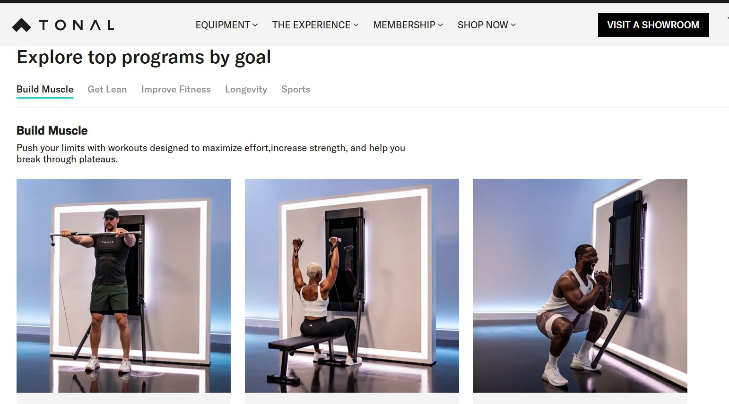
Tonal - premium strength & digital resistance. High-performance, tech-focused visuals that can feel intimidating for beginner or recovery-focused users.
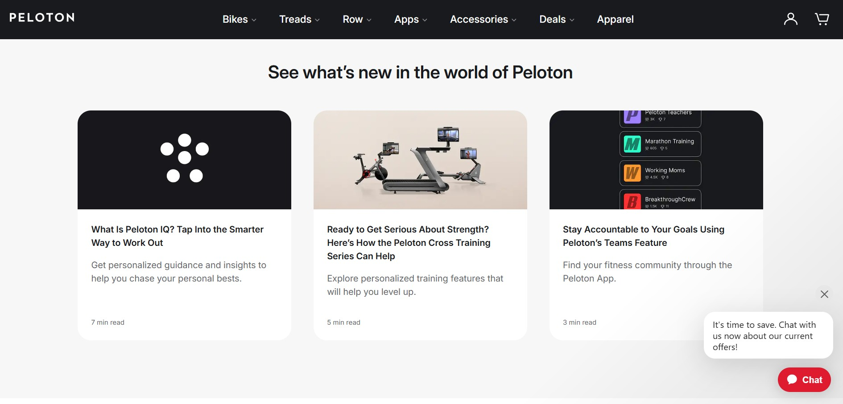
Peloton - instructor-led community culture. High-energy, charismatic tone with strong belonging cues, but a competitive edge throughout.
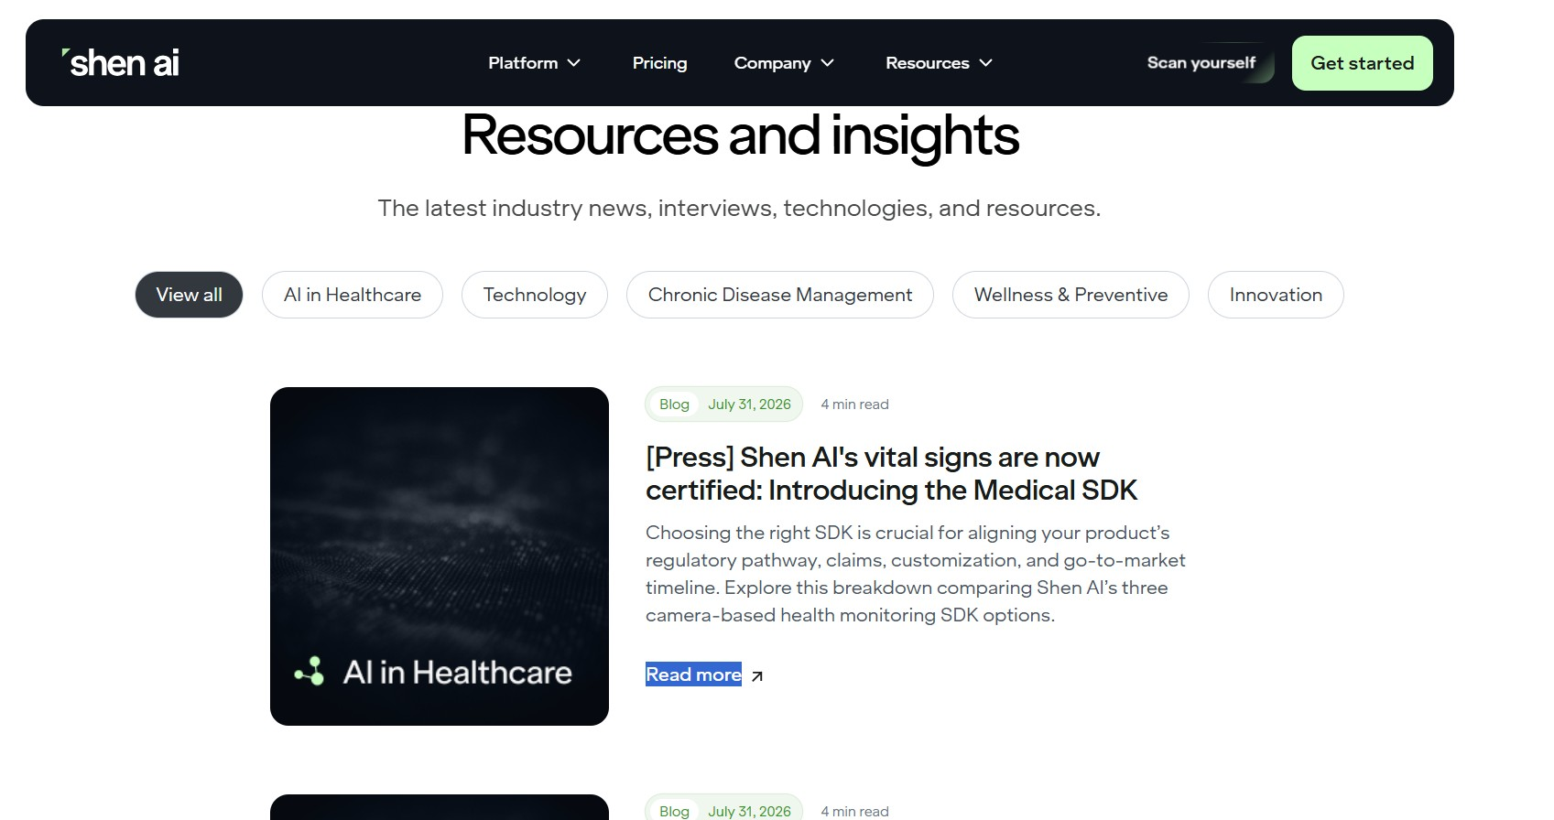
Shen AI - clinical, diagnostic health-metrics positioning (B2B-leaning resources hub). Credible but lacks lifestyle warmth or a fitness community feel.
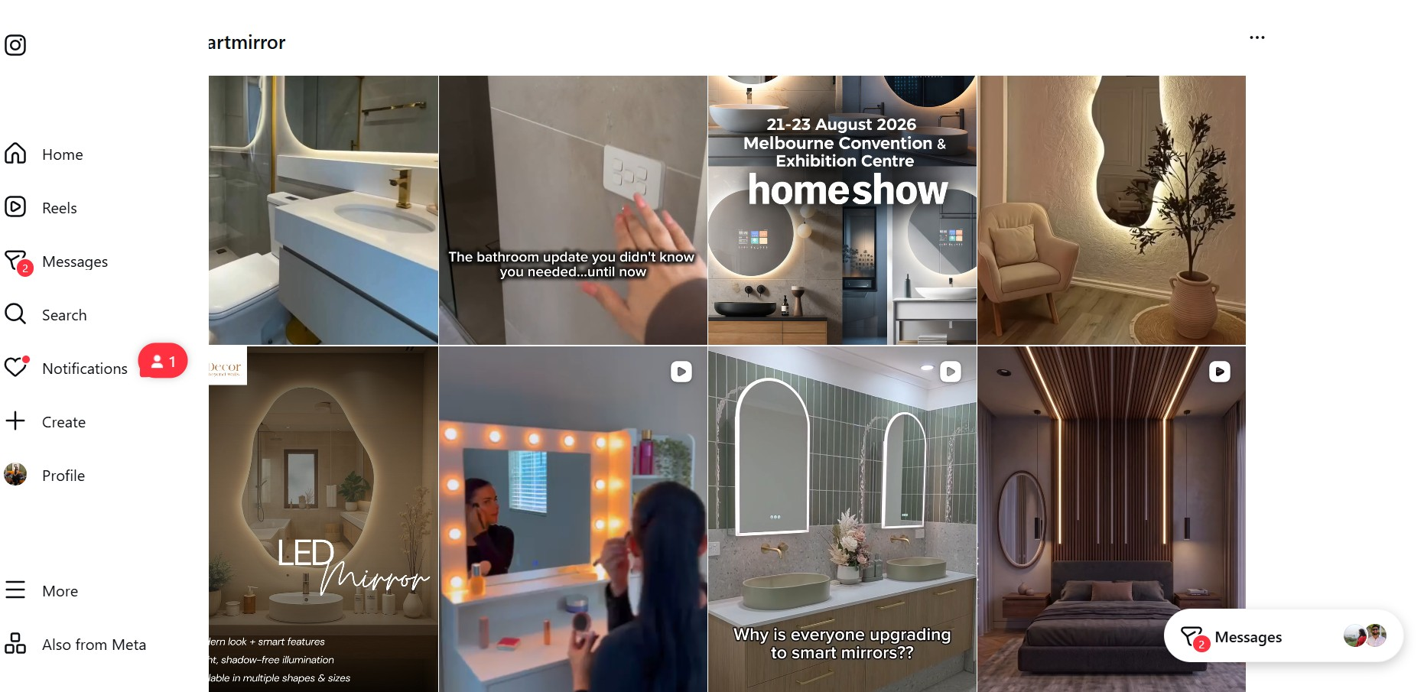
General "smart mirror" category content on Instagram is dominated by home-décor and bathroom-lifestyle framing rather than fitness or community, reinforcing how uncontested the wellness-mirror space still is.
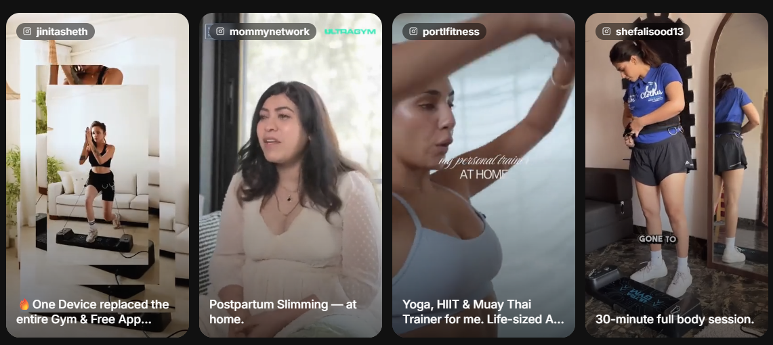
Indian competitor Instagram content (Portl / UltraGym, and influencer-style 'replaced my gym' framing) is mostly performance/HIIT leaning, with transactional product demos rather than community storytelling.
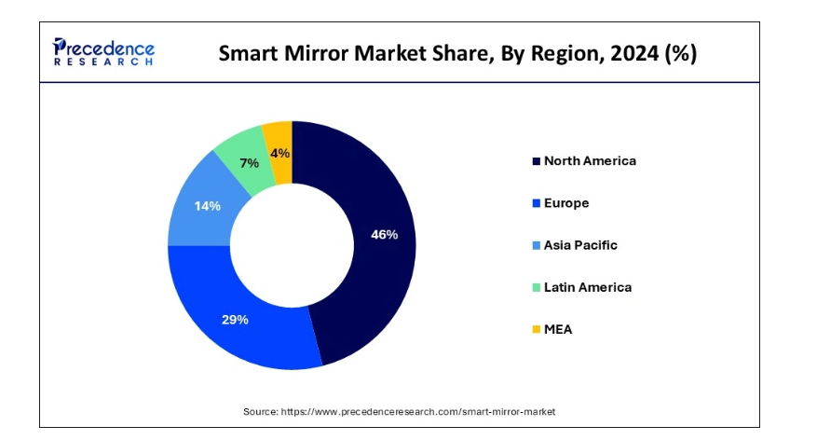
Global smart mirror market share by region, 2024. Asia Pacific holds only 14%, a still-emerging regional share that supports the case for an India-first positioning window. Source: Precedence Research.

6. Channels and Platforms
Selected channels (limited to platforms actually researched)
- Instagram (organic Reels and Carousels) - primary channel
- Meta Ads (Instagram + Facebook) - paid amplification
- YouTube - longer-form sample classes and educational content
Rationale grounded in research
Instagram was prioritised because the personas already use it heavily for health content and it supports both short-form belonging content and deeper educational carousels.
Google Trends data (India, May–August 2026) showed strong directional interest in low-barrier home workouts ("home workout without equipment" +250%, "easy workout at home" +200%, "online workout classes" +80%). These signals supported a content strategy focused on accessible, real-life routines rather than high-performance gym aesthetics.
Meta Ads were referenced to understand competitive creative approaches (lifestyle vs performance vs convenience).
YouTube was selected for longer sample classes that align with high-intent search behaviour.
Supporting Evidence: Google Trends - Home Workout Search Trends Report (India, May 25–Aug 25 2026)
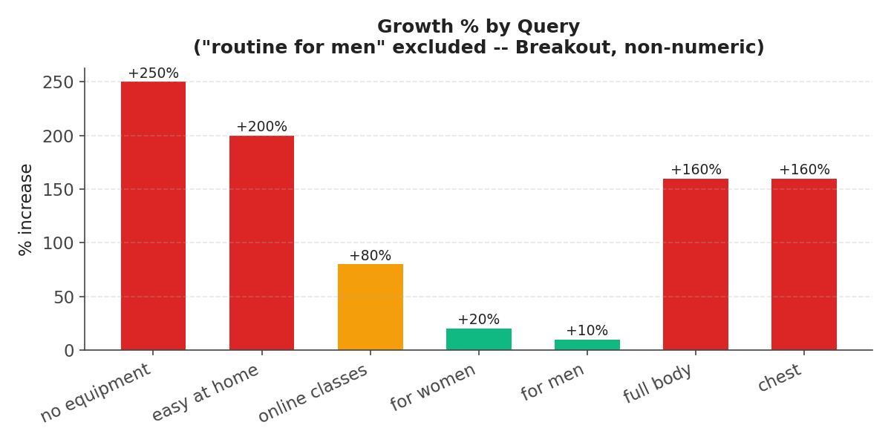
Growth % by query. The three headline figures cited above ("without equipment" +250%, "easy at home" +200%, "online classes" +80%) alongside related body-part queries. "Home workout routine for men" is a Google "Breakout" label (non-numeric, 5,000%+) and is excluded from this chart.
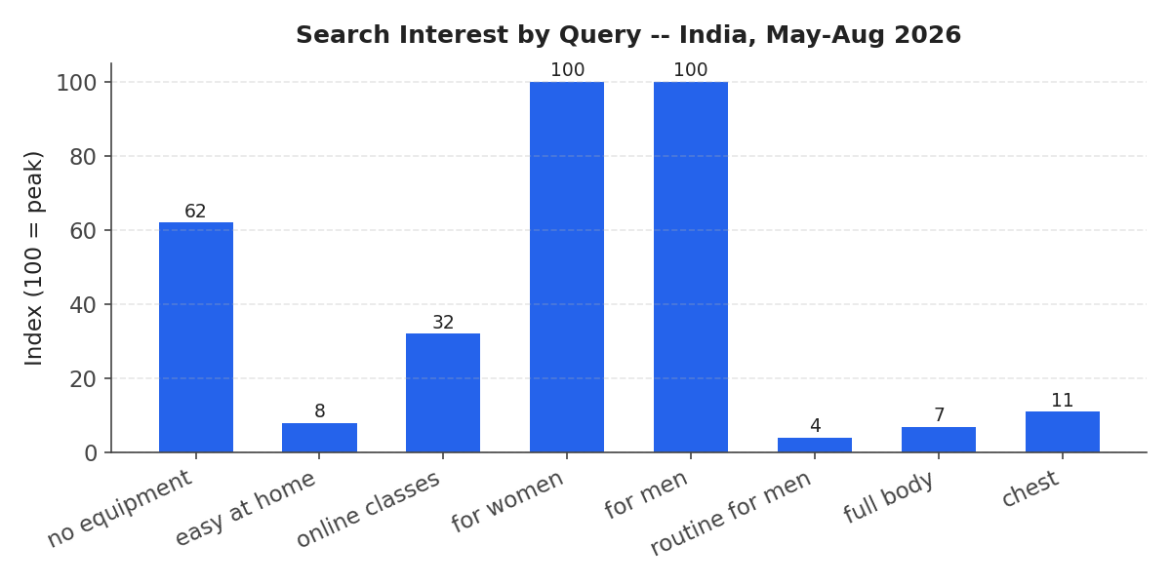
Search interest index (0–100) for the same queries. "No equipment" workouts already carry a meaningfully higher baseline (Index 62) than most other low-barrier queries; not just a percentage spike, but real search volume.
Full time-series breakdown and methodology available in the companion Home Workout Search Trends Report.

7. Creative Assets Needed
- Short-form Instagram Reels (realistic routines, inclusive movement, community moments)
- Mirror Specs Carousel (features, benefits, and how the device also functions as a normal everyday mirror)
- Educational carousels (installation guidance, renter considerations, mental wellness frameworks)
- Testimonial videos
- Diversity videos featuring real customers from different communities and countries
- Sample class videos for YouTube
- Email sequences and landing-page copy
- Influencer creative briefs
Why these assets
Reels and testimonials build authentic connection. The Specs carousel addresses practical purchase questions. Diversity and real-customer videos directly support the inclusivity and representation goals identified in the brand values and persona research. "Day in the life" carousels were intentionally excluded in favour of the more useful Specs format.
Instagram Content Audit: Real-World Reference Examples
The following real, publicly posted content illustrates the tone, formats, and audience pain points this campaign should draw on or differentiate from.
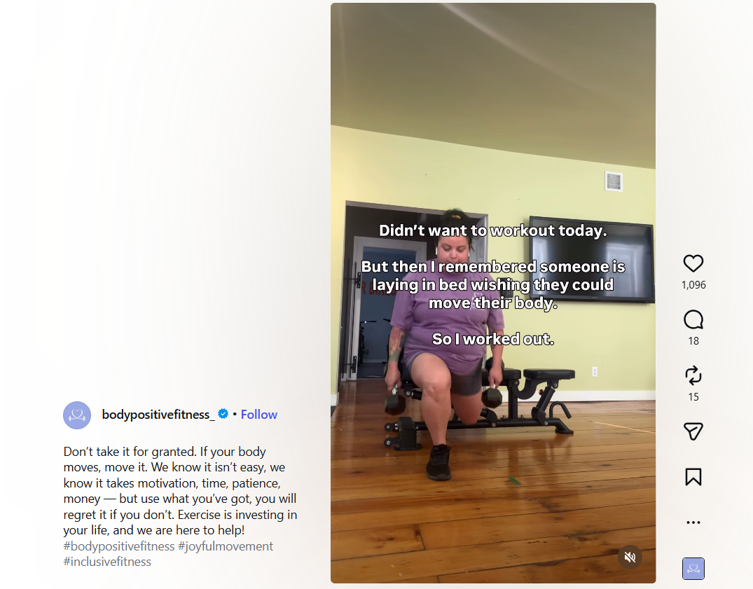
@bodypositivefitness_ - body-positive strength training content normalises diverse bodies working out. Directly supports our inclusivity and representation goals; a tonal reference for diversity-led Reels.
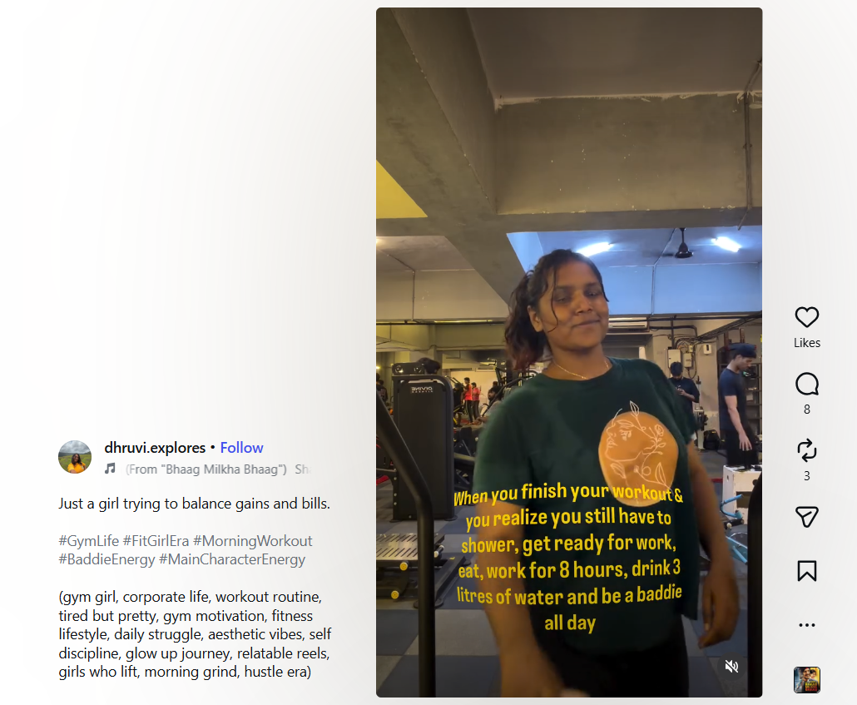
@dhruvi.explores - relatable, humorous "gym girl vs. 9-to-5" framing. Mirrors Persona 1 (Priya, the busy professional) and shows how self-aware humour builds authentic connection.
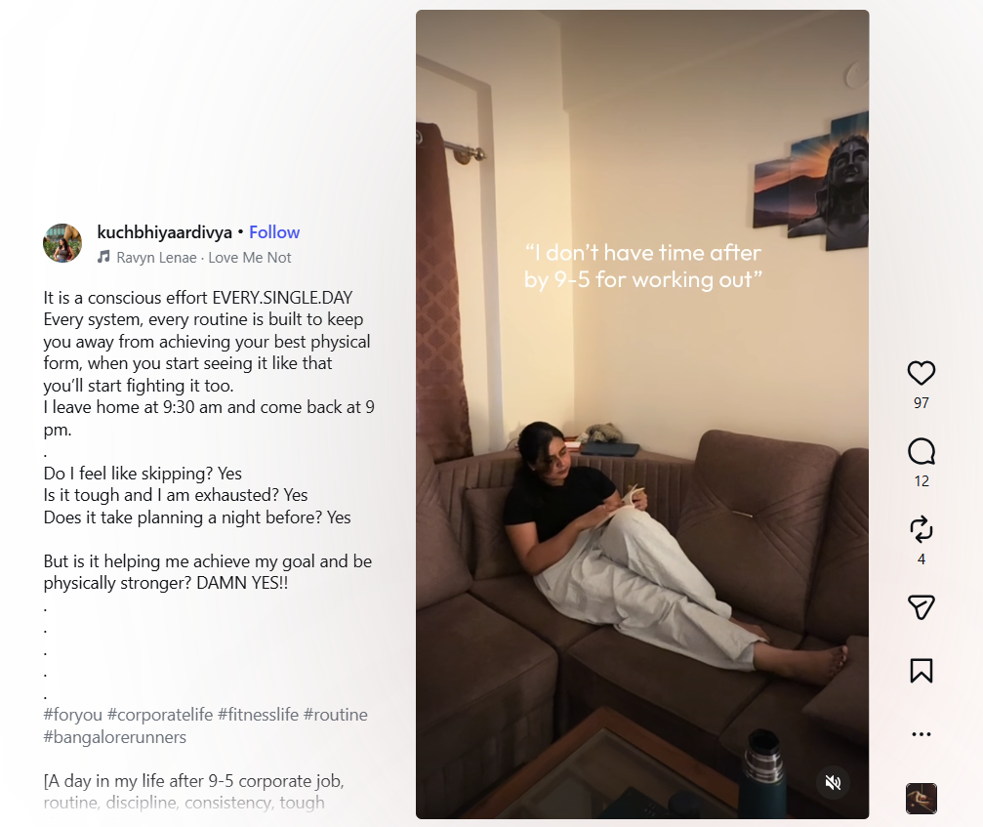
@kuchbhiyaardivya - an honest "I don't have time after 9-5" narrative that validates exhaustion rather than shaming it. A strong reference for our "supportive, not competitive" tone of voice.
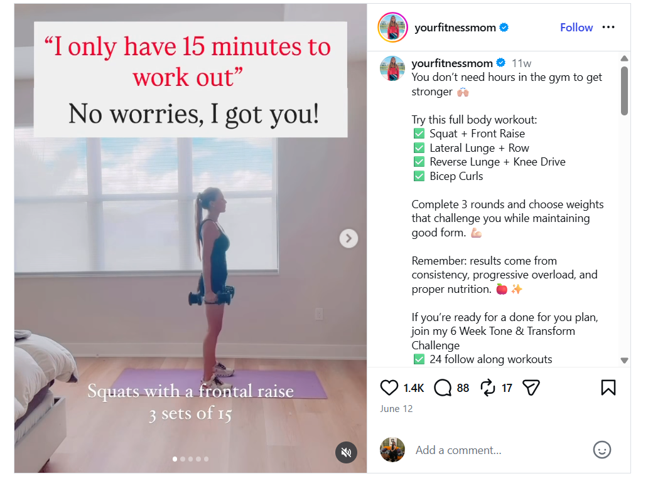
@yourfitnessmom - a no-excuses 15-minute full-body routine carousel.
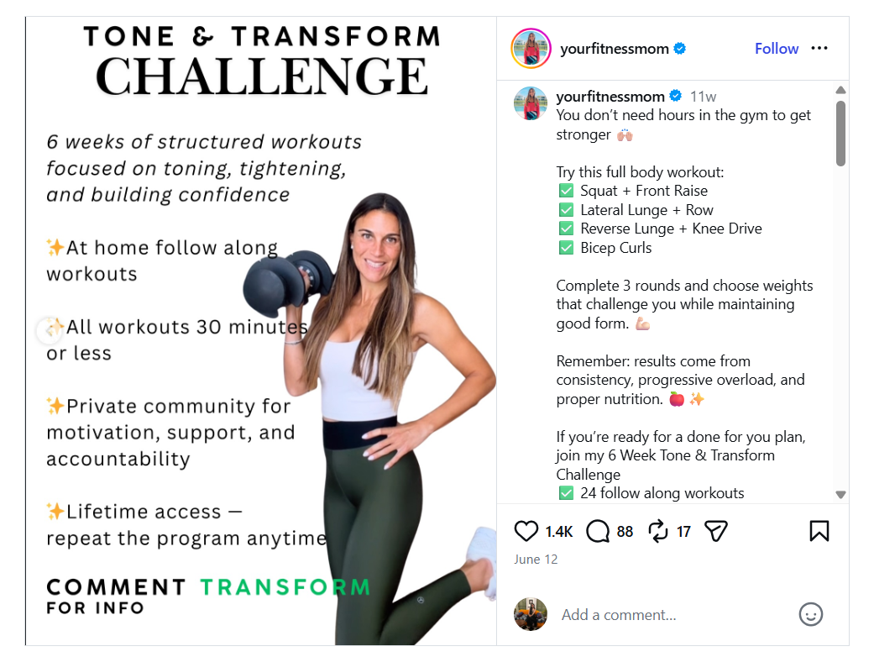
The same creator converts that content into a paid "6-Week Tone & Transform Challenge," a proven pattern for pairing efficient at-home workouts with a monetisable community offer, relevant to our free-trial and sales goals.
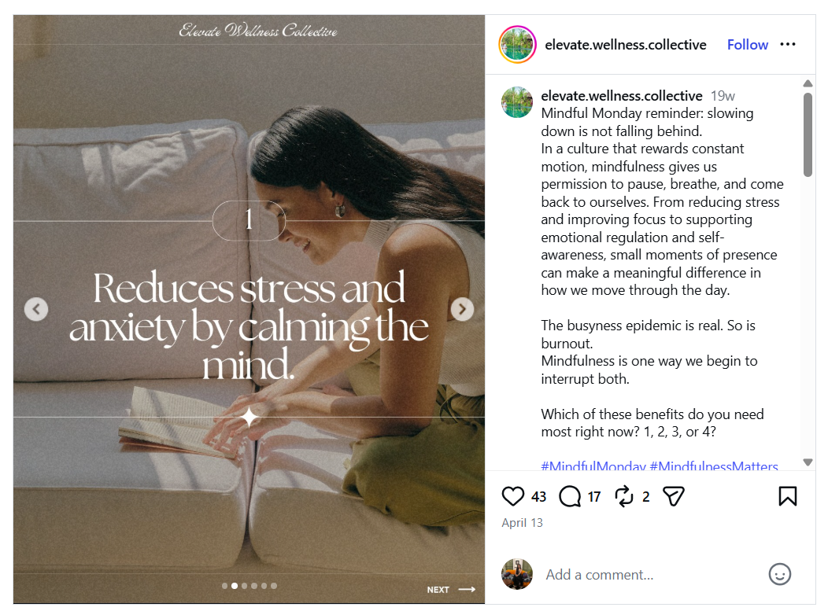
@elevate.wellness.collective - calm, editorial carousel format explaining the mental-health benefits of mindfulness.
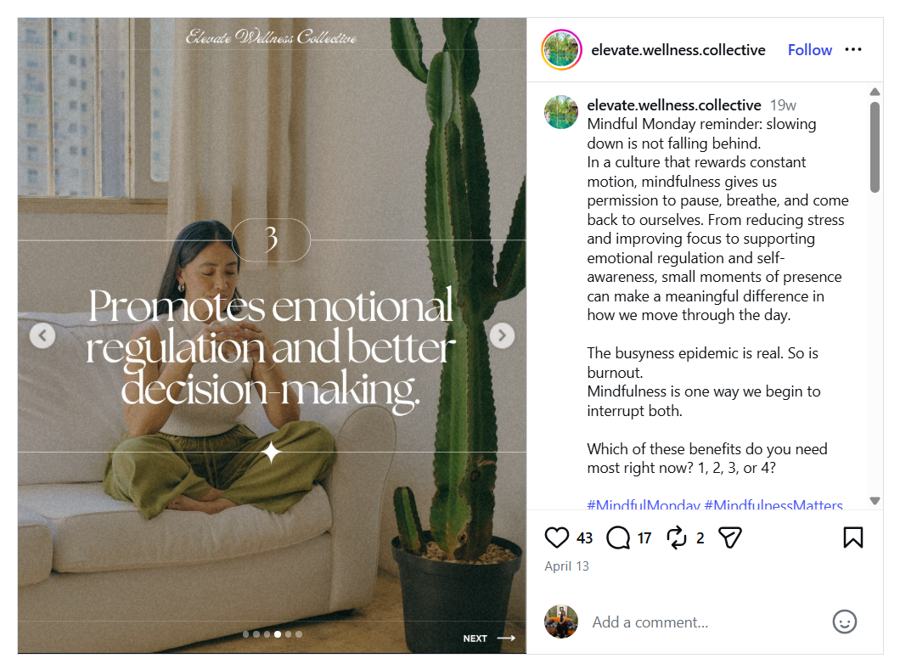
This slower, benefit-led carousel style is a strong visual and tonal reference for our own mental-wellness educational carousels.
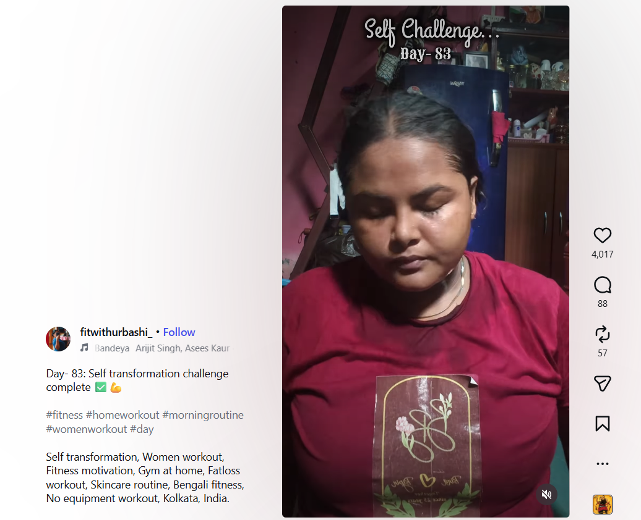
@fitwithurbashi_ (Kolkata, India) - a Day-83 no-equipment self-transformation challenge. Real diversity, real setting, and a direct on-the-ground match to the +250% "home workout without equipment" search spike identified in our Trends research.
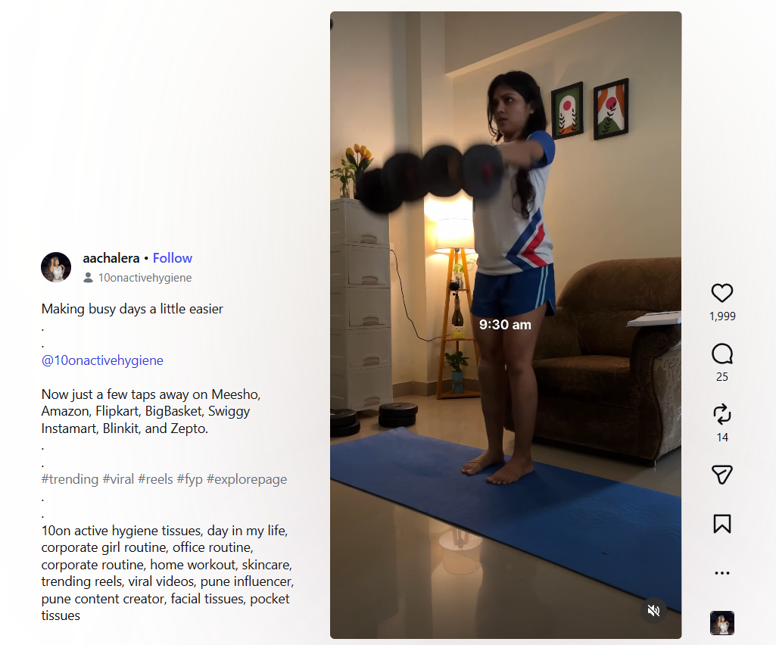
@aachalera - a trending home-workout Reel format that folds in a sponsored product mention. Useful as a lightweight reference for how influencer partnerships and product integrations could be structured without breaking the authentic, low-production tone.

8. Tone and Style
Tone: Supportive, inclusive, authentic, calm, practical, and human.
Visual style: Real living rooms, diverse bodies and fitness levels, natural lighting, soft/warm colour palette.
Voice: Honest, encouraging, free of hype and jargon.
This tone was derived from the original brand voice guidelines (authentic, transparent, supportive) and reinforced by the competitor gap analysis, which showed most brands over-indexing on performance or clinical messaging.

9. Timeline
Total campaign window: 5–7 months
- Pre-launch / Teaser: 12–16 weeks
- Launch: 2–4 weeks
- Sustained / Always-on: 8–12 weeks
- Evaluation: Formal reviews at T+2 weeks and T+8–12 weeks
How the timeline was concluded
Benchmarked against launch patterns of Tonal (staggered), Portl, Aroleap, and Flexnest, combined with realistic lead times for hardware/content readiness, creative production (6–10 weeks), influencer outreach (6–10 weeks), and Meta ads testing (3–4 weeks). A long pre-launch phase was prioritised to seed authentic community content before peak visibility.

10. Team Roles
Lean core team of 4–5 people
- Campaign / Marketing Lead
- Content & Social Media Manager
- Performance Marketing Specialist (Meta)
- Influencer & Partnerships Coordinator (can be combined with Content role)
- Creative Support (freelance video editor + graphic designer)
This structure was mapped directly to the timeline workstreams and kept deliberately lean for a growing lifestyle brand.

11. Success Metrics
Primary metrics
- Free-trial / waitlist sign-ups
- Product sales / conversion rate
- Engagement rate (saves + shares + meaningful comments)
- Video completion rate
- Brand sentiment (supportive and inclusive language in comments)
Secondary metrics
Reach & impressions, click-through rate, website traffic, carousel save rate, cost per acquisition.
These metrics balance commercial outcomes with the brand's researched commitment to belonging and authentic connection, and are fully measurable on the selected channels.

Sources
Assignment Brief
- Forage Academy - Developing an Integrated Marketing Plan (Omnichannel Marketing)
Competitor & Brand Websites
- Shen AI - Health AI Insights & News (Blog)
- Tonal
- Peloton - Impact and Inclusion
- Portl
- Aroleap
- Flexnest
Research & Industry References
- Google Trends data (India, May 25 – Aug 25, 2026) – Home Workout Search Trends Report
- Smart Mirror Market Size to Hit USD 1,299.83 Million by 2034 - Precedence Research
- Wellness Customer Personas for Marketing: 2025 - Muse Headquarters
- NASM Blog - Evidence-Based Fitness Articles & Industry Insights
- Wellness Branding - The Comprehensive Guide to Know in 2025 - Designer People
- Brand Strategy for a Wellness Brand: Complete Guide with Examples - Brand Strategist AI
- How To Create Unique Positioning & Messaging As A HealthTech Company - Insivia
- Personalization Is Key To Marketing Successful Wellness Products - Forbes
- How Tonal launched its product - TechCrunch
- Portl product launch coverage - YourStory · Business Standard
- AroLeap 2026 Company Profile: Valuation, Funding & Investors - PitchBook
- Product Launch Timeline resources - Atlassian · Product Marketing Alliance · Indeed
- Flexnest App - Founders, Business Model, Revenue & Growth - StartupTalky
- Instagram content examples and Meta Ads Library references (competitive creative patterns)
Note on Meta Ads
Meta Ads Library was used as a reference to analyse competitor creative approaches, messaging styles, and visual strategies. Specific ad screenshots were not included in this version of the document.

