The goal of this proposal is to quantify photoionization and production of primary and secondary photoelectrons in the D and E region ionosphere in response to changes in solar flux. We want to determine the altitudes of photoionization and photoelectron production due to high energy photons in the x-ray wavelength ranges, especially during the solar flares. The solar flares consist photons with high energy, high fluxes and are also highly variable in the x-ray ranges, so they must affect the photoionization and photoelectron flux production in altitudes below 90 km. Most of the existing models do not consider spectral variability in the x-ray ranges, therefore, we need better photoelectron models to study their effects in the earth’s ionosphere at lower altitudes.

We know that the solar flux, shortward of 30.4 nm deposits energy into the Earth’s thermosphere and initiates chemical processes that affect the composition and structure of the ionospheric D and E regions. One of the primary processes is the photoionization of the major neutral constituents N2, O2 and O. The photoionization of the major species leads to the formation of energetic photoelectrons. These primary photoelectrons create secondary electrons that can cause further ionization, dissociation, and excitation of particles. This process affects the dynamics of the Earth’s ionosphere and so it is important to know what wavelengths cause ionization at what altitudes, with a high level of accuracy.

In order to study the photoionization and photoelectron production, we will develop an improved photoelectron model that can resolve the altitude profiles of these fluxes with a high degree of accuracy than previously done. The model is an improved version of the GLOW model [Solomon et al., 1988; Solomon and Abreu 1989; Bailey et al 2002] and is based on the two-stream method of phototelectron flux calculation introduced by Nagy and Banks (1970). Our photoelectron model will be able to resolve solar energies below 3nm with high spectral resolution. This will help us to analyze solar fluxes in very fine wavelength bins and with very high energies, up to hard x-rays energies. We will also improve the ionization and absorption cross-sections of the neutral species and their various ionization and dissociation states at all wavelengths with the newest available laboratory data.

A secondary goal is to resolve the issue of the photoionization of the Lyman beta emission at 102.5 nm. We know that Lyman beta causes photoionization of O2, however, since the ionization threshold of molecular oxygen is very near that wavelength, most models improperly resolve the ionization and absorption cross-sections around it, which results in incorrect altitude profile for photoionization due to Lyman beta emission. With our improved cross-sections, we hope to resolve this issue of the photoionization of molecular oxygen by Lyman beta.

Initial Results

Figure 1 shows the initial results of photoionization and photoelectron fluxes for a synthetic input solar spectrum. The solar flux has non-zero values up to 500 angstroms and then the spectrum is set to zero. We have added a spectrum at 1025 Angstrom which is the Lyman beta line. This was done to test the effect of Lyman beta on photoionization. The photoionization rates and photoelectron fluxes for the three neutral species, N2, O2 and O are also shown. Our initial results show that although the solar flux is very small in the x-ray ranges, the model is able to resolve its effect at altitudes lower than 90 km. Therefore, the model should be able to correctly determine the photoionization and photoelectron rates for high resolution x-ray fluxes, including solar flares.

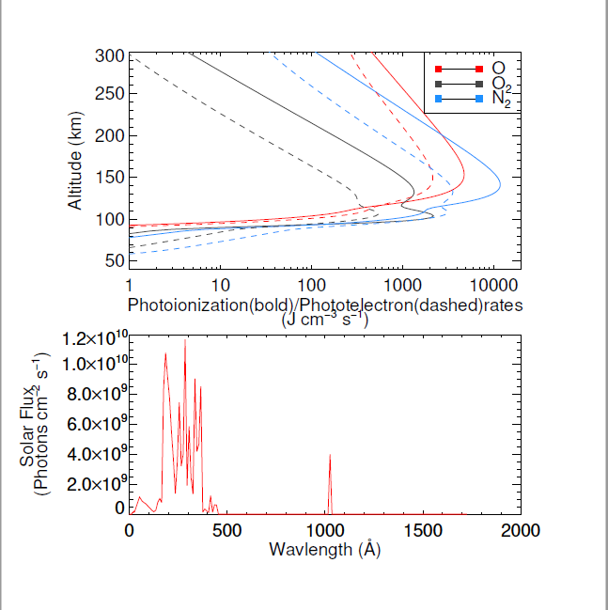

Figure 1: Photoionization and photoelectron rates as a function of altitudes and input solar spectrum

Project Implementation and Funding

The photoelectron mode is being developed by Virginia Tech’s Center for Space Science and Engineering Research. We plan to test our model with synthetic solar spectra developed by Space Science Division, Naval Research Laboratory (NRL). We have promising initial results as shown above. We propose a one-year project, beginning September 1st, 2019 and ending in August 31, 2020. We have estimated a fund amount of five thousand US dollars which will be used for travel related to project collaboration. This fund will help us to present our initial results at American Geophysical Union (AGU) conferences in December, 2019, in Summer of 2020, and also in our travel to NRL in Washington DC.