In this report, I have tried to assimilate the results of dissociation cross-sections due to electron impact excitation of N_{2.}
The first section lists the current excitation states that is used in the PE model. The names of the states are as given in the model, together with the excitation energy. The model calculates the excitation cross-sections and I have assumed any states above 12. 5eV dissociates completely. The plots of the excitation cross-sections vs electron energy is also given.

In the second section, I have listed all the excited states of N_{2.} All states with excitation energy less than 12.5 eV are grouped into lower states and all energies greater than 12.5 eV are upper states. Most of the pre-dissociation occurs due to the excitation of these upper states from ground states. Itikawa, 2005 has a tabulated cross-sections and energy values for the lower states, which are also plotted. However, I have mostly concentrated on the upper states here.
I have used a simple formula given in Zipf and Gorman 1980, to plot the excitation cross-sections of the upper states. The parameters used in the formula was taken from the Zipf and McLaughlin 1978 paper.
If we have the emission cross-sections for these states to the ground state, we can estimate the pre-dissociation branching ratios by the following assumptions: If an excited state is de-excited by emission only and there is no other cascading to any other intermediate state, then if the excitation cross-section is almost equal to the emission cross-section, then the pre-dissociation branching ratio is ~0 for that state and if the emission cross-section is very small compared to the excitation cross-section then the pre-dissociation branching ratio ~1.
I have also compared the sum of the excitation cross-section to the dissociation cross-sections given in the Zipf and McLaughlin paper. The cross-sections are in the range of each other. However, there are several discrepancy.
The equation used to calculate the cross-sections has some errors, particularly near the threshold and peak regions. Therefore, I have used the modified Born approximation described in the James 1990 and Shemansky, 1980 paper to obtain the cross-sections. They describe the cross-sections in terms of collision strength. They show a good fit to the Zipf and Gorman 1980 cross-sections. I was able to reproduce the collisions strengths as given in the paper, but the relation between collision strength and cross-sections is producing some error in dimensional analysis.
After I am able to solve this problem, I will try to reproduce emission cross-sections, so that the pre-dissociation branching ratios can be calculated.

Section I. Excitation States of N₂ in the current PE Model:
Our current PE model Has the following excitation states

A 6.17 eV
BW 8.16 eV
B’ 11.03 eV
C’ 8.40 eV
aa’w 12.85 eV
1Pu 14.00 eV
b’ 13.75 eV
Ryds 1.85 eV
vib 0. eV

I have assumed all states above 12.5 eV dissociates

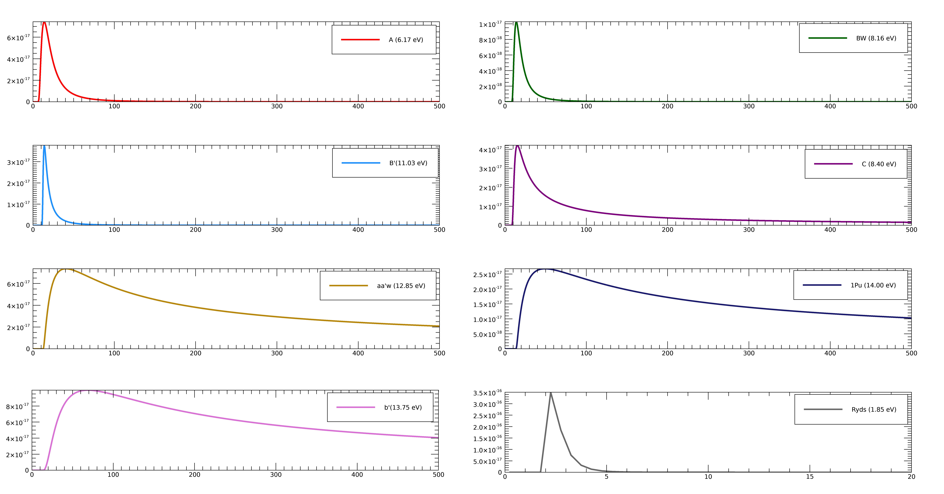
Fig 1: Cross-section (cm²) vs Energy(eV) diagram of excitation states of N₂ in our current model

Section II Excitation of Electronic States-

These are the lower states less than 12.5 eV. The table summaries for energy vs. cross-sections for the lower excited states are taken from Itikawa 2005, which are plotted below.
lower states T₀ (eV)
A ³Σ_{u}⁺ 6.169 Vegard Kaplan
B ³П_{g} 7.353
W ³∆_{u} 7.362
B’ ³Σ_{u}⁻ 8.165
a’ ¹Σ_{u}⁻ 8.399
a ¹П_{g} 8.549 Lyman Birge Hopefield
w ¹∆_{u} 8.890
C ³П_{u} 11.032
E ³Σ_{g}⁺ 11.875
a’’ ¹Σ_{g}⁺ 12.255
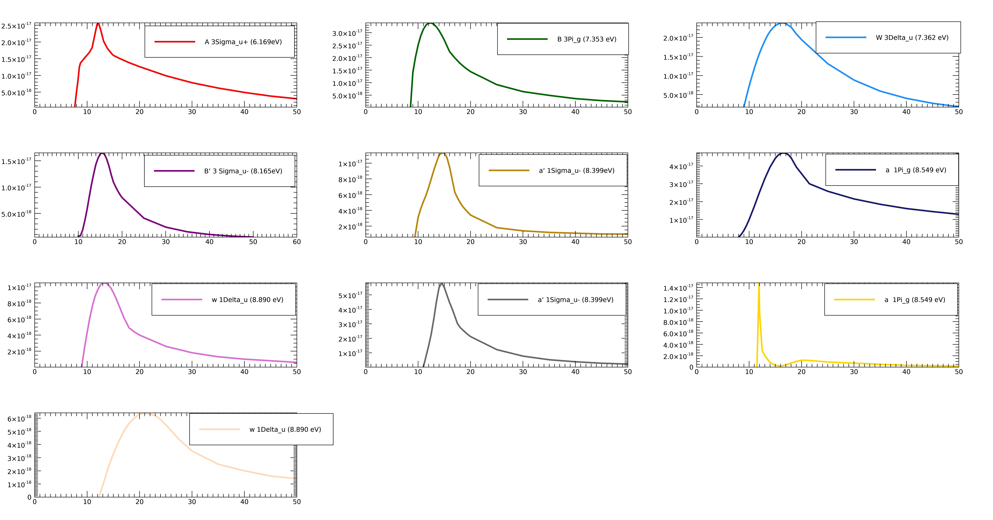
Fig 2: Cross-section (cm²) vs Energy(eV) diagram of lower excitation states of N₂ (Itikawa,2005)

The upper states have threshold energies greater than 12.5 eV.

Upper states T₀(eV)

b ¹П_{u} 12.500 Birge-Hopefield system
c’₄ ¹Σ_{u}⁺ 12.935 Caroll-Yoshino band system
b’ ¹Σ_{u}⁺ 12.854 Birge-Hopefield-II band system
c ¹П_{u} 12.91
o ¹П_{u} 13.1
e ¹П_{u} 14.33
e’ ¹Σ_{u}⁺ 14.35

F ³П_{u}
G ³П_{u}

Theory- In principle, all electronic states that are above the dissociating limit of N_{2,} should dissociate (~11.5 eV). The pre-dissociation caused by the electron impact excitation of the states b ¹П_{u} , c’₄ ¹Σ_{u}⁺ ,b’ ¹Σ_{u}⁺ and o ¹П_{u ,} is responsible for more than 85% of N₂ dissociation (Zipf and Gorman, 1980).

Testing out simple formula from Zipf and Gorman, 1980: At high electron-impact energies, the excitation cross-section for a vibrational level v’:

where

Table 2 of Zipf and Gorman, 1980 has the cross-sections , oscillator strength for each vibrational levels of b¹П_{u} . I used these values to estimate the value of C and then used these C values, to get the total excitation cross-section of N₂(b ¹П_{u} – X ¹Σ_{g}⁺). Then I compared these values to Table 3. The results are plotted below.

There is significant difference between cross-sections of the tabulated data and the calculated data in the threshold region. Ideally, the plot of cross-section vs ln(energy) is used to estimate the oscillator strength, which is the slop and the constant which is the intercept. However, the paper did not provide enough energies and cross-sections data to carry out such analysis, so I used the given values for one particular electron energy 200eV to estimate C. That could be the reason for discrepancy between the cross-sections, since the cross-sections provide erroneous results at thresholds and peak. This is referenced in several papers that I looked at.
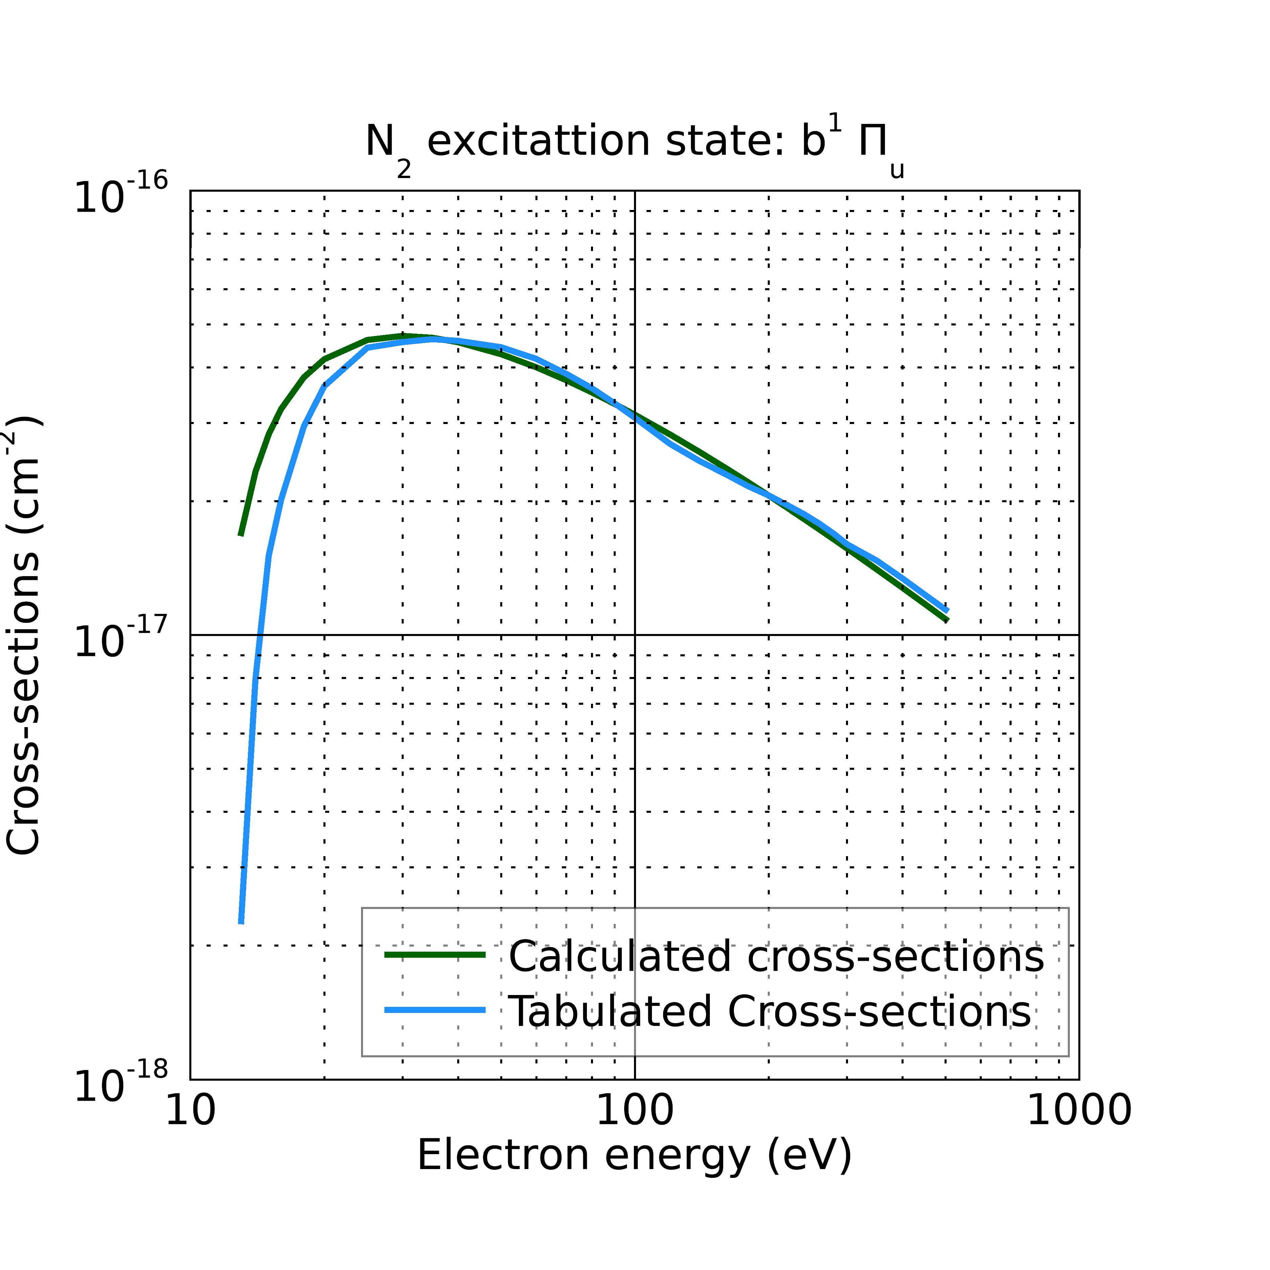

Similarly, I used the above formula to estimate the total cross-sections of the excited states
c’₄ ¹Σ_{u}⁺ (v’=0,1,3,4,5,6,7)- X ¹Σ_{g}⁺,
b’¹Σ_{u}⁺ (v’=5,6,9,10,11,12,13,14,15,16,17,18,19,20,22,23,24) -X ¹Σ_{g}⁺ and
o ¹П_{u} -X ¹Σ_{g}⁺ vs electron energy from the Table I of Zipf and McLaughlin 1978.
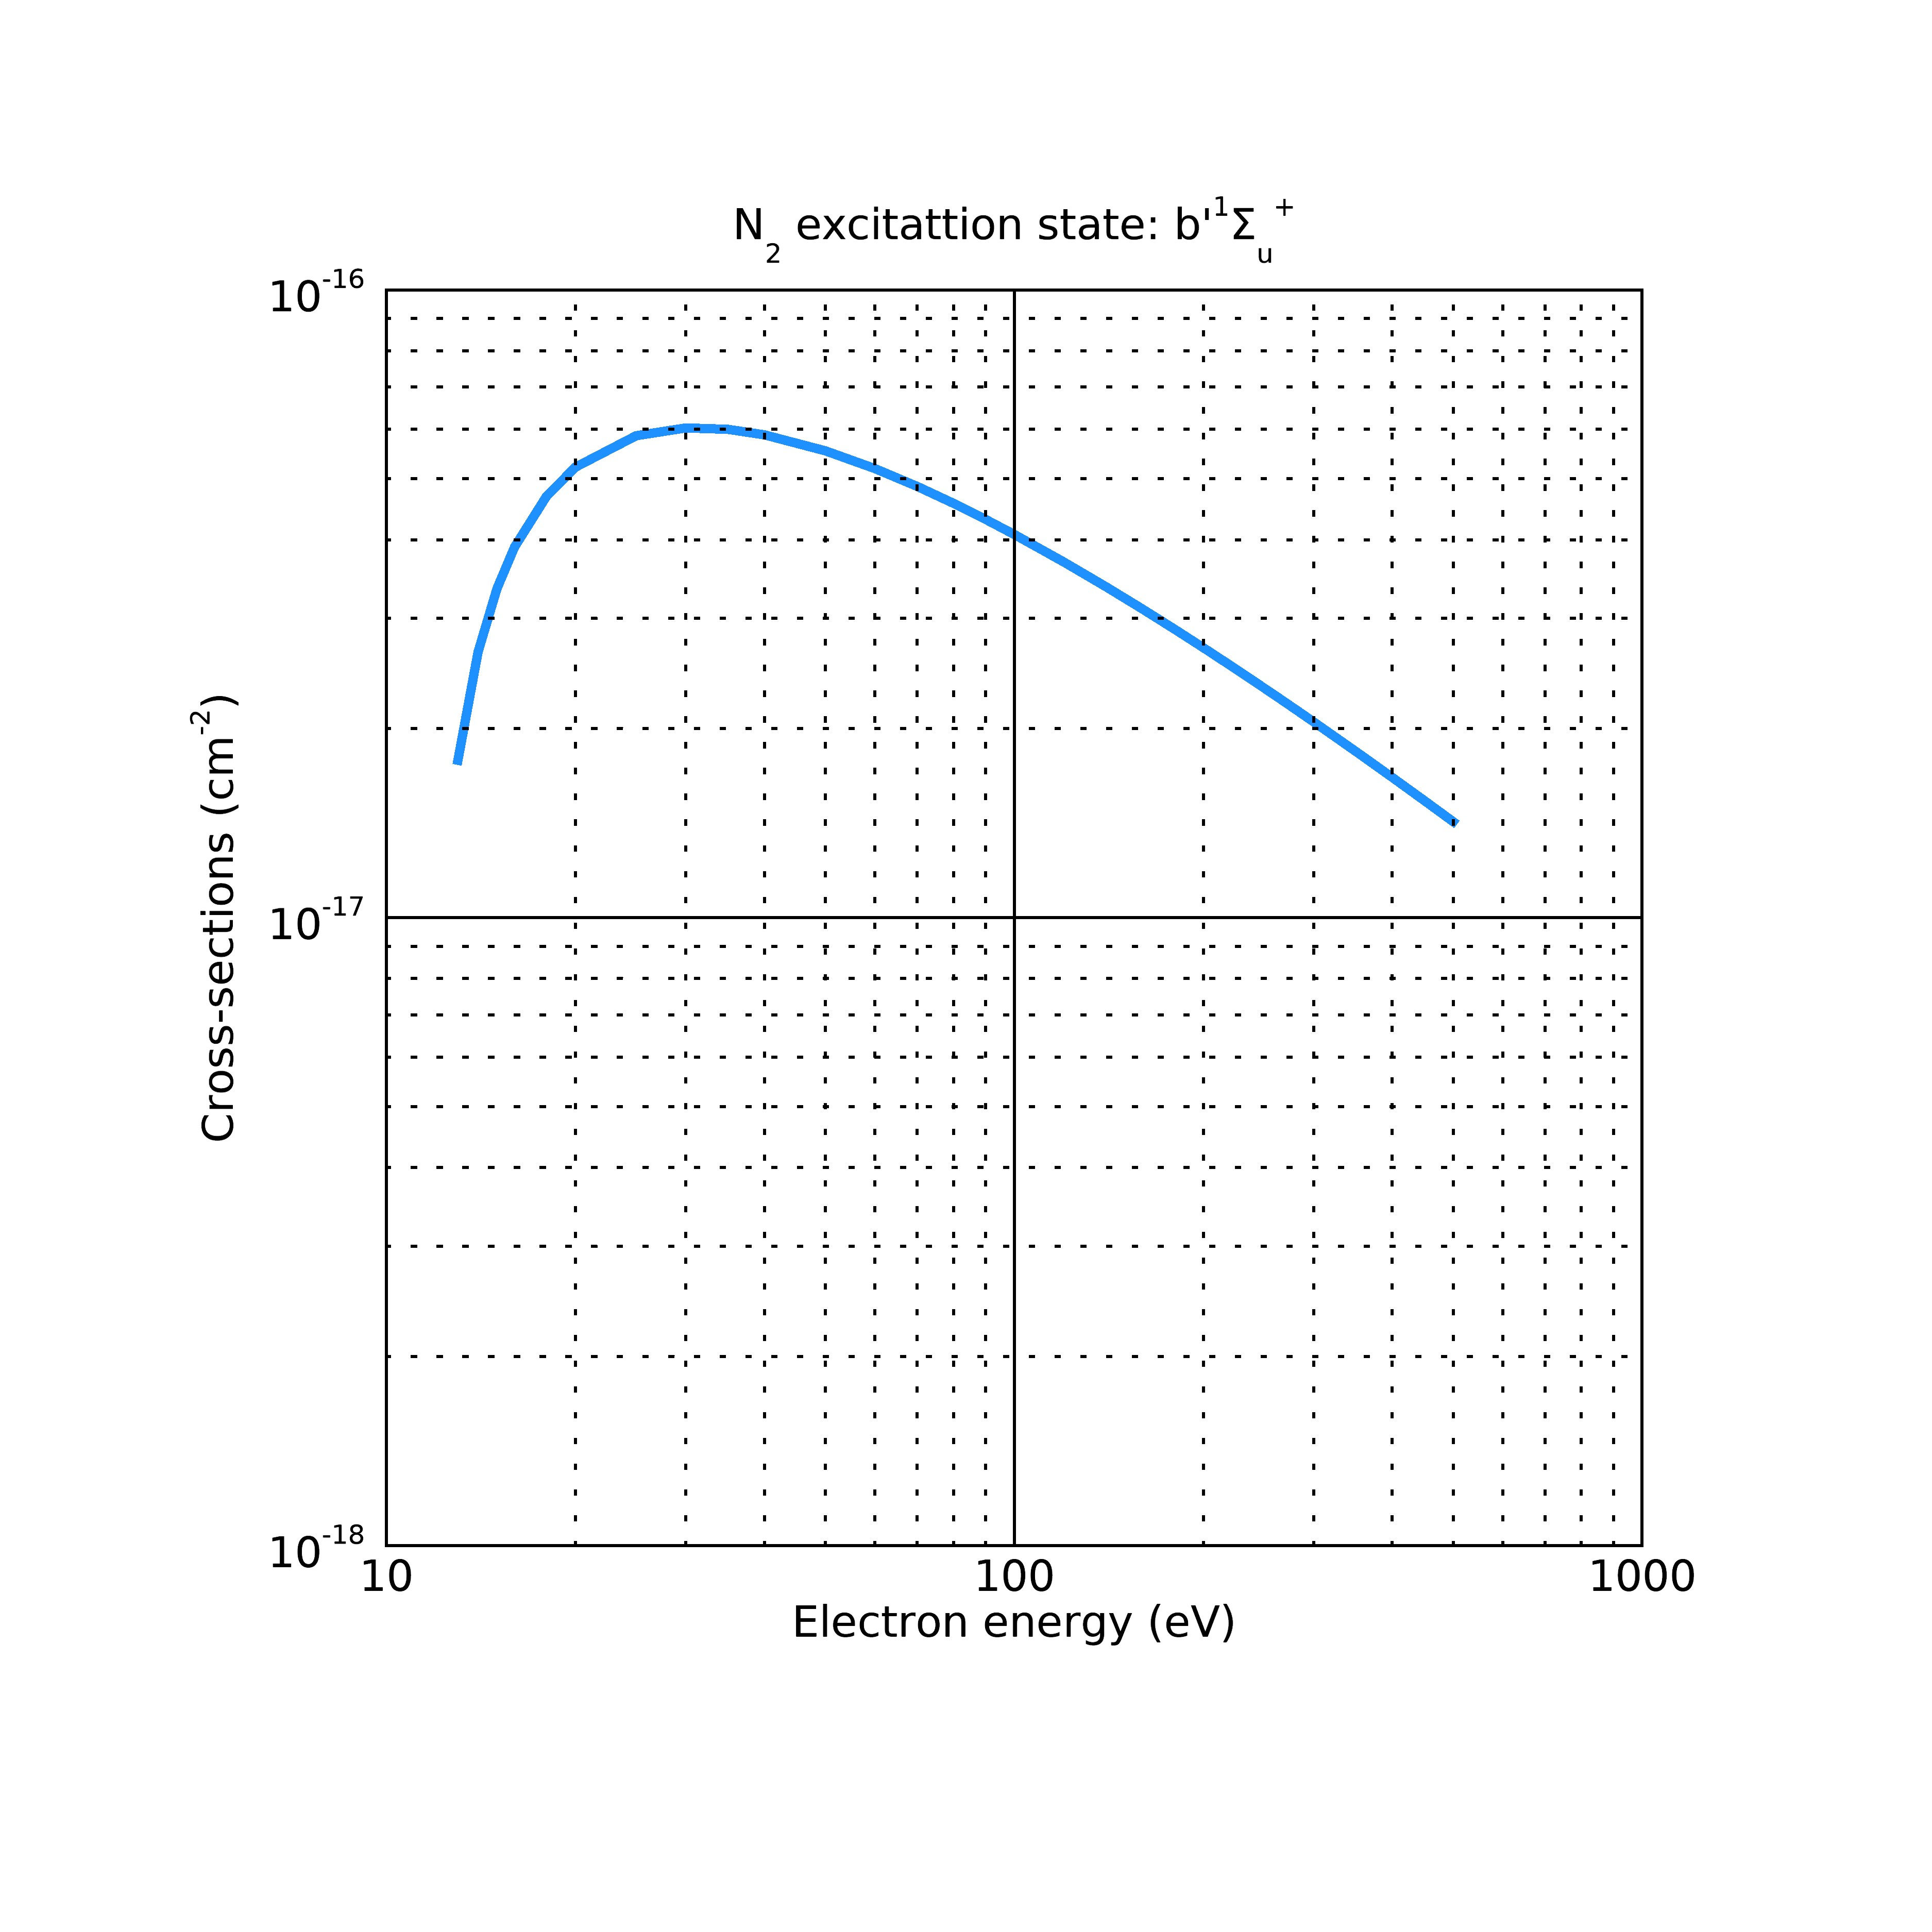
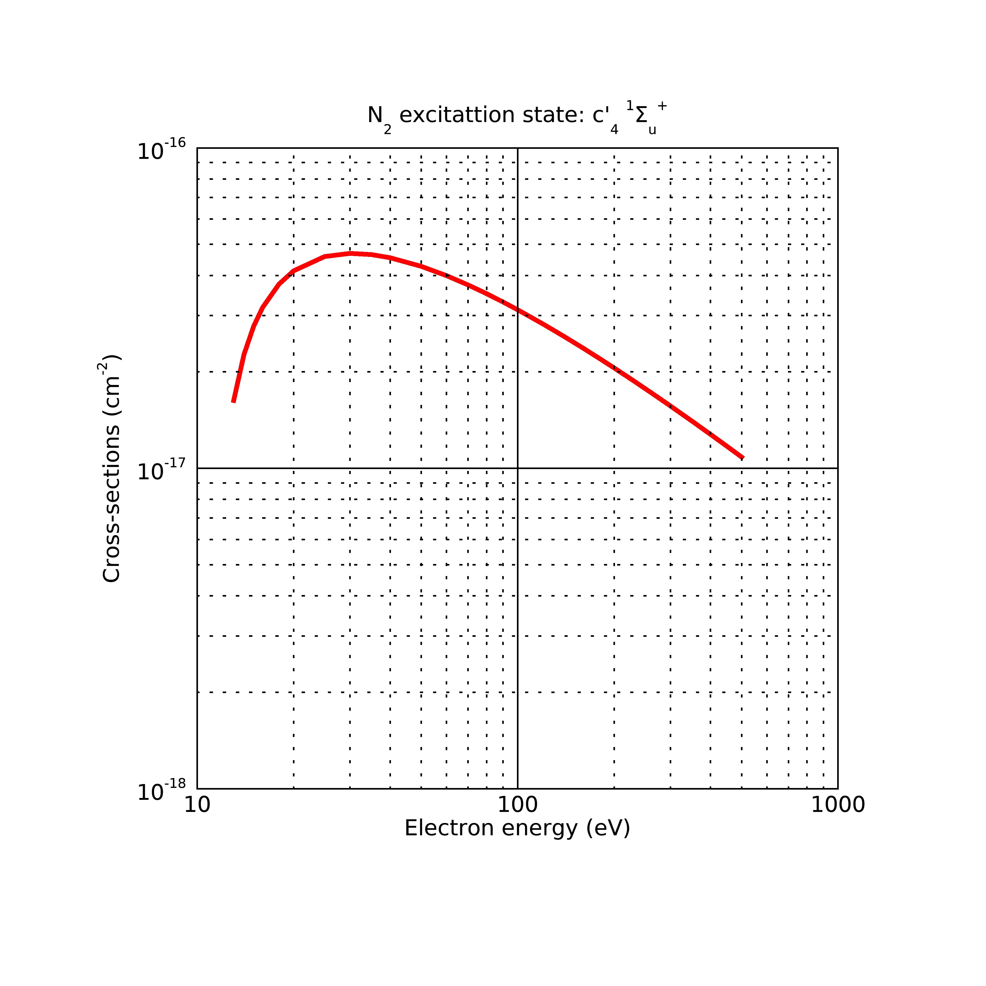

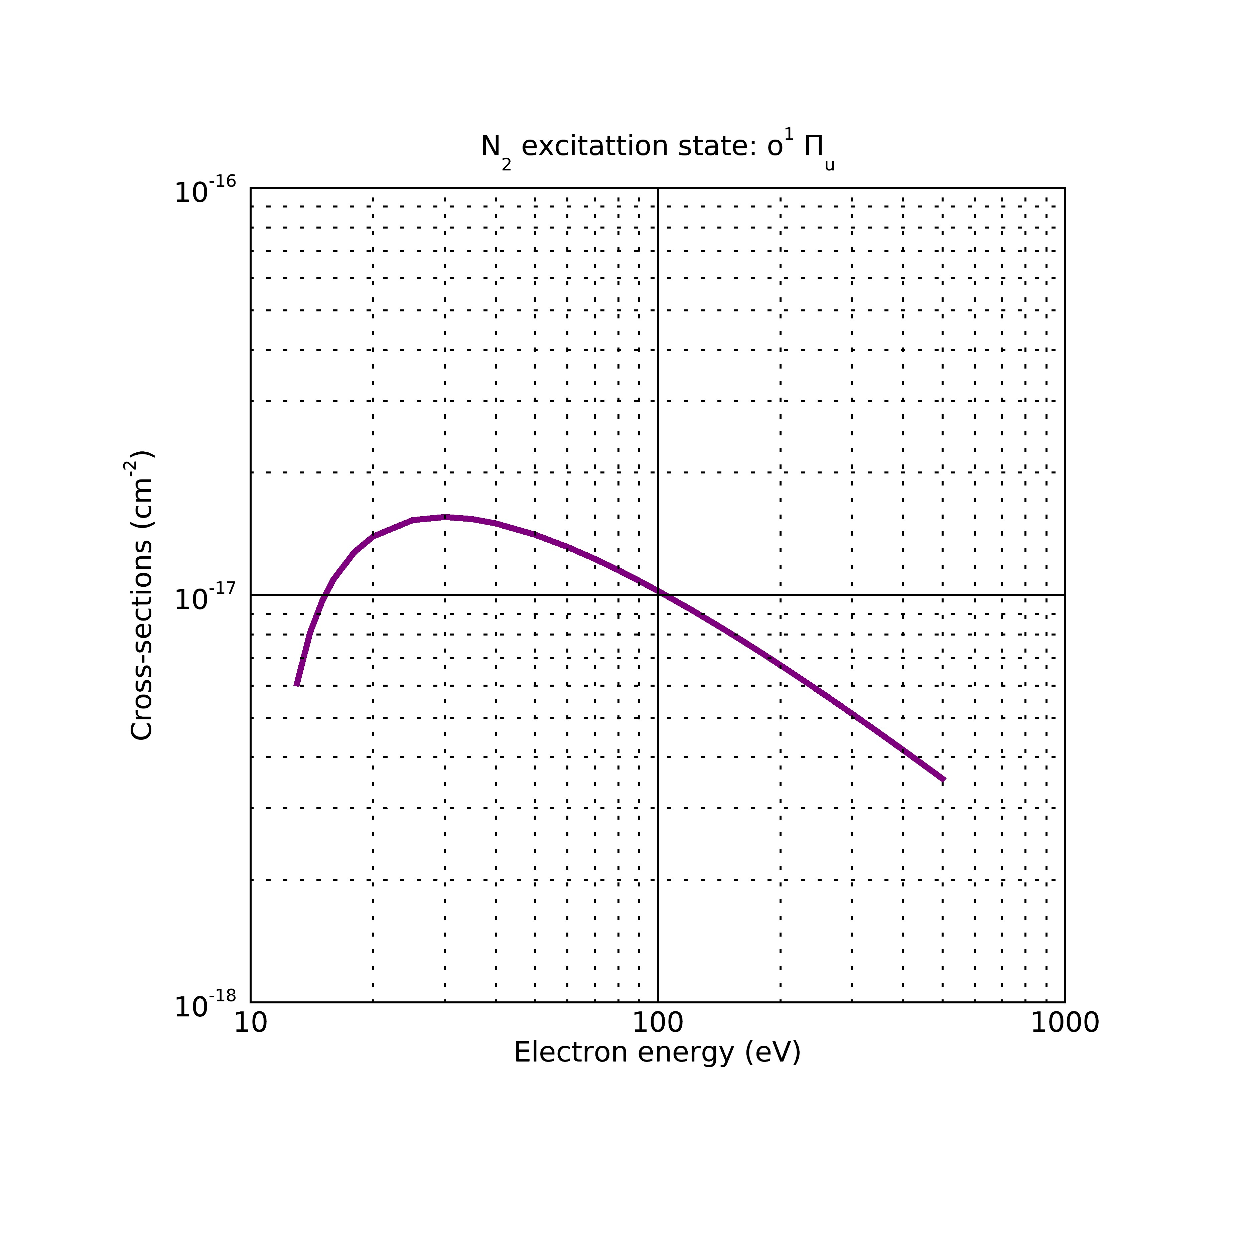
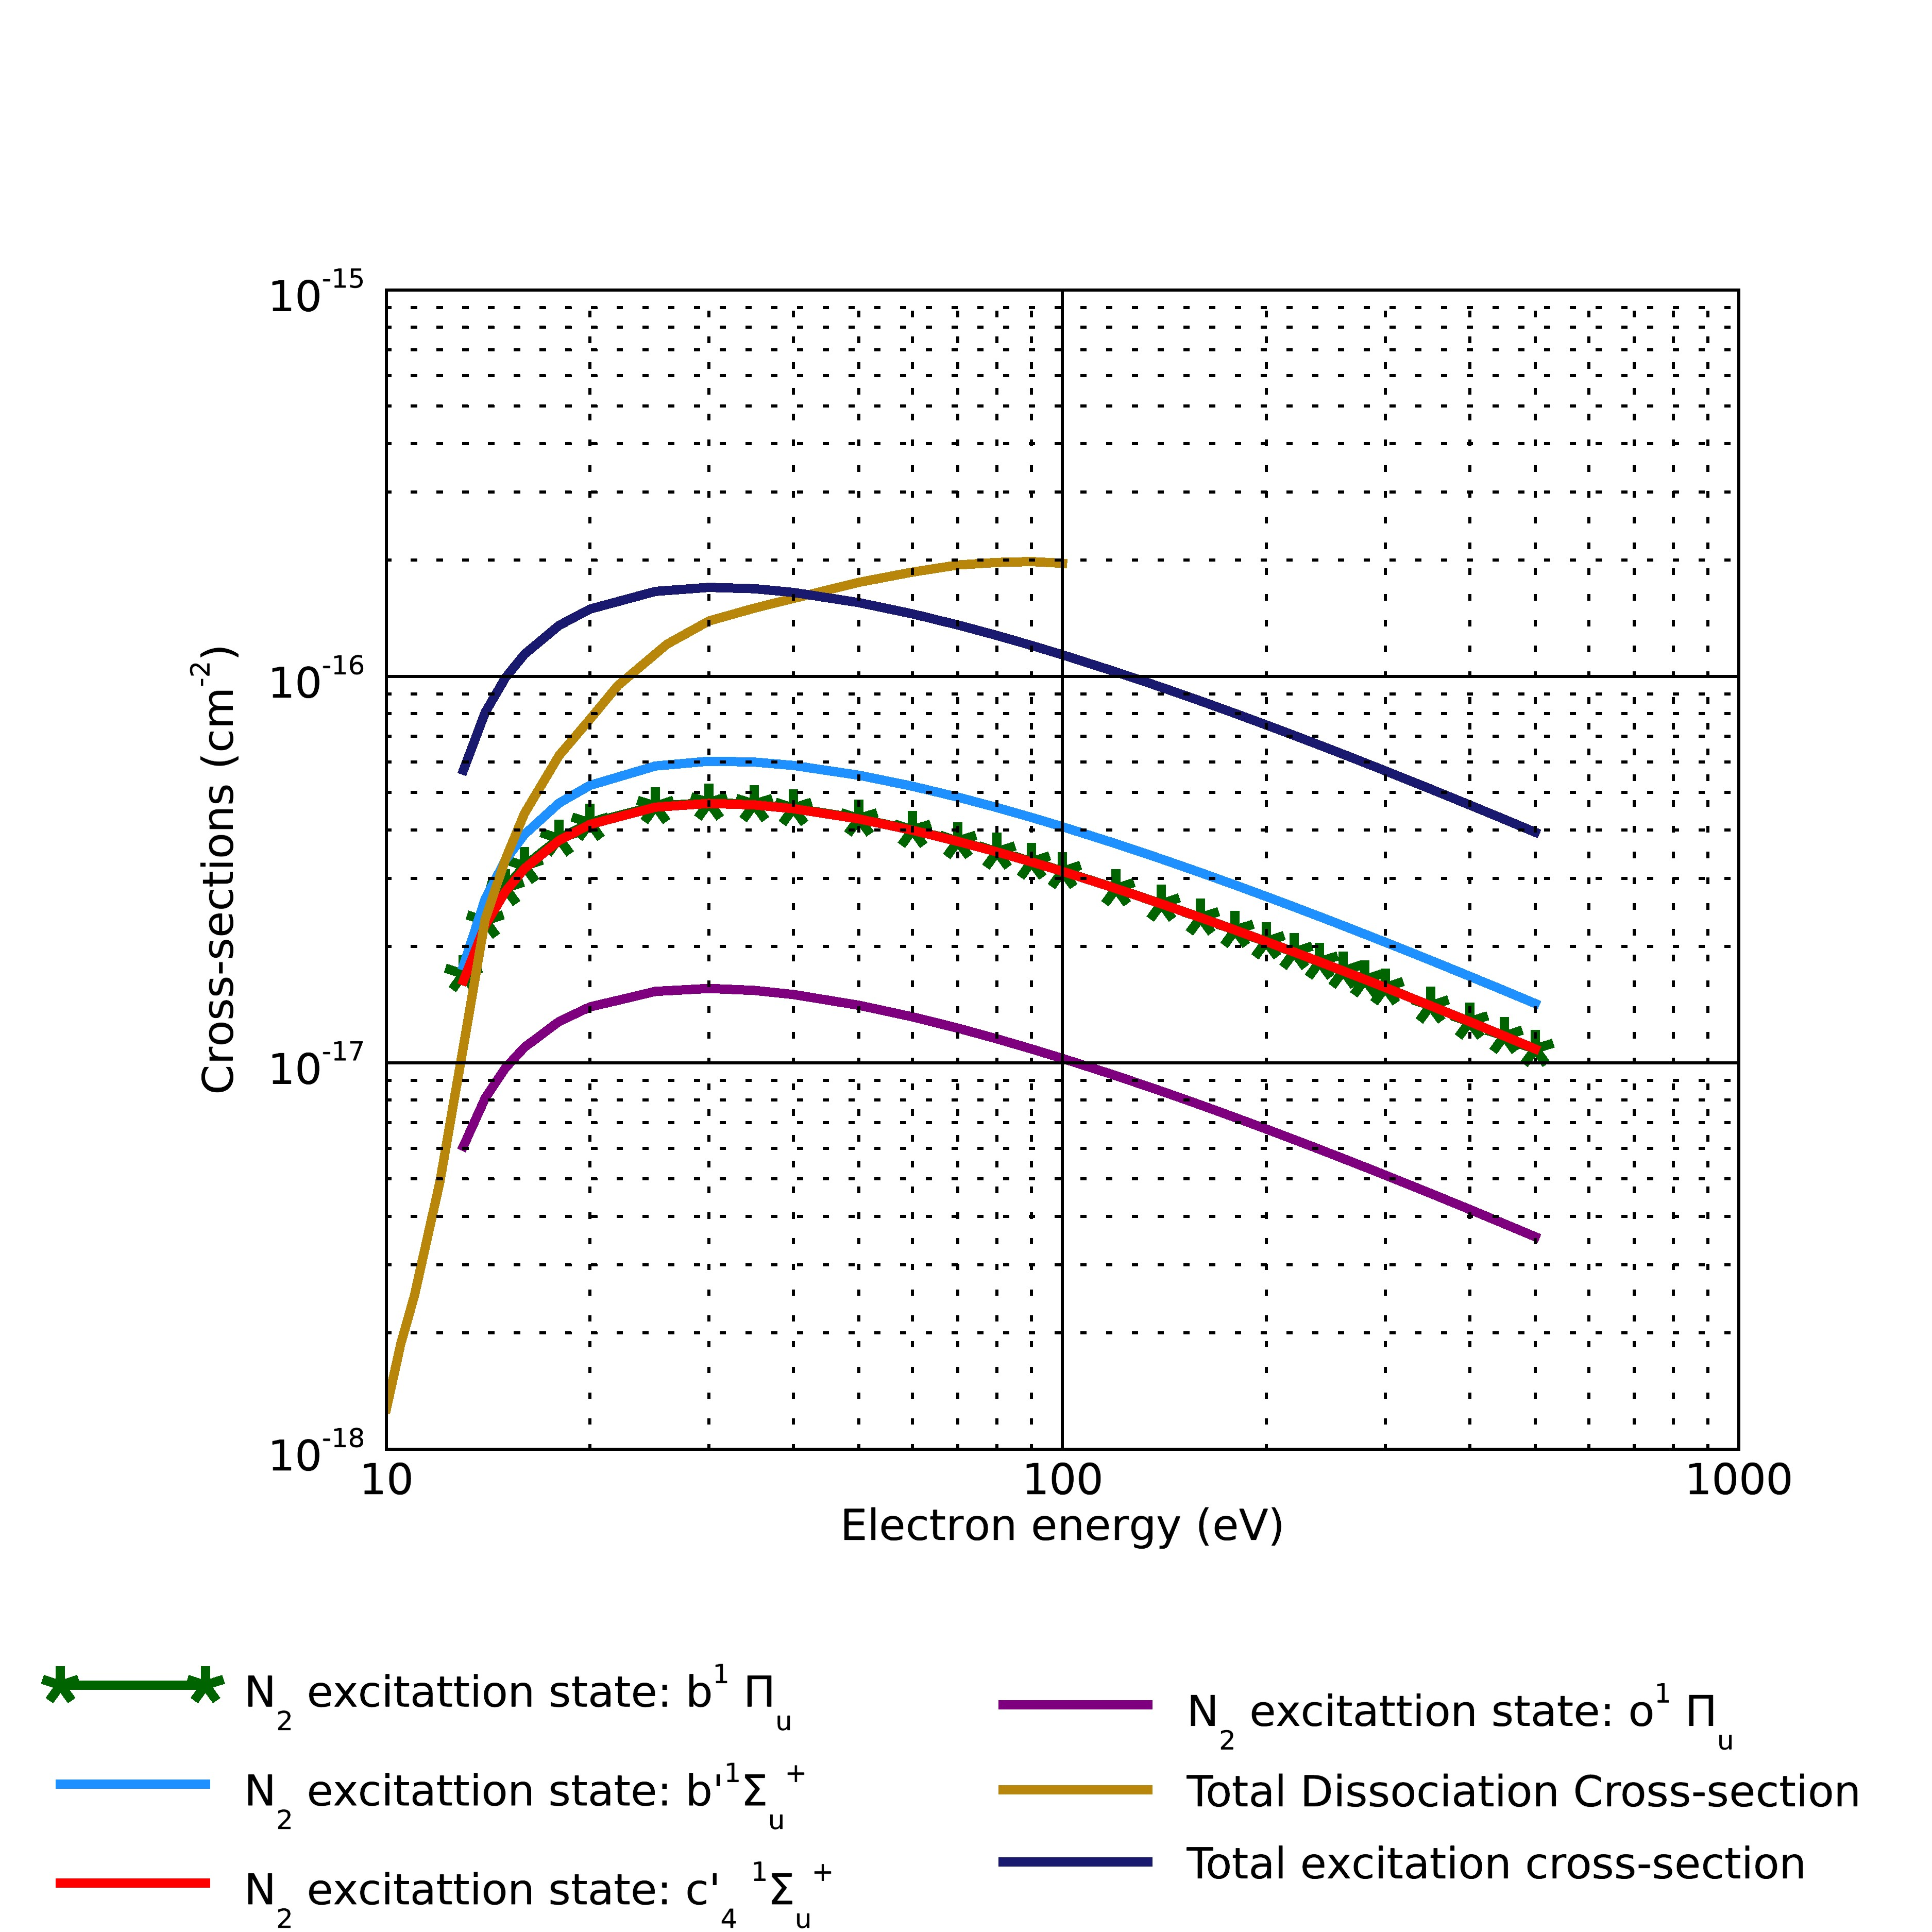

I have compared the total dissociation cross-sections for optically thin conditions. From the last figure in the panels above, we see that the excitation states considered here accounts for most of the dissociation of N₂

If we get the emission cross-section of these states and then find the ratio of the excitation and the emission cross-sections, that should give us an estimate of the pre-dissociation branching ratios.

The b 1Pi_u state

Relationship between cross-section and energy: (Shemansky 1985)

Ajello (1989) has the collision strength fitting function: I used this collision strength and the fitting constants from the James 1990 paper for the excitation cross-sections and the collision strengths plots given below:

The collision strength is similar to the plot given in the paper (James 1990 figure 9). The excitation cross-section is ~10 times more than what is plotted in the paper. This is probably because there is dimensionality mismatch in the equations provided which I am trying to understand.
The paper lists the pre-dissociation, which is the ratio of the emission cross-section and the emission cross-section for different vibrational states of the b-X band. The b 1Pi_u state predissociates about 95% from this result.

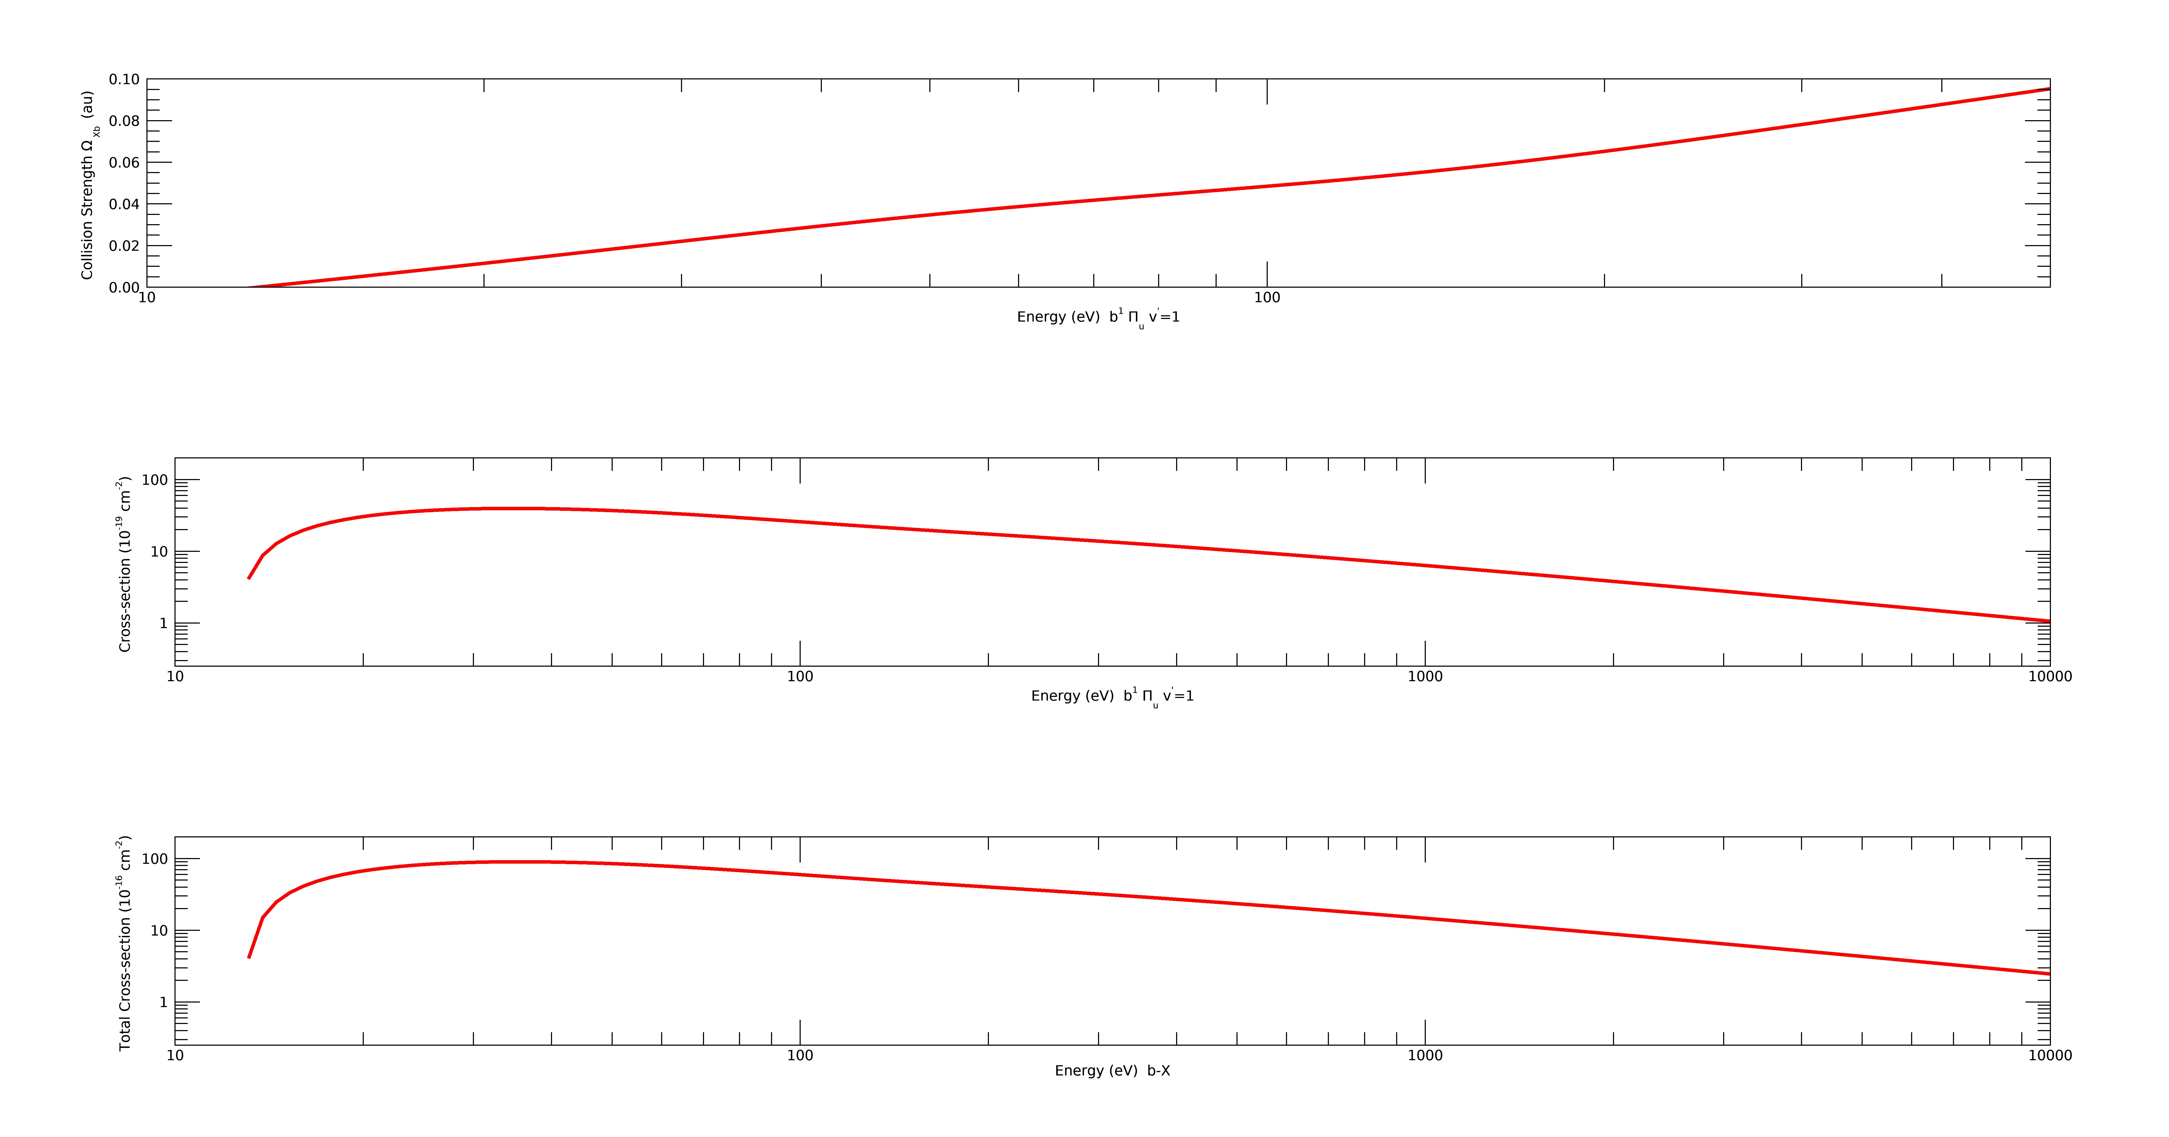

lower states T₀ (eV) Predissociation
branching ratio
A ³Σ_{u}⁺ 6.169
B ³П_{g} 7.353
W ³∆_{u} 7.362
B’ ³Σ_{u}⁻ 8.165
a’ ¹Σ_{u}⁻ 8.399
a ¹П_{g} 8.549 12% Ajello 1985
w ¹∆_{u} 8.890
C ³П_{u} 11.032
E ³Σ_{g}⁺ 11.875
a’’ ¹Σ_{g}⁺ 12.255

Upper states T₀(eV) Predissociation
branching ratio

b ¹П_{u} 12.500 0.97(ZM’78),0.949(James’90)
c’₄ ¹Σ_{u}⁺ 12.935 v’=0-4 ratio=0.15, v’=5-7 ratio =0.95 (ZM’78), 0 James’90, .10 (A’89)
b’ ¹Σ_{u}⁺ 12.854 0.83 (ZM’78), (0.84 A’89)
c ¹П_{u} 12.91 0.99(ZM’78)
o ¹П_{u} 13.1 0.99(ZM’78)
e ¹П_{u} 14.33 0.99(ZM’78)
e’ ¹Σ_{u}⁺ 14.35 0.99(ZM’78)

F ³П_{u}
G ³П_{u}

