I. Excitation States of N₂ in the current PE Model:
Our current PE model Has the following excitation states

A 6.17 eV
BW 8.16 eV
B’ 11.03 eV
C’ 8.40 eV
aa’w 12.85 eV
1Pu 14.00 eV
b’ 13.75 eV
Ryds 1.85 eV
vib 0. eV

I have assumed all states above 12.5 eV dissociates

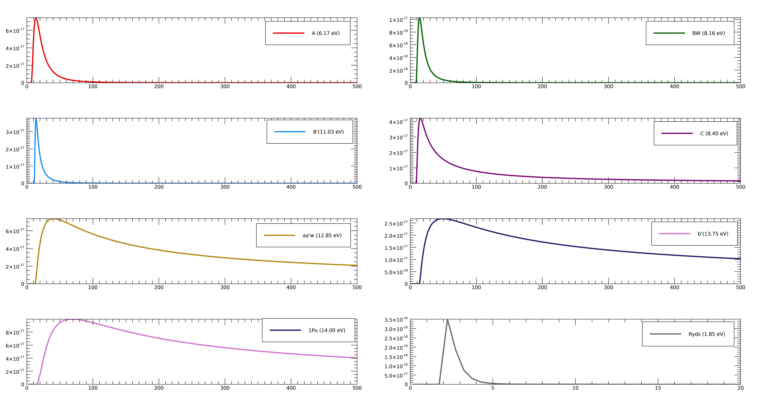
Fig 1: Cross-section (cm²) vs Energy(eV) diagram of excitation states of N₂ in our current model

- Itikawa_2005-
This paper has a compilation of cross-sections for different cross-sections as follows:
Total Cross-sections:
1. Elastic Scattering cross-sections
2. Momentum-transfer cross-sections
3. Rotational Cross-sections
4. Vibrational Cross-sections
5. Excitation of Electronic States
6. total dissociation cross-sec

These are the lower states less than 12.5 eV. There are table summaries for energy vs. cross-sections for the lower excited states which are plotted below.

Excitation of Electronic States

lower states To (eV)
A 3Sigma_u+ 6.169
B 3Pi_g 7.353
W 3Delta_u 7.362
B’ 3 Sigma_u- 8.165
a‘ 1Sigma_u- 8.399
a 1Pi_g 8.549
w 1Delta_u 8.890
C 3Pi_u 11.032
E 3Sigma_g+ 11.875
a’’ 1Sigma_g+ 12.255

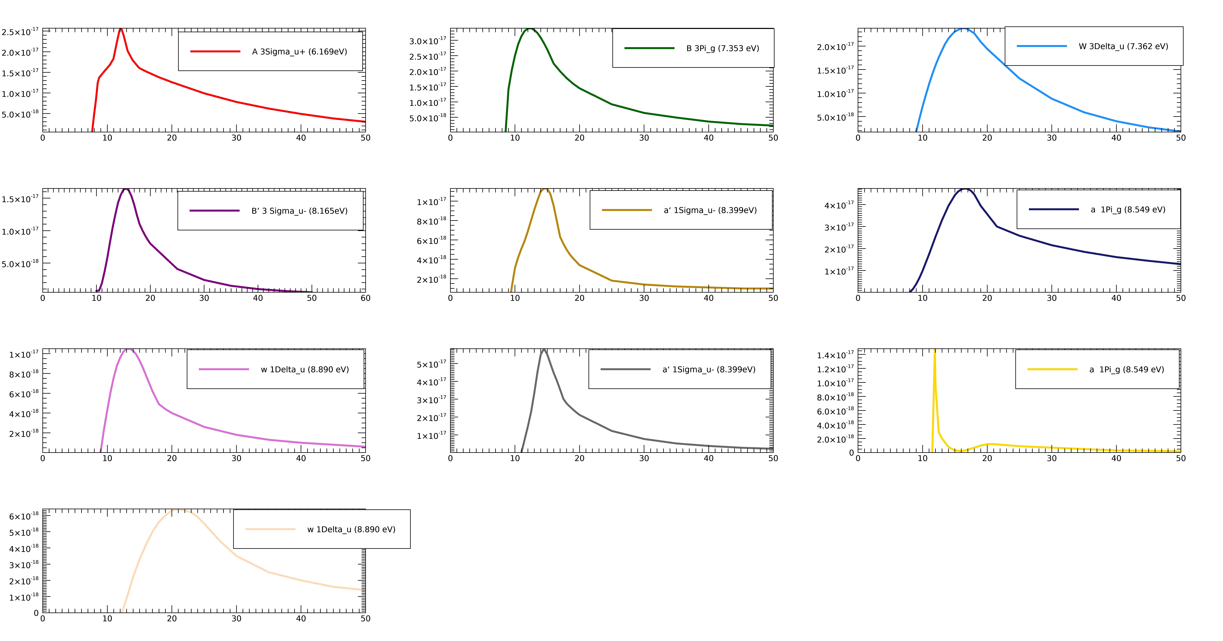
There are upper states which have threshold energies greater than 12.5 eV. The paper only has plots for these states.
upper states

b 1Pi_u 12.500
c’4 1Sigma_u+ 12.935
b’ 1Sigma_u+ 12.854

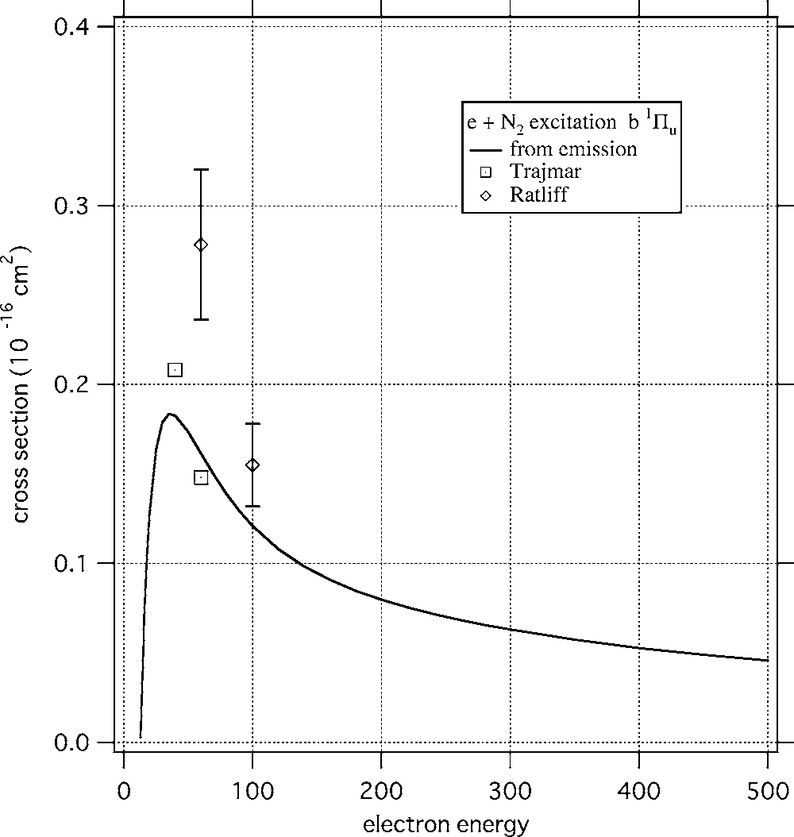
Emission Measure from: ⁶⁸G. K. James, J. M. Ajello, B. Franklin, and D. E. Shemansky, J. Phys. B23, 2055 (1990).

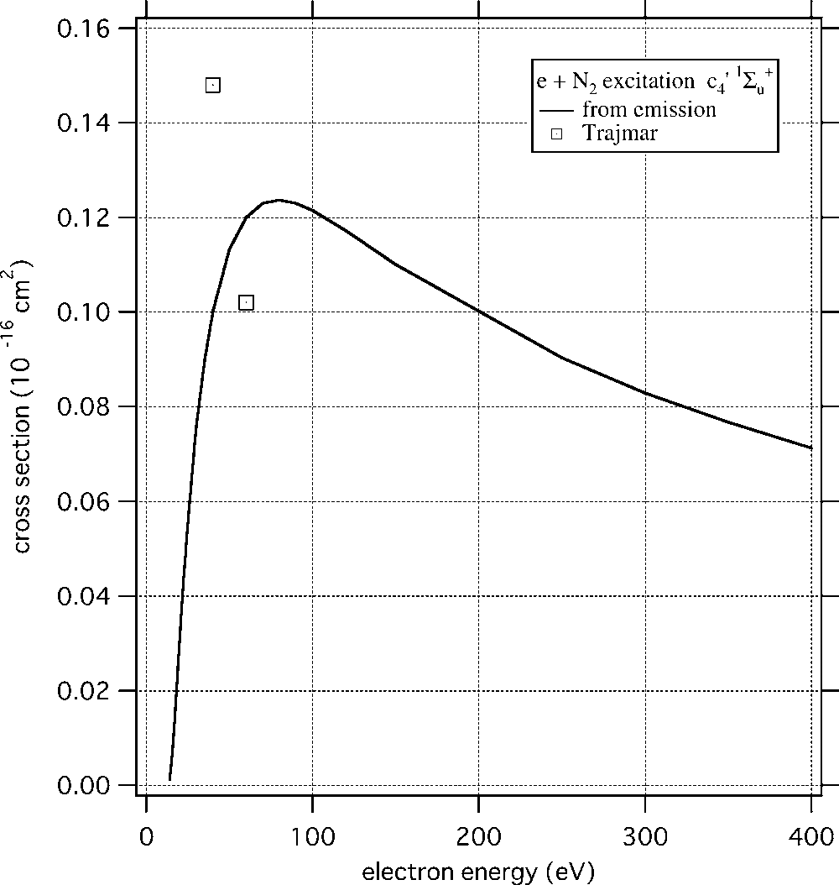
⁷⁰J. M. Ajello, G. K. James, B. O. Franklin, and D. E. Shemansky, Phys.Rev. A 40, 3524 (1989).
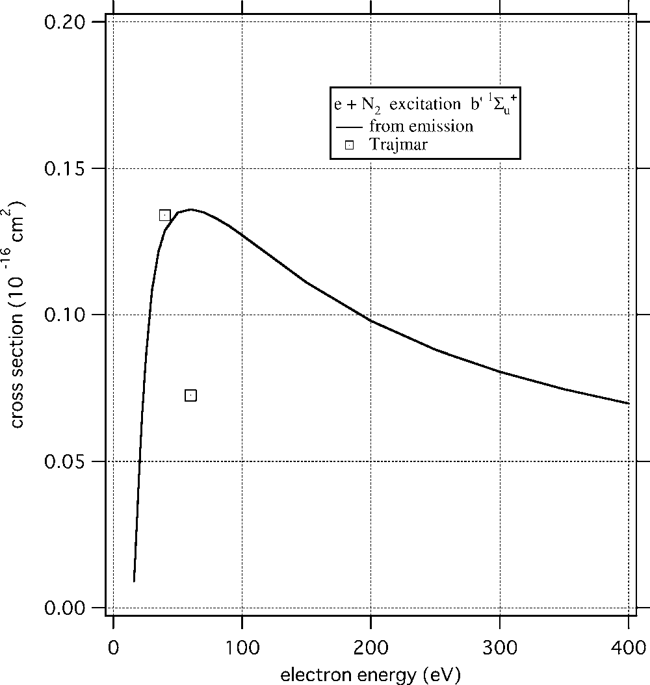
⁷⁰J. M. Ajello, G. K. James, B. O. Franklin, and D. E. Shemansky, Phys.Rev. A 40, 3524 (1989).

Other upper states :
F 3Pi_u
G 3Pi_u
c 1Pi_u
o 1Pi_u

__________________________________________________________________________________________
__________________________________________________________________________________________

The b 1Pi_u state

Relationship between cross-section and energy: (Shemansky 1985)

Ajello (1989) has the collision strength fitting function: I used this collision strength and the fitting constants from the James 1990 paper for the excitation cross-sections and the collision strengths plots given below:

The collision strength is similar to the plot given in the paper (James 1990 figure 9). The excitation cross-section is ~10 times more than what is plotted in the paper. This maybe due to some unit conversion mistake or some normalization mistake that I am making, I am trying to understand the problem.
The paper lists the pre-dissociation, which is the ratio of the emission cross-section and the emission cross-section for different vibrational states of the b-X band. The b 1Pi_u state predissociates about 95% from this result.

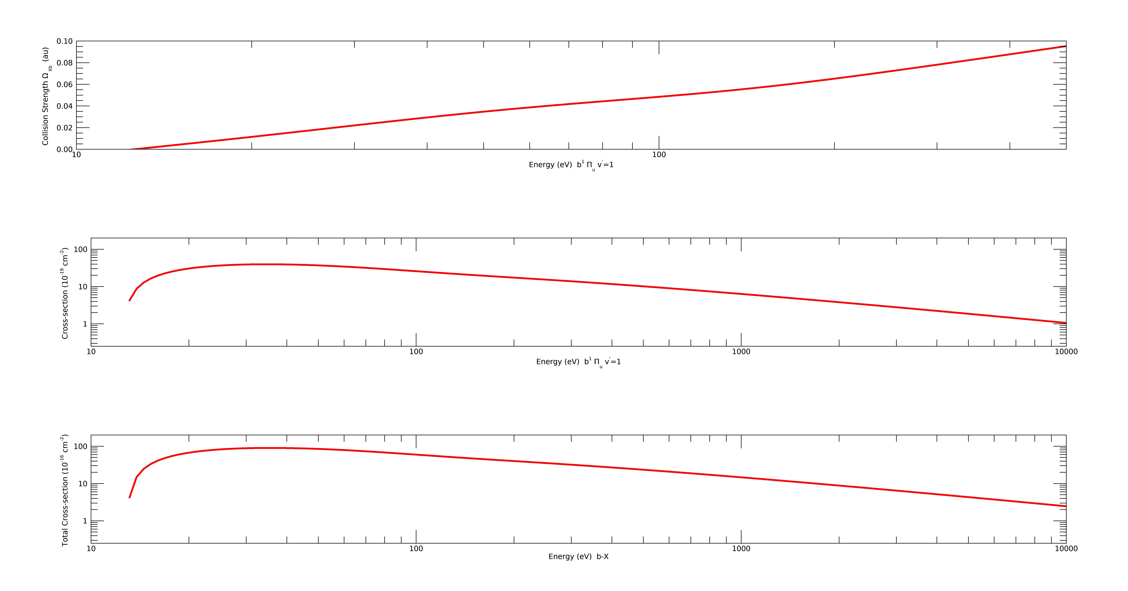
If we compare the excitation cross-sec plot in the third panel above to the one shown below taken from the total emission cross-sections from James et al 1990 paper, then there is a 100 times difference . I am still in the process of identifying the error.

Emission Measure from: ⁶⁸G. K. James, J. M. Ajello, B. Franklin, and D. E. Shemansky, J. Phys. B23, 2055 (1990).

If we can fit the emission and excitation cross-sections for all the higher energy states , then their ratios can give us the dissociation branching ratios

____________________________________________________________________________________________________________________________________________________________________________________

Also, I compared the Itikawa 2005 compilation of the N2 dissociation cross-sections to the Zip McLaughlin 1978 paper and the results are very different. The different states that are included in these two papers are different. Itikawa paper also has electron impact dissociative ionization states added in it.
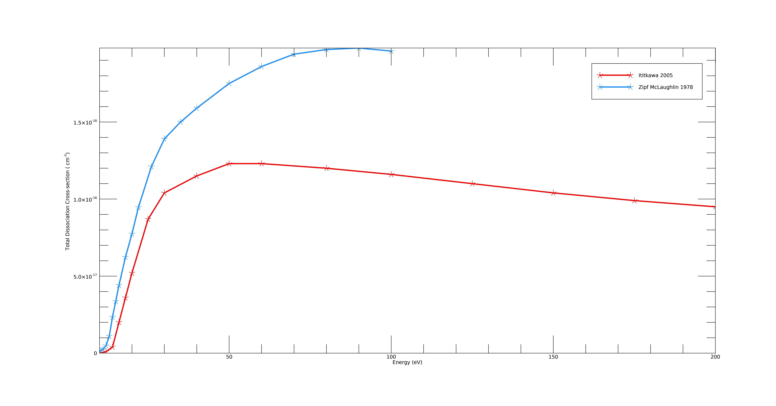

Other references

- ⁶M. J. Brunger and S. J. Buckman, Phys. Rep. 357, 215 (2002)
- ³⁴ M. J. Brunger, S. J. Buckman, and M. T. Elford, in Photon and Electron Interactions with Atoms, Molecules and Ions, Landolt-Börnstein Vol.I/17, Subvolume C, edited by Y. Itikawa (Springer, New York, 2003).
- ⁴⁷Y. Ohmori, M. Shimozuma, and H. Tagashira, J. Phys. D 21, 724 (1988).
- ⁵⁰ D. C. Cartwright, A. Chutjian, S. Trajmar, and W. Williams, Phys. Rev. A16, 1013 (1977).
- ⁵¹ D. C. Cartwright, S. Trajmar, A. Chutjian, and W. Williams, Phys. Rev. A16, 1041 (1977).
- ⁵² S. Trajmar, D. F. Register, and A. Chutjian, Phys. Rep. 97, 219 (1983).
- ⁵³ M. J. Brunger and P. J. O. Teubner, Phys. Rev. A 41, 1413 (1990).
- ⁵⁴L. Campbell, M. J. Brunger, A. M. Nolan, L. J. Kelly, A. B. Wedding, J.Harrison, P. J. O. Teubner, D.C. Cartwright, and B. McLaughlin, J. Phys.B 34, 1185 (2001).
- ⁵⁵ C. J. Gillan, J. Tennyson, B. M. McLaughlin, and P. G. Burke, J. Phys. B29, 1531 (1996).
- ⁵⁶ T. G. Finn and J. P. Doering, J. Chem. Phys. 64, 4490 (1976).
- ⁵⁷N. J. Mason and W. R. Newell, J. Phys. B 20, 3913 (1987).
- ⁵⁸ J. M. Ajello and D. E. Shemansky, J. Geophys. Res. 90, 9845 (1985).
- ⁵⁹M. Zubek and G. C. King, J. Phys. B 27, 2613 (1994).
- ⁶⁰ G. Poparic, M. Vicic, and D. S. Belic, Chem. Phys. 240, 283 (1999).
- ⁶²J. Mazeau, R. I. Hall, G. Joyez, M. Landau, and J. Reinhardt, J. Phys. B6, 873 (1973).
- ⁶³ M. J. Brunger, P. J. O. Teubner, and S. J. Buckman, Phys. Rev. A 37, 3570(1988).
- ⁶⁴M. Zubek, Chem. Phys. Lett. 146, 496 (1988).
- ⁶⁵G. Poparic, M. Vicic, and D. S. Belic, Phys. Rev. A 60, 4542 (1999).
- ⁶⁶G. Poparic, M. D. Vicic, and D. S. Belic, Phys. Rev. A 66, 022711 (2002).
- ⁶⁷A. Chutjian, D. C. Cartwright, and S. Trajmar, Phys. Rev. A 16, 1052(1977).
- ⁶⁸G. K. James, J. M. Ajello, B. Franklin, and D. E. Shemansky, J. Phys. B23, 2055 (1990).
- ⁶⁹J. M. Ratliff, G. K. James, S. Trajmar, J. M. Ajello, and D. E. Shemansky,J. Geophys. Res. 96, 17559 (1991).
- ⁷⁰J. M. Ajello, G. K. James, B. O. Franklin, and D. E. Shemansky, Phys.Rev. A 40, 3524 (1989).

