Comparisons of SQ05 and NRLX28

The plots for SQ’05 are made by using the Table A1 of the paper to get the solar flux bins.

I took the f10.7=70 as mentioned in the plots

For the electron impact ionisation, the local and transport calculations match till 300 km, then the local calculations fail because at these altitudes we have to take transport into consideration.

The photoionization plots also match the SQ05 fig 5

The transport pe/pi matches the fig 4 but the local calculation fails above 270 km

For the X28 Nrl flare, we see the similar results in the local and transport calculation trend. Here also the local calculation fails at 300km for electron impact ionisation and the pe/pi at 270 km.

Also, looking at the mean free path vs altitude for three different energy bins, it becomes 10s km at above 100km and the altitude bins are 2km wide, so, the transport is important in the flux calculation.

So, the first conclusion is, that the model can reproduce the SQ05 results to a good precision.

Secondly, it is better to use the transport calculation for the electron impact ionisation for all the altitude ranges.

So we cannot use the local calculations for high altitudes because the transport terms come into play when we add high energy bins.

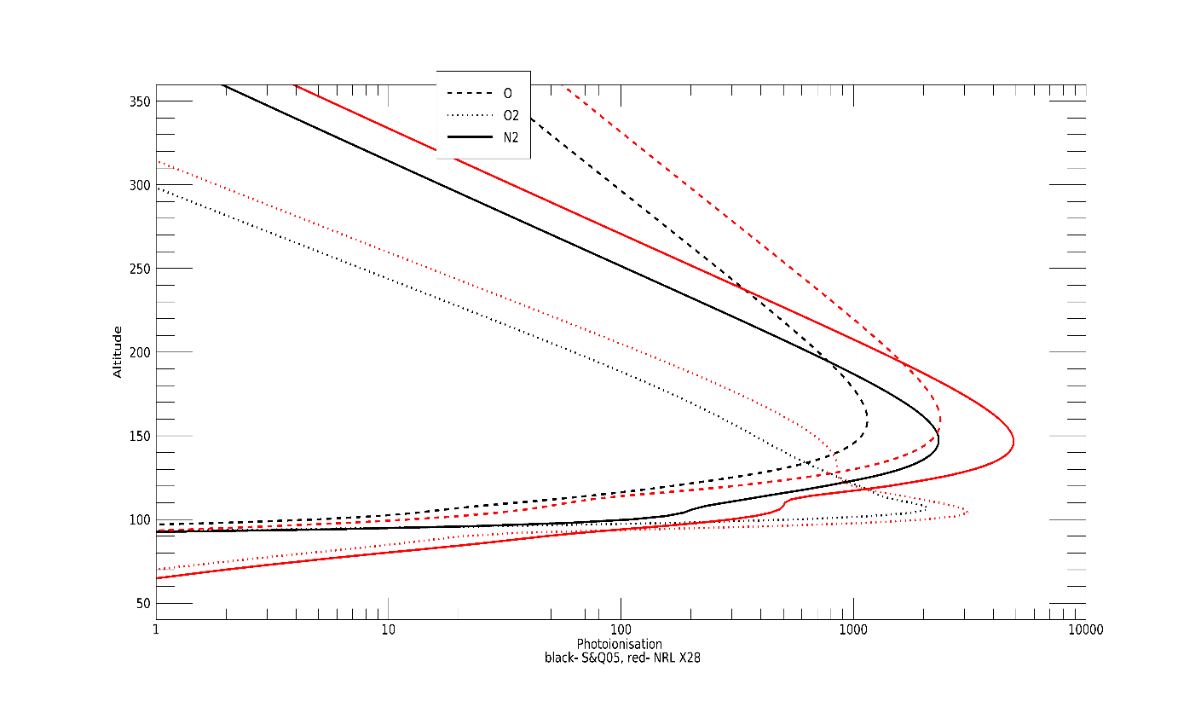

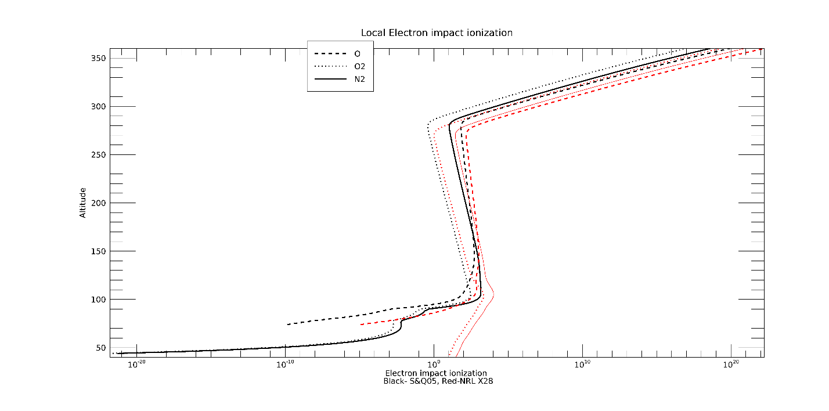

Comparisons of SQ05 and NRL plots

The photoionisation, electron impact ionization and the pe/pi ratios are higher for the NRL spectrum than the SQ’05. We have more fine bins in the NRL spectrum than the SQ bins. Also, we have more photoionisation states that we added for the NRL spectrum.

The pe/pi ratios for the SQ and the NRL match till ~120 km for O2 (from 350 km ), 160 km for O and ~120 km for N2

The electron impact ionisation (transport) for SQ and NRL are similar for O, till ~120 km for O2 and N2

The comparison of the transport flux and local flux for SQ and NRL, are also different. The difference is maximum at the lowest altitude (60 km), which accounts for the difference in altitude in electron impact ionisation rate and pe/pi ratios.

The ratio of the transport flux and local flux is ~1 for middle altitudes and energies <~10 keV. The ratio is < 1 from high altitudes , around 240 km and higher energies.

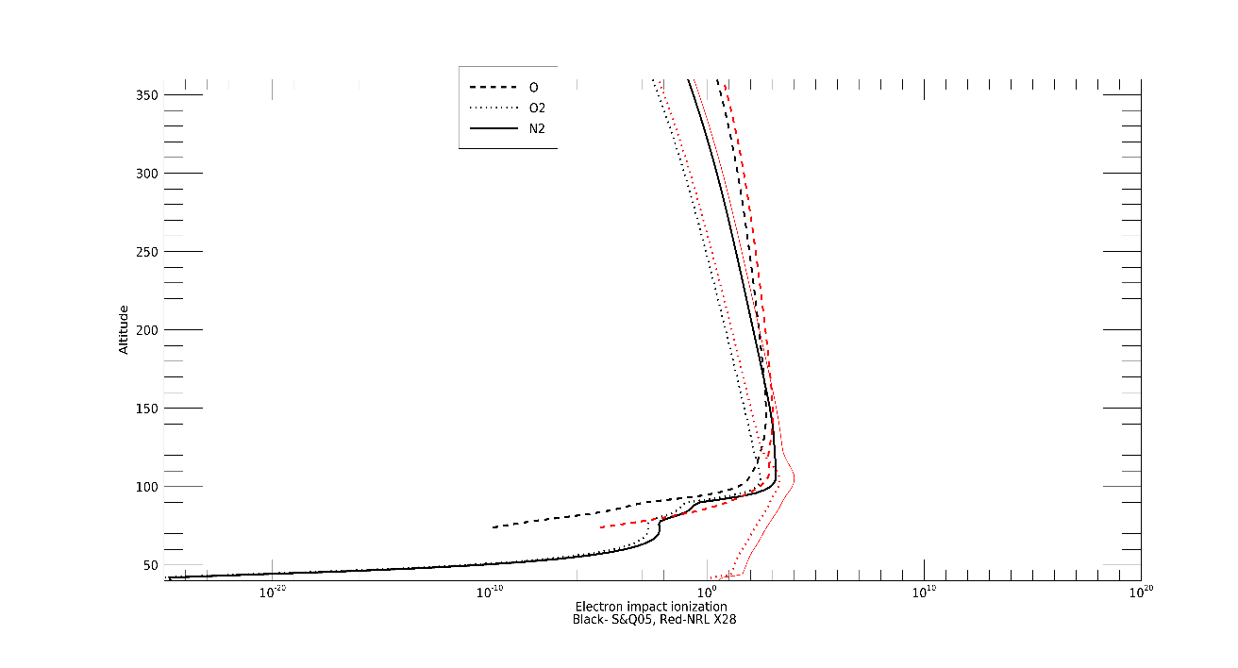 Transport electron impact ionisation

