SYSTEM VALIDATION FINAL REPORT

Author 1 (#)

Author 2 (#)

Author 3 (#)

Author 4 (#)

16th October 2015

# Introduction

The purpose of this document is to design and validate an Automated Railroad Crossing System (ARCS). The goal of the system is to provide a fully automated and failsafe method for monitoring a railroad intersection to avoid accidents.

The primary functionality of the system is to monitor the intersection for the arrival and departure of trains using an array of train sensors on either side of the intersection and actuate the traffic signals, barriers, warning lights and alarms based on the data from the train sensors. The system also takes into account the failure of a train monitoring sensor, which is treated as a critical failure causing the system to enter the failsafe mode, thereby closing the barriers and switching the signals to red until the sensors are replaced and the system is reset.

The possibility of two trains approaching the intersection has also been addressed to and the behavior is designed such that a safe sequence of barrier actions and signals are followed. The rest of the document gives a formal description of the system, the system model and the verification of the requirements using the mCRL2 toolset.

# List of Requirements

# List of External Actions

# Requirements Expressed in terms of Actions

# Architecture

# List of Internal Actions

# Model of the System

# Requirements in terms of Modal Formulas

# Verification

The requirements translated into modal formulas are verified using the mCRL2 toolset. The verification is done as follows:

1. mCRL2 toolset is installed.
2. The model is saved with a .mcrl2 extension.
3. The modal formulas are saved with a .mcf extension.
4. A Parameterized Boolean Equation System is created.
5. The validity of the .pbes file is checked using pbes2bool operation
6. The output will be true of the formula is valid.

A Python script (“Checking_Script.py”) was written to automatically verify all the requirements against the .mcrl2 file sequentially.

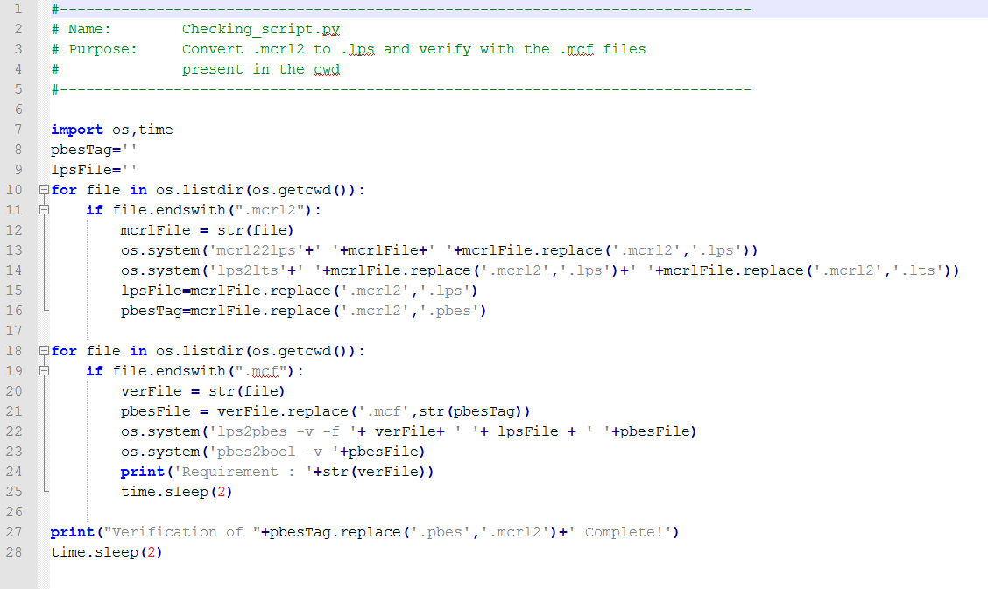

# Conclusions

# References

1. J.F.Groote and M.R.Mousavi, “Modelling and Analysis of Communicating Systems”, 2013.
2. mCRL2 201210.1 documentation (http://www.mcrl2.org/release/user_manual/user.html)