**Queries:**

**DataBase:**

CREATE DATABASE <database_name>;

CREATE DATABASE rajesh_database;

DROP DATABASE <database_name>;

**Table:**

CREATE TABLE <table_name>(<column 1><data_type1>,<column 2><data_type2>,);

CREATE TABLE employee_tbl (emp_id integer not null primary key, emp_name varchar(20));

CREATE VIEW <view_name> as <query>

CREATE VIEW v_name as select* from employee_tbl;

//it will call directly employee_tbl

ALTER VIEW <viename> AS ...query...;

DROP VIEW <viewname>;

CREATE INDEX <index_name> on <table_name>;

CREATE INDEX i_name on employee_tbl (emp_id);

CREATE CLUSTERED INDEX <index_name> on <table_name>;

CREATE CLUSTERED INDEX i_name on employee_tbl (emp_id)

ALTER TABLE <table_name> ADD <name> <datatype>;

ALTER TABLE employee_tbl ADD emp_phone integer;

ALTER TABLE <table_name> MODIFY <name> <datatype> AFTER <name2>;

ALTER TABLE employee_tbl MODIFY emp_phone integer AFTER id;

ALTER TABLE <table_name> ALTER COLUMN <name> <datatype>;

ALTER TABLE employee_tbl ALTER COLUMN emp_phone varchar(10);

ALTER TABLE <table_name> CHANGE COLUMN <old_name> <newname><datatype>;

ALTER TABLE employee_tbl CHANGE COLUMN emp_phone empp_phone varchar(10);

ALTER TABLE <table_name> DROP COLUMN <name> <datatype>;

ALTER TABLE employee_tbl DROP COLUMN emp_phone integer;

ALTER TABLE <table_name> RENAME TO <newtablename>;

ALTER TABLE employee_tbl RENAME TO employee_table;

TRUNCATE TABLE <tablename>;

DROP TABLE <tablename>;

DELETE (FROM)<tablename>;

RENAME TABLE <oldtablename> TO <newtablename>;

Truncate will remove data from table, Drop will remove tables and databse

**Inserting data:**

INSERT INTO <table_name> (<column1,column2,…>) VALUES (<values1>,<values2>)

INSERT INTO employee_tbl (emp_id,emp_name) VALUES (01,’rajesh’);

INSERT INTO <table_name> <column1,column2,…> SELECT *FROM <another_table>

INSERT INTO employee_tabl2 (emp_id,emp_name) SELECT *FROM employee_tbl;

INSERT INTO <table_name> (value1, value2)

INSERT INTO employee_tbl (02,’ ’);

INSERT INTO employee_tbl (02,NULL); //these two are called null only

**Updating data:**

UPDATE table_name SET column value WHERE condition

UPDATE employee_tbl SET emp_name ‘ganesh’,emp_name=”vignesh” WHERE emp_id=02,emp_id=03;

**Deleting:**

DELETE FROM <table_name>

DELETE FROM employee_tbl //delete all records in table

DELETE FROM <table_name> WHERE condition

DELETE FROM employee_tbl WHERE id=01;

**Selecting:**

SELECT ALL <coloum_name> FROM <table_name>

SELECT ALL emp_name FROM employee_table;

**Special Selecting:**

DISTINCT

ORDER BY

GROUP BY

LIKE

NOT LIKE

IN

NOT IN

IS NULL

IS NOT NULL

BETWEEN

LIMIT

SELECT DISTINCT <column_name> FROM <table_name>

SELECT DISTINCT emp_name FROM employee_tbl; //does not show repeated values

SELECT *FROM <table_name> WHERE <column_name> ORDER BY <value> ASC

SELECT *FROM employee_tbl WHERE emp_id=01 ORDER BY emp_name ASC

SELECT *FROM <table_name> WHERE <column_name> ORDER BY <value> DESC

SELECT *FROM employee_tbl WHERE emp_id=01 ORDER BY emp_name DESC

SELECT <column_name> FROM <table_name> GROUP BY <value> //ascending sorting

SELECT salary FROM employee_tbl GROUP BY salary,emp_name; //not display identical

SELECT * FROM <tablename> WHERE <column_name> LIKE “%rajesh%”;

SELECT * FROM <tablename> WHERE <column_name> NOT LIKE “%rajesh%”;

SELECT * FROM <tablename> WHERE <column_name> IN (‘muthu’,’rajesh’);

SELECT * FROM <tablename> WHERE <column_name> NOT IN (‘muthu’,’rajesh’);

SELECT * FROM <tablename> WHERE <column_name> IS NULL;

SELECT * FROM <tablename> WHERE <column_name> IS NOT NULL;

SELECT * FROM <tablename> WHERE <column_name> BETWEEN 1 AND 3;

SELECT * FROM <tablename> LIMIT 2;

**Datatype:**

|  |  |  |
| --- | --- | --- |
| Integer | BigInt  Int  SmallInt  TinyInt  MediumInt | 9*1019  2*109  -32768 to 32768  0 to 255  -8388608 to -8388608 |
| Real | Bit  Decimel  Float  Real  Double  Boolean  Serial | 0,1  1.0000  1.0000000  1  1.0000000000000  TRUE FALSE |
| String | Char  VarChar  Text  MediumText  LongText  Binary  VarBinary | 65,535 chars  16777215 chars  4,294,967,295 chars |
| Date | Date  DateTime  TimeStamp  Time  Year | YYYY-mm-dd  YYYY-mm-dd hh:mm:ss  YYYY-MM=DD HH:MM:SS  hh:mm:ss  YY or YYYY |
| Large object | TinyBlob  Blob  MediumBlob  LongText |  |
| Spactial | Geometry  Point  LinString  Polygon  MultiPoint  MultiLineString  MultiPolygon  Geometry colleation |  |

Int, VarChar,Text, Date

Numeric : TinyInt, SmallInt, MediumInt, Int, BigInt, Decimel, Float, Double, Real, Bit, Boolean, Serial

DataTime: Date, DateTime, TimeStamp, Date, Year

String:Char, VarChar, TinyText, Text, MediumText,LongText,Binary,VarBinary, TinyBlob, MediumBlob, TinyBlob,Blob, Enum, Set

Spactial: Geometry, Point, LinString, Polygon, MultiPoint, MultiLineString, MultiPolygon, GeometryCollection

**Operator:**

Comparision operator

|  |  |  |
| --- | --- | --- |
| = | Equality | SELECT * FROM employee_tbl WHERE id=1000 |
| <> | Non Equality | SELECT * FROM employee_tbl WHERE i<>1000 |
| < | Less than | SELECT * FROM employee_tbl WHERE id >1000 |
| > | Greater than | SELECT * FROM employee_tbl WHERE id <1000 |
| <= | Less than or Equal to | SELECT * FROM employee_tbl WHERE id <= 1000 |
| >= | Greater than or Equal to | SELECT * FROM employee_tbl WHERE id >= 1000 |
| AND |  | WHERE id<1000 AND salary > 2000 |
| OR |  | WHERE id<1000 AND salary > 2000 |

**Logical Operator** 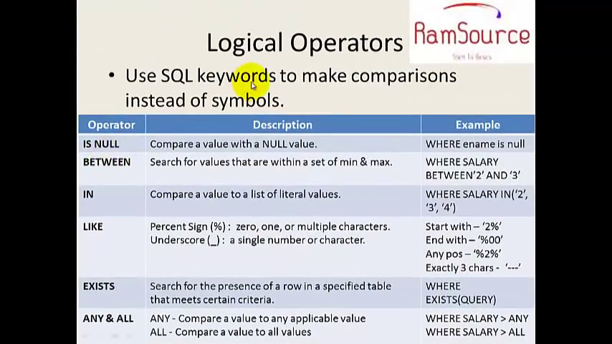

SELECT * FROM employee_tbl WHERE emp_name IS NULL;

SELECT *FROM employee_tbl WHERE salary BETWEEN 10 AND 20;

SELECT *FROM employee_tbl WHERE salary IN (10,20);

SELECT *FROM employee_tbl WHERE emp_name LIKE‘r%’,’%r’,’%r%’

SELECT *FROM employee_tbl WHERE emp_name LIKE ‘___’;

SELECT *FROM employee_tbl WHERE emp_name LIKE ‘___%’,’%___’;

SELECT emp_name FROM employee_tbl obj1 WHERE EXISTS

(SELECT * FROM employee_tabl2 obj2 WHERE OBJ2.emp_id=03 AND obj1.id=obj2.id)

SELECT * FROM employee_tbl WHERE salary >ALL

(SELECT * FROM employee_tbl WHERE salary< 15000) //compare to that <15000 condit

SELECT * FROM employee_tbl WHERE salary >ANY

(SELECT * FROM employee_tbl WHERE salary< 15000) //compare to lowest value

Negative Operator- NOT BETWEEN, NOT IN, NOT LIKE, IS NOT NULL, NOT EXISTS

Arithmatic Operator- +, -, *, /

SELECT salary+20000 FROM employeee_tbl WHERE emp_name=’rajesh’;

SELECT salary-200 FROM employeee_tbl WHERE emp_name=’rajesh’;

SELECT salary*2 FROM employeee_tbl WHERE emp_name=’rajesh’;

SELECT salary/2 FROM employeee_tbl WHERE emp_name=’rajesh’;

**Aggregate Function:**

|  |
| --- |
| SELECT COUNT (*) AS newcolumn_name,  SUM (salary) AS sum_name,  MAX (salary) as maxcolumn_name;  MIN (salary) as mincolumn_name;  AVG (salary) as avgcolumn_name; |

SUM- return total of values in column

COUNT- count rows donot contain null

MAX-return max value from group of rows

MIN-return min value from group of rows

AVG- return average value

Group by:

SELECT <column_name> FROM <table_name> GROUP BY <value> //ascending sorting

SELECT salary FROM employee_tbl GROUP BY salary,emp_name; //not display identical

Order by:

SELECT <column_name> FROM <table_name> ORDER BY <value> //ascending sorting

SELECT salary FROM employee_tbl ORDER BY salary,emp_name; //not display identical

Having:

HAVING <value> <condition>;

Ex. SELECT SUM(salary) AS sum_name FROM emp_tbl GROUP BY salary

HAVING salary>15000 ORDER BY sum_name //orderby do same as groupby

**Join**:

1.cross join : without condition

2.Inner join (or) Equi join

3.Non equi join – compare each row in first table with all row in 2nd table

4.Outer join – a)Left outer join b)right outer join

5.Self join

6.Union,Union All

7.Intersect, Expect

**Cross Join:**without condition

SELECT e.ename s.sname FROM employee_tbl AS e CROSS JOIN employe_tbl2 AS s

//4 rows in E and 3 rows in S so output is 28 rows

**Inner Join:** join with condition

SELECT E. emp_id,E.emp_name,S.emp_id,S.emp_name

FROM employee_tbl E INNER JOIN employee_tbl2 S ON E.emp_id=S.emp_id //AS no need

//output is printing same equal name in both S and E

**Non Equi Inner Join**

SELECT E. emp_id,E.emp_name,S.emp_id,S.emp_name

FROM employee_tbl E INNER JOIN employee_tbl2 S ON E.emp_id<>S.emp_id

//ouput is 27 rows not display that one equal cond row

**Left Outer Join:**

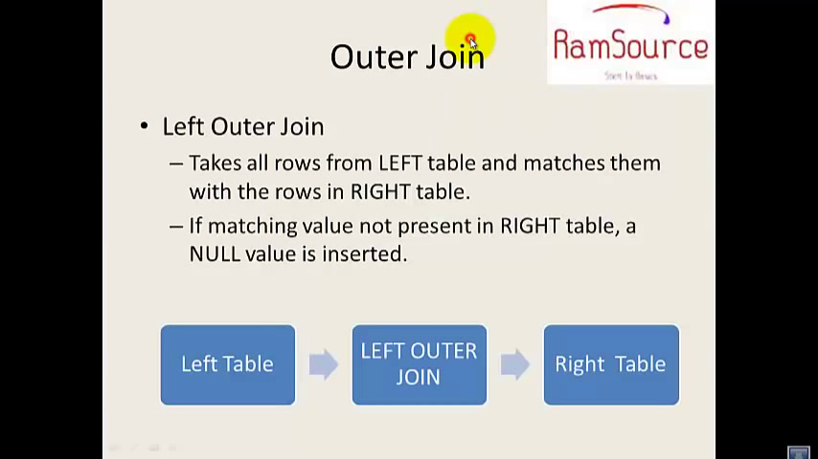

SELECT E.emp_id, E.emp_name, S.dname

FROM employee_tbl E LEFT OUTER JOIN employee_tbl2 S

ON E.emp_id=S.emp_id

//match left table with right and display null if right table not have left table values

**Right Outer Join:**

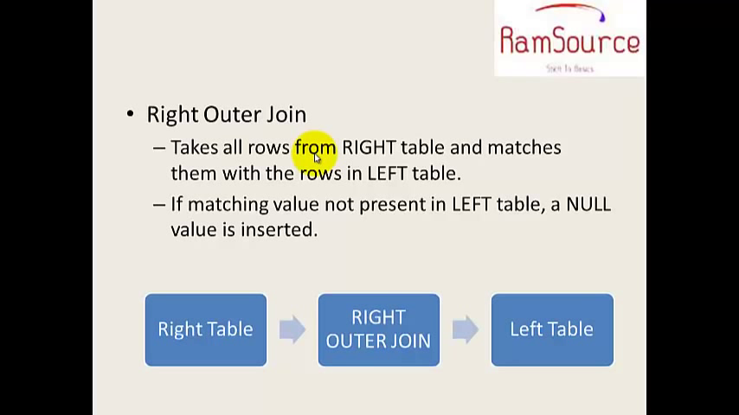

just opposite to left outer join

**Self Join:**

SELECT E.ename, E1.ename as mname //mname for not to confuse while output

FROM employee_tbl E, employee_tbl E2 //same table diff alieas name

WHERE E.eid=E1.mid

**Union and Union All:**

SELECT emp_name FROM employee_tbl UNION SELECT emp_id FROM employee_tbl2

/display name and id shuffled

SELECT emp_name FROM employee_tbl UNION SELECT emp_name FROM employee_tbl2

**Intersect:**

SELECT e_name FROM employe_tbl INTERSECT SELECT m_name FROM employe_tbl2

//display only values which are same

**Except:**

SELECT e_name FROM employe_tbl EXCEPT SELECT m_name FROM employe_tbl2

//display only values in first table

**SUB Query:** ANY, ALL, IF, IF NULL, NULL IF

first inner query will execute and then outer will execute

SELECT E.ename E.city E.salary FROM emp_tbl E

WHERE E.salary >(SELECT salary FROM emp_tbl2 WHERE saalry<15000)

INSERT INTO emp_tbl SELECT E.eid, E.ename, E.salary

WHERE E.salary >(SELECT salary FROM emp_tbl2 WHERE salary <15000 )

UPDATE emp_tbl SET salary =salary+5000

WHERE eid IN (SELECT eid FROM emp_tbl2 WHERE city=’chennai’)

DELETE FROM emp_tbl

WHERE eid=(SELECT eid FROM emp_tbl2 WHERE ename=’rajesh’)

**Embedded Sub Query:**

SELECT E.eid ,E.ename, E.salary FROM emp_tbl E

WHERE E.eid IN (SELECT ED.eid FROM emp_tbl2 ED

WHERE eid=(SELECT EP.eid FROM emp_tbl3 EP

WHERE salary=15000 ))

**Foriegn Key:**

create table stu_table

(r_emp_id int(2),

FOREIGN KEY (r_emp_id) REFERENCES emp_table (emp_id),

stu_id int(2) AUTO INCREMENT,

stu_name (2) VARCHAR(30) NULL);

**Character Function:**  
Concatenation: SELECT ‘muthu’+’rajesh’

Replace: SELECT city REPLACE(city, ‘mum’,’bom’) FROM emp_tbl; //bombai mumbai

Uppercase: SELECT city UPPER(cityname) FROM emp_tbl; //mumbai MUMBAI

Lowercase SELECT LOWER(cityname) FROM emp_tbl; //MUMBAI mumbai

Substring: SELECT SUBSTRING(ename,1,3) FROM emp_tbl; //rajesh raj

Length: SELECT ename, LEN(ename) FROM emp_tbl; //rajesh 5

Absloute: SELECT ABS(emp_id) as absolutecolumn_name FROM employee_tbl;

Ceiling: SELECT CEILING(emp_id) as absolutecolumn_name FROM employee_tbl;

Floor: SELECT FLOOR(emp_id) as absolutecolumn_name FROM employee_tbl;

Squareroot: SELECT SQRT(emp_id) as absolutecolumn_name FROM employee_tbl;

Power: SELECT POWER(emp_id,2) as absolutecolumn_name FROM employee_tbl;

Date Functions:

SELECT GETDATE();

SELECT DATEADD(DAY,1,DOJ) FROM emp_tbl; date incremented by value 1

SELECT DATEADD(MONTH,2,DOJ) FROM emp_tbl; month incremented by value 2

SELECT DATEADD(YEAR,3,DOJ) FROM emp_tbl; year incremented by value 3

SELECT DATENAME (MONTH,DOJ) FROM emp_tbl; display months in names

SELECT DATEPART(MONTH,1,DOJ) FROM emp_tbl; display months in numbers

Data conversion:

SELECT emp_id= (str)emp_id FROM emp_tbl; //strng typecasting

Cursor:

used to indicate which row, the operation is now. it should open before fetch

DECLARE cursor_name CURSOR FOR SELECT * FROM emp_tbl;

OPEN cursor_name

FETCH cursor_name

CLOSE cursor_name

DEALLOCATE cursro_name

Store Procedure:

CREATE PROCEDURE procedures_name AS SELECT ename,salary FROM emp_tbl

EXEC procedure_name //to execute

DROP PROCEDURE procedure_name //to close

Trigger:

|  |  |
| --- | --- |
| CREATE TRIGGER trigger_name  ON database_name  FOR CREATE_TABLE, ALTER_TABLE, DROP_TABLE  AS  print ‘DDL operation is not allowed, trigger is enable’  ROLLBACK | CREATE TRIGGER trigger_name  ON database_name  FOR insert, delete,update  AS  print ‘DDL operation is not allowed, trigger is enable’  ROLLBACK |
| DISABLE TRIGGER trigger_name ON database_name | DISABLE TRIGGER trigger_name ON database_name |
| DROP TRIGGER trigger_name ON database_name | DROP TRIGGER trigger_name ON database_name |

**Some Fucking extra theories:**

**Aggregate function:** we should use this function before groupby

AVG

COUNT

SUM

MIN

MAX

**Keys:**

1.super key - set attributes identify row

2.candidate key - minimal set of identity rwo

3.Primary key - an attribute identify row

4.Foreign key - column of one table points of onetable points

5.Unique - can have null

6.Secoundary key - might not be unique but we can strill use it identitfier

**Normalisation reduces dublication:**

1.First Normal form

2.Second Normal form

3.Third Normal form

4.Boyce-codd normal function

5.Fourth Normal form

6.Fifth Normal form

DataModels

1. Record Based a)Network model

b)Hierarical model

c)Relational model

2)Object based a)ER model

b)Object oriented model

c)sematic model

d)functional model

ER Model:

|  |  |
| --- | --- |
| Entity - |  |
| Relationship- |  |
| Attributes |  |
| Multivalued attributes |  |
| Derived aatribute |  |
| Composite attribute address |  |

**Cardinality:**

OneToOne

OneToMany

ManyToOne

ManyToMany

**Crow Foot Notation:**

|  |  |
| --- | --- |
| One |  |
| OneOrMore |  |
| Zero or one or more |  |
| Zero or one |  |
| many |  |

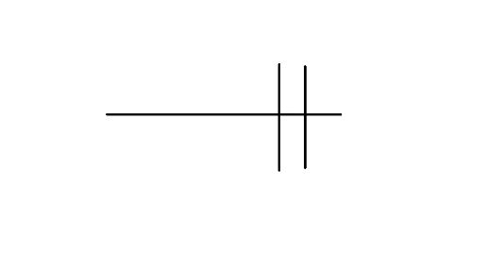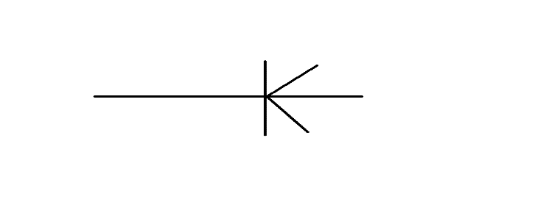

Many House

Rajesh

Rajesh

House

1 many