**UCS1712 – GRAPHICS AND MULTIMEDIA LAB**

**Ex. No. 1 Study of Basic Output Primitives in C++ using OpenGL**

**Date:** 19/7/21 **Name:** Srinath S

**Class:** CSE-C  **Roll:** 185001205

**Question:**

a). To create an output window using OPENGL and to draw the following basic output primitives – POINTS, LINES, LINE_STRIP, LINE_LOOP, TRIANGLES, QUADS, QUAD_STRIP, POLYGON.

b) To create an output window and draw a checkerboard using OpenGL.

c) To create an output window and draw a house using POINTS,LINES,TRAINGLES and QUADS/POLYGON.

**Code:**

**A) Shapes:**

#include<GL/glut.h>

#include<stdio.h>

void myInit()

{

   glClearColor(0.0,0.0,0.0,1.0);

   gluOrtho2D(-1.0,1.0,-1.0,1.0);

}

void myDisplay()

{

   glClear(GL_COLOR_BUFFER_BIT);

   // 1) POINTS

   glColor3f(1.0,1.0,1.0);

   glBegin(GL_POINTS);

       glVertex2f(-0.1,-0.7);

   glEnd();

   // 2) LINES

   glColor3f(1.0,1.0,1.0);

   glBegin(GL_LINES);

       glVertex2f(-0.3,-0.3);

       glVertex2f(0.3,-0.3);

   glEnd();

   // 3) LINE_STRIP

   glColor3f(0.0,0.0,1.0);

   glBegin(GL_LINE_STRIP);

       glVertex2f(-0.1,-0.3);

       glVertex2f(0.0,0.2);

       glVertex2f(0.2,0.5);

   glEnd();

   // 4) LINE_LOOP

   glColor3f(1.0,0.0,0.0);

   glBegin(GL_LINE_LOOP);

       glVertex2f(-0.1 - 0.15,-0.3);

       glVertex2f(0.0 - 0.15,0.2);

       glVertex2f(0.2 - 0.15,0.5);

   glEnd();

   // 5) TRIANGLES

   glColor3f(0.3,0.7,0.4);

   glBegin(GL_TRIANGLES);

       glVertex2f(-0.1 - 0.4,-0.3 + 0.5);

       glVertex2f(0.0 - 0.4,0.2 + 0.5);

       glVertex2f(0.2 - 0.4,0.5 + 0.5);

   glEnd();

   // 6) TRIANGLE STRIP

   glColor3f(0.0,0.7,0.8);

   glBegin(GL_TRIANGLE_STRIP);

       glVertex2f(-0.1 +0.4,-0.3 - 0.2);

       glVertex2f(0.0 +0.4,0.2 - 0.2);

       glVertex2f(0.2 +0.4,0.5 - 0.2);

       glVertex2f(0.4 +0.4, 0.6 - 0.2);

   glEnd();

   // 7) TRIANGLE FAN

   glColor3f(0.7,0.1,0.8);

   glBegin(GL_TRIANGLE_FAN);

       glVertex2f(-0.1 -0.75,-0.3 - 0.55);

       glVertex2f(0.0 -0.75,0.2 - 0.55);

       glVertex2f(0.2 -0.75,0.5 - 0.55);

       glVertex2f(0.4 -0.75, 0.6 - 0.55);

   glEnd();

   // 8) QUADS

   glColor3f(0.1,0.1,0.8);

   glBegin(GL_QUADS);

       glVertex2f(-0.1, -0.1 - 0.6);

       glVertex2f(-0.1, 0.1 - 0.6);

       glVertex2f(0.1, 0.1 - 0.6);

       glVertex2f(0.1, -0.1 - 0.6);

   glEnd();

   // 9) QUAD_STRIP

   glColor3f(0.6,0.1,0.5);

   glBegin(GL_QUAD_STRIP);

       glVertex2f(-0.1 + 0.5, -0.1 - 0.6);

       glVertex2f(-0.1 + 0.5, 0.1 - 0.6);

       glVertex2f(0.1 + 0.5, -0.1 - 0.6);

       glVertex2f(0.1 + 0.5, 0.1 - 0.6);

       glVertex2f(0.3 + 0.5, -0.1 - 0.6);

       glVertex2f(0.3 + 0.5, 0.2 - 0.6);

   glEnd();

   // 10) POLYGON

   glColor3f(0.6,0.1,0.5);

   glBegin(GL_POLYGON);

       glVertex2f(-0.1 + 0.5, -0.1 + 0.6);

       glVertex2f(-0.1 + 0.5, 0.1 + 0.6);

       glVertex2f(0.0 + 0.5, 0.2 + 0.6);

       glVertex2f(0.1 + 0.5, 0.1 + 0.6);

       glVertex2f(0.1 + 0.5, -0.1 + 0.6);

   glEnd();

   glFlush();

}

int main(int argc,char* argv[])

{

   glutInit(&argc,argv);

   glutInitDisplayMode(GLUT_SINGLE|GLUT_RGB);

   glutInitWindowSize(640,480);

   glutCreateWindow("check");

   glutDisplayFunc(myDisplay);

   myInit();

   glutMainLoop();

   return 1;

}

**B) Checkerboard:**

#include <GL/glut.h>

void initGL() {

    glClearColor(1.0f, 1.0f, 1.0f, 1.0f);

    glMatrixMode(GL_PROJECTION);

    glLoadIdentity();

    gluOrtho2D(0.0, 640.0, 0.0, 480.0);

}

void display() {

    glClear(GL_COLOR_BUFFER_BIT);

    GLint x;

    GLint y;

    GLint colorCode = 1;

    for(y = 50; y <= 350; y += 50) {

        for(x = 50; x <= 350; x += 50) {

            if (colorCode == 1) {

                glColor3f(0.0, 0.0, 0.0);

                colorCode = 0;

            }

            else {

                glColor3f(1.0, 1.0, 1.0);

                colorCode = 1;

            }

            glBegin(GL_QUADS);

            glVertex2i(x, y);

            glVertex2i(x, y + 50);

            glVertex2i(x + 50, y + 50);

            glVertex2i(x + 50, y);

            glEnd();

        }

    }

    glFlush();

}

int main(int argc, char** argv) {

    glutInit(&argc, argv);

    glutCreateWindow("Understandable Checkers");

    glutInitWindowSize(640, 480);

    glutInitWindowPosition(50, 50);

    glutDisplayFunc(display);

    initGL();

    glutMainLoop();

    return 0;

}

**C) House:**

#include<GL/glut.h>

#include<stdio.h>

void myInit()

{

   glClearColor(0.0,0.0,0.0,1.0);

   gluOrtho2D(-1.0,1.0,-1.0,1.0);

}

void myDisplay()

{

   glClear(GL_COLOR_BUFFER_BIT);

   // glColor3f(1.0,0.0,0.0);

   // glBegin(GL_LINES);

   //     glVertex2f(-0.7,-0.7);

   //     glVertex2f(-0.1,-0.7);

   //     glVertex2f(-0.7,-0.7);

   //     glVertex2f(-0.7,-0.1);

   //     glVertex2f(-0.1,-0.7);

   //     glVertex2f(-0.1,-0.1);

   //     glVertex2f(-0.7,-0.1);

   //     glVertex2f(-0.1,-0.1);

   // glEnd();

   // glColor3f(0.0,1.0,0.0);

   // glBegin(GL_LINES);

   //     glVertex2f(-0.7,-0.1);

   //     glVertex2f(-0.1,-0.1);

   // glEnd();

   glColor3f(0.0,1.0,0.0);

   glBegin(GL_QUADS);

       glVertex2f(-0.7, -0.7);

       glVertex2f(-0.7, 0.3);

       glVertex2f(0.7, 0.3);

       glVertex2f(0.7, -0.7);

   glEnd();

   glColor3f(1.0,0.0,0.0);

   glBegin(GL_TRIANGLES);

       glVertex2f(-0.7, 0.3);

       glVertex2f(0.7, 0.3);

       glVertex2f(0.0, 0.75);

   glEnd();

   // door

   glColor3f(0.0,0.0,1.0);

   glBegin(GL_QUADS);

       glVertex2f(-0.15, -0.7);

       glVertex2f(-0.15, -0.25);

       glVertex2f(0.15, -0.25);

       glVertex2f(0.15, -0.7);

   glEnd();

   // left window

   glColor3f(0.0,0.5,0.5);

   glBegin(GL_QUADS);

       glVertex2f(-0.3, -0.6);

       glVertex2f(-0.3, -0.4);

       glVertex2f(-0.5, -0.4);

       glVertex2f(-0.5, -0.6);

   glEnd();

   // right window

   glColor3f(0.0,0.5,0.5);

   glBegin(GL_QUADS);

       glVertex2f(0.3, -0.6);

       glVertex2f(0.3, -0.4);

       glVertex2f(0.5, -0.4);

       glVertex2f(0.5, -0.6);

   glEnd();

   glColor3f(0.0, 0.0, 0.0);

   glBegin(GL_LINES);

       glVertex2f(-0.7, -0.15);

       glVertex2f(0.7, -0.15);

   glEnd();

   // upper window

   glColor3f(0.5,0.5,0.0);

   glBegin(GL_QUADS);

       glVertex2f(-0.6, -0.05);

       glVertex2f(-0.6, 0.15);

       glVertex2f(0.6, 0.15);

       glVertex2f(0.6, -0.05);

   glEnd();

   // glBegin(GL_POINTS);

   //     glVertex2f(-0.1,-0.7);

   // glEnd();

   glFlush();

}

int main(int argc,char* argv[])

{

   glutInit(&argc,argv);

   glutInitDisplayMode(GLUT_SINGLE|GLUT_RGB);

   glutInitWindowSize(640,480);

   glutCreateWindow("check");

   glutDisplayFunc(myDisplay);

   myInit();

   glutMainLoop();

   return 1;

}

**OUTPUTS:**

**A)**

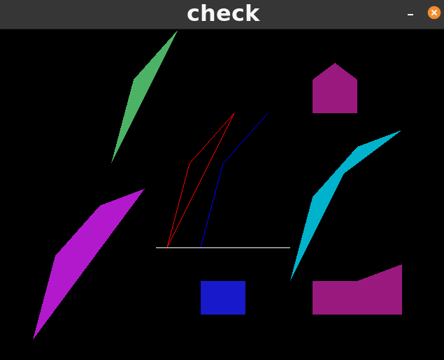

**B)**

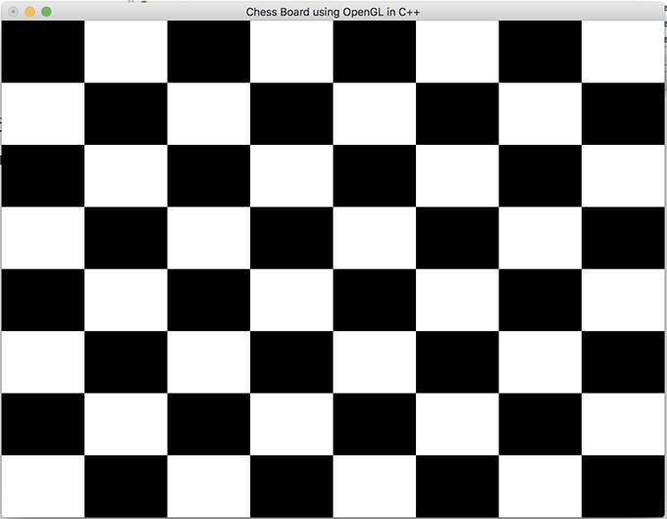

**C)**

