**UCS1712 – GRAPHICS AND MULTIMEDIA LAB**

**Ex. No.12 Creating 2D animation**

**Date:** 18/10/21 **Name:** Srinath S

**Class:** CSE-C  **Roll:** 185001205

**Question:**

Using GIMP, include layers and create a simple animation of your choice.

**Output Screenshots:**

**Layers:**

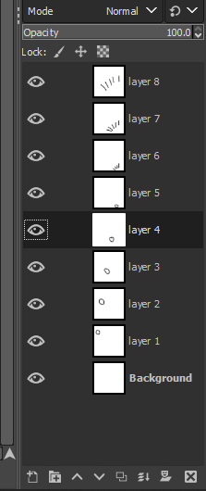

**Animation:**

