Step1:Entering Person ID
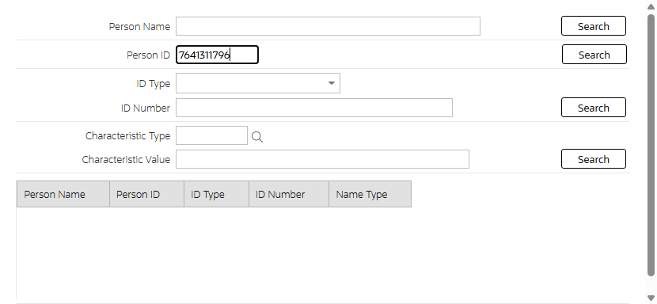
Step2:Person Details
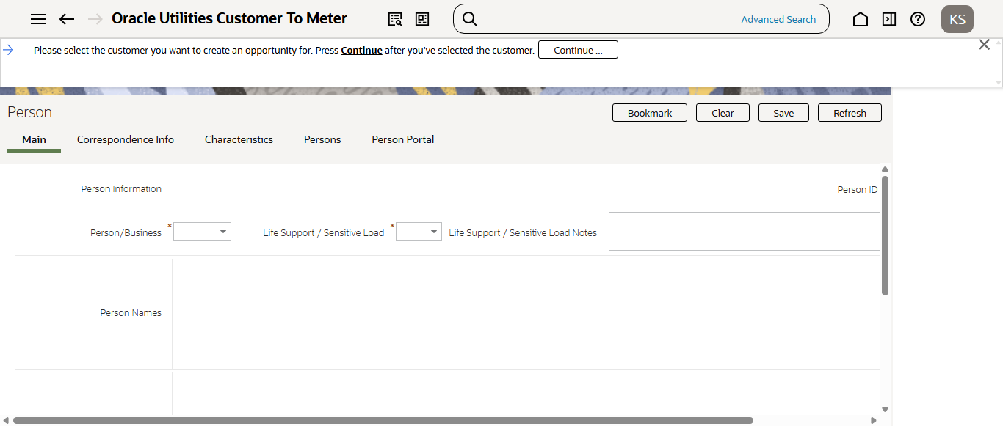
Step3:Entering Opportunity details
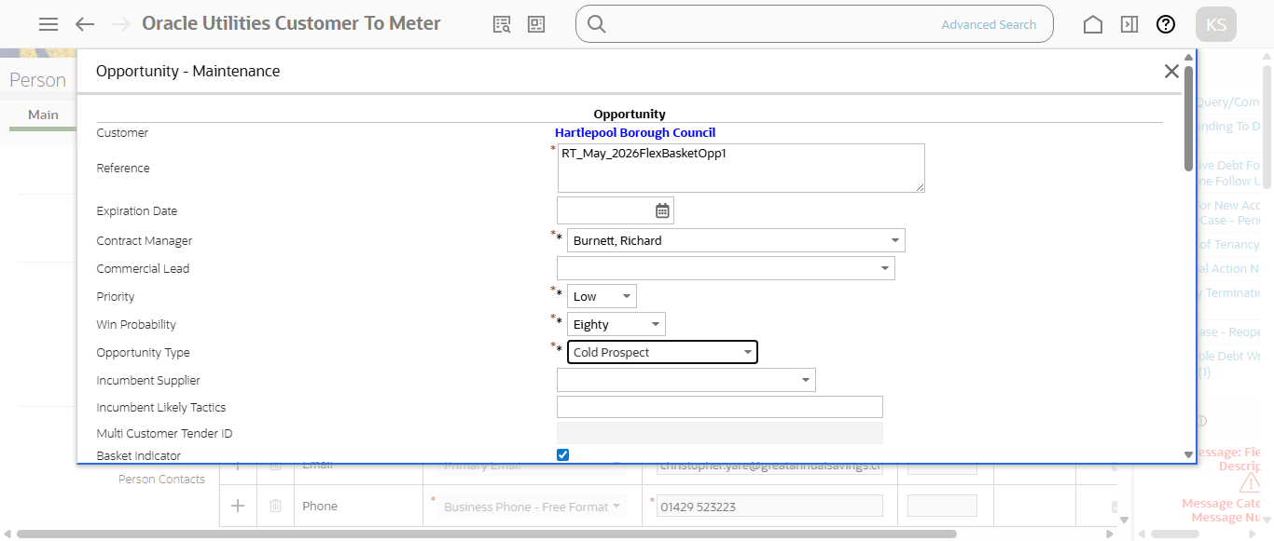
Step4:Enter Start and end date
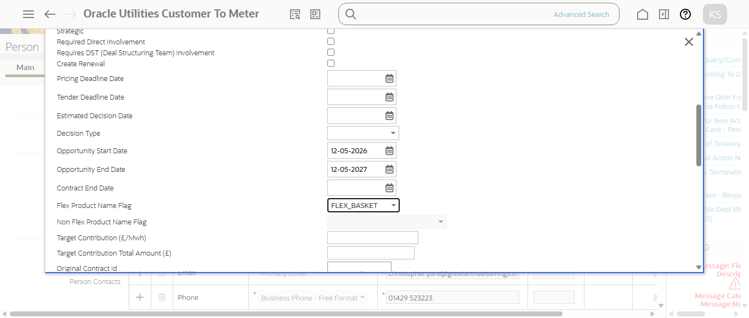
Step5:1st Opportunity created in Identified status:9328330186 (ID: 9328330186 )
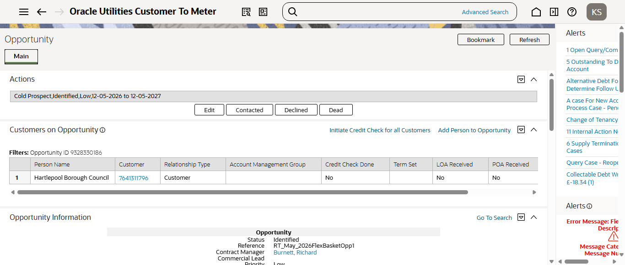
Step1:Entering Person ID
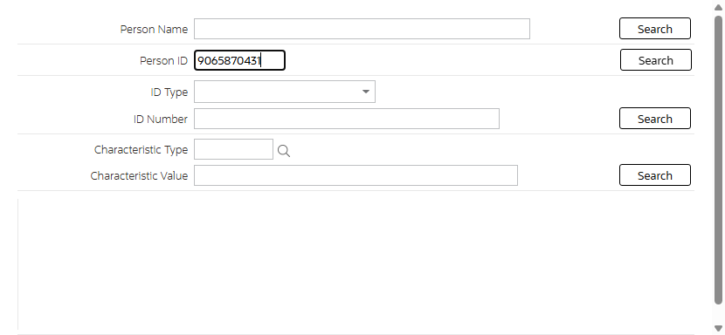
Step2:Person Details
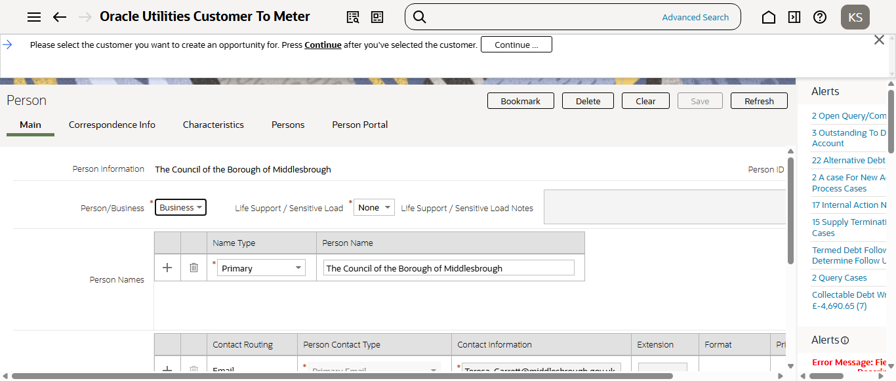
Step3:Enter Start and end date
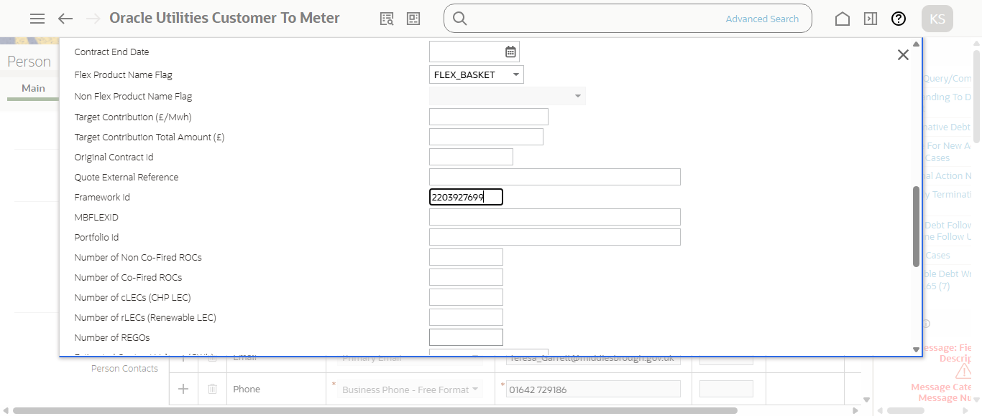
Step4:2nd Opportunity created in Identified status:3237380237 (ID: 3237380237 )
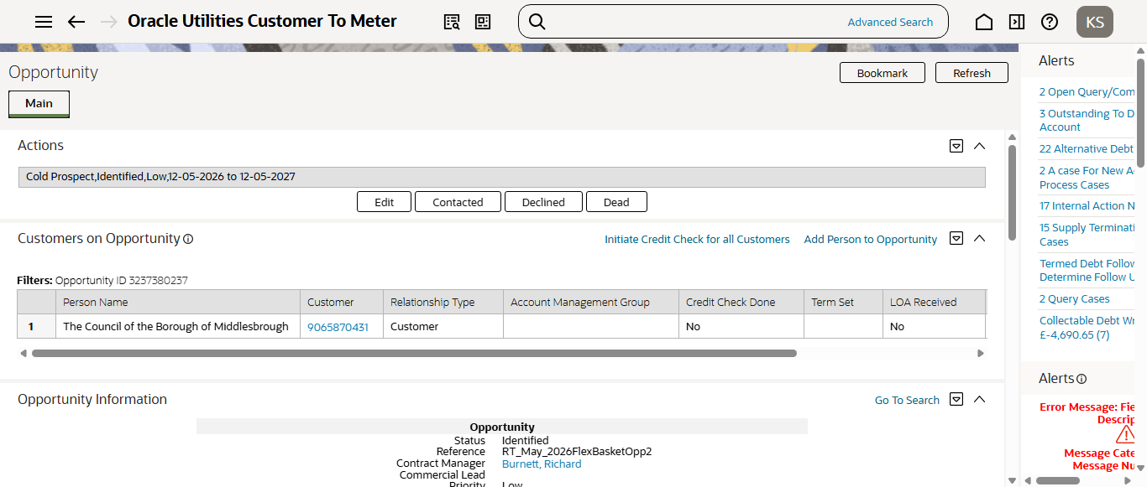
Step1:Entering Person ID
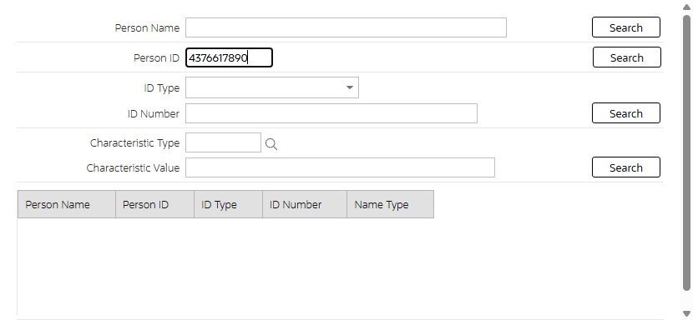
Step2:Person Details
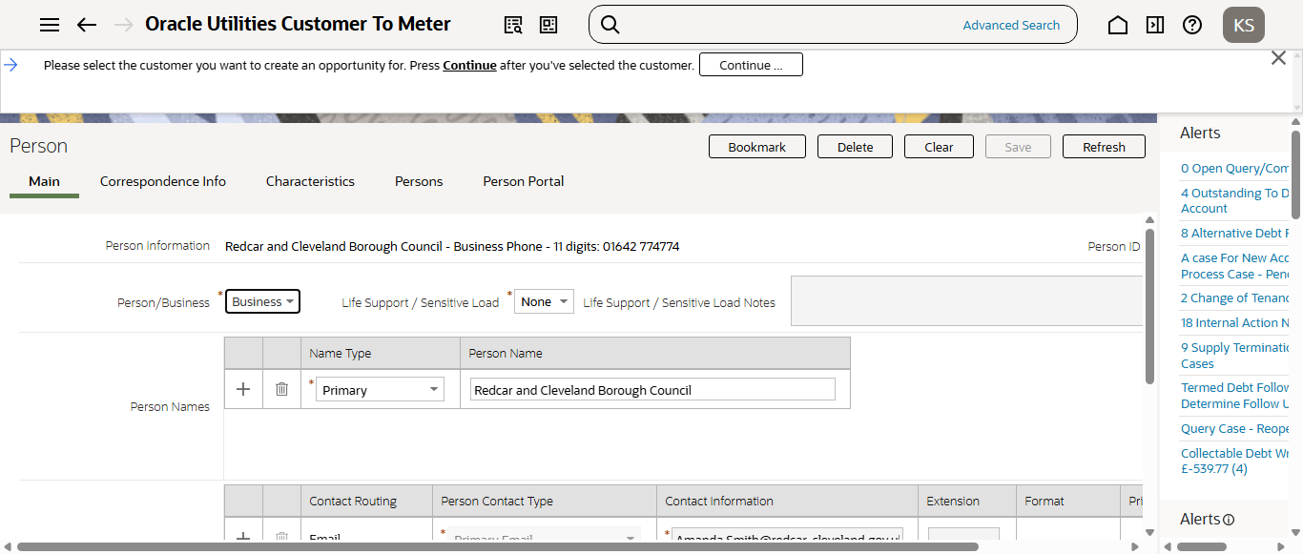
Step3:Enter Start and end date
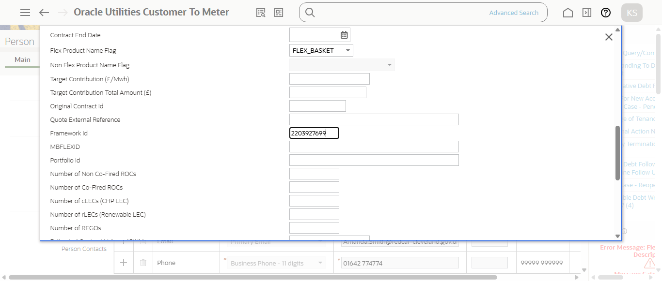
Step4:3rd Opportunity created in Identified status:4302254944 (ID: 4302254944 )
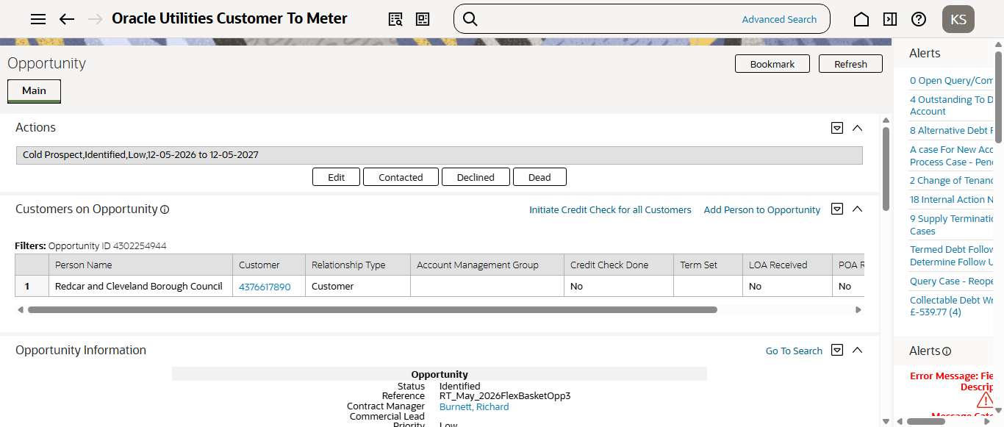
Customer Upload batch is running
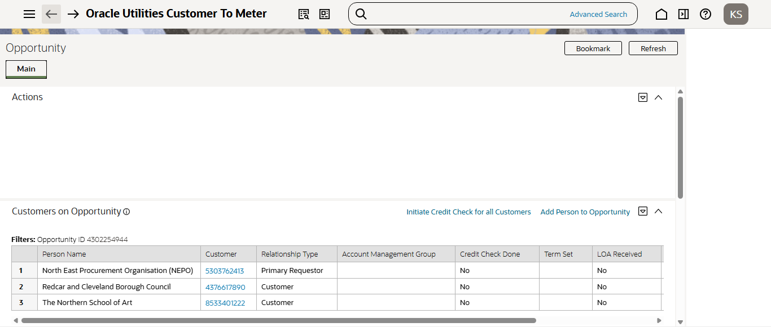
Running CMCROPSP Batch to move Staging data from Pending to In progress
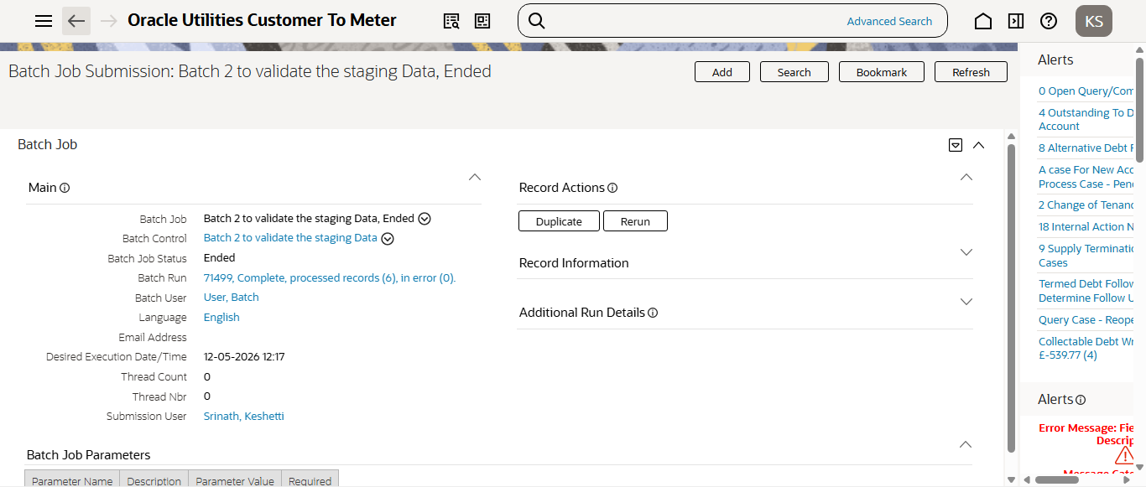
Running CMRPGEN Batch to Complete Staging data
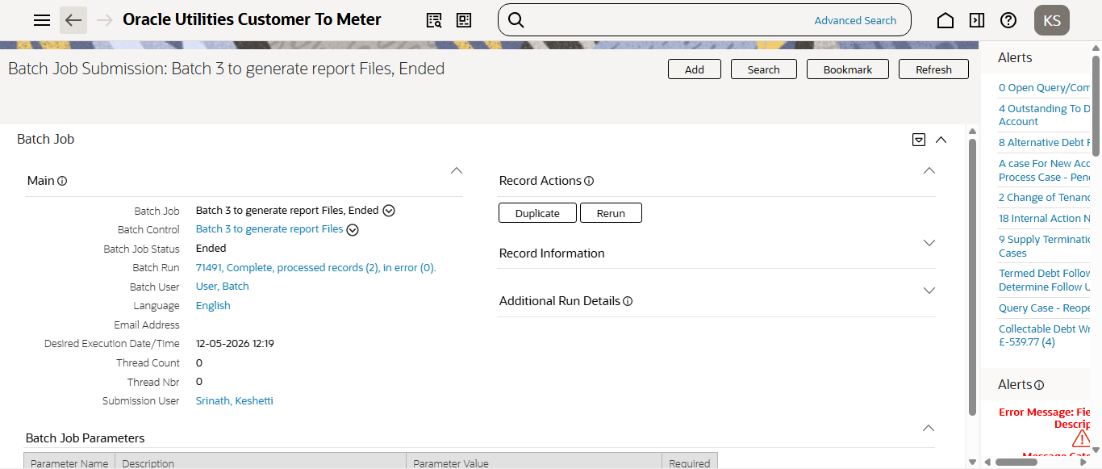
Credit Check processed
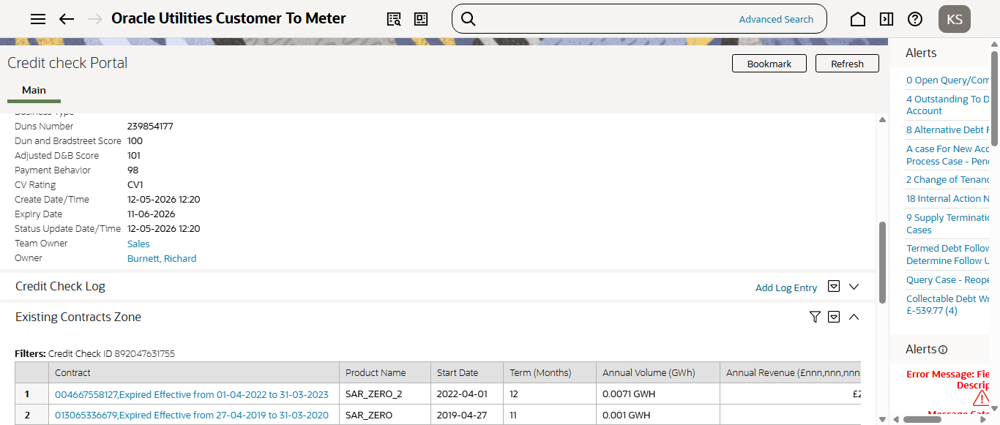
Opportunity Qualified
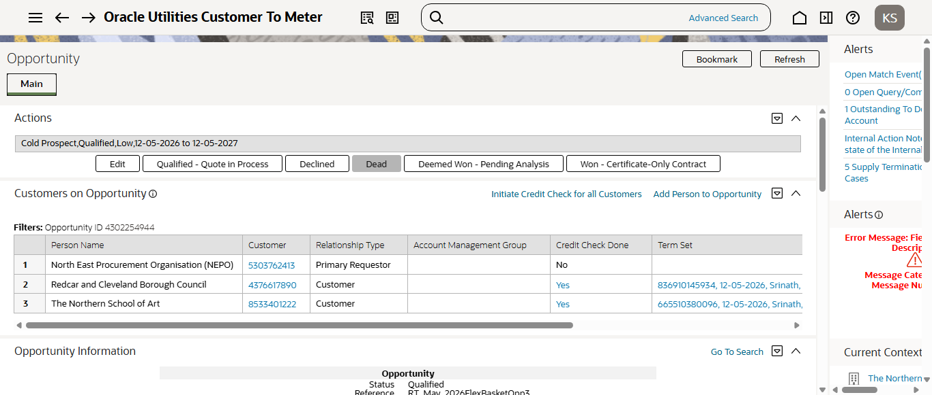
3rd Opportunity Moved to QRBATCH mode..
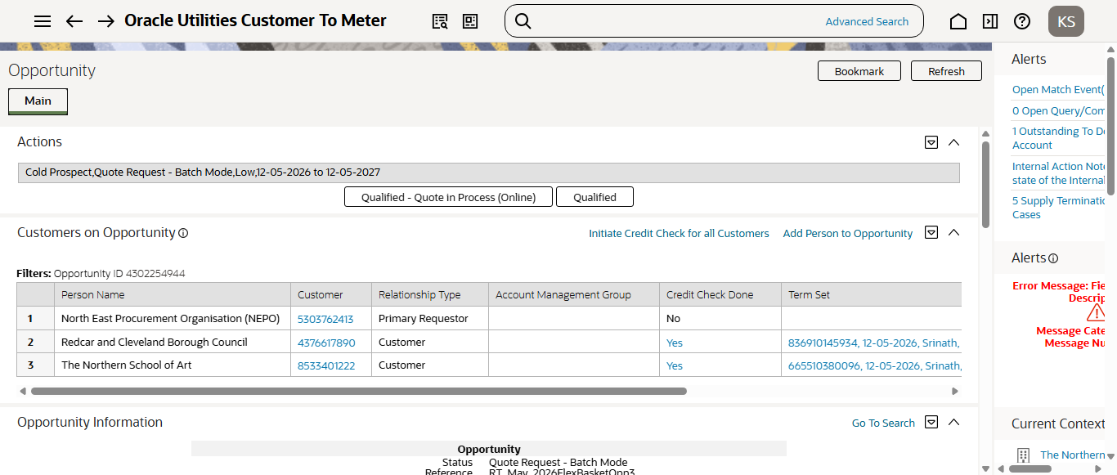
Here, I am adding evidence for only one Opportunity details, 2nd Opportunity Moved to QRBATCH mode..
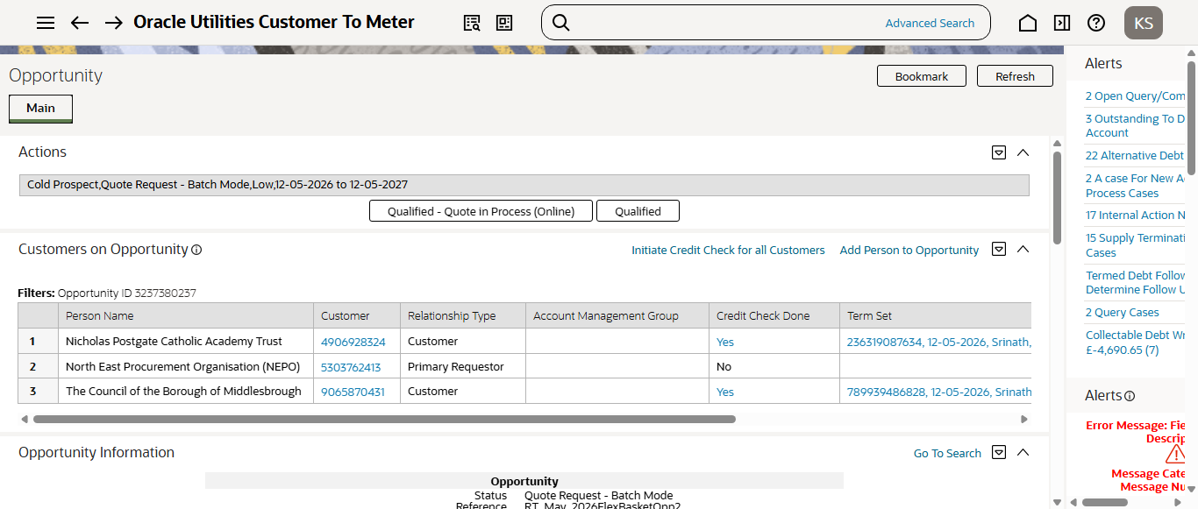
1st Opportunity Moved to QRBATCH mode..
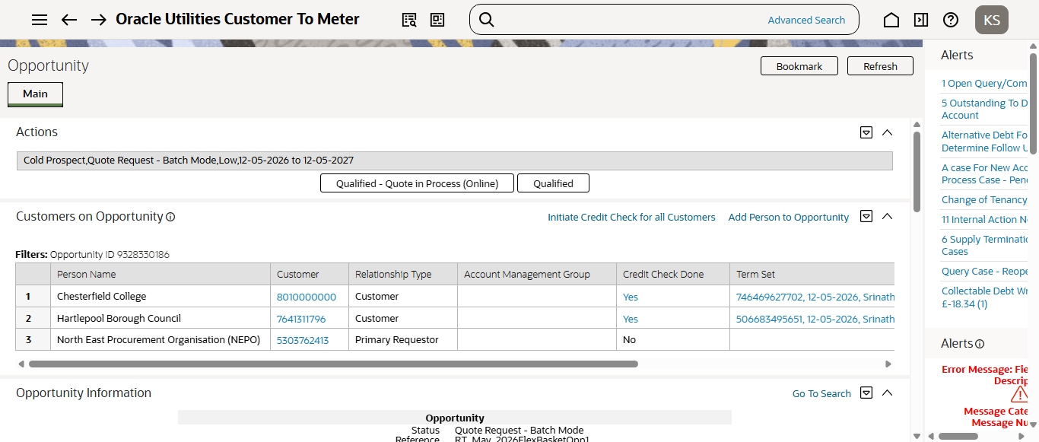
Running CM-MOPPB batch to generate Quote ID's for all 3 Opportunities
