Quote Accepted and Sync Request Created in system
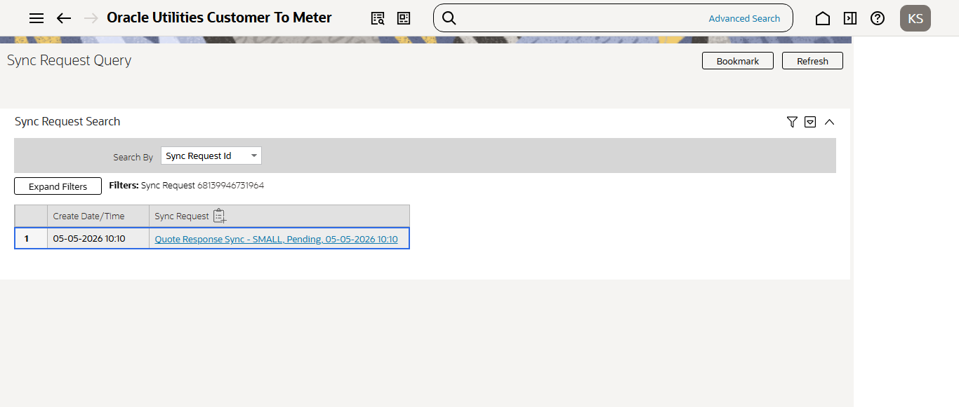
Quote Accepted and Sync Request Created in system

Quote Accepted and Sync Request Created in system
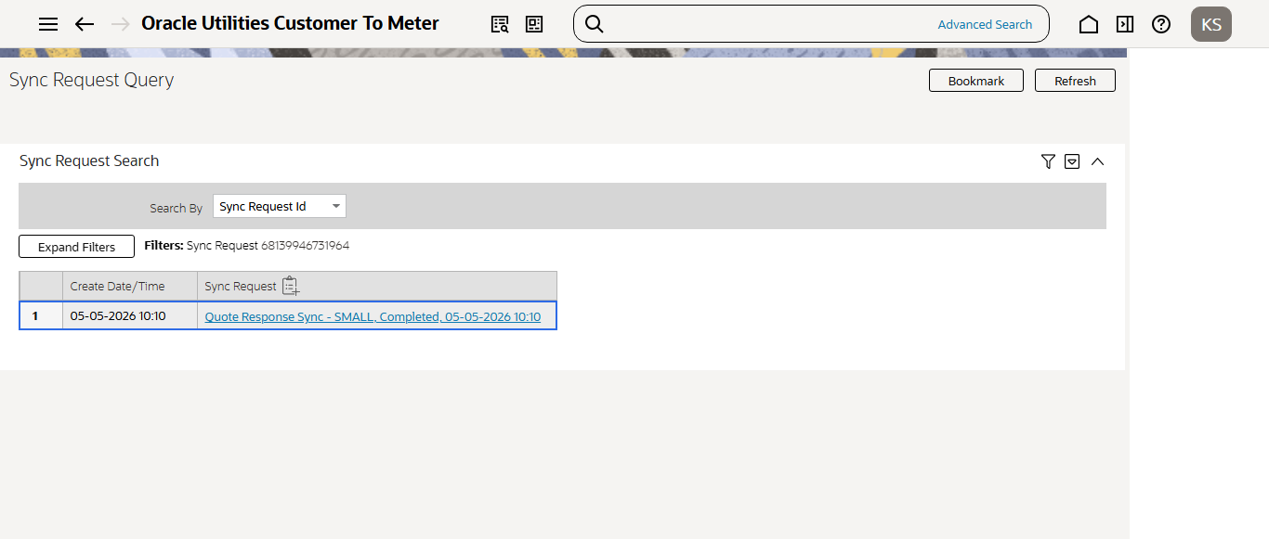
Sync Request Validation completed
