Step1:Entering Person ID
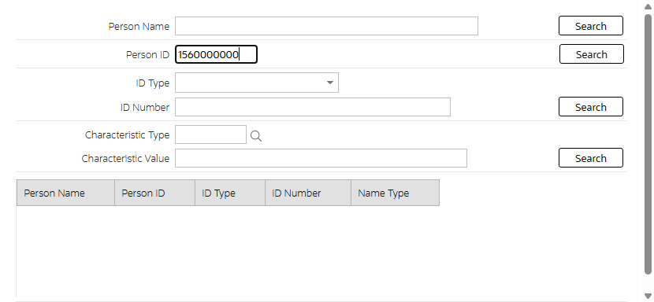
Step2:Person Details
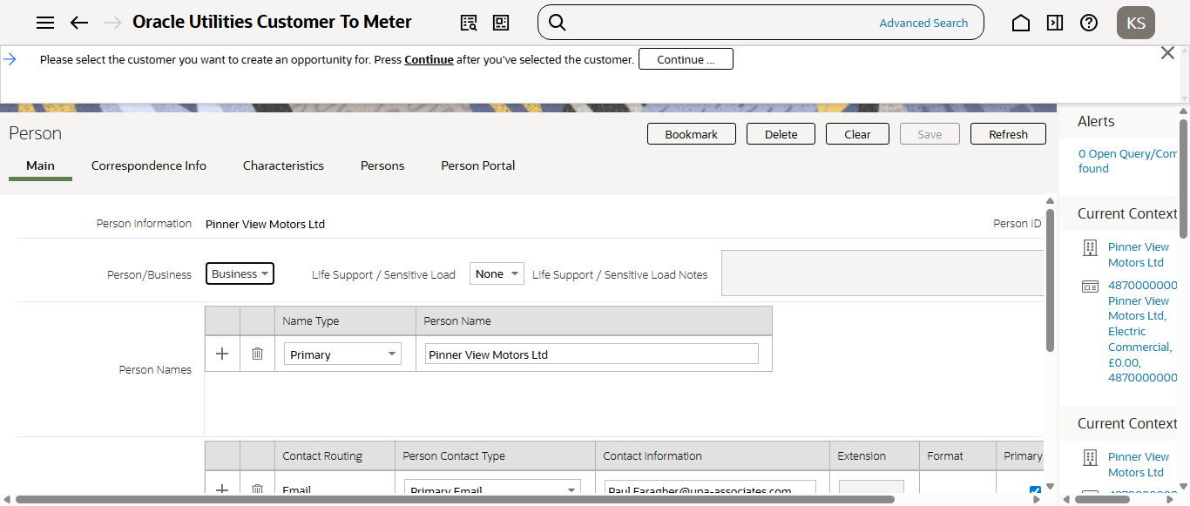
Step3:Entering Opportunity details
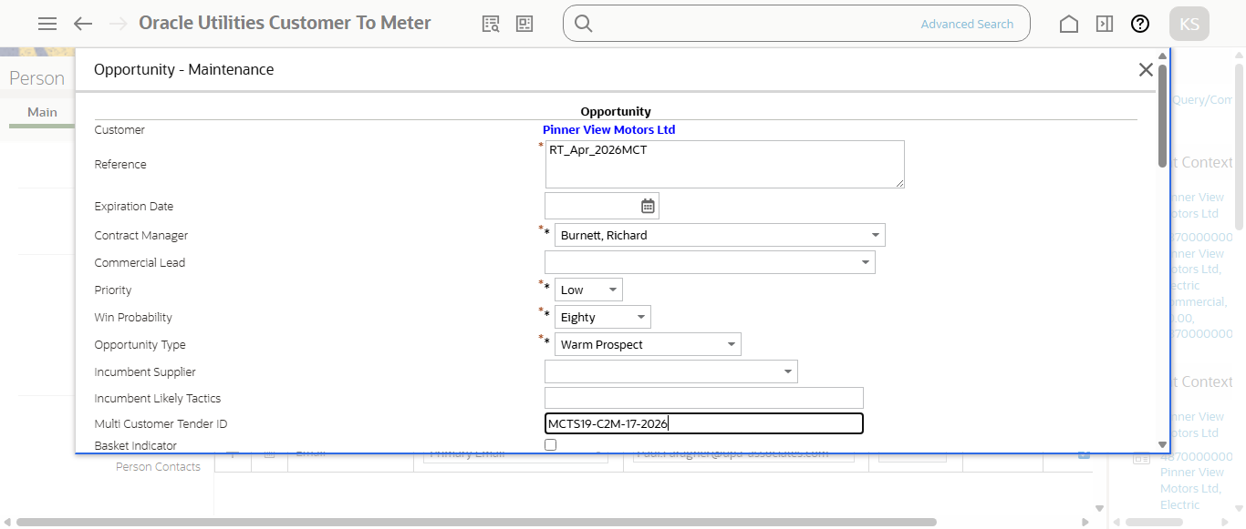
Step4:Enter Start and end date
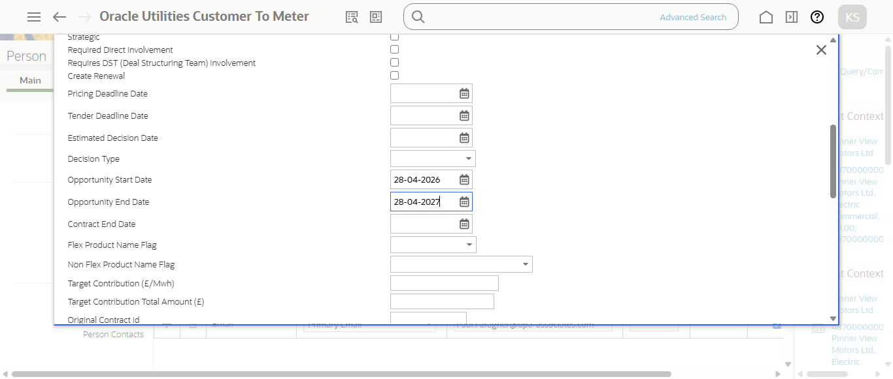
Step5:Opportunity created in Identified status (ID: 4104294675 )
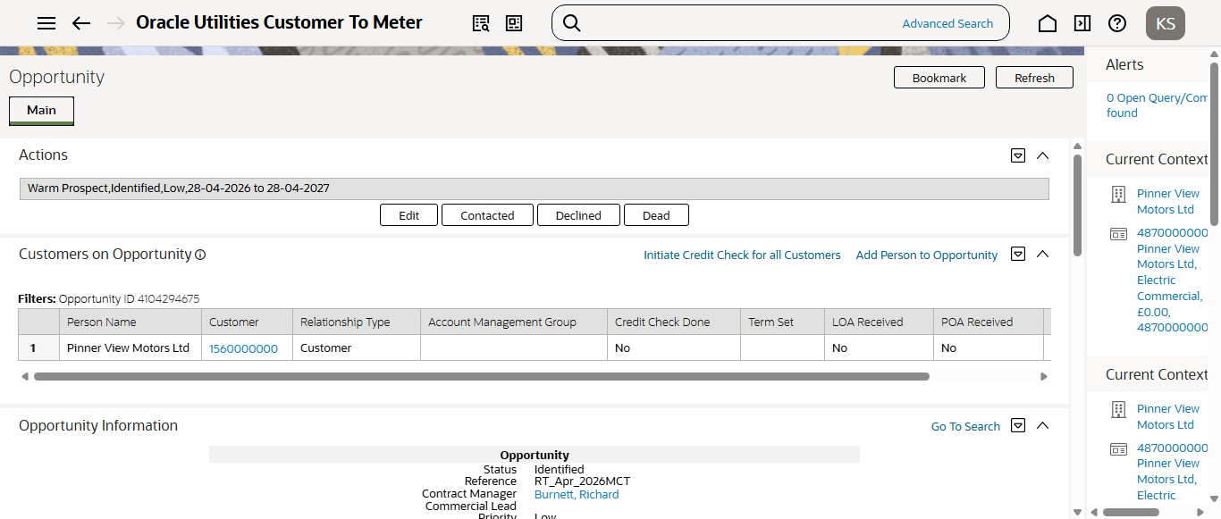
Quote Generated for 4th Opportunity
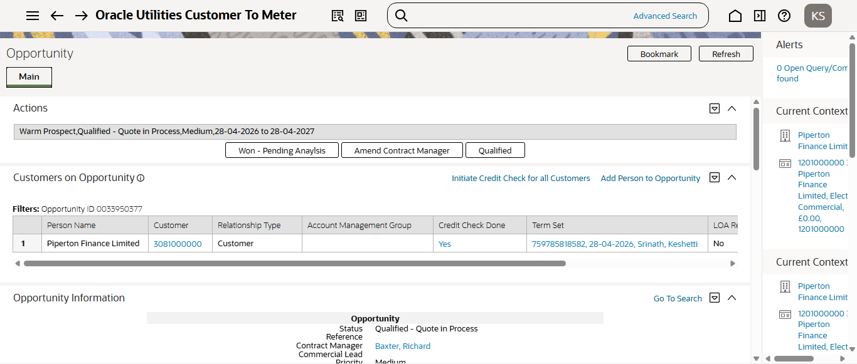
Quote Generated for 3rd Opportunity
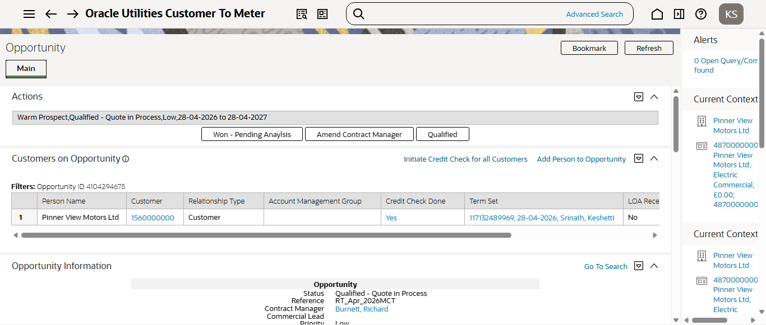
Quote Generated for 2nd Opportunity
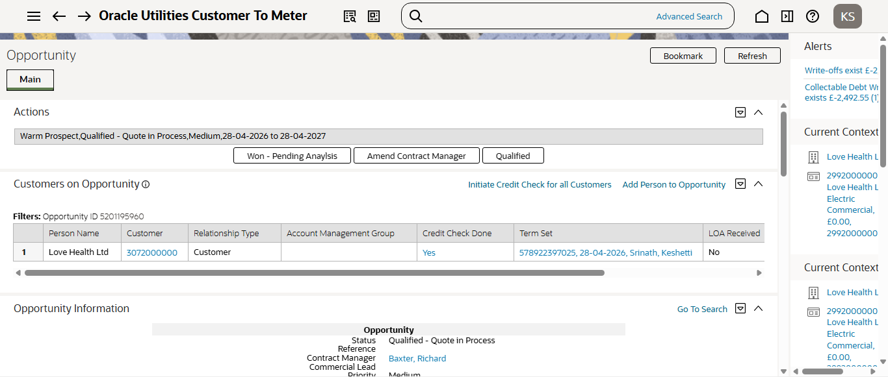
Quote Generated first Opportunity
