HOCSX payment upload batch is running
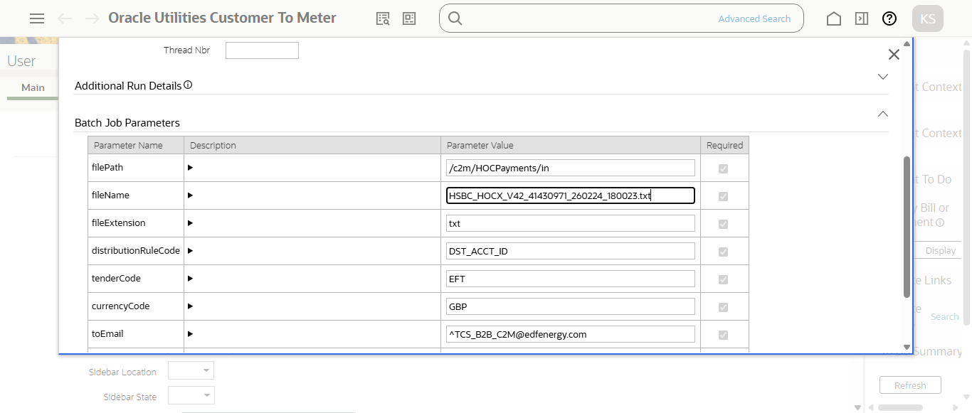
Enter EXT Transmit ID for HOCX file and click on search
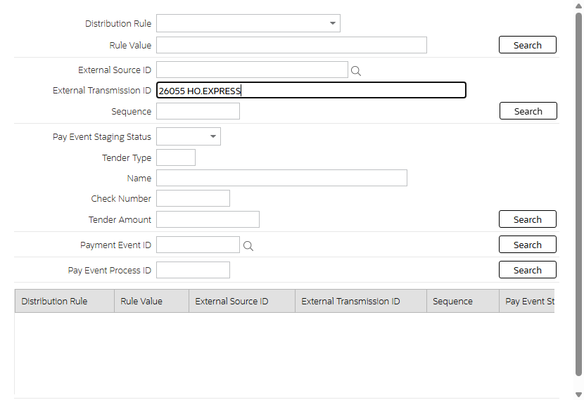
Payment Event upload staging
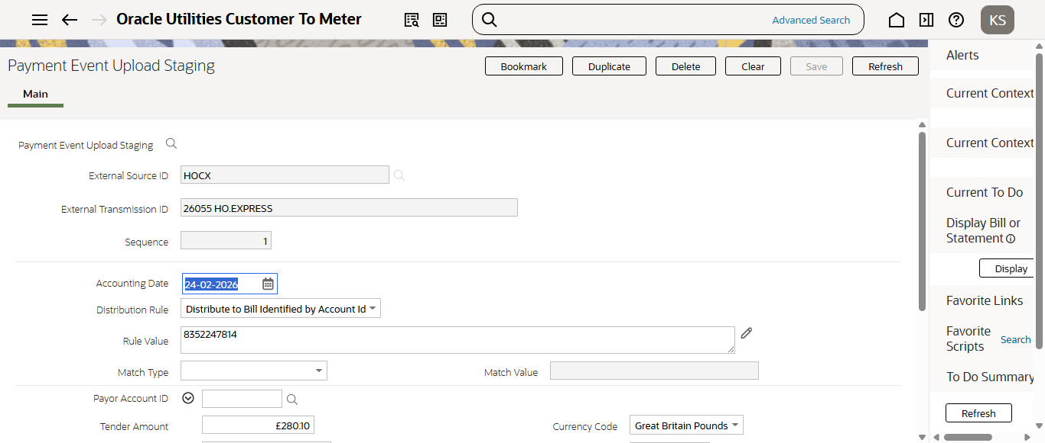
Payment Event upload staging is in 'Incomplete' status for HOCX payment
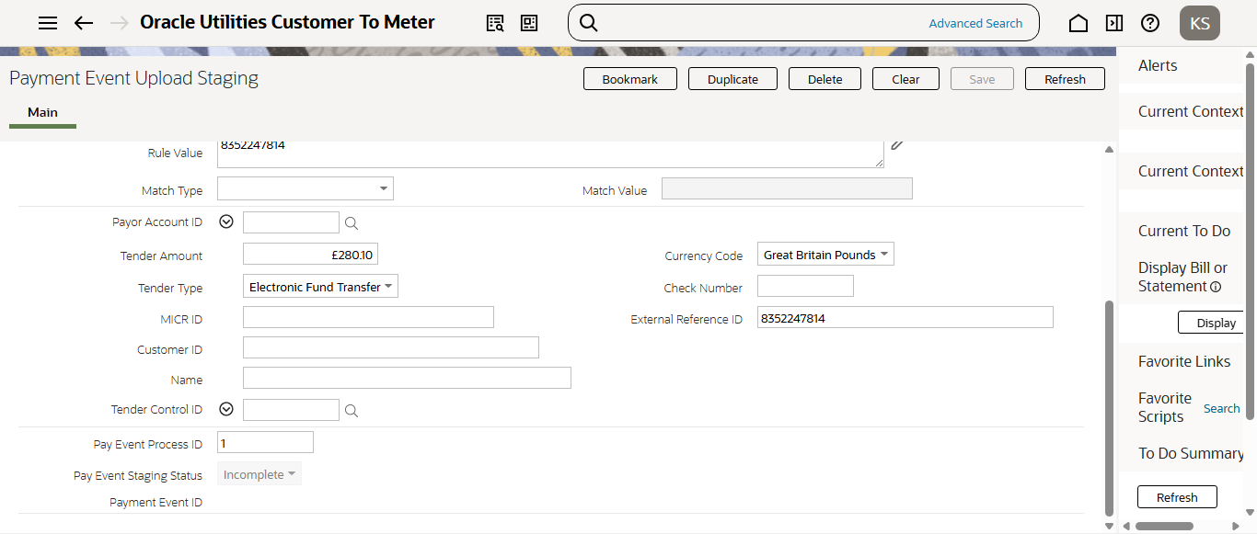
Payment Event upload staging
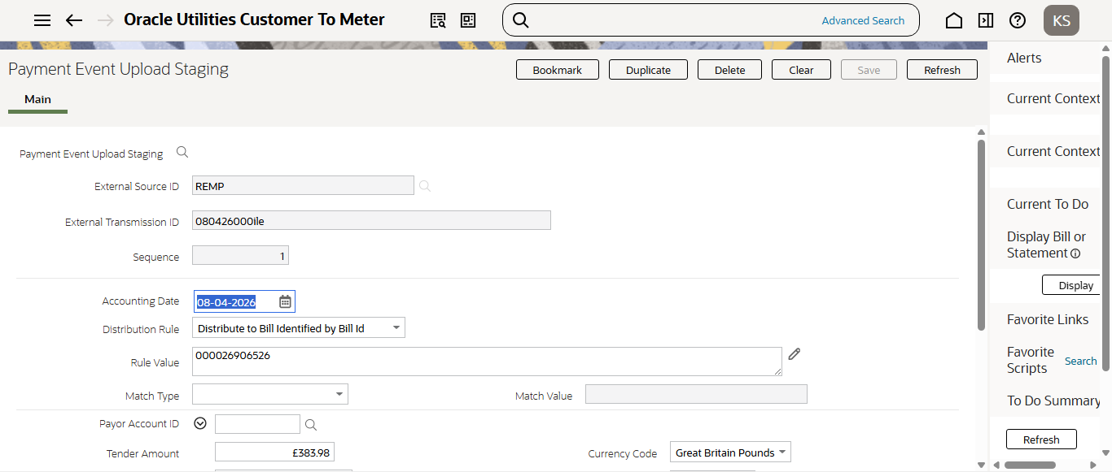
Payment Event upload staging is in 'Incomplete' status for REMP payment
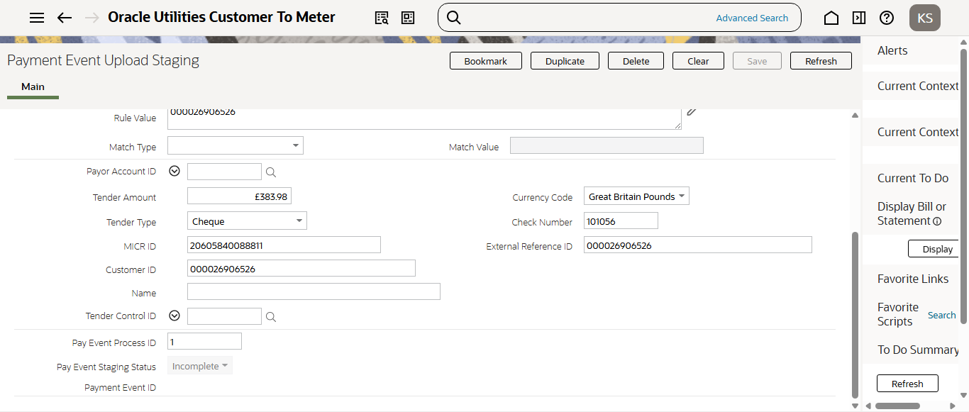
Payment Event Upload Stage-1 batch is running
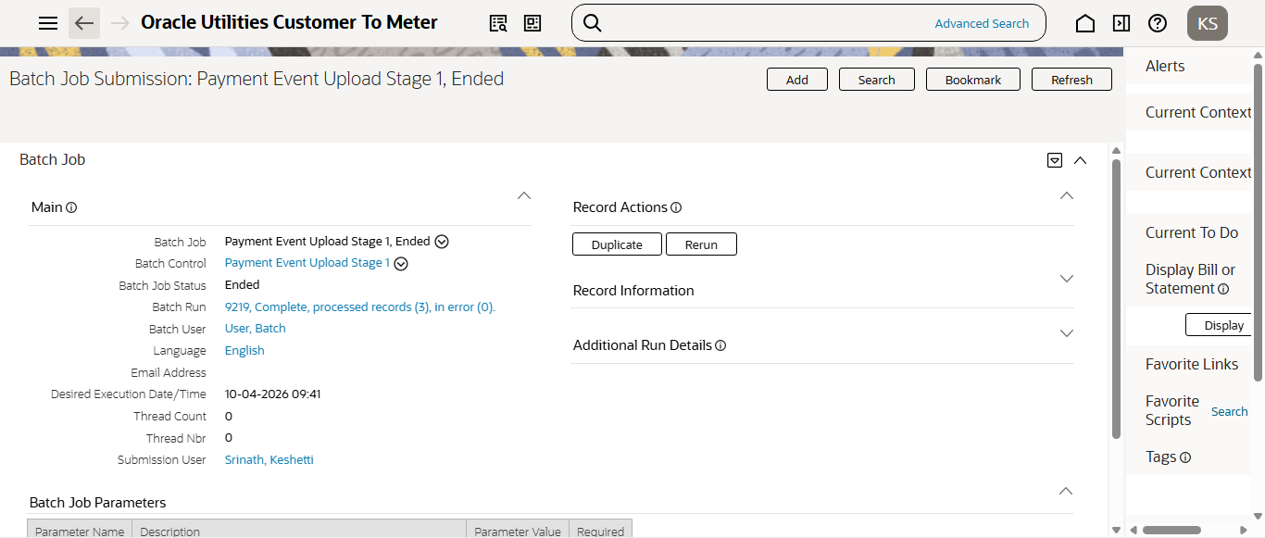
Payment Event upload staging for REMP payment file is in 'Pending' status..
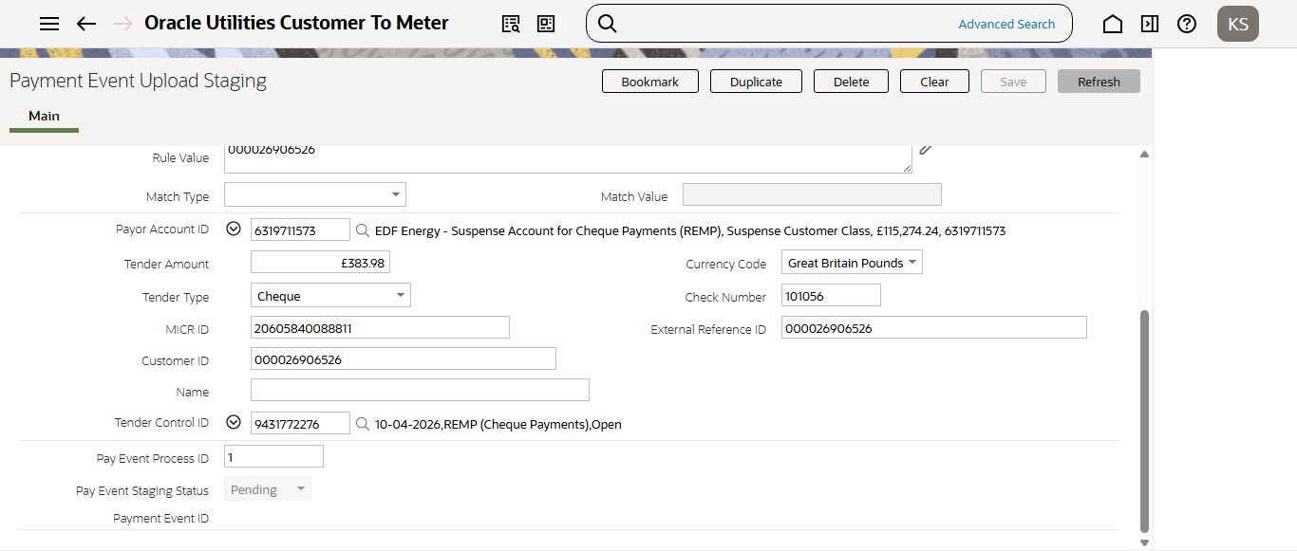
Tender Control is Created Open status for REMP payment
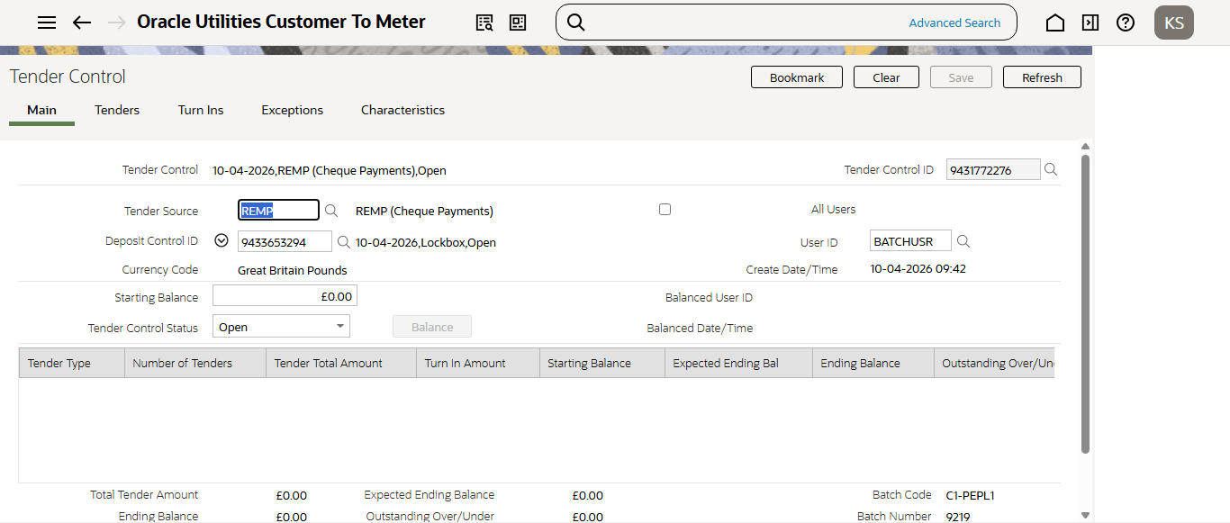
Payment Event upload staging is moved to 'pending' status for HOCX payment
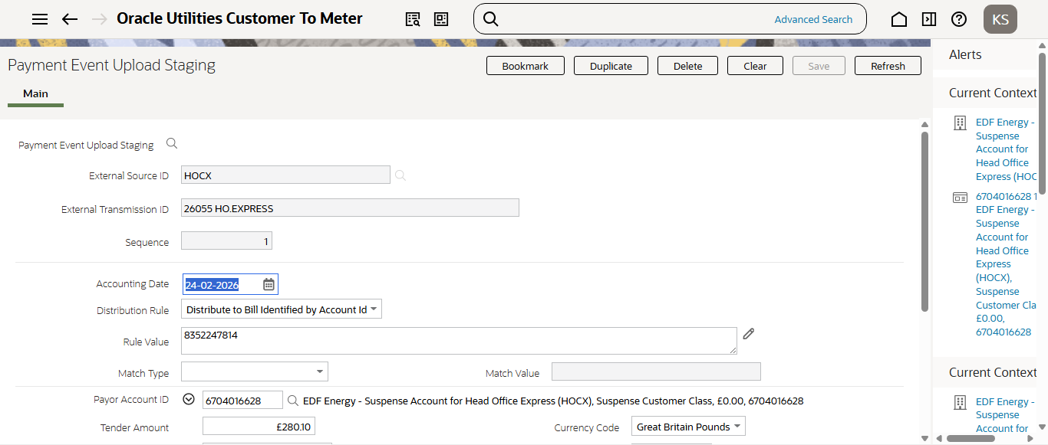
Tender Control is Created Open status for HOCX payment
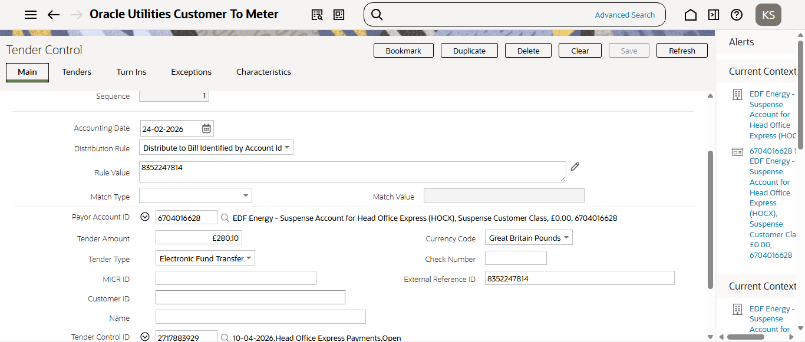
Payment Event Upload Stage-2 batch is running
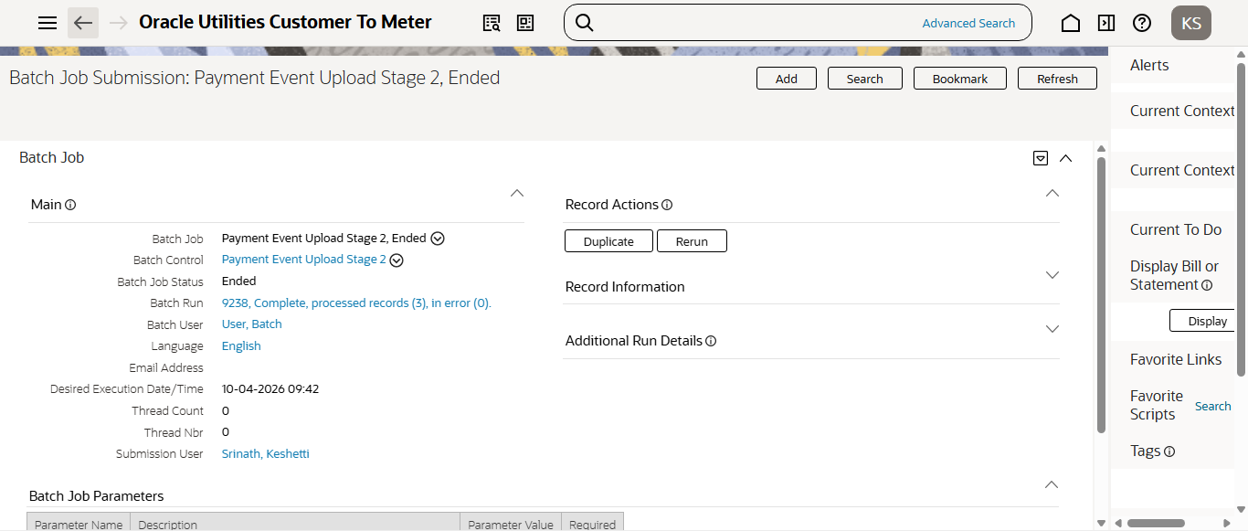
Payment Event upload staging for HOCX payment file is Completed
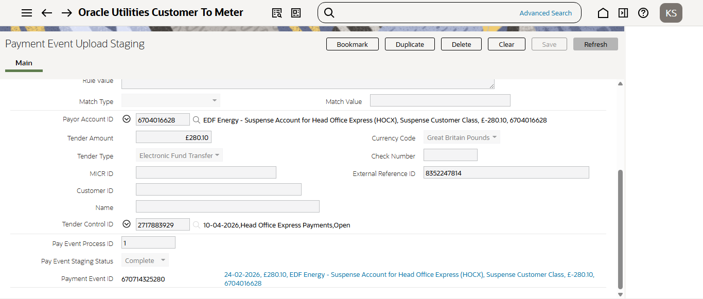
Payment Event upload staging for REMP payment file is Completed
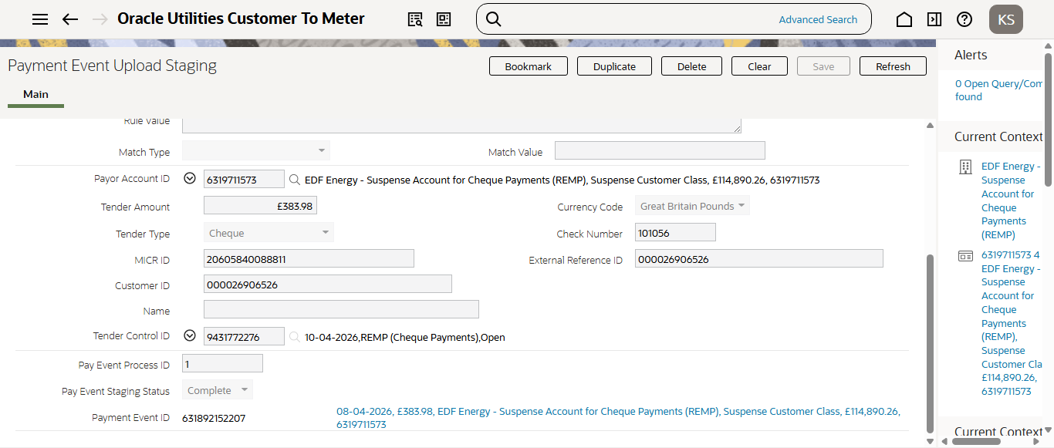
Balance Tender Controls batch is running
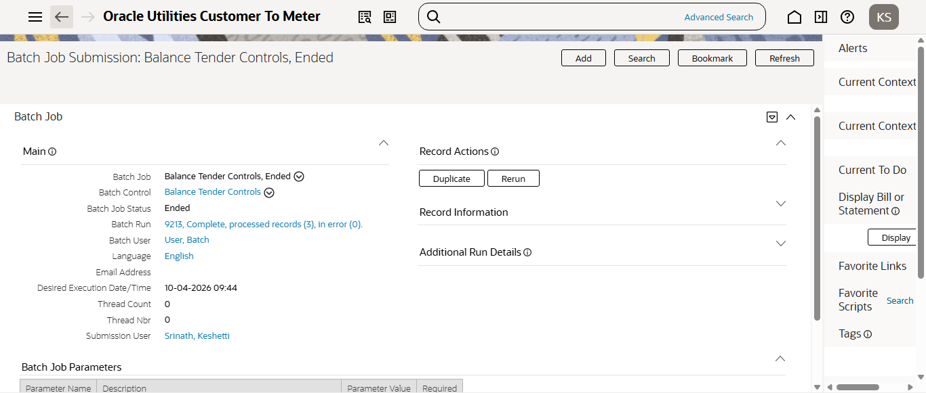
Tender Control is now Balanced for REMP payment
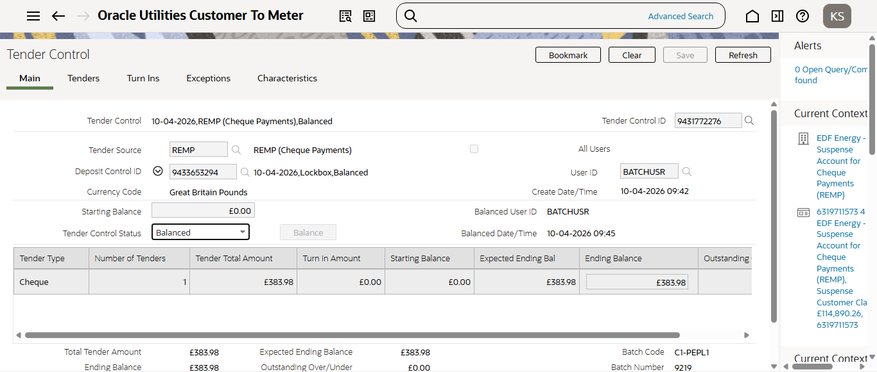
Tender Control is now Balanced for HOCX payment
