Step1:Entering Person ID
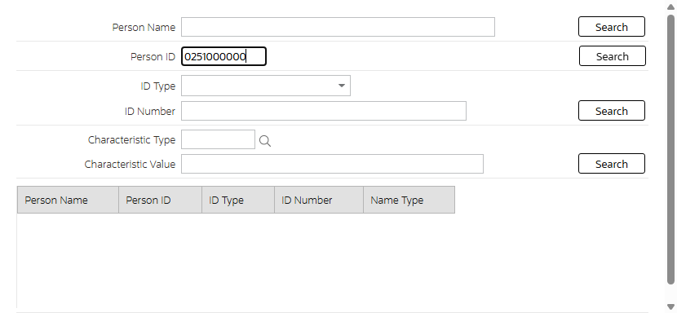
Step2:Person Details
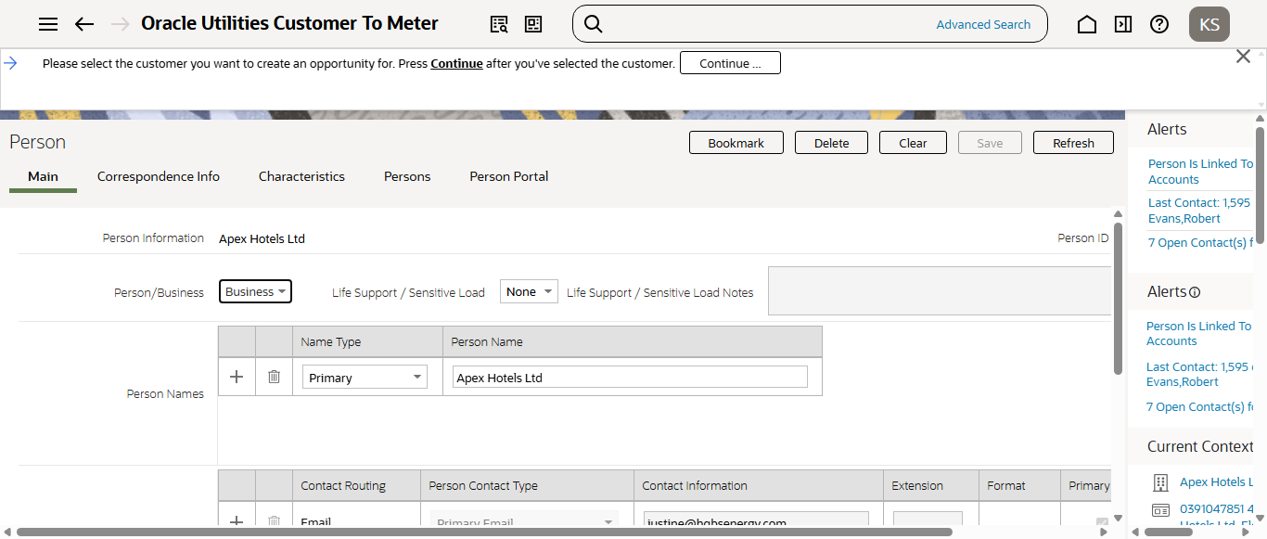
Step3:Entering Opportunity details
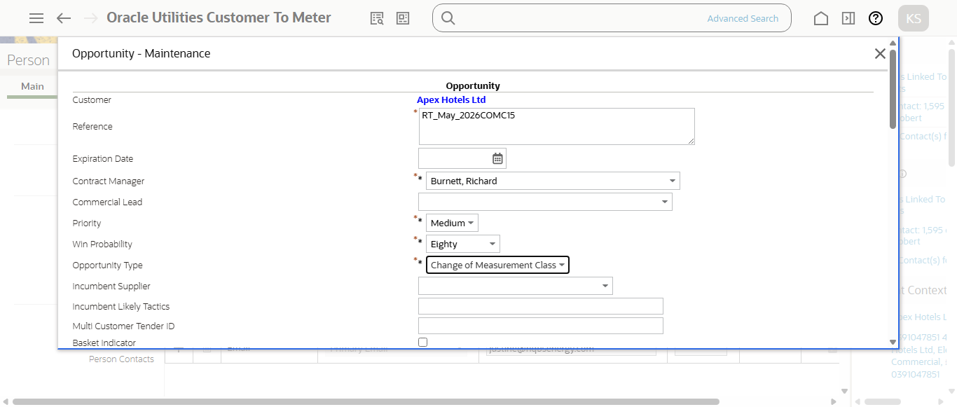
Step4:Enter Start and end date
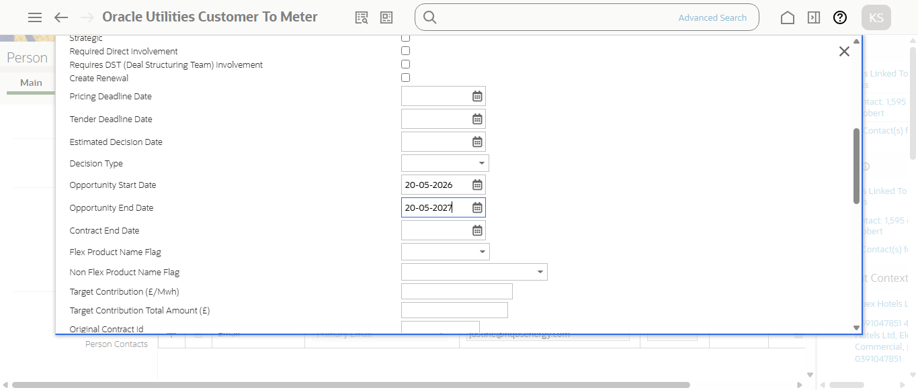
Step5:Opportunity created in Identified status (ID: 2768212218 )
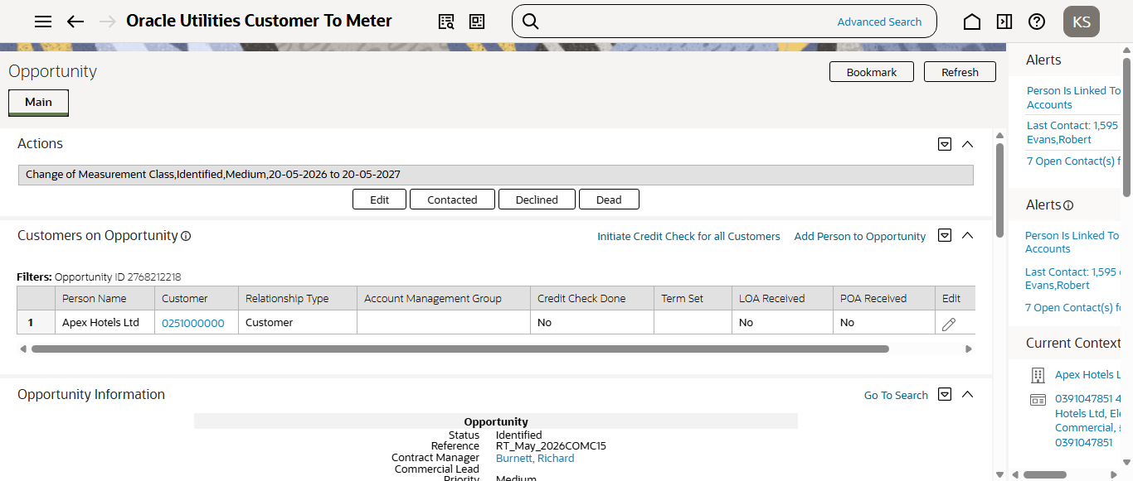
Step6:Search Premise ID to add site
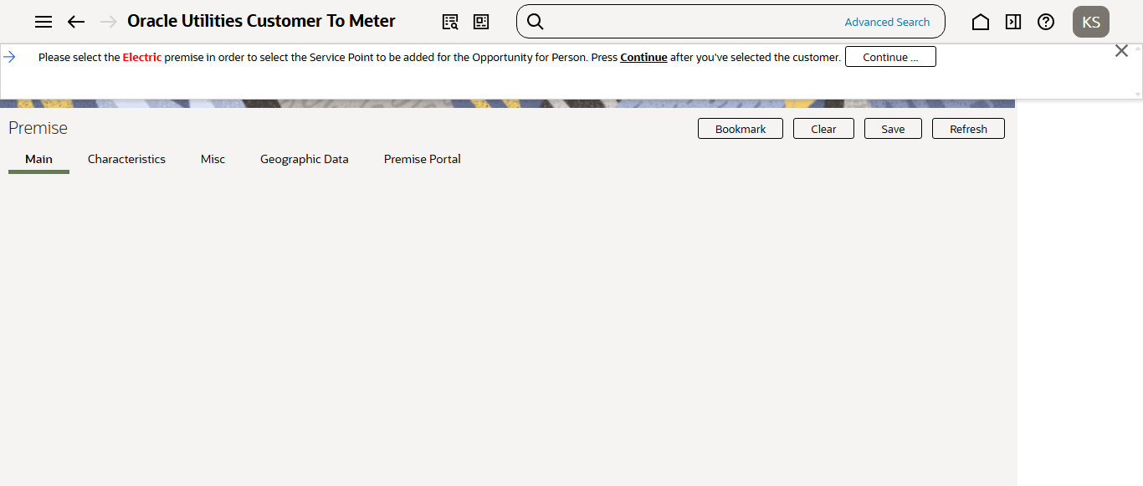
Select MPAN
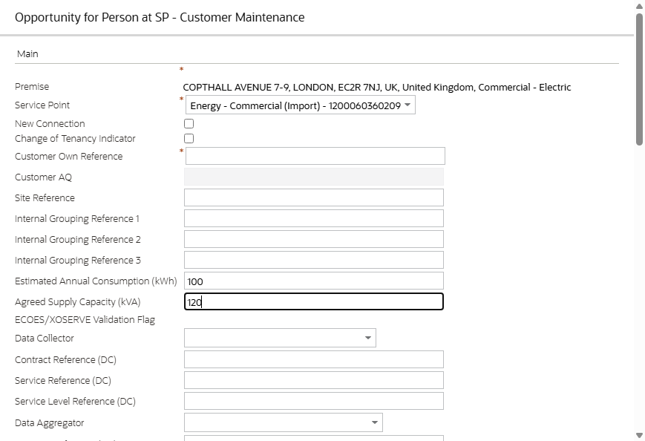
Adding Site details
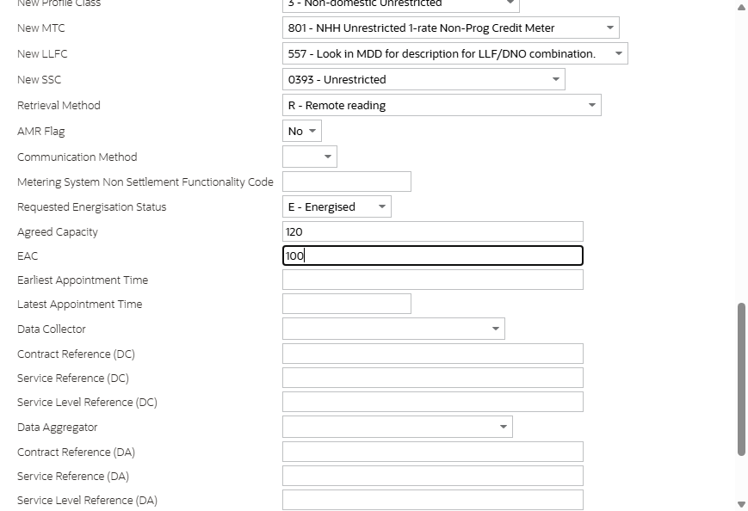
Adding DA, DC and MOP details
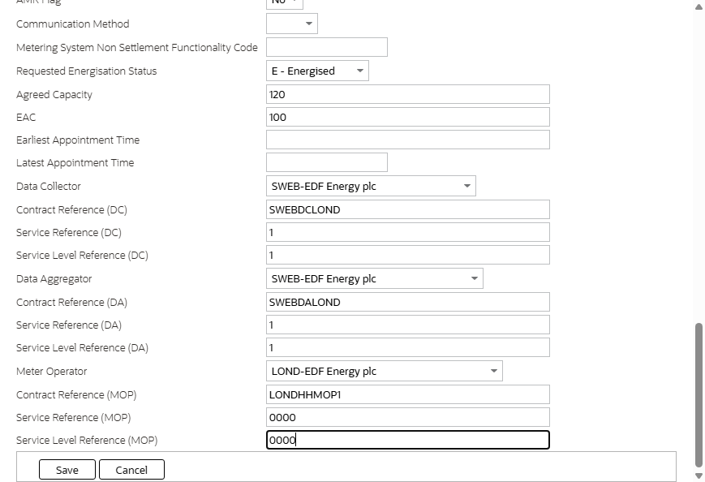
Site added succesfully.
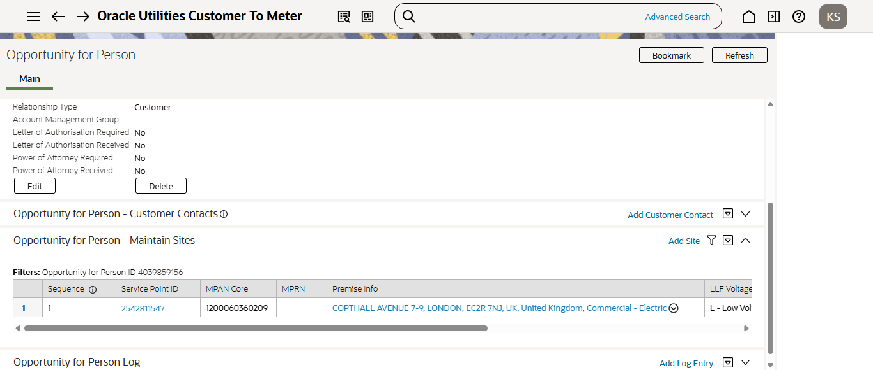
Credit Check Processed Succesfully
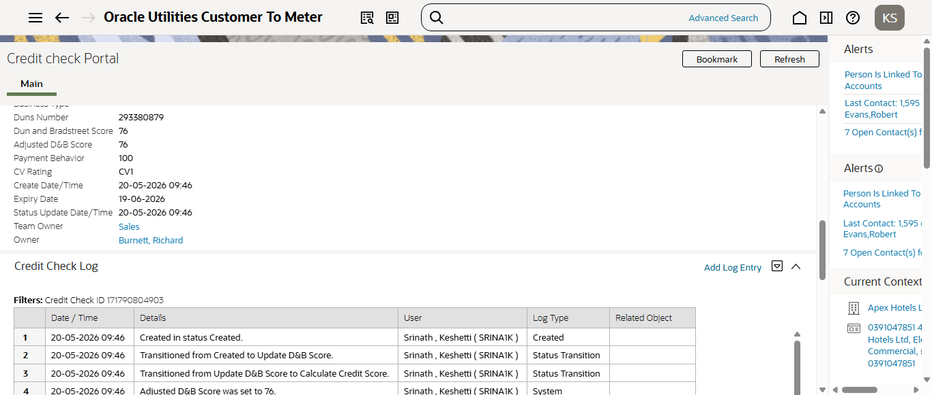
Opportunity Qualified
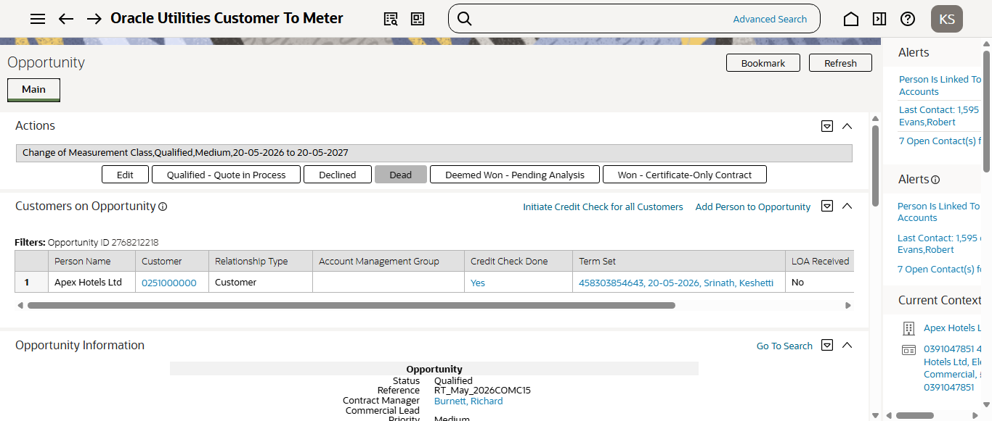
Step12:RunningCM-ECCHKbatch
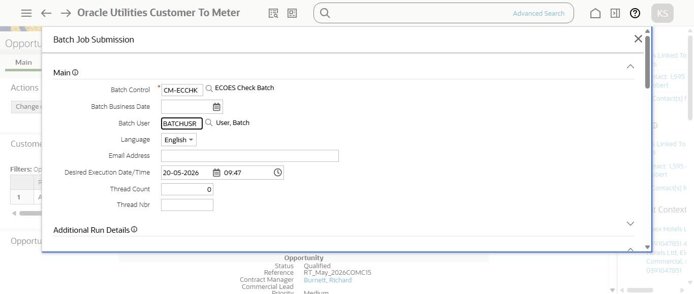
Step12:Running Ecoes batch
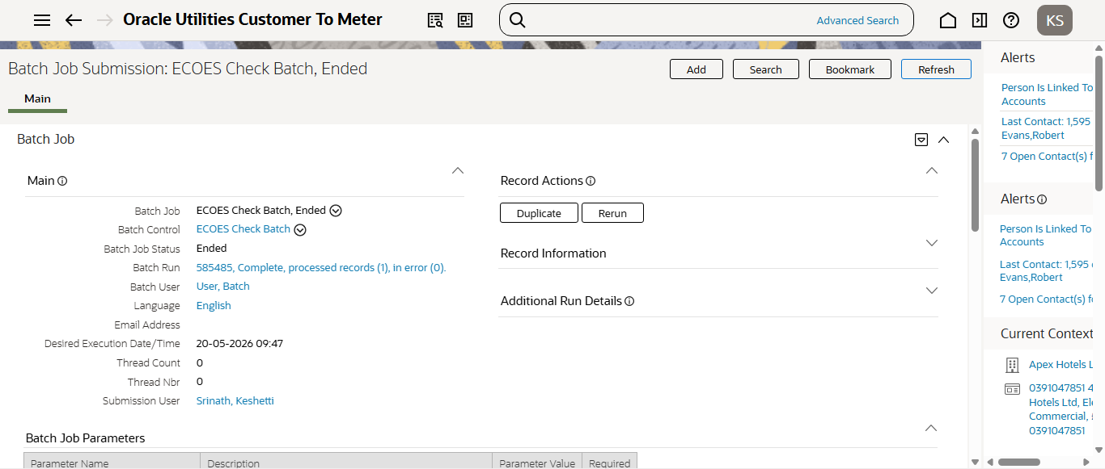
Step12:RunningCM-ECCHKbatch
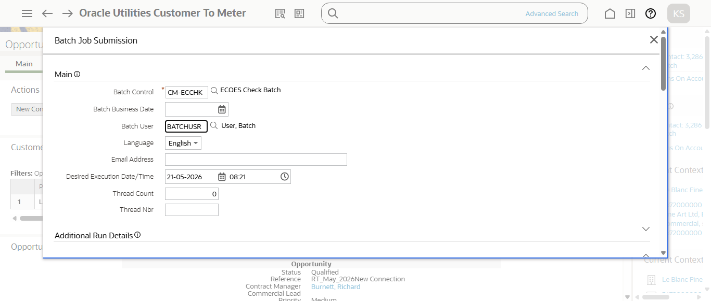
Step12:Running Ecoes batch
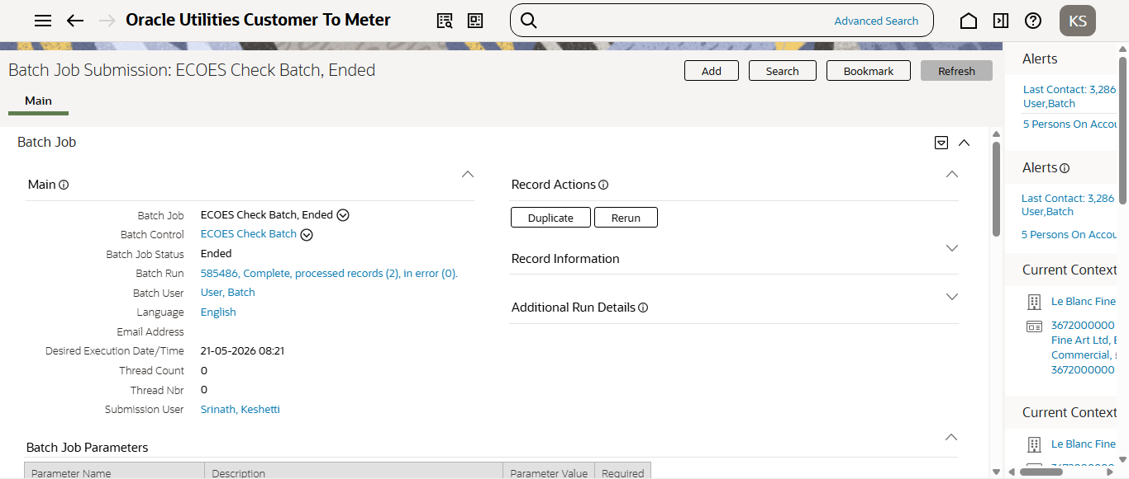
Step12:RunningCM-ECCHKbatch
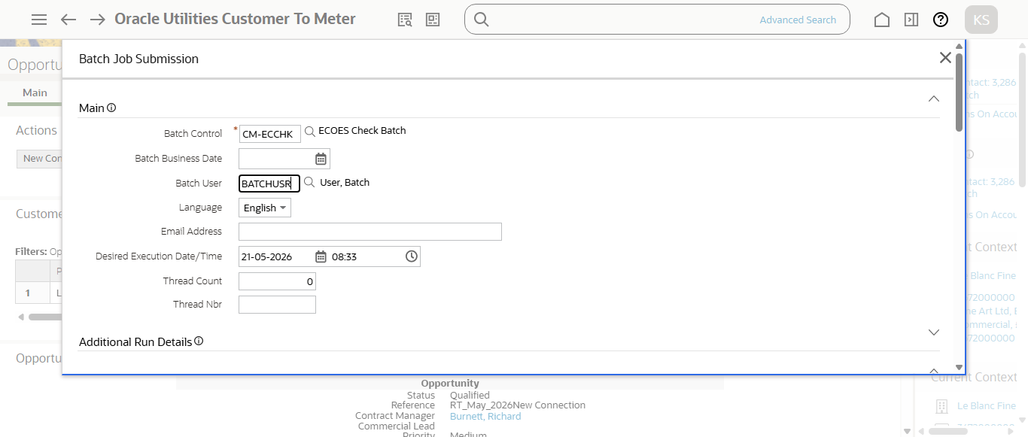
Step12:Running Ecoes batch
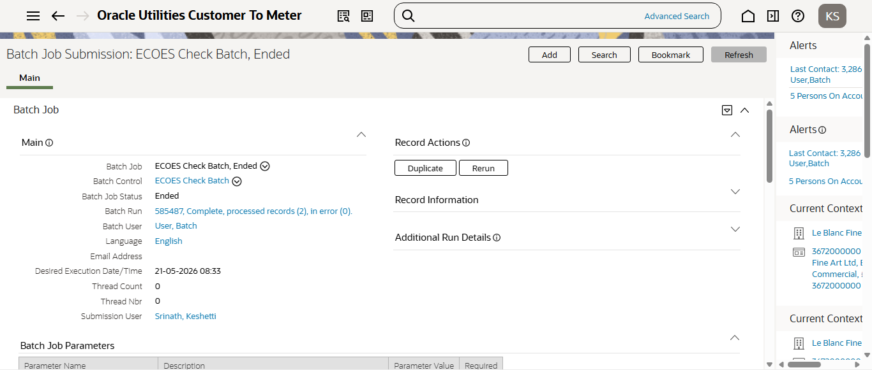
Step12:RunningCM-ECCHKbatch
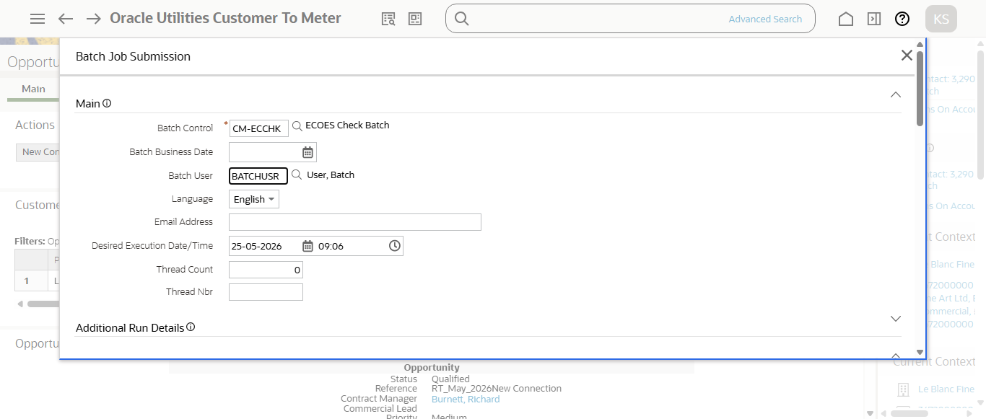
Step12:Running Ecoes batch
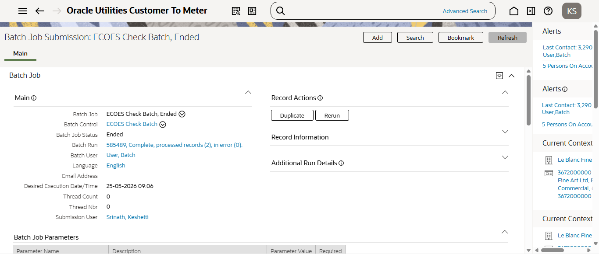
Step12:RunningCM-ECCHKbatch
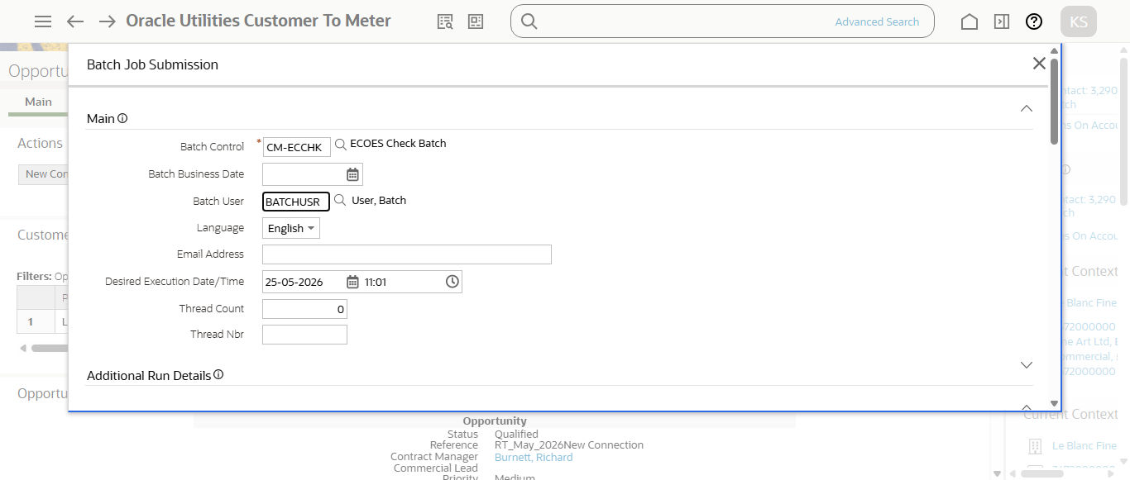
Step12:Running Ecoes batch
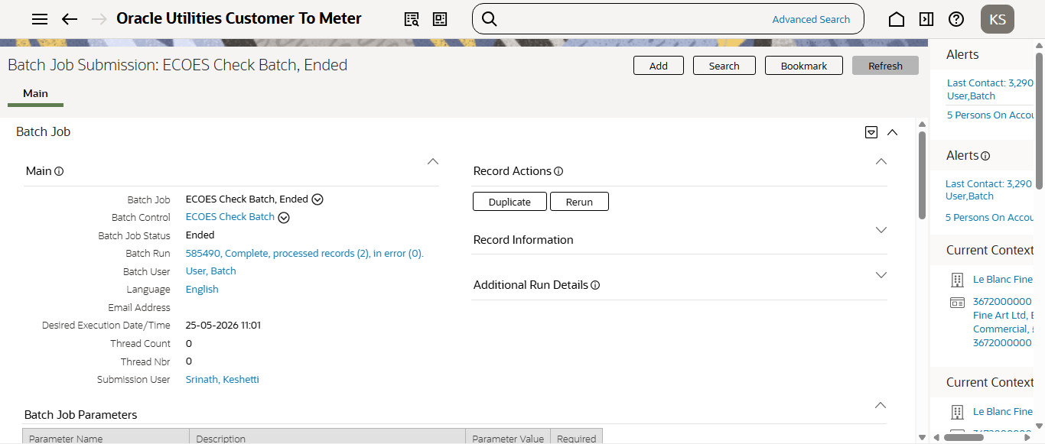
Step12:RunningCM-ECCHKbatch
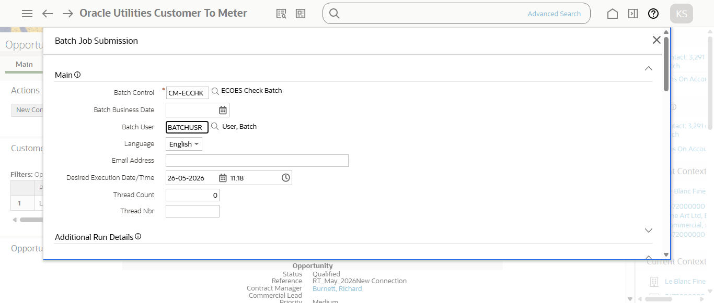
Step12:Running Ecoes batch
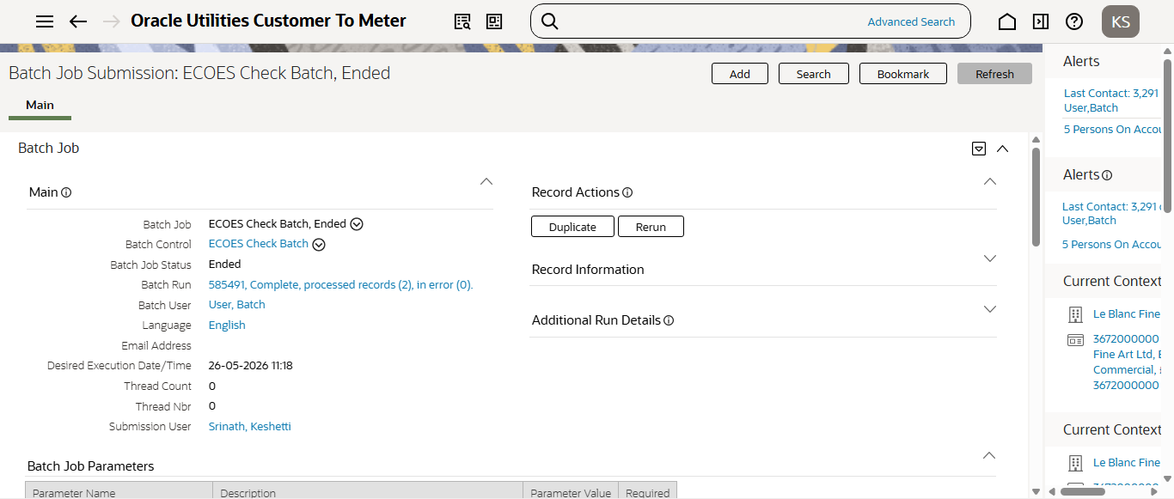
Step12:RunningCM-ECCHKbatch
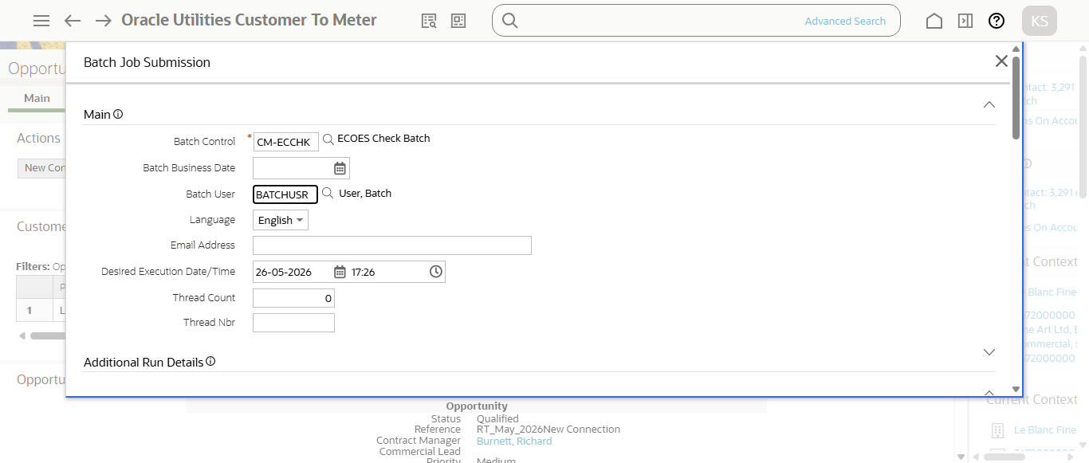
Step12:Running Ecoes batch
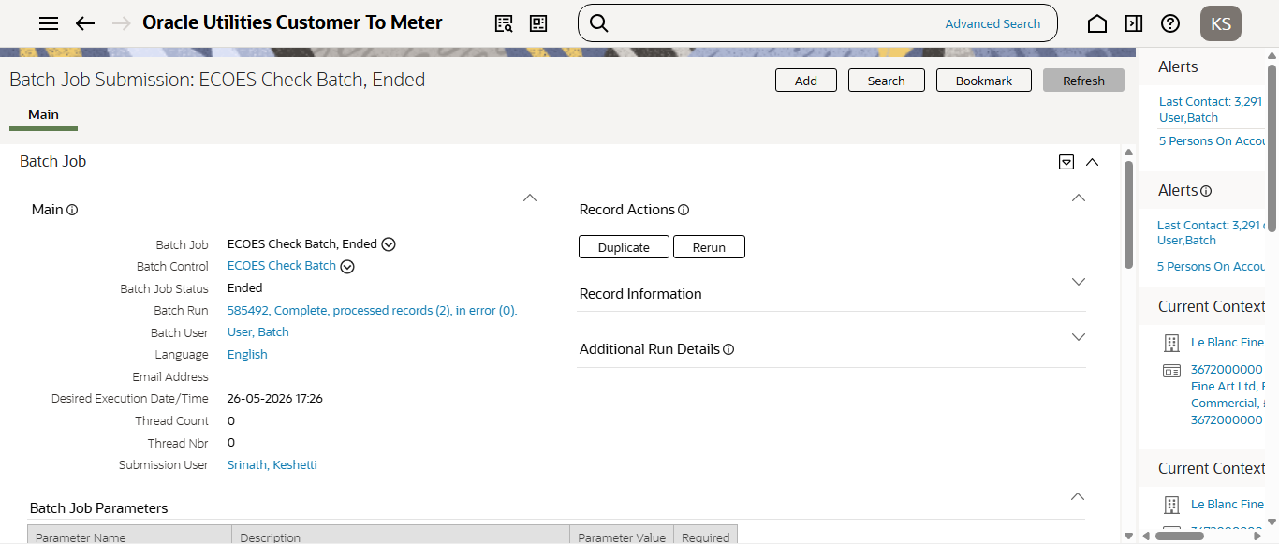
Step12:RunningCM-ECCHKbatch
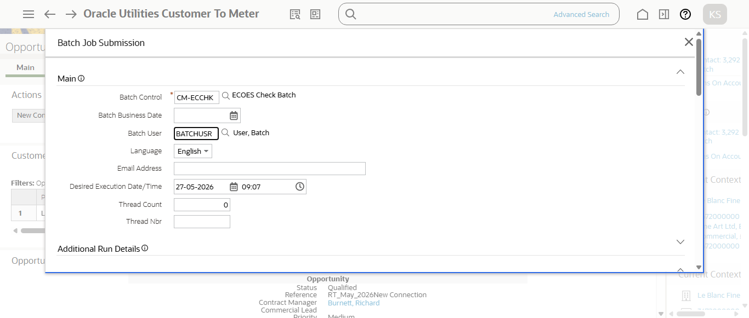
Step12:Running Ecoes batch
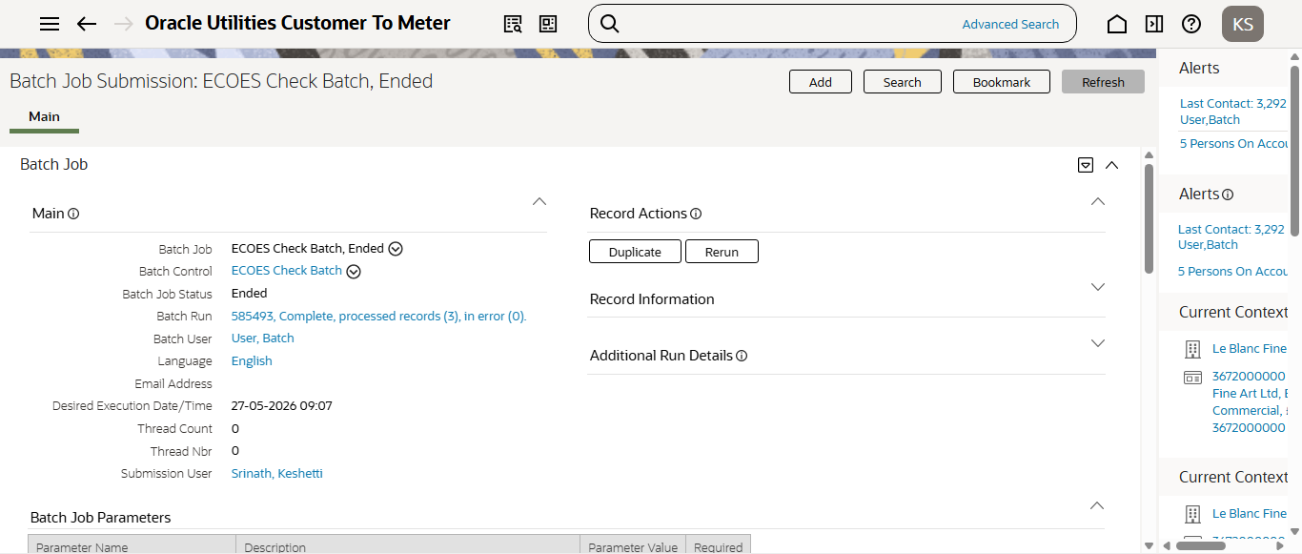
Step12:RunningCM-ECCHKbatch
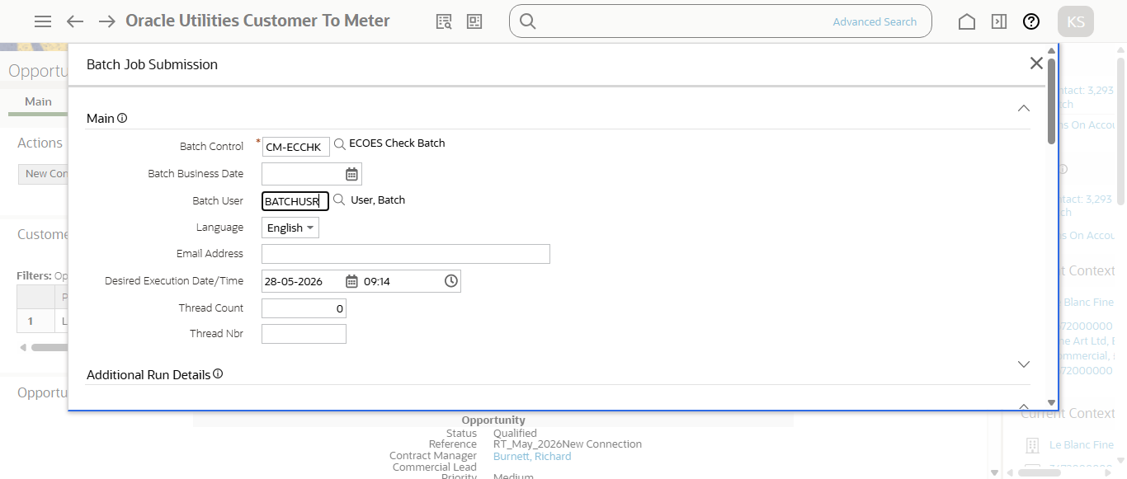
Step12:Running Ecoes batch
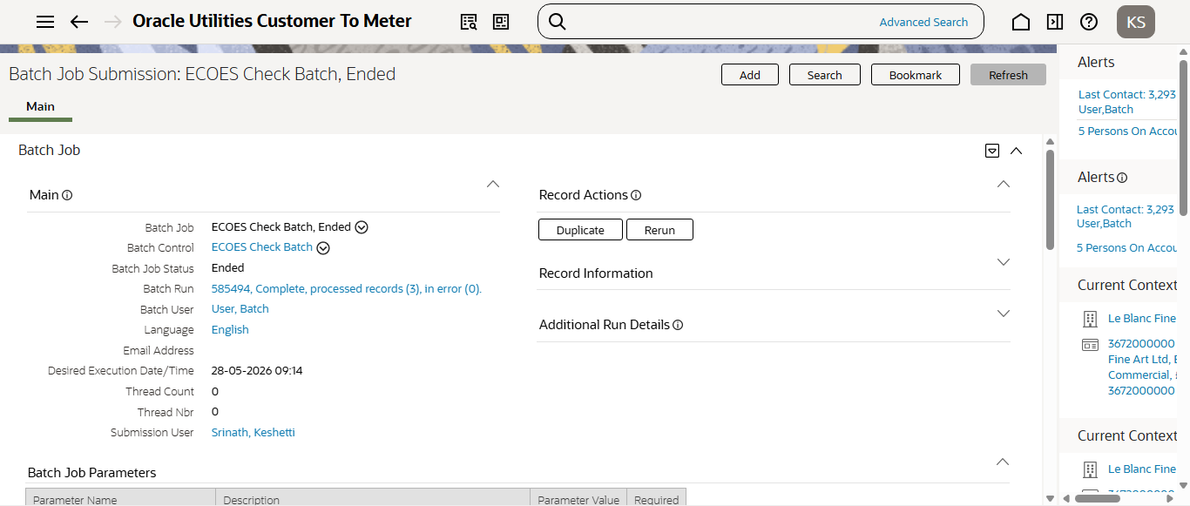
Step12:RunningCM-ECCHKbatch
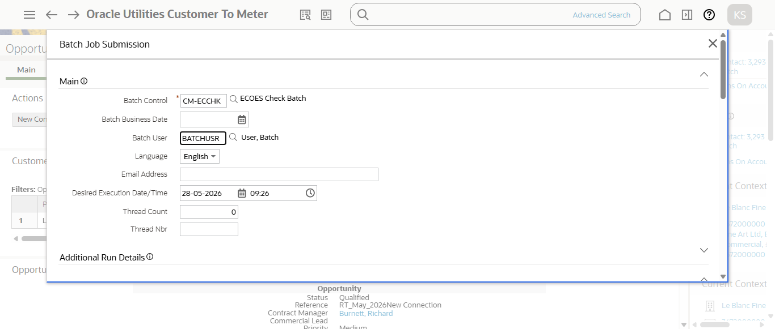
Step12:Running Ecoes batch
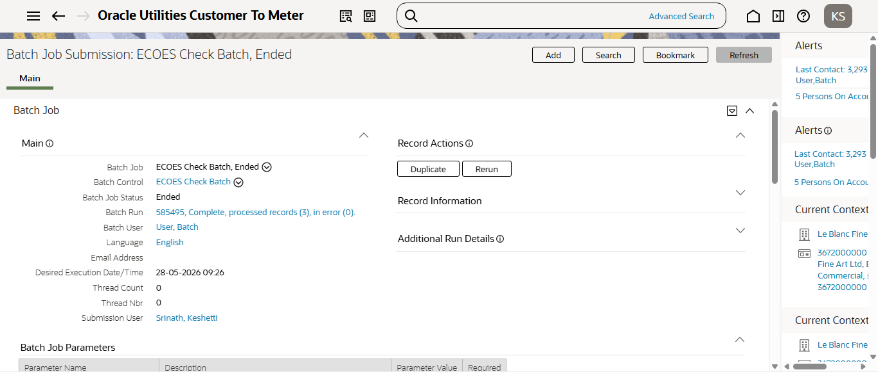
Step12:RunningCM-ECCHKbatch
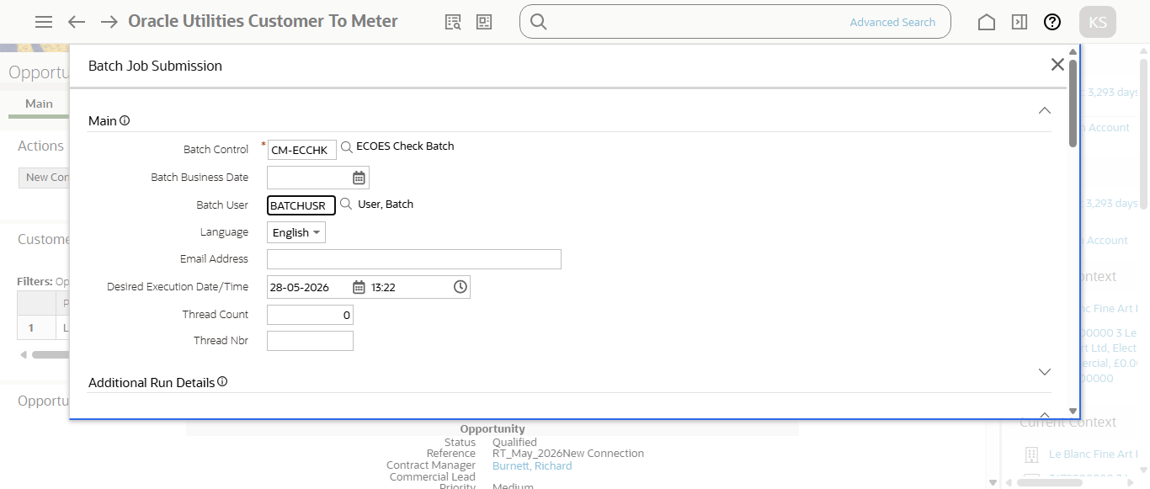
Step12:Running Ecoes batch
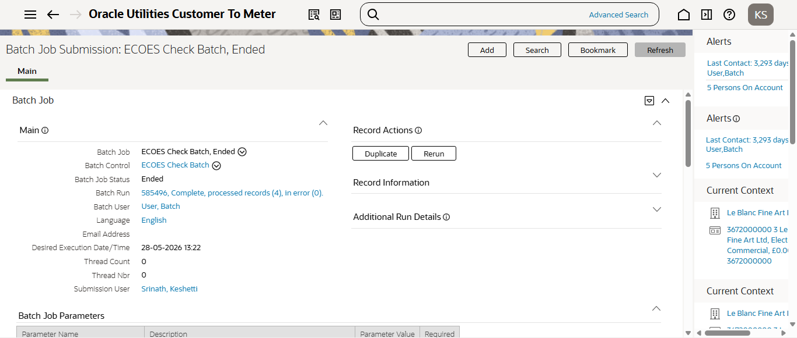
Step12:RunningCM-ECCHKbatch
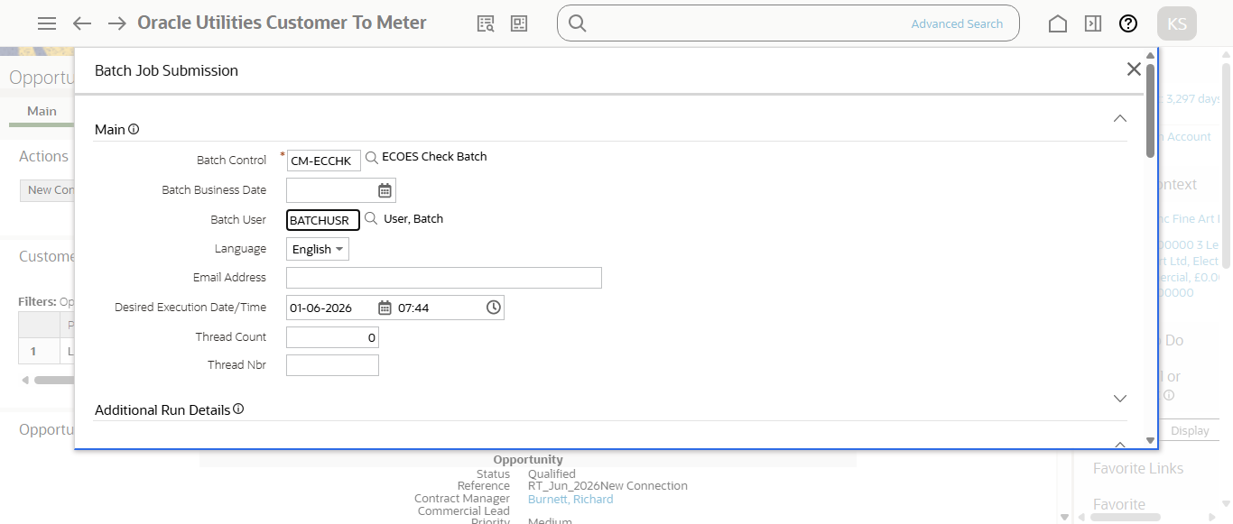
Step12:Running Ecoes batch
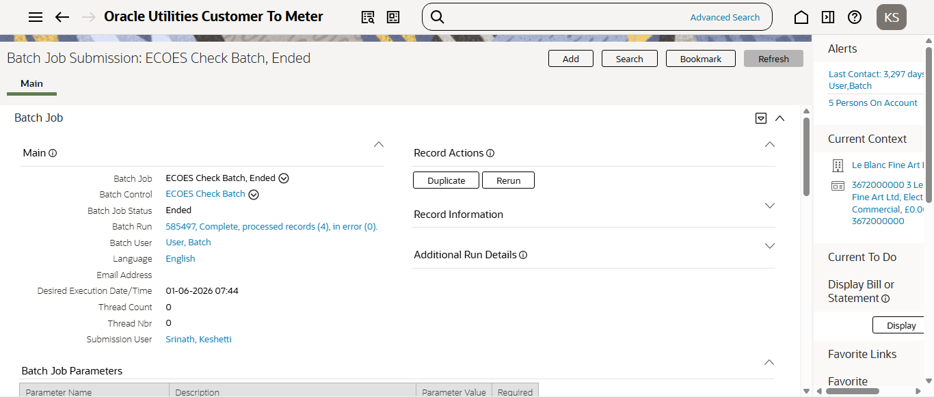
Step12:RunningCM-ECCHKbatch
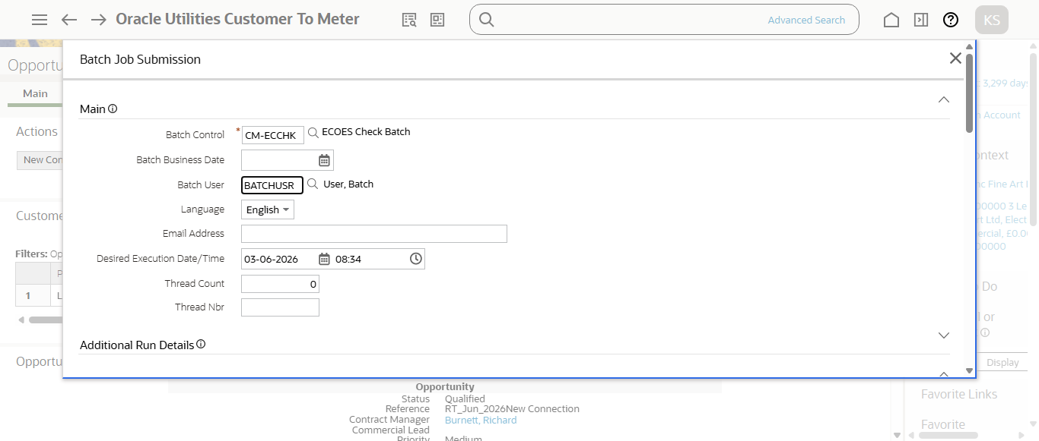
Step12:Running Ecoes batch
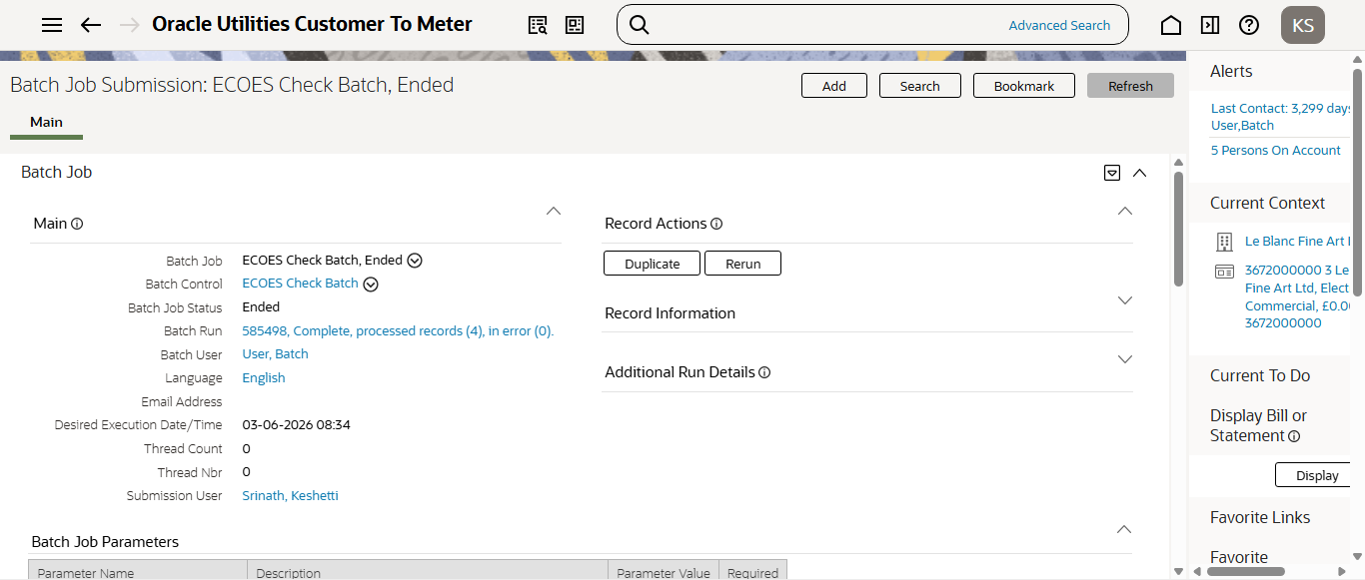
Step12:RunningCM-ECCHKbatch
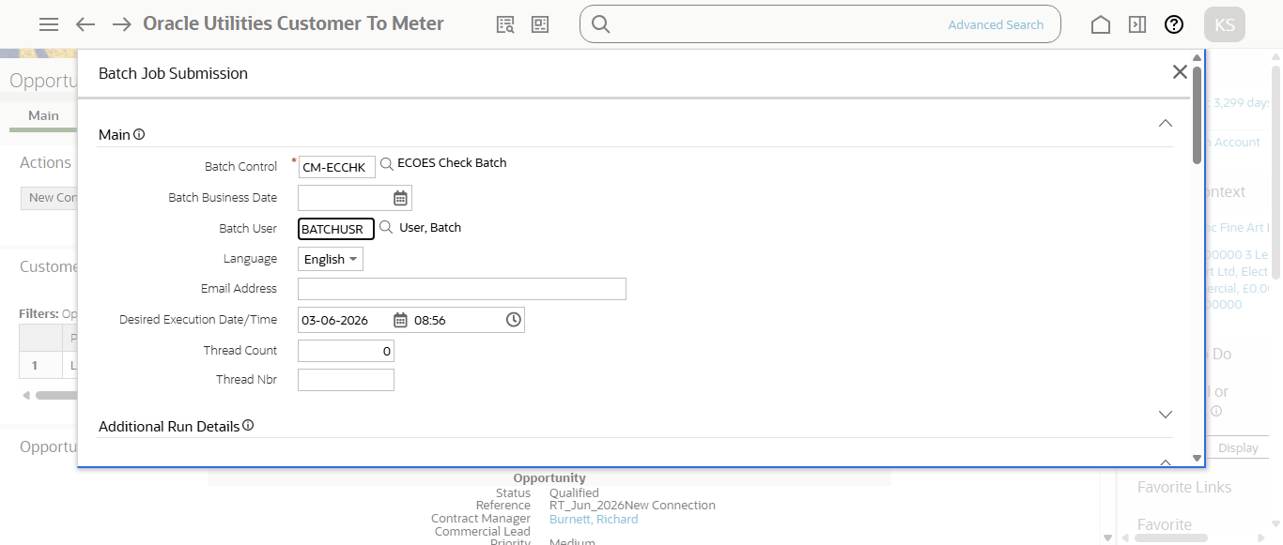
Step12:Running Ecoes batch
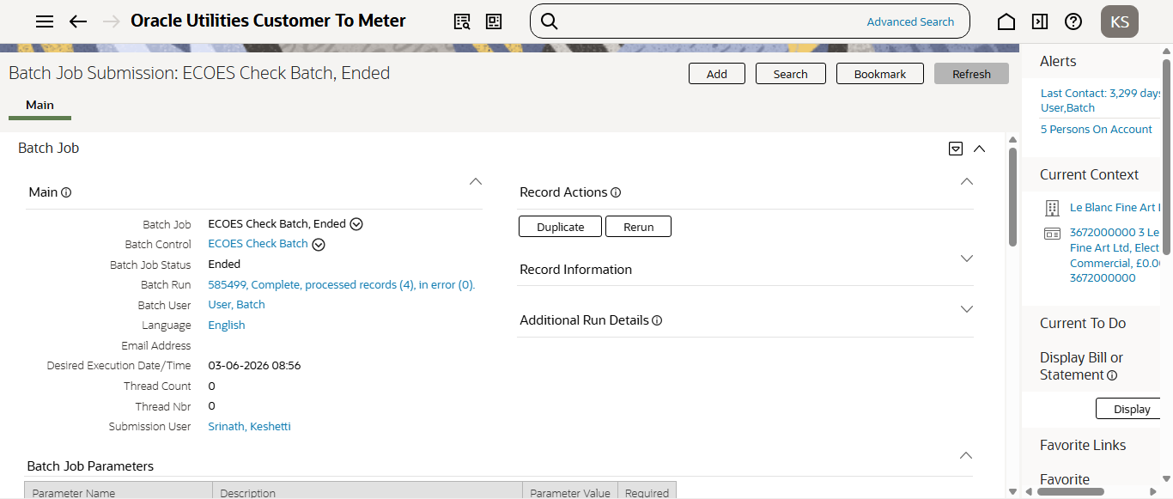
Step12:RunningCM-ECCHKbatch
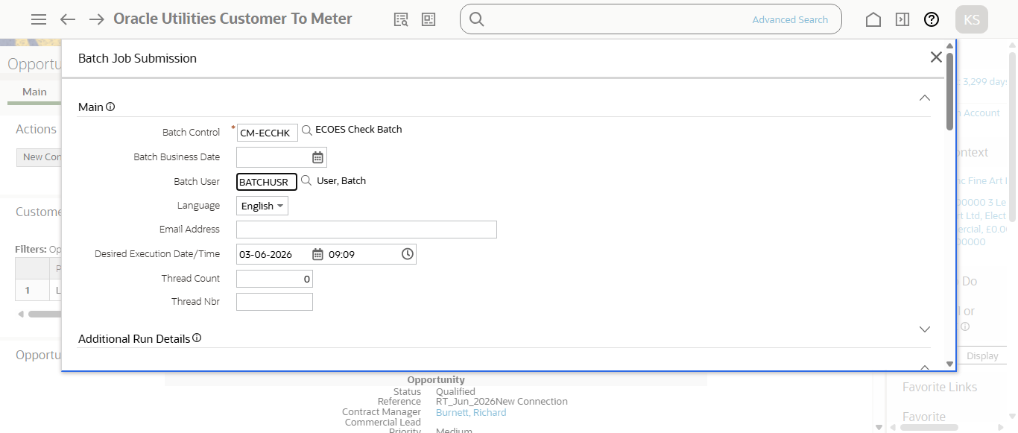
Step12:Running Ecoes batch
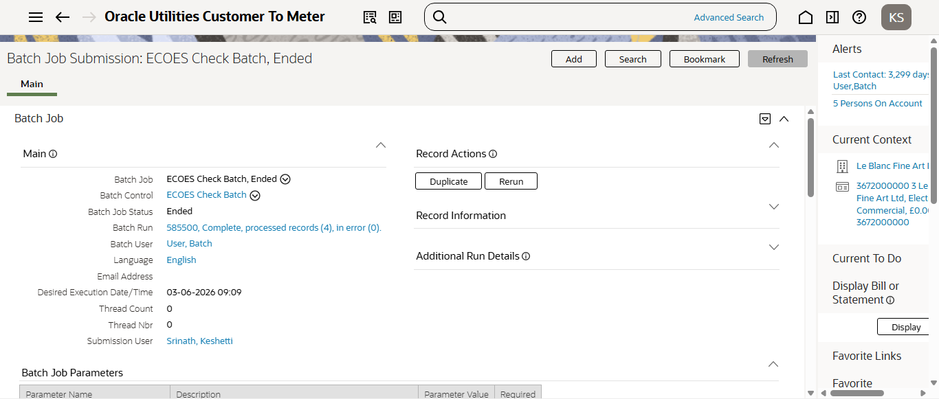
Step12:RunningCM-ECCHKbatch
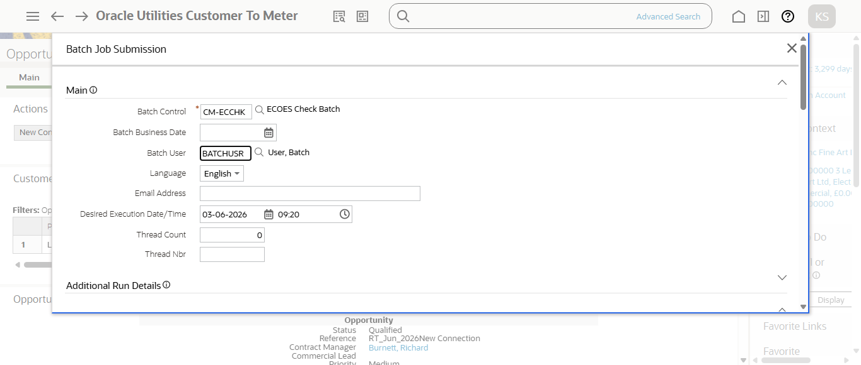
Step12:Running Ecoes batch
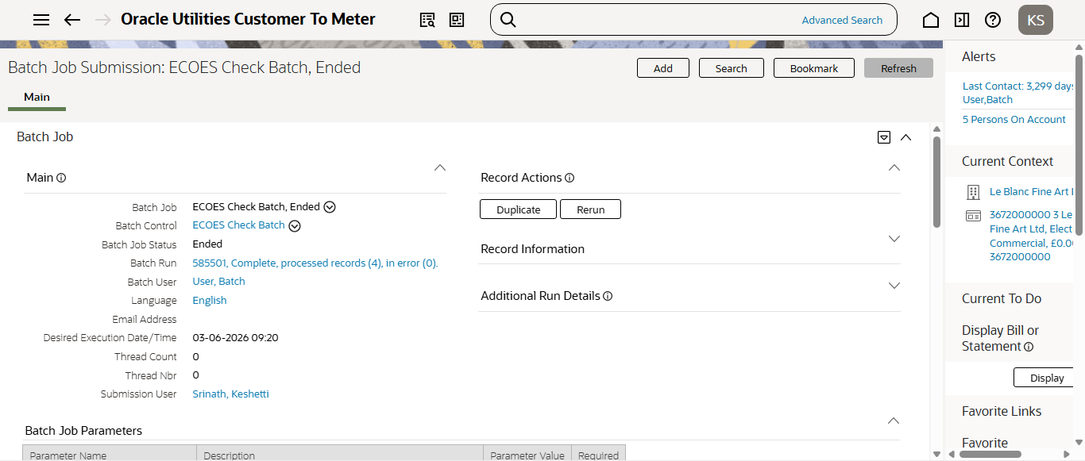
Step12:RunningCM-ECCHKbatch
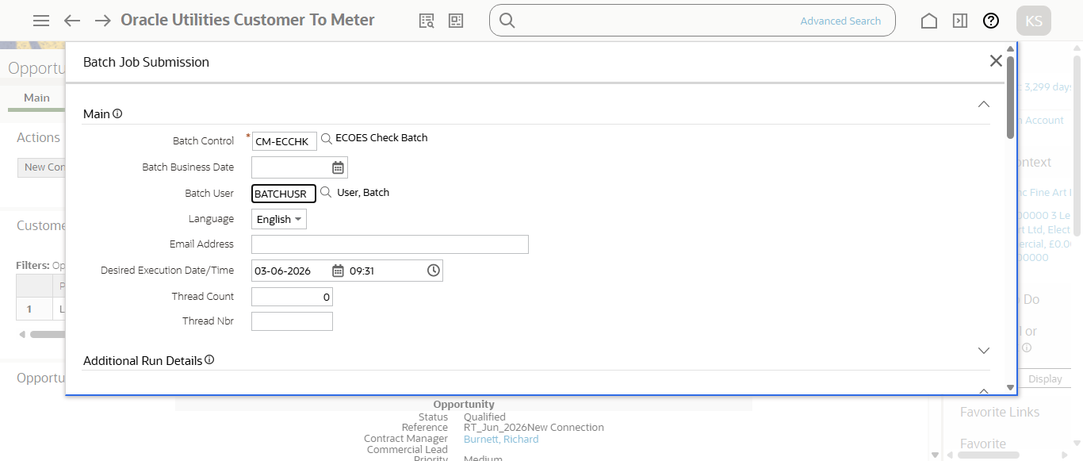
Step12:Running Ecoes batch
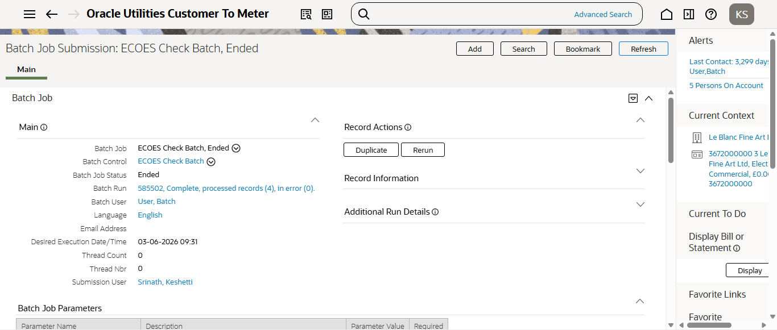
Step12:RunningCM-ECCHKbatch
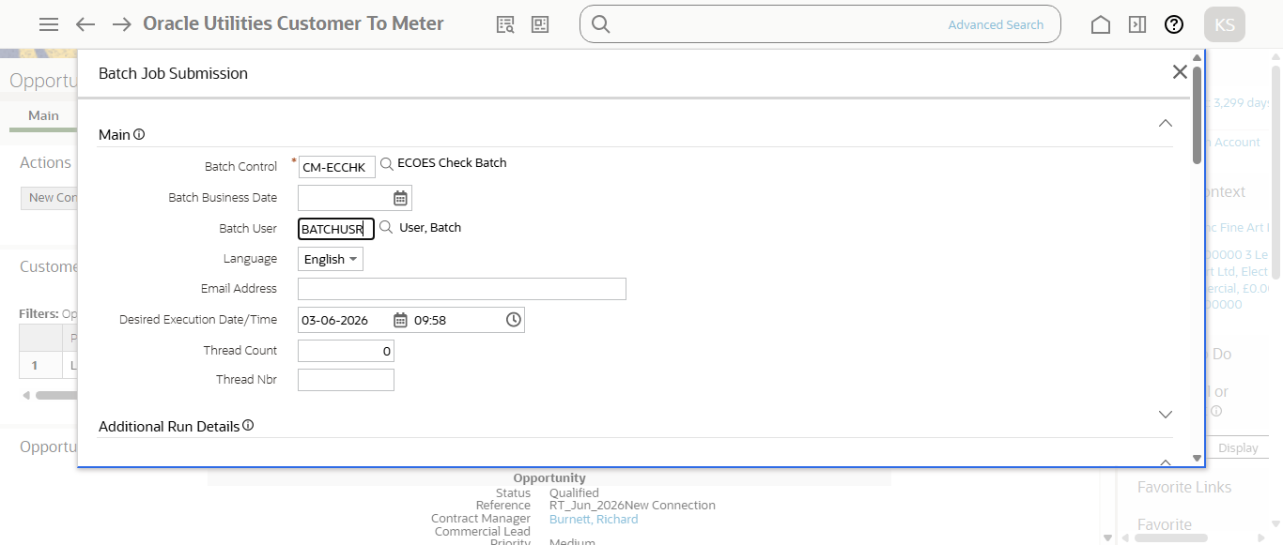
Step12:Running Ecoes batch
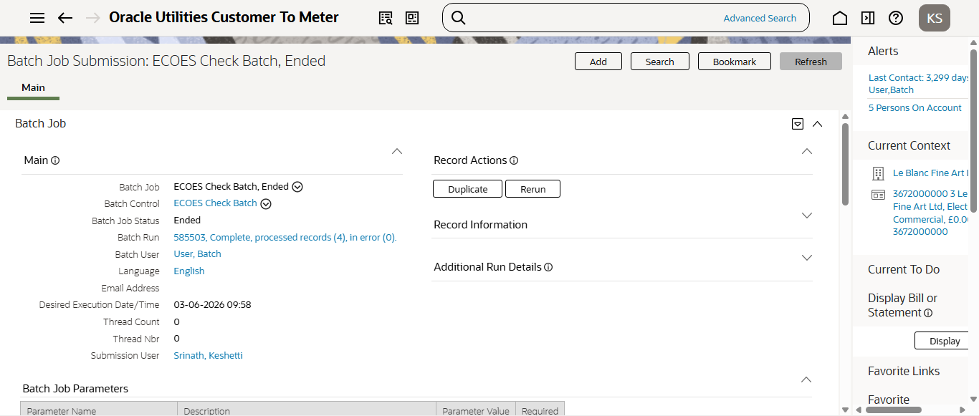
Step12:RunningCM-ECCHKbatch
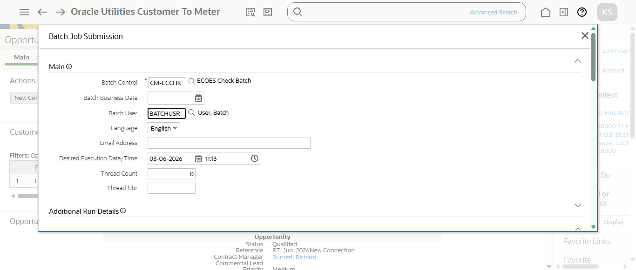
Step12:Running Ecoes batch
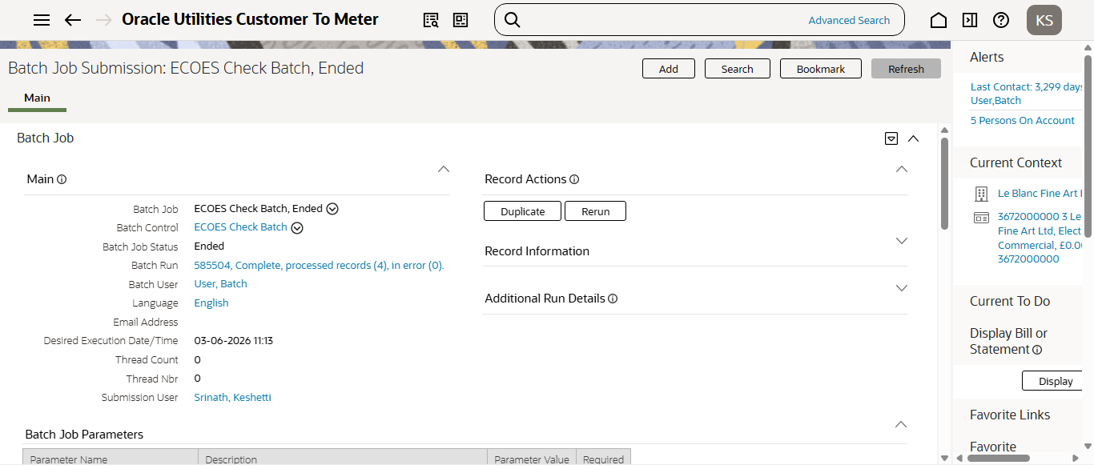
Step12:RunningCM-ECCHKbatch
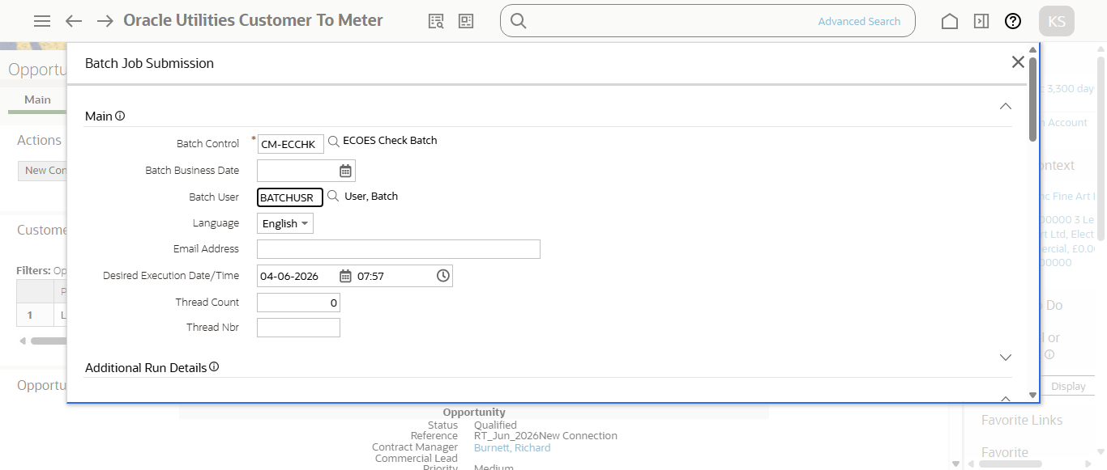
Step12:Running Ecoes batch
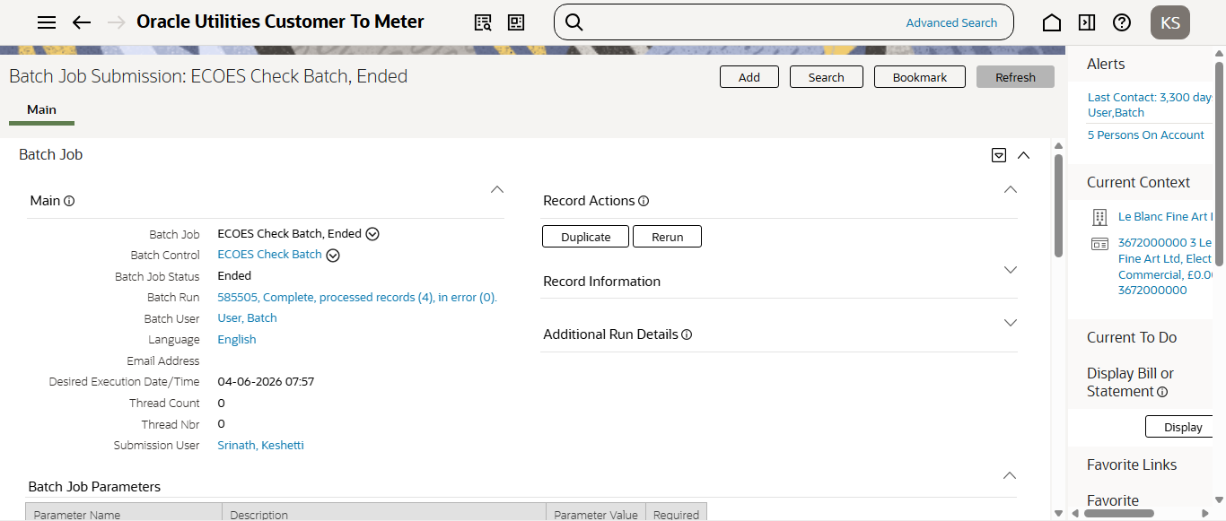
Step12:RunningCM-ECCHKbatch
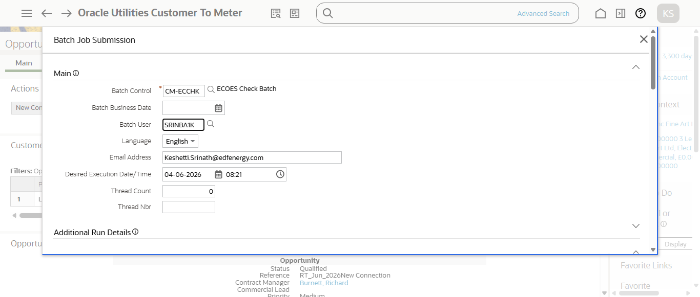
Step12:RunningCM-ECCHKbatch
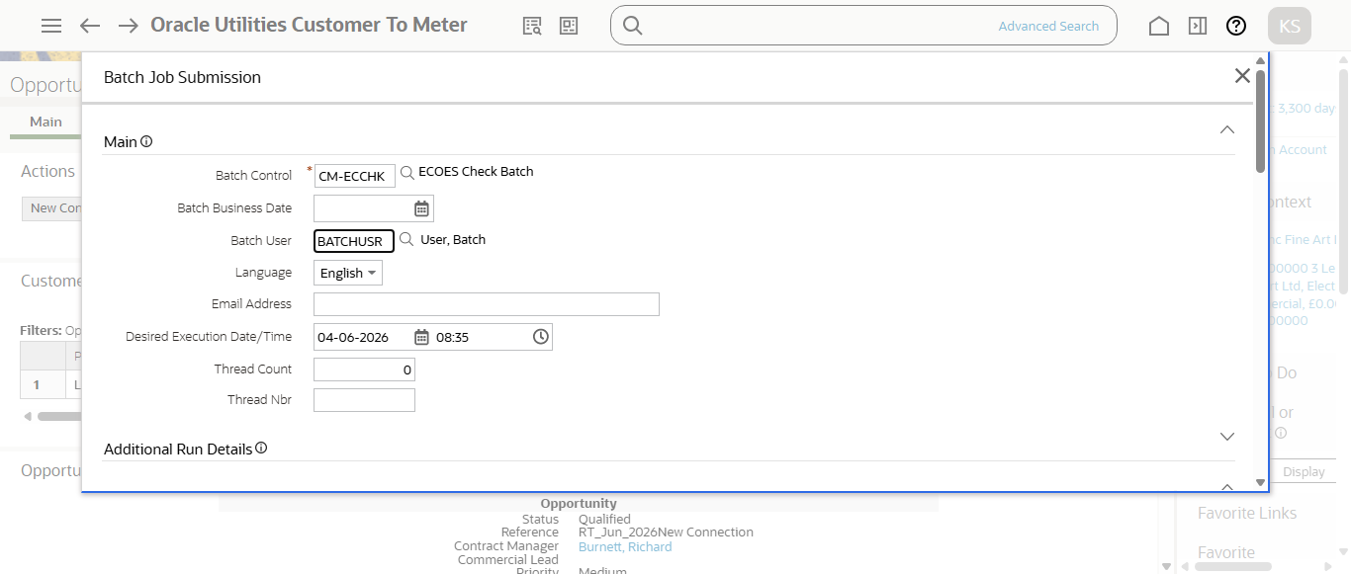
Step12:Running Ecoes batch
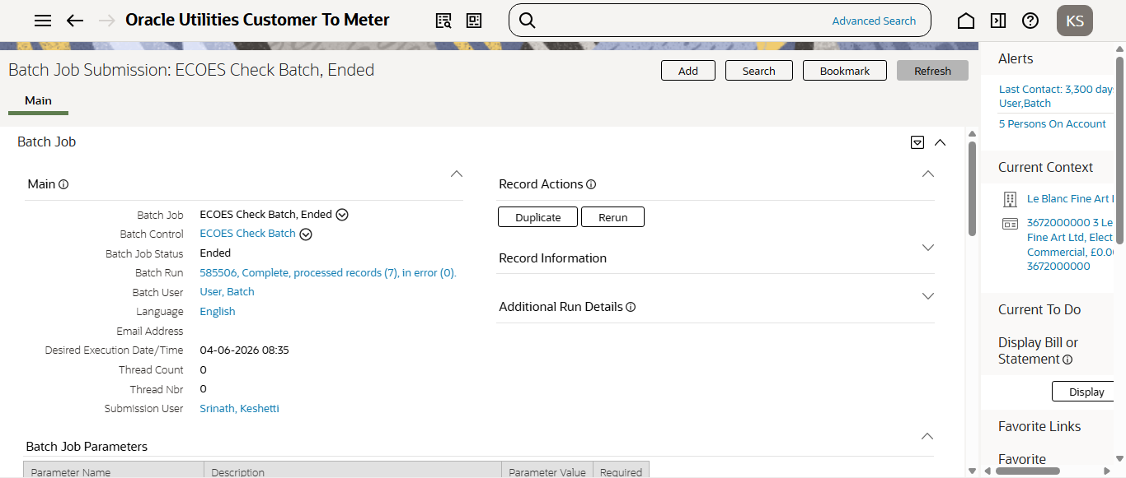
Step12:RunningCM-ECCHKbatch
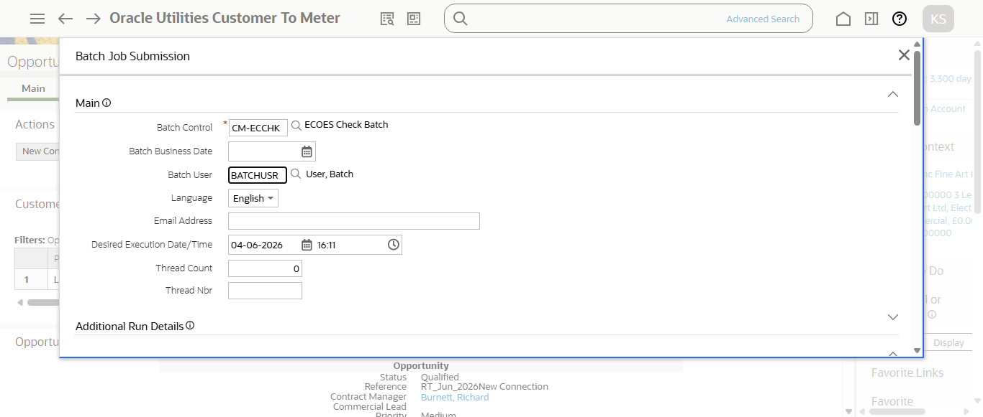
Step12:Running Ecoes batch
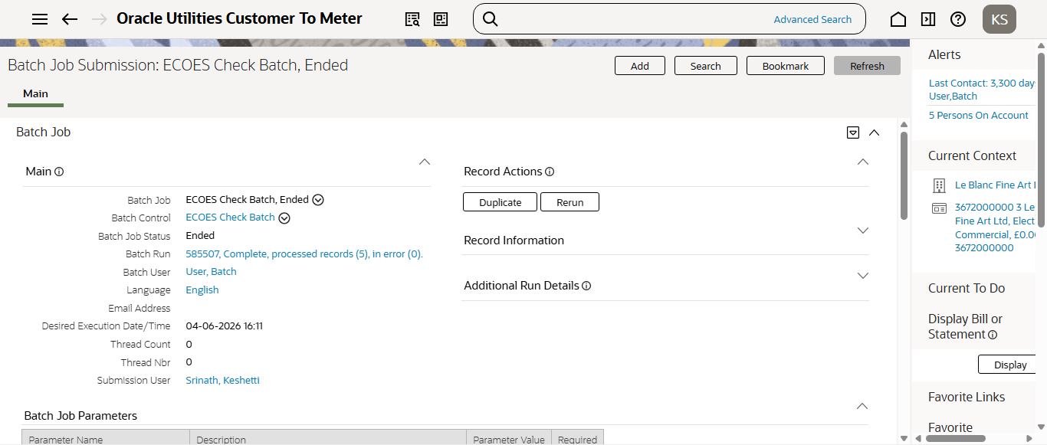
Step12:RunningCM-ECCHKbatch
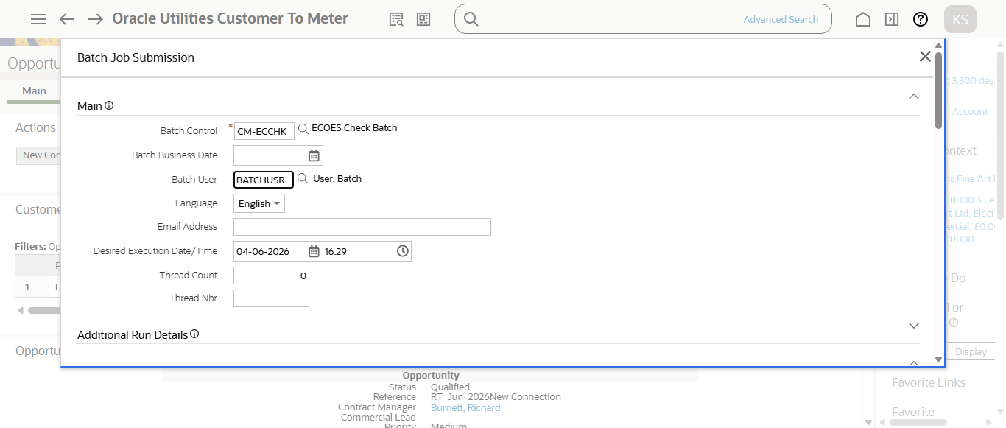
Step12:Running Ecoes batch
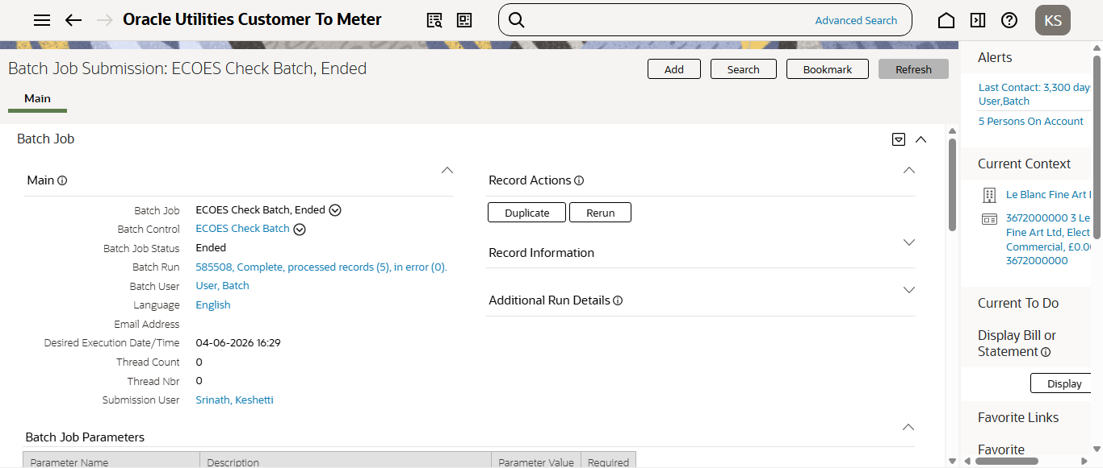
Step12:RunningCM-ECCHKbatch
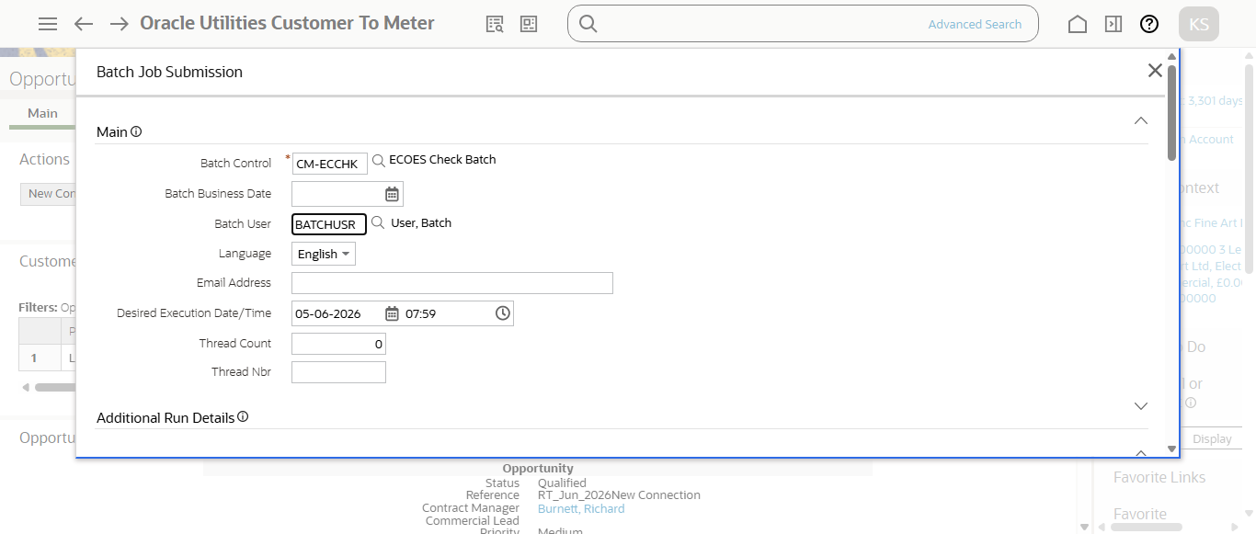
Step12:Running Ecoes batch
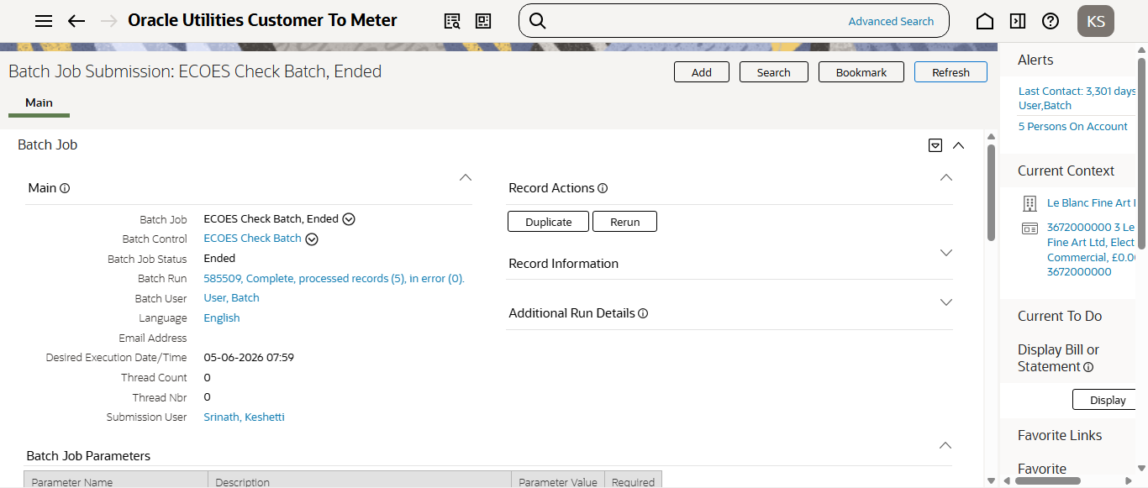
Step12:RunningCM-ECCHKbatch
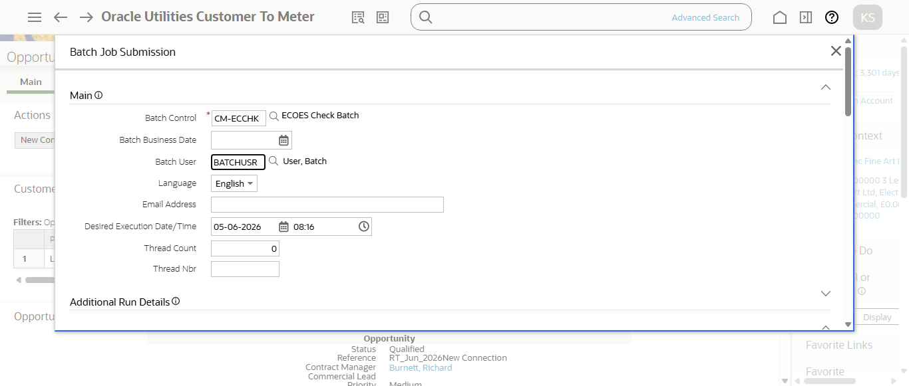
Step12:Running Ecoes batch
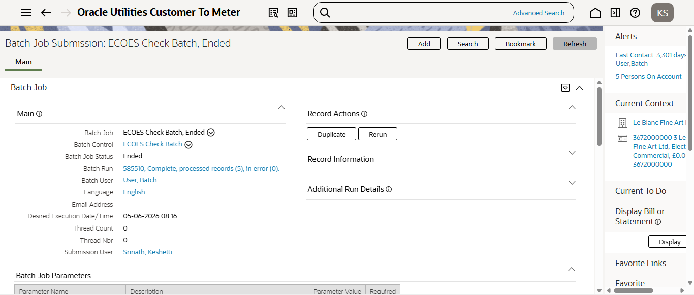
Step12:RunningCM-ECCHKbatch
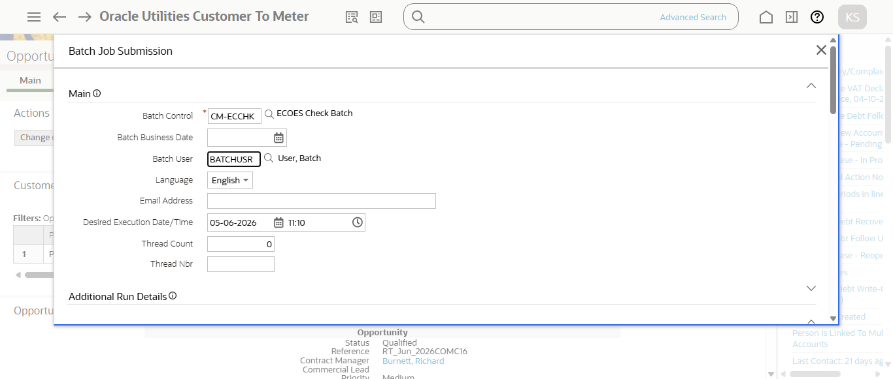
Step12:Running Ecoes batch
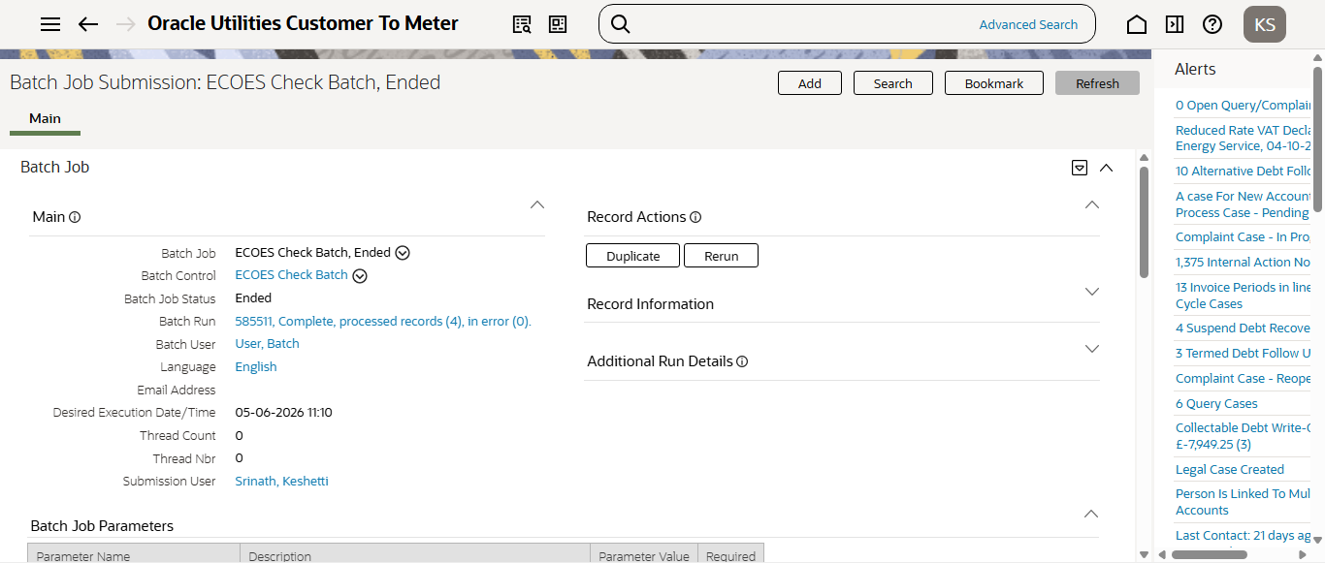
Step12:RunningCM-ECCHKbatch
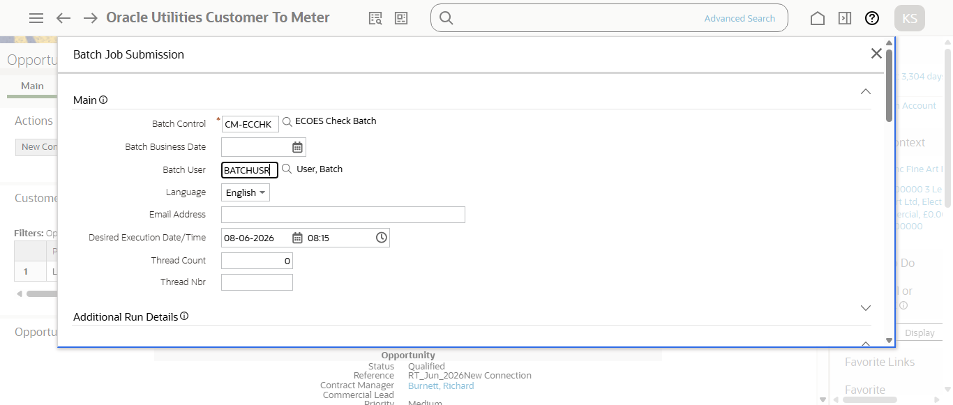
Step12:Running Ecoes batch
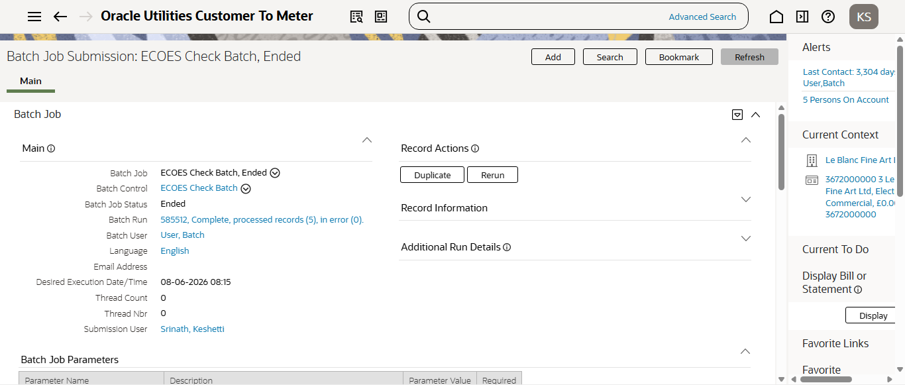
Step12:RunningCM-ECCHKbatch
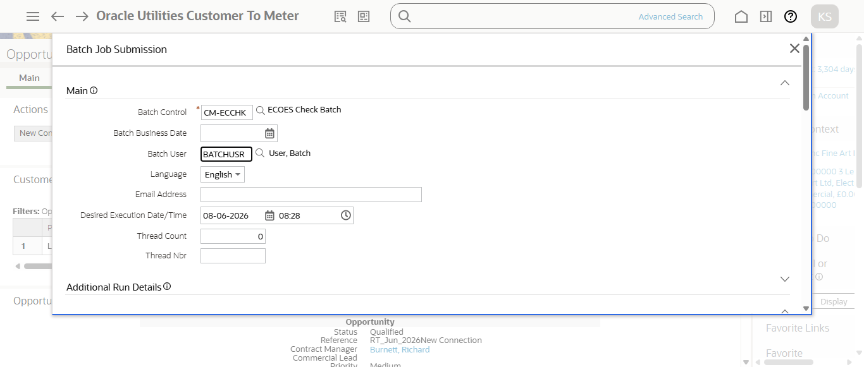
Step12:Running Ecoes batch
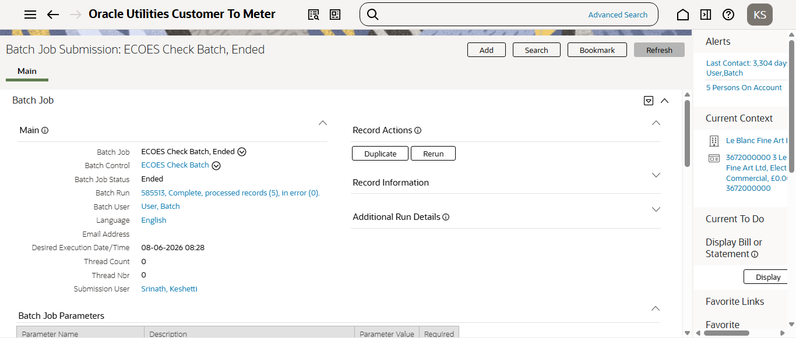
Step12:RunningCM-ECCHKbatch
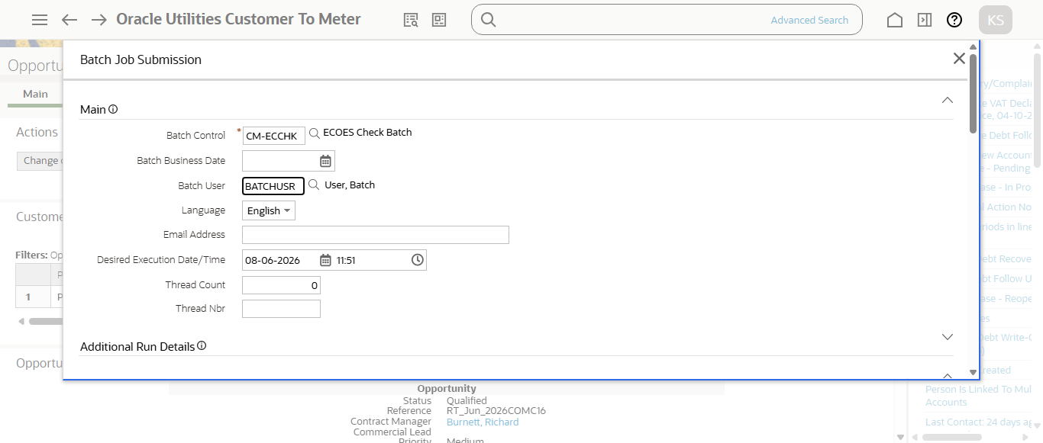
Step12:Running Ecoes batch
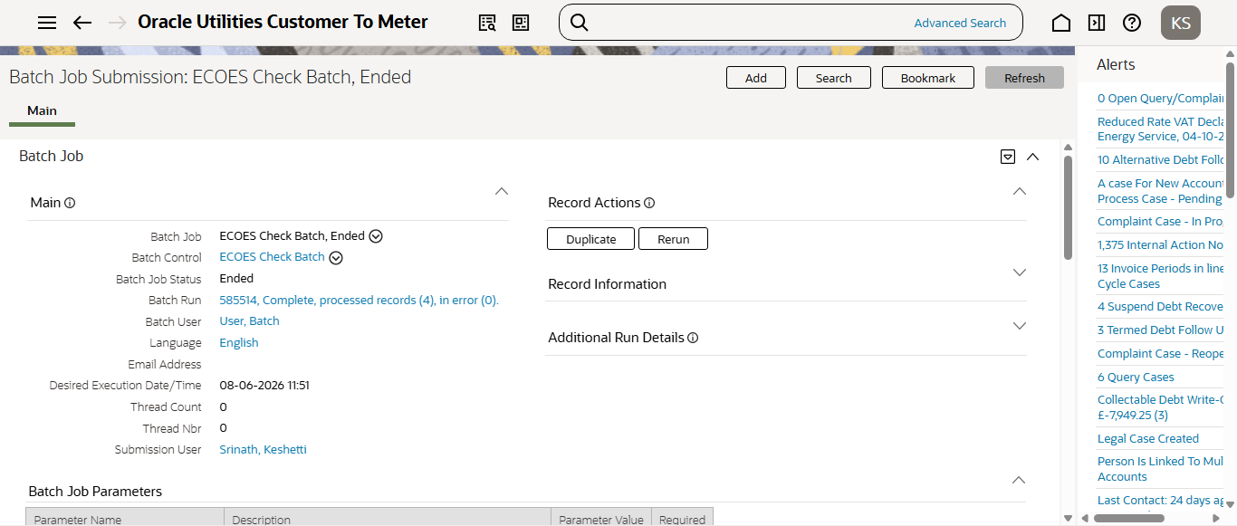
Step12:RunningCM-ECCHKbatch
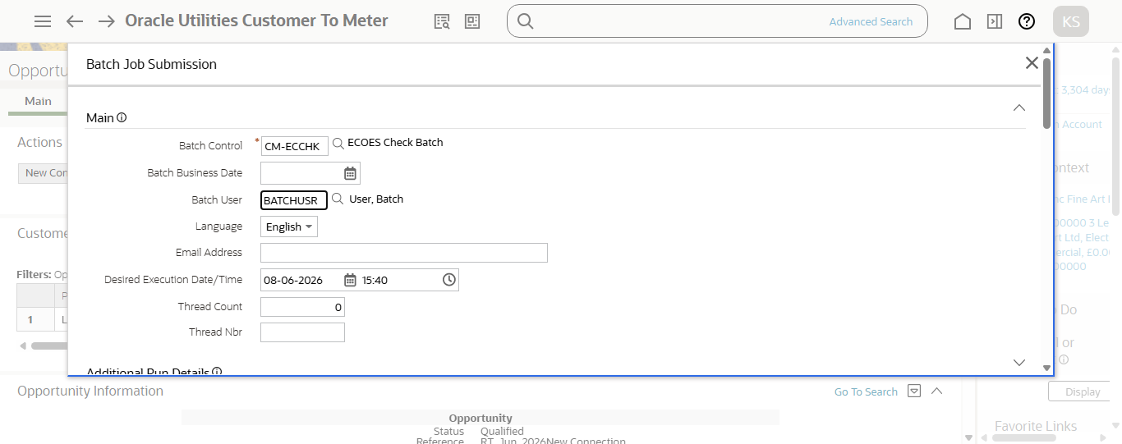
Step12:Running Ecoes batch
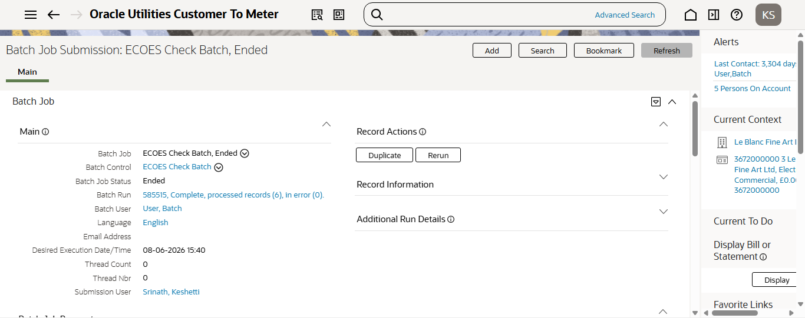
Step12:RunningCM-ECCHKbatch
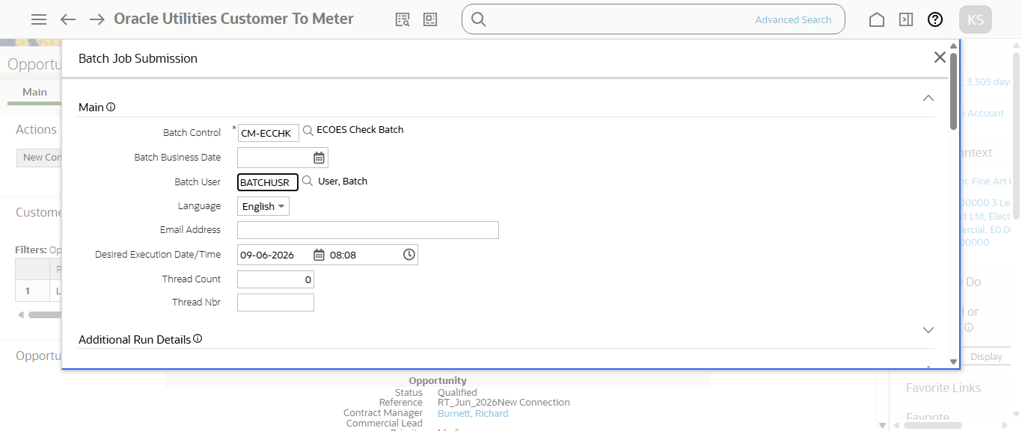
Step12:Running Ecoes batch
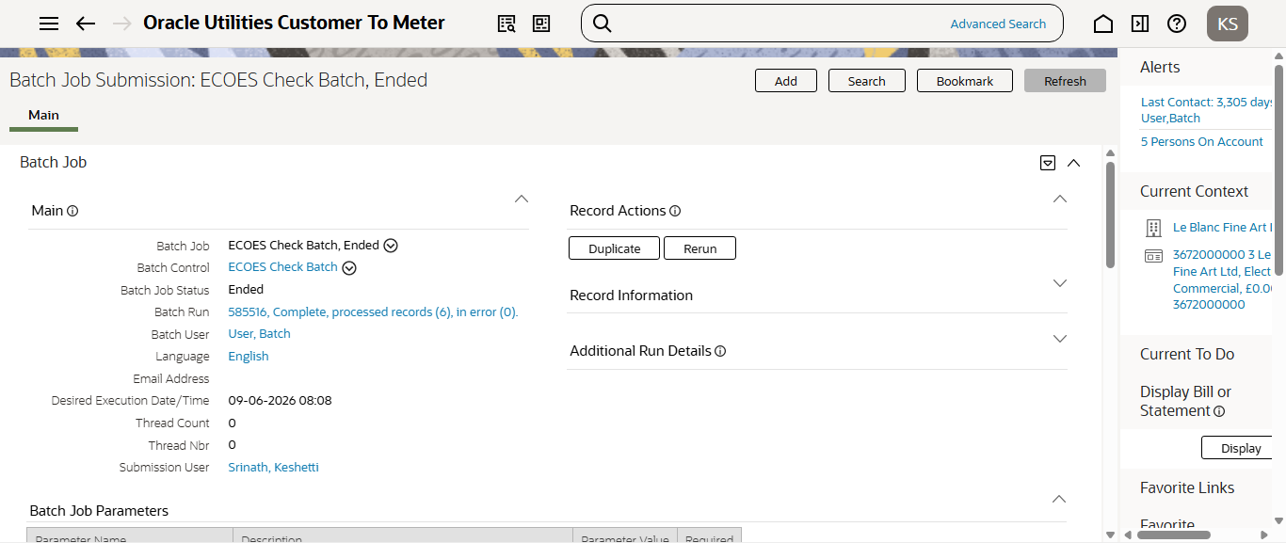
Step12:RunningCM-ECCHKbatch
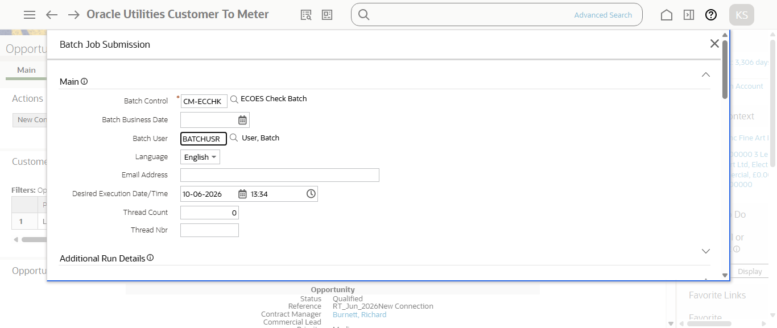
Step12:Running Ecoes batch
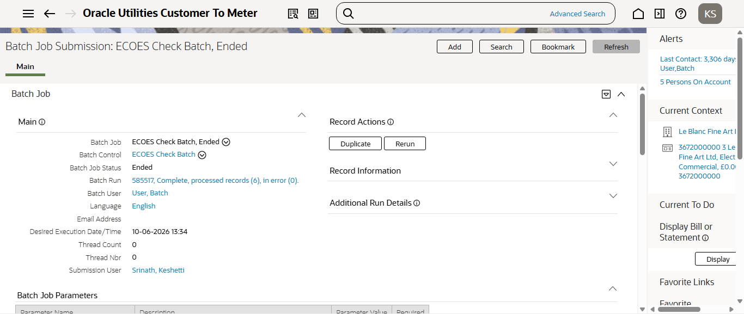
Step12:RunningCM-ECCHKbatch
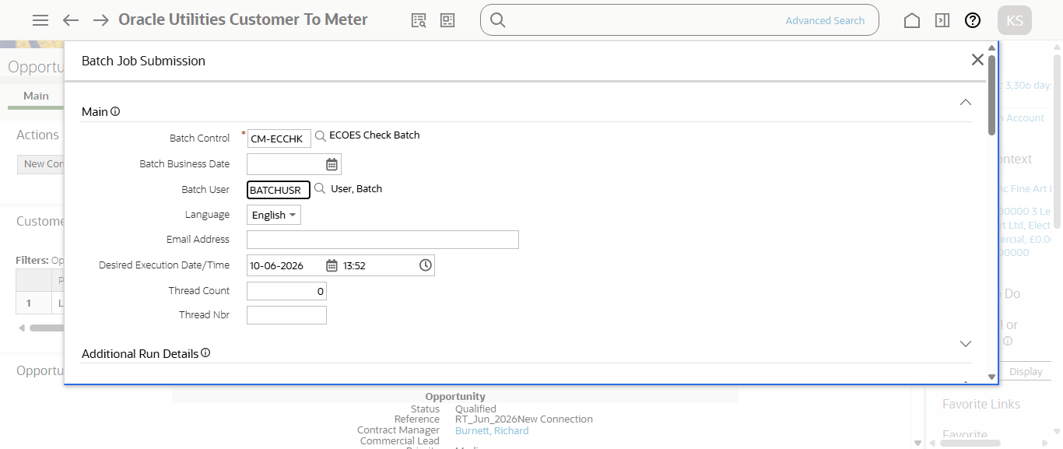
Step12:Running Ecoes batch
