Quote Accepted and Sync Request Created in system
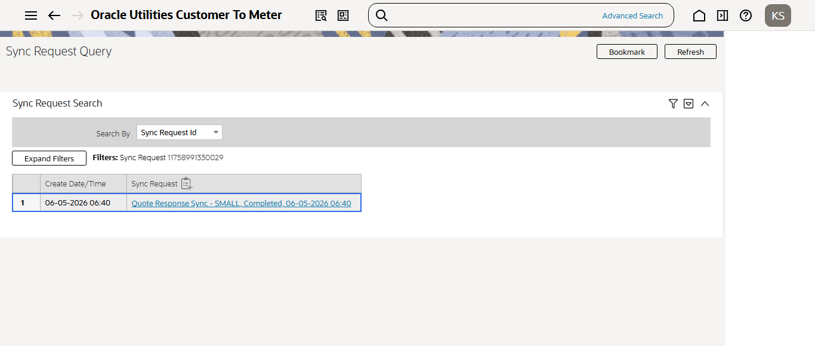
Sync Request Validation completed
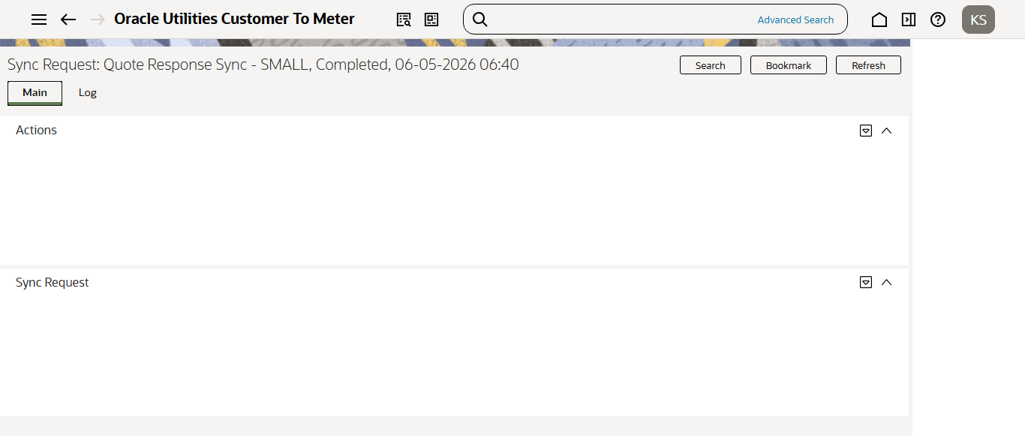
Batch Completed
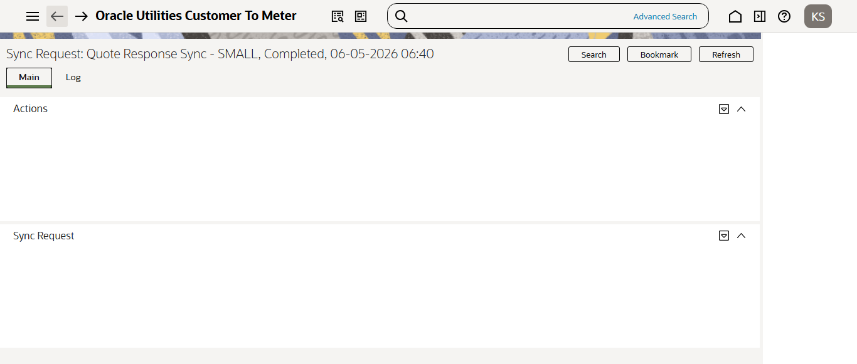
Contract is created in Set-Up Inprogress status
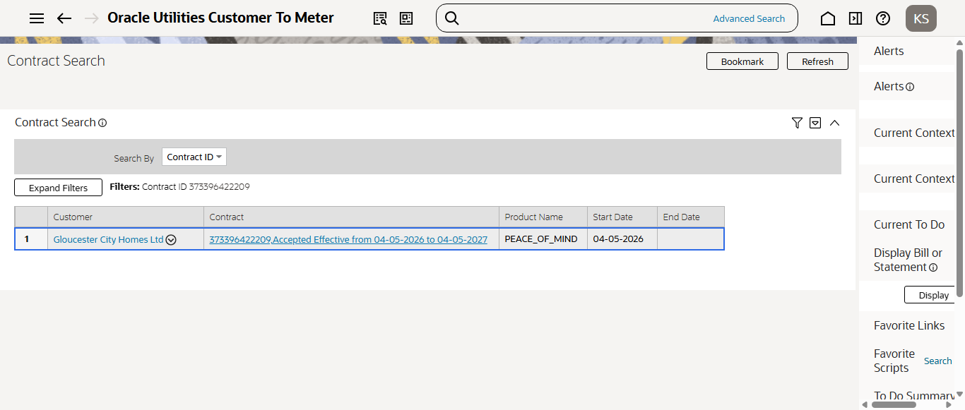
Contract is validated and Accepted
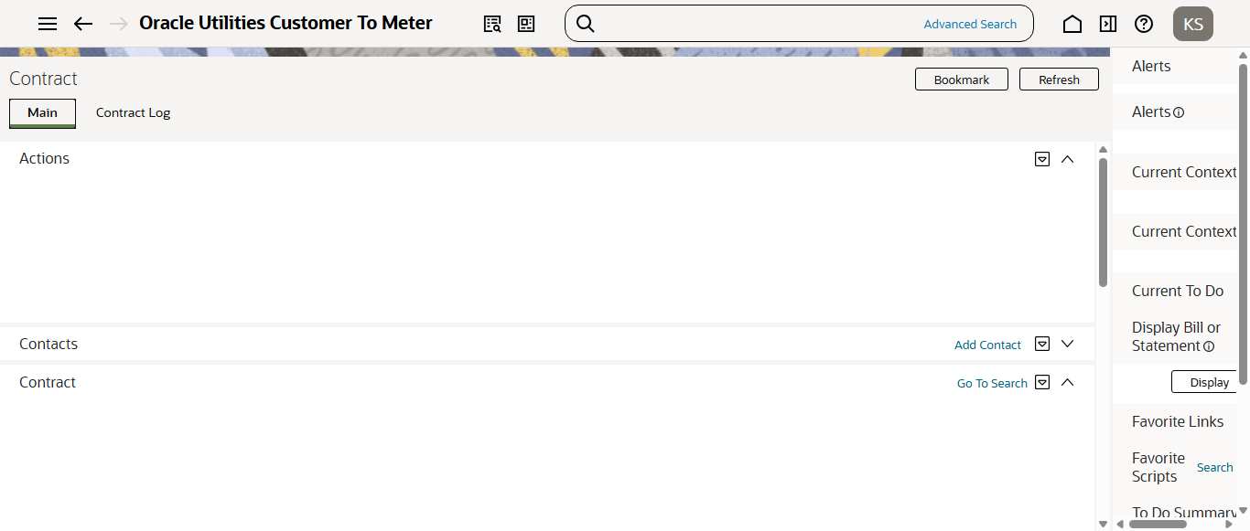
Market Message is created in Pending status
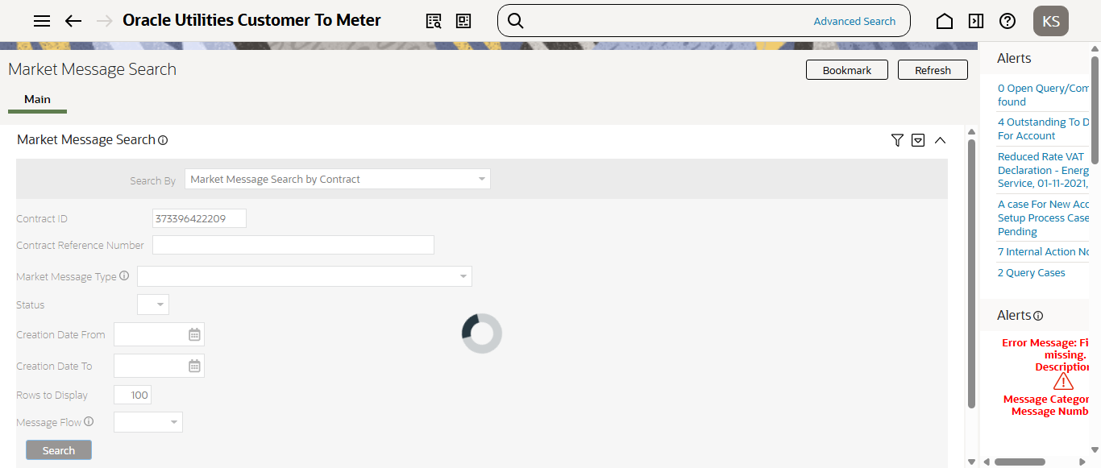
Batch Completed. Market message Moved to Completed Status
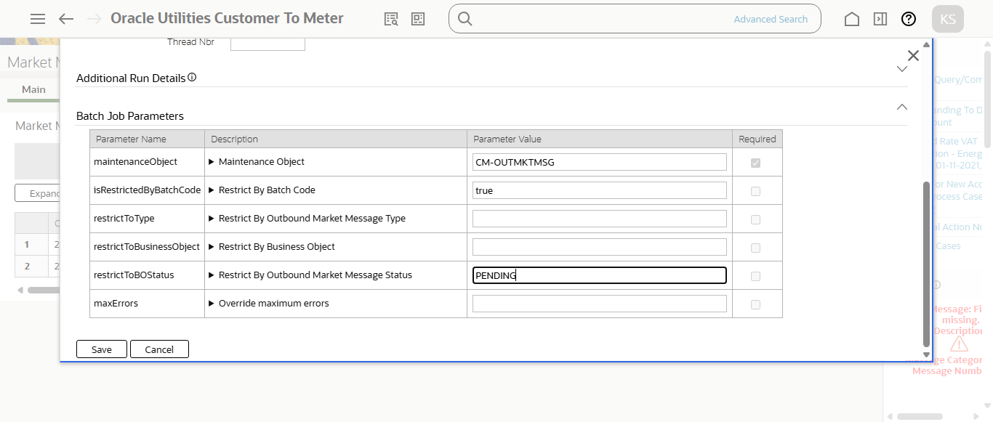
New SA created in Pending Start Status
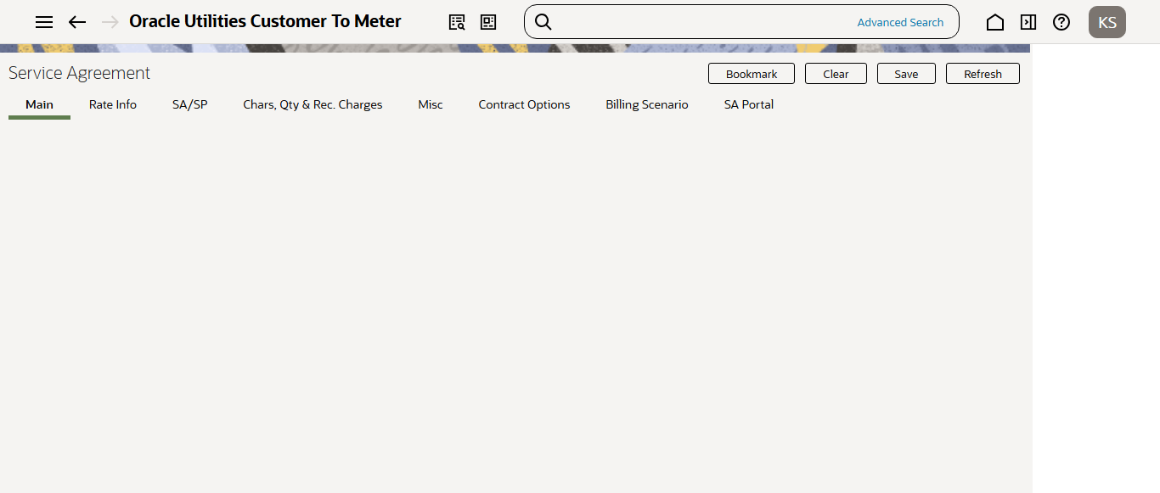
Running SAACT batch to Activate SA created in Pending Start
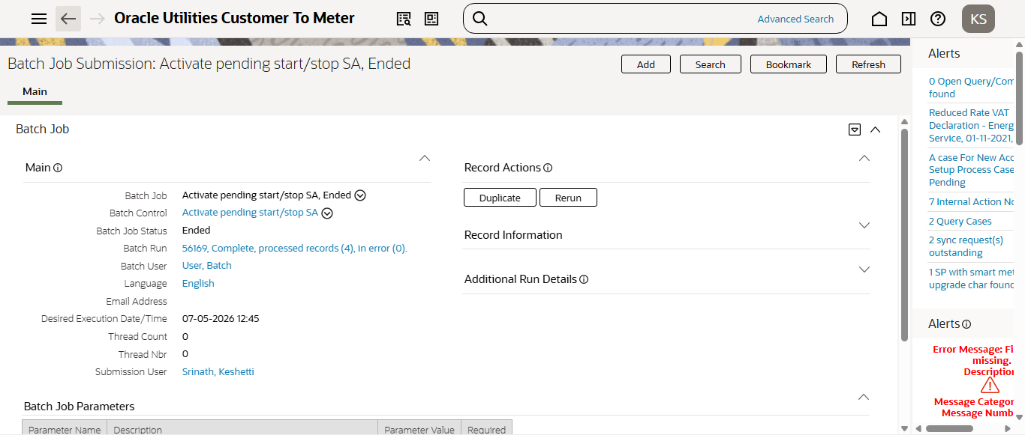
After completion of SAACT batch SA is Activated
