**SMART PLUG**

**ABSTRACT**

The massive dissemination of smart devices in current markets provides innovative technologies that can be used in energy management systems. Particularly, smart plugs enable efficient remote monitoring and control capabilities of electrical resources at a low cost. However, smart plugs, besides their enabling capabilities, are not able to acquire and communicate information regarding the resource's context, a new environmental awareness smart plug with knowledge capabilities concerning the context of where and how users utilize a controllable resource.

Furthermore, the proposed framework enables home controller systems to monitor and control home energy consumption efficiently. Subsequently an analysis of energy consumption of a pilot house, prior and after the installation of the smart plug, based on a hypothetical scenario, is provided. The results present positive impacts of using the smart plug on energy consumption rate; especially during peak hours.

**USAGE OF ELECTRICITY**

India is the third largest producer of electricity in the world. The national electric grid in India has an installed capacity of 393.389 GW as of 31 December 2021. Renewable power plants, which also include large hydroelectric plants, constitute 37% of India's total installed capacity. During the fiscal year (FY) 2019-20, the gross electricity generated by utilities in India was 1,383.5 TWh and the total electricity generation (utilities and non utilities) in the country was 1,598 TWh. The gross electricity consumption in FY2019 was 1,208 kWh per capita. In FY2015, electric energy consumption in agriculture was recorded as being the highest (17.89%) worldwide. The per capita electricity consumption is low compared to most other countries despite India having a low electricity tariff.

India has a surplus power generation capacity but lacks adequate transmission and distribution infrastructure.[citation needed] India's electricity sector is dominated by fossil fuels, in particular coal, which produced about three-quarters of the country's electricity. The government is making efforts to increase investment in renewable energy. The government's National Electricity Plan of 2018 states that the country does not need more non-renewable power plants in the utility sector

until 2027, with the commissioning of 50,025 MW coal-based power plants under construction and addition of 275,000 MW total renewable power capacity after the retirement of nearly 48,000 MW old coal-fired plants. It is expected that non-fossil fuels generation contribution is likely to be around 44.7% of the total gross electricity generation by 2029-30.

Our idea :

The usage of electric appliances also increased a lot day to day, this Smart Plug allows us to reduce the Electricity and minimizes the short circuits of the appliances

**Usage of Electric Appliances**

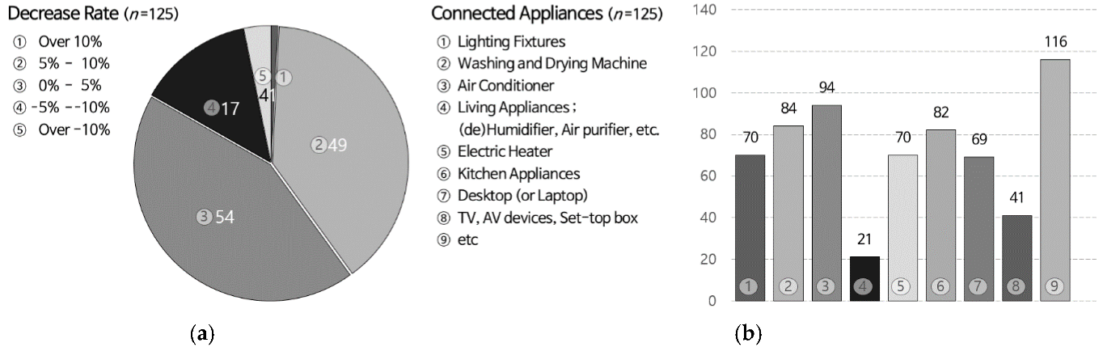

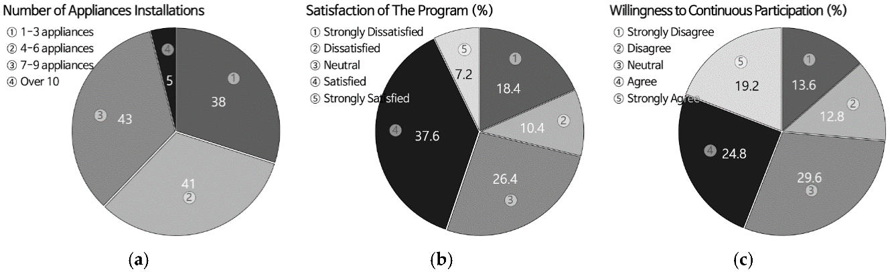

**EXISTING SYSTEMS**

Smart plug in the market is available to only turn on/off the electrical appliances and there is no voltage stabilizers with them, we have to separately install stabilizers this increase cost and the MCBs presently using in home for reducing the voltage fluctuations. Sometimes it causes damage to the appliances.

**PROBLEMS WITH EXISTING SYSTEM**

* Cost
* Difficult Installation

**THE IDEA**

We might sometime forget to on/off our Electrical appliances which consume lot of current and waste of time, sometimes it causes electric shocks. Sophisticated appliances are sensitive to voltage fluctuations.

Smart plug allow you to turn almost any wired appliances with an on/off switch in your home in to an automated one that can be controlled by a simple tap on your phone or voice command.

It also shows the power ranking which indicates the power consumption.

It acts like a stabilizer when there is high/low voltage of current, it automatically shutdowns.

They plug directly into a wall outlet or traditional power strip, and have their own outlet you then plug into with the device you want to automate. You're not gaining or losing any outlets by plugging one in you're simply making an existing outlet smart by connecting it to your home Wi-Fi network.

It can be used at any place and any time to switch on/off the home appliances.

It minimizes the power consumption as well as from short circuits.

**KEY FEATURES**

WI-FI ENABLED

This plug comes with Wi-Fi capabilities embedded in it which makes it innovative and technically advanced. To get hold of your device, connect it with the Wi-Fi plug and control it via App.

CREATE ON/OFF SCHEDULES FOR YOUR DEVICES

This App comes with scheduling feature which is useful to plan the switching on/off of your connected device as per the scheduled time.

VOICE ASSISTANT SUPPORTED

Smart Plug is a smart device which can be controlled through voice assistant like Amazon Alexa and Google Assistant. You control every device attached with the plug through your voice.

PREVENT YOUR DEVICES FROM OVERHEATING

The plug can help your device from getting overheated by maintaining its temperature limit.

CONTROL DEVICES WITH THE MOBILE APP

Now switch on/off your connected device easily through the App. With a tap via the app you are in charge of your device.

ACTS LIKE A STABILIZER

It automatically shutdowns when there is a High Voltage.

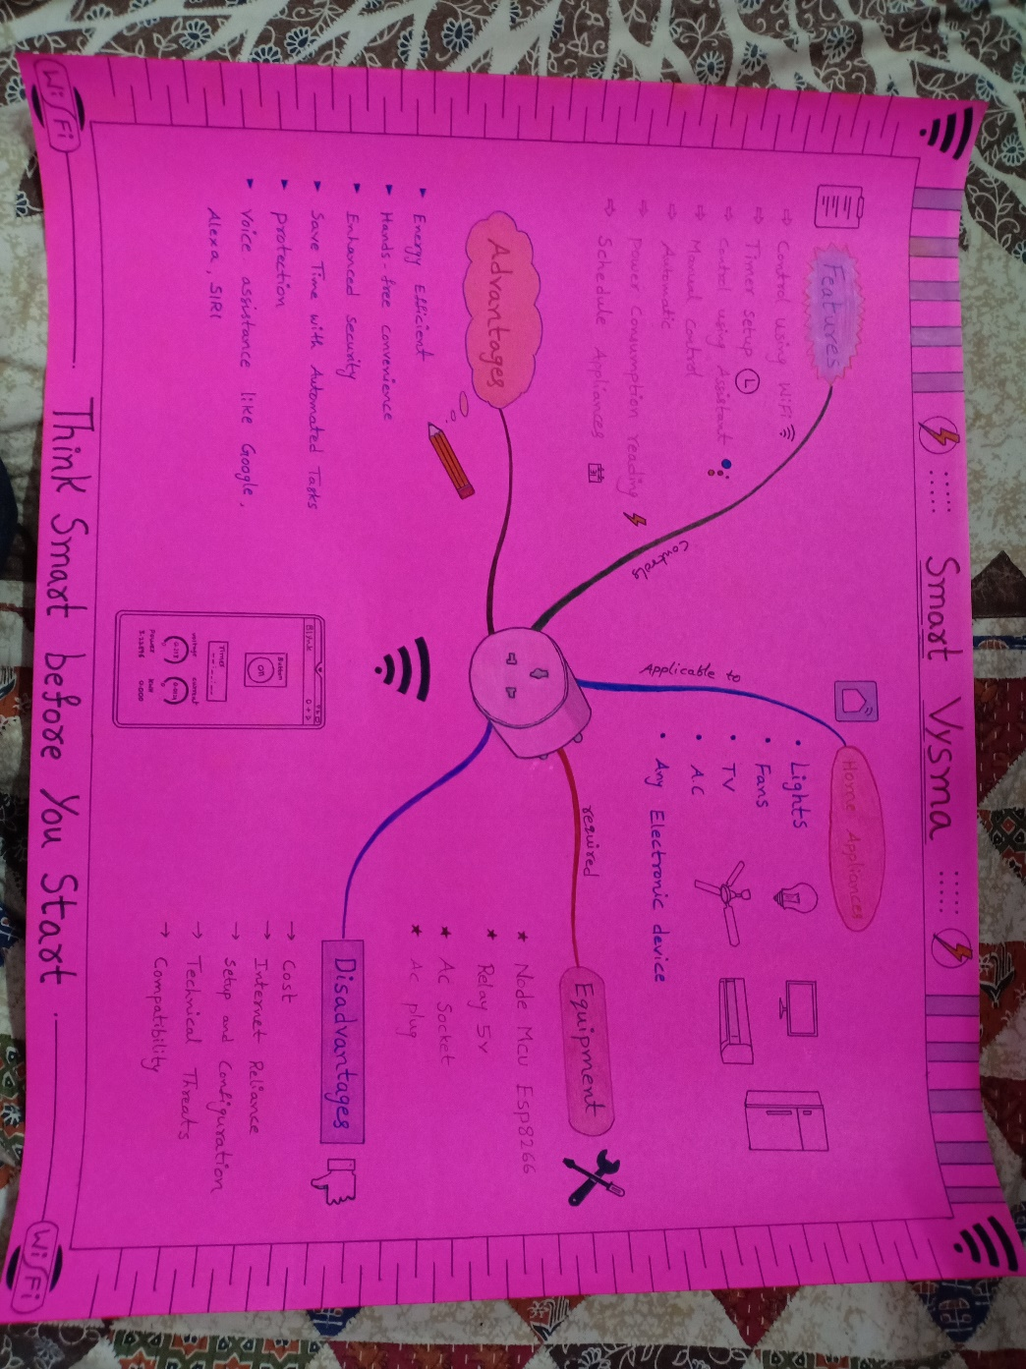**FLOWCHART**

**BLOCK DIAGRAM**

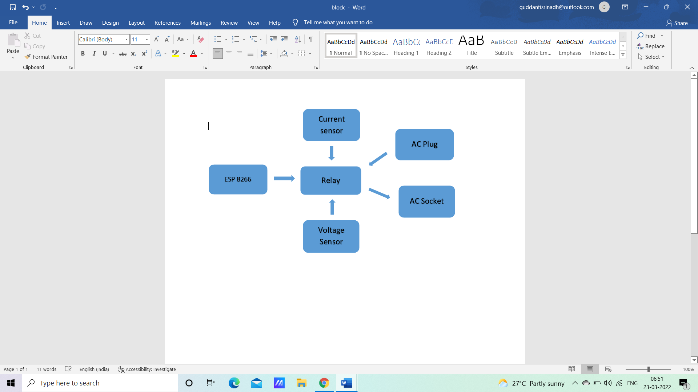

**BLUEPRINT**

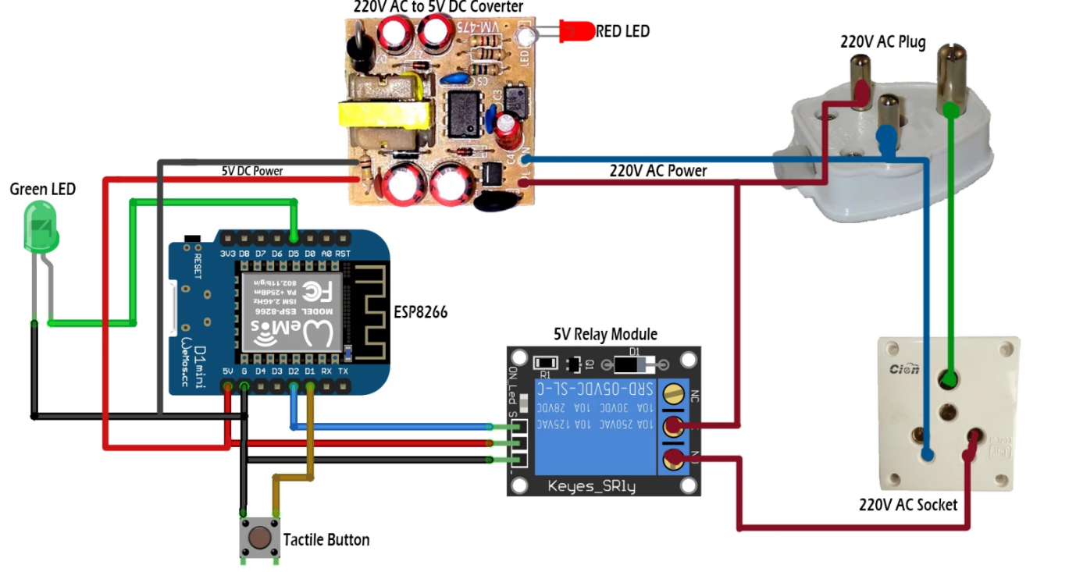

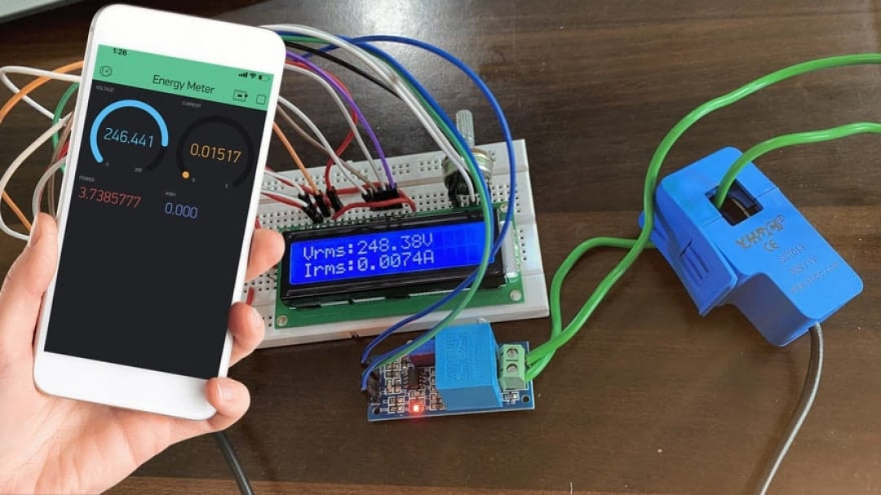

**COMPONENTS USED**

* Node MCU ESP 8266
* Relay
* AC Socket
* Ac Plug
* LED’s
* Switch
* 220v to 5v AC-DC Converter

**Node MCU ESP8266**

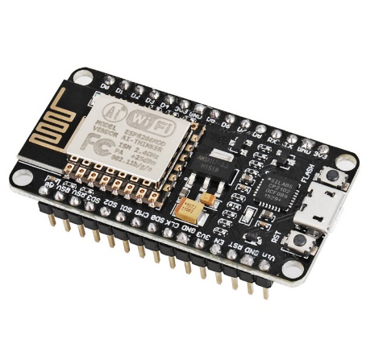

**NodeMCU** is an open source Lua based firmware for the ESP8266 WiFi SOC from Espressif and uses an on-module flash-based SPIFFS file system. NodeMCU is implemented in C and is layered on the Espressif NON-OS SDK.

The firmware was initially developed as is a companion project to the popular ESP8266-based NodeMCU development modules, but the project is now community-supported, and the firmware can now be run on any ESP module.

**Relay**

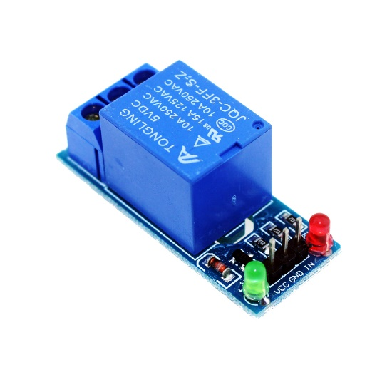

A power **relay module** is an electrical switch that is operated by an electromagnet. The electromagnet is activated by a separate low-power signal from a micro controller. When activated, the electromagnet pulls to either open or close an electrical circuit.

A simple relay consists of wire coil wrapped around a soft iron core, or solenoid, an iron yoke that delivers a low reluctance path for magnetic flux, a movable iron armature and one or more sets of contacts.

**AC Socket**

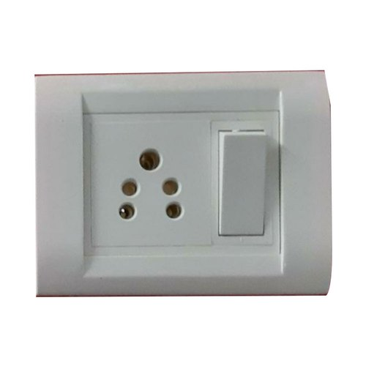

AC power plugs and sockets allow electric equipment to be connected to the primary alternating current (AC) power supply in buildings and at other sites. Electrical plugs and sockets differ from one another in voltage and current rating, shape, size, and connector type. Different systems of plugs and sockets have been standardized, and different standards are used in different parts of the world.

**AC Plug**

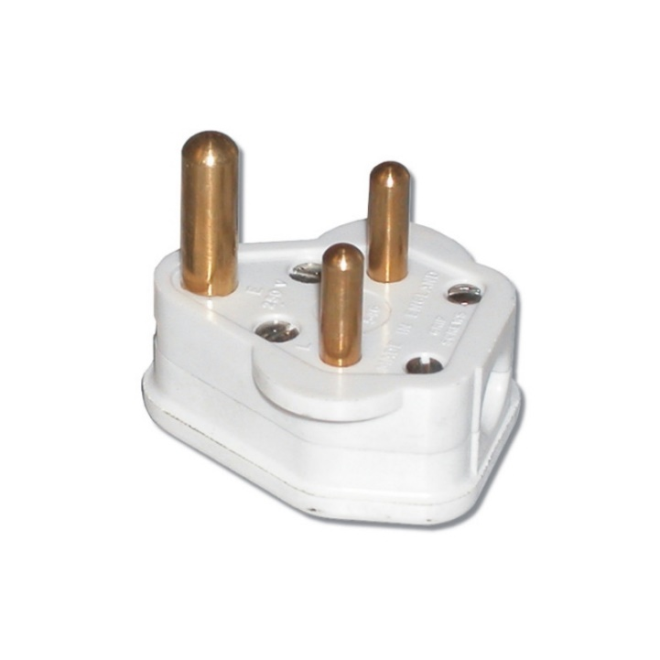

A mechanical piece of equipment (connector) that act as the electrical interface/bridge between electrical/electronic device (or any electrically operated equipment) and the electrical power source.

**220V AC to 5V DC Converter**

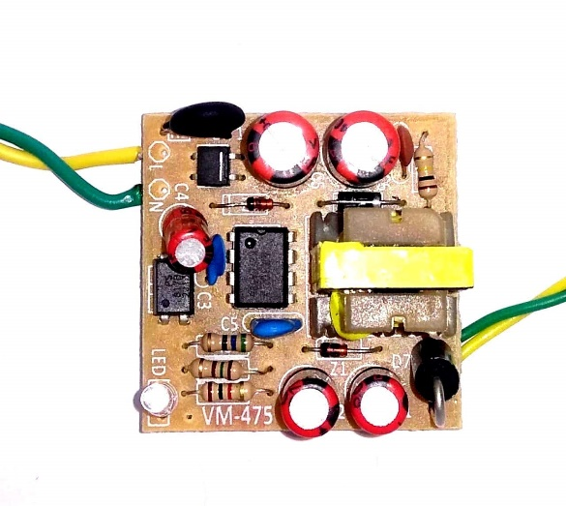

The circuit board converts an input voltage of 220V AC and converts it into a 5V DC output. The circuit has a transformer that steps down the voltage from 220V AC to 5V AC, The four diodes in the circuit act as a rectifier that converts the AC voltage to DC voltage. The circuit consists of numerous resistors and capacitors, which acts as filters. The resistors and capacitors smooth the current and the voltage flow giving an approximate, average voltage value that is required.

**METHADOLOGY AND PROCESS**

Initially, ESP8266 is connected to Relay module ,the AC power is supplied through AC plug to the relay, this AC power is converted into 5V DC and then supplied to ESP8266 module, the relay module is connected to the Current sensor and Voltage sensors to measure the current consumption and voltage supplied, the IN pin of relay module is connected to AC Socket and VCC pin is connected to power supply. The code is uploaded to the ESP8266 module and the setup this installation and required widgets in Blynk App. Now we can pulgin any Electrical appliances to this plug, we can on/off the power supply through anywhere and we can set timer for particular time to switch on/off, we can also

Control using Google Assitant

**Prototype / Model**

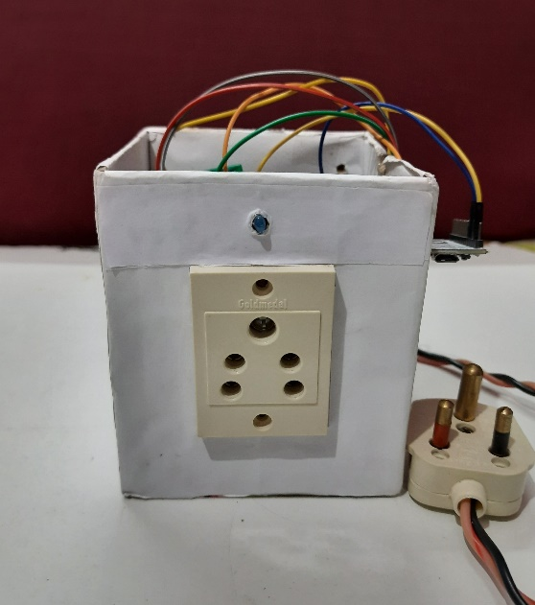

**Application used**

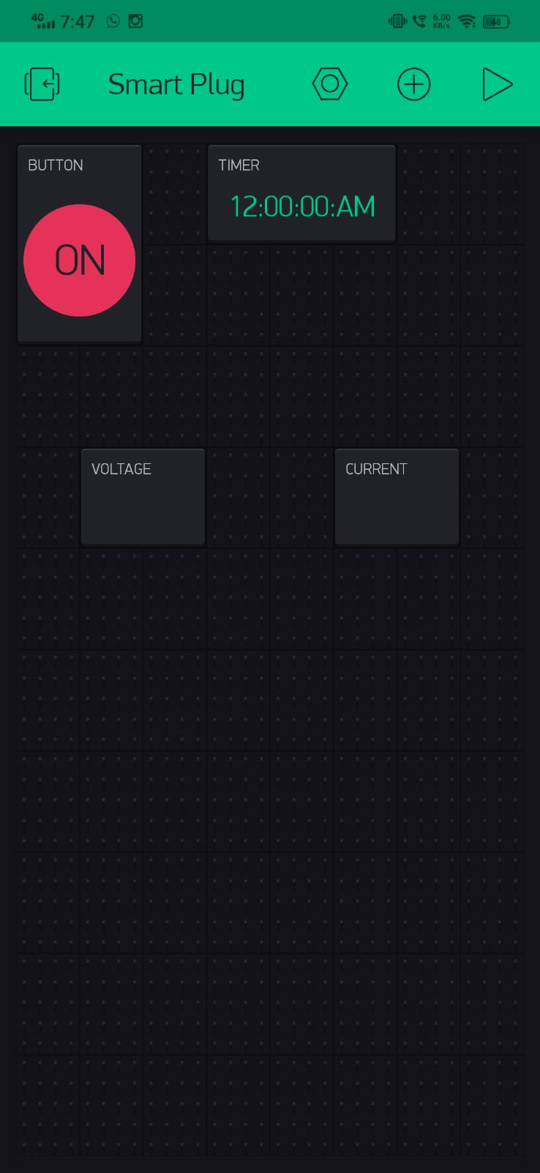

**OUR MOTIVATION FOR DOING IT**

We are the people from middle class background, buying smart appliances is not possible for everyone, eventhough if we buy we can control it over a certain radius only, so we came across with this idea making Any Electrical Appliances smart with this small product, it is useful for anyone like aged and physically challenged people by making the control more reliable with hands-on experience

**DEMAND FOR OUR PRODUCT**

As of the raising of technology almost all the Electrical Aplliances getting converted to smart. Now adays people are getting lazy and busy with their professional life and they want everything within the touch of their fingers. Our product makes this possible, by automating any electrical device.

**Uniqueness of the product**

Our product is cost efford compare to others and easy installation, and we can control over any geographical area.

**ADVANTAGES**

* Reduces Electricity
* Reduces Electric Shocks
* Eco friendly
* Anyone can efford
* Useful to aged and physically challenged people
* Save time with Automated tasks

**DISADVANTAGES**

* Cost
* Internet Reliance
* Setup and Configuration

**CONCLUSION**

We are the people from middle class background, buying smart appliances is not possible for everyone, eventhough if we buy we can control it over a certain radius only, so we came across with this idea making Any Electrical Appliances smart with this small product, it is useful for anyone like aged and physically challenged people by making the control more reliable with hands-on experience.

Our product makes this possible, by automating any electrical device and is cost efford compare to others and easy installation, and we can control over any geographical area