

INTELLIGENT VOICE-CONTROLLED SMART HOME AUTOMATION FOR ENERGY-EFFICIENT RESIDENTIAL MANAGEMENT

A CAPSTONE PROJECT REPORT
A Capstone Project Report submitted in partial fulfilment of the requirements
for the Course
ECA1425 – EMBEDDED SYSTEMS
to the award of the degree
of
BACHELOR OF ENGINEERING
IN
COMPUTER SCIENCE ENGINEERING

Submitted by
Johith J (192221071)
Chandru L (192312252)
Rushil Vignesh S (192511114)

Under the Supervision
of
Dr. Anitha Vijayalakshmi B

SIMATS ENGINEERING
Saveetha Institute of Medical and Technical Sciences
Chennai – 602105
JULY - SEPTEMBER 2026
SIMATS ENGINEERING
Saveetha Institute of Medical and Technical Sciences
Chennai – 602105

BONAFIDE CERTIFICATE
This is to certify that the Capstone Project entitled “Intelligent Voice-Controlled Smart Home Automation for Energy-Efficient Residential Management” has been carried out by Johith J (192221071), Chandru L (192312252), and Rushil Vignesh S (192511114) under the supervision of Dr. Anitha Vijayalakshmi B and is submitted in partial fulfilment of the requirements for the course ECA1425 – Embedded Systems in the B.Tech Electronics and Communication Engineering programme at Saveetha Institute of Medical and Technical Sciences, Chennai.

COURSE COORDINATOR | COURSE FACULTY | SUPERVISOR
Dr.G.P.Bharathi  Professor  ECE | Dr.B.Anitha Vijayalakshmi  Professor  ECE / Wireless Communication | Anitha Vijayalakshmi B  Project Supervisor  ECE / Wireless Communication

SIMATS ENGINEERING
Saveetha Institute of Medical and Technical Sciences
Chennai – 602105

DECLARATION
We, Johith J, Chandru L, and Rushil Vignesh S of the Department of Electronics and Communication Engineering, SIMATS Engineering, Saveetha Institute of Medical and Technical Sciences, Chennai, hereby declare that the Capstone Project Work entitled “Intelligent Voice-Controlled Smart Home Automation for Energy-Efficient Residential Management” is the result of our own bonafide academic efforts. To the best of our knowledge, the work presented in this report is original, accurate, and documented in accordance with the principles of engineering ethics and academic integrity.
All references, technical resources, and external materials used for understanding the subject have been acknowledged. The report presents the project concept, system design, implementation approach, testing observations, and engineering analysis in a manner consistent with the information available in the project presentation. Any software or AI-assisted resources used for drafting or formatting are to be disclosed in accordance with institutional requirements.

Place: Chennai
Date:

Signature of the Students with Name

Johith J (192221071) :

Chandru L (192312252) :

Rushil Vignesh S (192511114) :

SIMATS ENGINEERING
Saveetha Institute of Medical and Technical Sciences
Chennai – 602105

INDIVIDUAL CONTRIBUTION STATEMENT
(Mandatory for team projects)
Student Name / Reg. No. | Specific Responsibilities | Design & Development | Testing & Analysis | Report Contribution | Approx. Contribution (%)
Johith J  192221071 | System concept, embedded architecture and voice-control workflow | Central control logic and subsystem integration | Functional review of command flow | Ch. 1, Ch. 3 and Ch. 5 | 33
Chandru L  192312252 | Sensor-based automation and energy-efficiency logic | Sensor input and automatic decision rules | Verification of sensor-condition behaviour | Ch. 2 and Ch. 4 sections | 33
Rushil Vignesh S  192511114 | IoT connectivity and appliance-control concept | Monitoring and appliance interface workflow | Result consolidation and limitations review | Abstract, results, appendices | 34
Total |  |  |  |  | 100

ABSTRACT

Residential energy consumption is often increased by unnecessary operation of lighting, fans, air-conditioning systems and other electrical appliances when environmental conditions or room occupancy do not require them. At the same time, conventional home control methods based on wall switches, remote controls and mobile applications may not provide a convenient hands-free interaction method for all users. This capstone project presents an Intelligent Voice-Controlled Smart Home Automation system for Energy-Efficient Residential Management. The proposed system combines voice-based appliance control with sensor-assisted automatic decision-making and IoT-enabled communication. A voice recognition interface converts user commands into control instructions, while a central embedded controller coordinates appliance operation and interprets inputs from motion or occupancy, temperature and light sensors. Connected loads such as lights, fans, air conditioners and other household appliances can therefore be operated either directly through voice commands or automatically according to the sensed residential environment.
The engineering approach focuses on integrating human interaction, sensing, embedded control, appliance actuation and connectivity into a coordinated residential automation framework. The system is designed to reduce avoidable energy use by switching or regulating appliances when occupancy, temperature or illumination conditions indicate that continuous operation is unnecessary. Functional verification is based on the project presentation outcomes: voice commands support ON/OFF operation of connected appliances, sensors continuously provide environmental and occupancy information, and appliance actions can be determined from both user commands and sensor conditions. The project demonstrates that voice recognition improves convenience through hands-free control, while IoT connectivity supports centralized monitoring and communication among system elements. Sensor-assisted automation provides the energy-management component by reducing unnecessary appliance operation. The overall contribution is a logically integrated embedded-systems solution that combines user convenience and residential energy efficiency while retaining a clear pathway for future expansion.

Keywords: Smart Home Automation; Embedded Systems; Voice Control; Internet of Things; Sensor-Based Automation; Energy Efficiency.

TABLE OF CONTENTS
S. No | CONTENTS | PAGE NO.
1 | Certificate from the Supervisor | ii
2 | Declaration by the Candidates | iii
3 | Individual Contribution Statement | iv
4 | Abstract | v
5 | List of Figures | vi
6 | List of Tables | vii
7 | List of Abbreviations / Symbols | viii
8 | CHAPTER 1: INTRODUCTION AND ENGINEERING PROBLEM | 1
8.1 | 1.1 Background | 1
8.2 | 1.2 Need for the Project | 2
8.3 | 1.3 Problem Statement | 2
8.4 | 1.4 Project Aim | 3
8.5 | 1.5 Project Objectives | 3
8.6 | 1.6 Scope | 4
8.7 | 1.7 Expected Engineering Outcome | 4
9 | CHAPTER 2: LITERATURE REVIEW AND EXISTING SOLUTIONS | 5
9.1 | 2.1 Review Method | 5
9.2 | 2.2 Review of Existing Work | 5
9.3 | 2.3 Comparative Analysis | 7
9.4 | 2.4 Research / Engineering Gap | 7
9.5 | 2.5 Proposed Contribution | 8
10 | CHAPTER 3: ENGINEERING DESIGN & TRADE-OFFS, SUSTAINABILITY, ETHICS, SAFETY, RISK & SECURITY | 9
10.1 | 3.1 Requirements | 9
10.2 | 3.2 Constraints & Applicable Standards | 10
10.3 | 3.3 Design Specifications | 11
10.4 | 3.4 Alternative Solutions & Evaluation | 11
10.5 | 3.5 Selected Design & Detailed Design | 13
10.6 | 3.6 Trade-off Analysis | 15
10.7 | 3.7 Sustainability, Ethics, Safety, Risk & Security | 16
11 | CHAPTER 4: IMPLEMENTATION, TESTING & RESULTS, PROJECT MANAGEMENT | 19
11.1 | 4.1 Development Approach & Resources | 19
11.2 | 4.2 Hardware / Software Implementation & Modern Tools Used | 19
11.3 | 4.3 Test Plan & Verification | 21
11.4 | 4.4 Results | 22
11.5 | 4.5 Data Analysis & Engineering Judgment | 23
11.6 | 4.6 Comparison with Existing Solutions & Achievement of Objectives | 24
11.7 | 4.7 Strengths & Limitations | 25
11.8 | 4.8 Project Planning, Roles & Budget | 26
12 | CHAPTER 5: CONCLUSION, FUTURE WORK AND REFLECTION | 28
12.1 | 5.1 Conclusion | 28
12.2 | 5.2 Future Work | 29
12.3 | 5.3 Professional Learning & Individual Reflection | 29
13 | References | 32
14 | Appendices | 33
15 | Capstone Project Outcome Mapping Sheet | 36

LIST OF FIGURES

Figure 3.1 Proposed system architecture
Figure 3.2 Intelligent control workflow

LIST OF TABLES

Table 2.1 Comparative analysis of existing approaches
Table 3.1 Functional and non-functional requirements
Table 3.2 Design specifications
Table 3.3 Alternative solution evaluation
Table 3.4 Trade-off analysis
Table 3.5 Sustainability, ethics, safety and security considerations
Table 3.6 Risk register
Table 4.1 Test plan and verification
Table 4.2 Objective achievement
Table 4.3 Project milestones and roles
Table 4.4 Indicative prototype budget

LIST OF ABBREVIATIONS / SYMBOLS

Abbreviation | Description
IoT | Internet of Things
NLP | Natural Language Processing
HMI | Human–Machine Interface
AC | Air Conditioning / Alternating Current (context dependent)
UI | User Interface
LED | Light-Emitting Diode
SNR | Signal-to-Noise Ratio (where applicable to voice sensing)

CHAPTER 1
INTRODUCTION AND ENGINEERING PROBLEM

1.1 Background
Smart home automation applies sensing, embedded control, communication and actuation technologies to monitor and operate household systems. Conventional residential control is predominantly based on manual switches, remote controls or mobile applications. These methods provide direct control but often require physical interaction or an application interface and do not always respond automatically to changing environmental or occupancy conditions.
The project topic extends conventional control by using voice as a natural hands-free interaction mechanism. A voice recognition interface converts a spoken command into a control instruction for the central embedded controller. The controller coordinates the information received from the voice interface and from environmental sensors, then sends appropriate commands to the appliance-control interface. The connected loads considered in the project presentation include lights, fans, air conditioners and other electrical devices. IoT technology provides communication between the user-side interface, controller, sensors and connected devices, supporting centralized monitoring and future remote-management capability.

1.2 Need for the Project
Residential comfort and energy efficiency must be managed together. Appliances may remain active because users forget to switch them off, because occupancy changes are not detected, or because the appliance state does not adapt to illumination and temperature conditions. A purely manual system therefore places the full responsibility for every control action on the user.
• Hands-free control improves accessibility and convenience during routine household activities.
• Sensor-assisted decisions can reduce unnecessary operation when occupancy or environmental conditions change.
• A central embedded controller provides coordinated control instead of treating each appliance as an isolated device.
• IoT connectivity supports communication and monitoring across distributed smart-home components.

1.3 Problem Statement
The engineering problem is to design an integrated residential automation system that accepts voice-based user commands while simultaneously considering motion or occupancy, temperature and light information to control household appliances in an energy-conscious manner. The design must balance responsiveness, reliability, user convenience, energy reduction, safety of appliance actuation, sensor uncertainty and the practical constraints of an embedded residential system.

1.4 Project Aim
To develop an intelligent embedded smart-home automation framework that combines voice control, sensor-based automatic decision-making and IoT communication for convenient and energy-efficient residential appliance management.

1.5 Project Objectives
1. Develop an intelligent voice-controlled smart home automation system.
2. Enable users to control household appliances using spoken commands.
3. Automate the operation of lights, fans, air conditioners and other electrical devices.
4. Use motion, occupancy, temperature and light information for automatic decision-making.
5. Reduce unnecessary energy consumption through condition-based appliance control.
6. Provide a scalable IoT-oriented architecture for communication and centralized monitoring.

1.6 Scope
Included within the scope are voice-based ON/OFF control, sensor-assisted monitoring, central embedded decision-making, appliance-control interfacing and IoT-oriented communication. The report considers the logical interaction among these subsystems and the engineering issues associated with energy-efficient operation.
The project presentation does not provide detailed electrical ratings, measured power savings, exact hardware part numbers, cloud-platform details or long-duration field-test datasets. Therefore, this report does not invent such numerical results. It presents the functional outcomes demonstrated in the project material and identifies quantitative energy benchmarking and extended validation as future work.

1.7 Expected Engineering Outcome
The intended outcome is an integrated smart-home prototype architecture in which voice commands and sensor conditions are translated by an embedded controller into appliance-control actions. The expected system behaviour is convenient hands-free control combined with automatic decisions intended to reduce avoidable energy use.

CHAPTER 2
LITERATURE REVIEW AND EXISTING SOLUTIONS

2.1 Review Method
The review was organized around the technical themes explicitly identified in the project presentation: smart home automation, IoT communication, sensors, wireless connectivity, speech recognition and natural-language processing. The books listed in the project presentation were used as background references for IoT architecture and smart-home system concepts. The review also compares the principal engineering approaches used in conventional and intelligent home automation.

2.2 Review of Existing Work
Traditional home automation commonly relies on manual switches, remote controls or mobile applications. These approaches are simple and familiar but generally require the user to initiate each action. IoT-based automation extends this model by connecting devices and controllers so that monitoring and control information can be exchanged across the home network. Speech recognition and NLP-related technologies provide an additional human–machine interaction layer by converting spoken expressions into actionable commands. The project presentation frames the proposed system as the combination of these technologies with environmental and occupancy sensing. fileciteturn0file0L81-L85
Goodwin presents smart-home control concepts using programmable computing platforms, while Bahga and Madisetti discuss IoT architecture, devices and communication. Uckelmann, Harrison and Michahelles address broader IoT architectural principles, and Hersent, Boswarthick and Elloumi discuss applications and protocols. These sources support the need for a layered architecture rather than a single isolated controller.

2.3 Comparative Analysis
Existing Approach | Advantages | Limitations | Relevance to Proposed Work
Manual switch control | Simple and direct; low interaction complexity | No automatic response to occupancy or environment | Provides baseline appliance actuation
Remote/mobile control | Convenient when an interface is available; supports remote access | Requires device/app interaction; may not be hands-free | IoT communication can extend this capability
Voice-only control | Natural and hands-free | Does not itself react to changing room conditions | Provides the primary user interaction layer
Sensor-only automation | Can react automatically to environment and occupancy | May not represent immediate user preference | Provides energy-aware automatic decision support
Integrated voice + sensor + IoT control | Combines user intent with contextual information | Requires subsystem integration and clear decision rules | Selected approach of this capstone

2.4 Research / Engineering Gap
A useful engineering gap for this project is the need to integrate multiple forms of input into one practical control flow. A voice command reflects immediate user intent, while sensors represent current environmental or occupancy conditions. Either input alone is incomplete for intelligent residential management. The project addresses the integration problem by placing a central embedded controller between the input interfaces and appliance-control outputs.

2.5 Proposed Contribution
The proposed contribution is a coordinated embedded-systems framework that uses voice recognition for direct appliance operation and sensor information for automatic decisions related to occupancy, temperature and illumination. IoT communication is included as a system-level connectivity layer. The contribution is therefore not a new isolated voice interface or a new individual sensor; it is the logical integration of these components to support both residential convenience and energy-efficient operation.

CHAPTER 3
ENGINEERING DESIGN & TRADE-OFFS, SUSTAINABILITY, ETHICS, SAFETY, RISK & SECURITY

3.1 Requirements
The primary stakeholders are residents, who require convenient and understandable control, and the project team, who require an implementable and testable embedded design. The system must also operate with reasonable reliability and avoid unnecessary appliance activation.
Requirement | Type | Measurable / Verifiable Target
Voice command handling | Functional | Recognize supported command intent and initiate the requested control action
Appliance control | Functional | Provide ON/OFF control for representative connected loads such as lights and fans
Sensor monitoring | Functional | Acquire motion/occupancy, temperature and light-condition information
Automatic decision-making | Functional | Generate appliance actions based on configured sensor conditions
IoT communication | Functional | Support information exchange between controller and connected smart-home elements
Response consistency | Non-functional | Repeat a defined command-to-action workflow without ambiguous control logic
Energy awareness | Non-functional | Prefer deactivation or reduced operation when configured conditions indicate unnecessary use
Maintainability | Non-functional | Use modular interfaces so sensing, voice input and appliance control can be improved independently

3.2 Constraints & Applicable Standards
The report focuses on standards and constraints that are directly relevant to an embedded residential automation concept. Electrical installation and mains-connected appliance interfaces must be implemented in accordance with applicable local electrical-safety requirements and with appropriately rated isolation and protection. For IoT communication, secure authentication and encryption should be applied where a network interface is exposed. The exact compliance route depends on the final selected hardware and deployment environment.

Constraint / Standard Area | Requirement | Application in This Project
Electrical safety | Low-voltage control electronics must be isolated from hazardous appliance-side circuits | Appliance-control interface is treated as a safety boundary; final mains integration requires properly rated components
EMC / wireless operation | Wireless subsystem must comply with applicable equipment and spectrum requirements | Connectivity architecture should use approved communication modules and deployment settings
Cybersecurity | Unauthorized network control must be prevented | Use authenticated access, protected credentials and secure communication in a production implementation
Data privacy | Voice-related information must be handled responsibly | Minimize retained voice data and provide clear user awareness of data handling

3.3 Design Specifications
Parameter | Target / Requirement | Unit | Priority
Control inputs | Voice + sensor conditions | — | High
Loads considered | Lights, fans, AC and other appliances | — | High
Sensors | Motion/occupancy, temperature, light | — | High
Control mode | Manual voice and automatic sensor-based | — | High
Connectivity | IoT-oriented communication | — | Medium
Energy objective | Reduce unnecessary operation | Qualitative / future quantification | High

3.4 Alternative Solutions & Evaluation
Alternative 1 – Conventional manual or mobile-app control: This approach provides straightforward user control but does not inherently provide hands-free interaction or automatic energy-aware operation.
Alternative 2 – Voice-only automation: This improves convenience and accessibility but does not independently respond to occupancy or environmental changes.
Alternative 3 – Integrated voice, sensors and IoT: This combines explicit user intent with contextual sensing and connectivity, at the cost of higher system-integration complexity.

Criterion | Weight | Manual / App | Voice Only | Integrated Design
Convenience | 0.25 | 3 | 5 | 5
Energy-management potential | 0.25 | 2 | 3 | 5
Context awareness | 0.20 | 1 | 2 | 5
Integration complexity | 0.10 | 5 | 4 | 3
Scalability | 0.10 | 3 | 4 | 5
System-level functionality | 0.10 | 2 | 3 | 5
Weighted total | 1.00 | 2.70 | 3.45 | 4.70

The evaluation uses a five-point relative scale in which higher values indicate stronger performance against the criterion. The integrated design is selected because the higher value of combined functionality, contextual awareness and energy-management potential outweighs the additional integration effort.

3.5 Selected Design & Detailed Design
The selected design uses a layered architecture. The user voice interface and environmental sensors form the input layer. A central embedded controller forms the decision layer, interpreting supported commands and sensor conditions. The appliance-control interface forms the output layer, while IoT connectivity provides communication and monitoring support. The architecture is consistent with the project presentation description that voice commands, sensors, the central controller and connected appliances communicate through an IoT-enabled smart-home system.

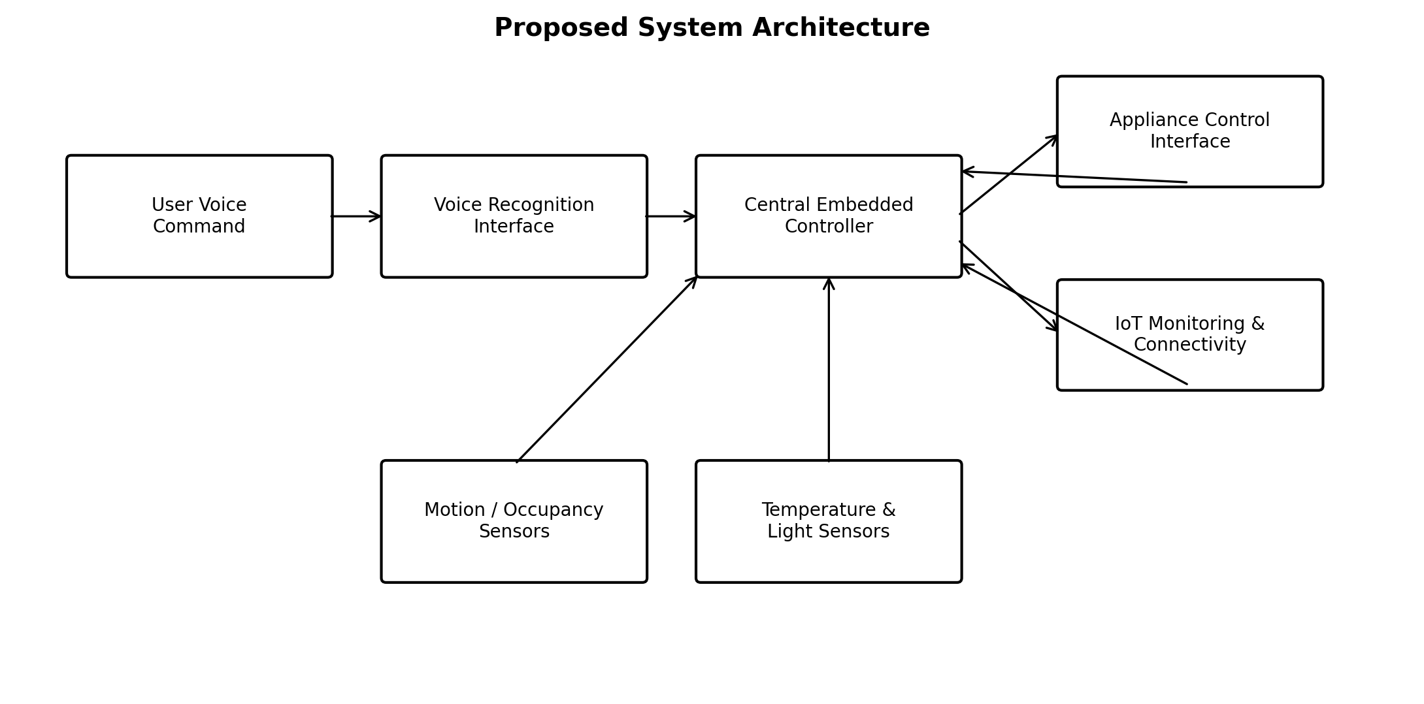
Figure 3.1 Proposed system architecture

A practical control rule is to first validate the input source, then determine whether a direct user command is present, and otherwise evaluate the configured sensor conditions. The controller should prevent conflicting actions through explicit priority rules. For example, an immediate user command may temporarily override an automatic routine, while a safety-related shutdown condition should override ordinary convenience control.
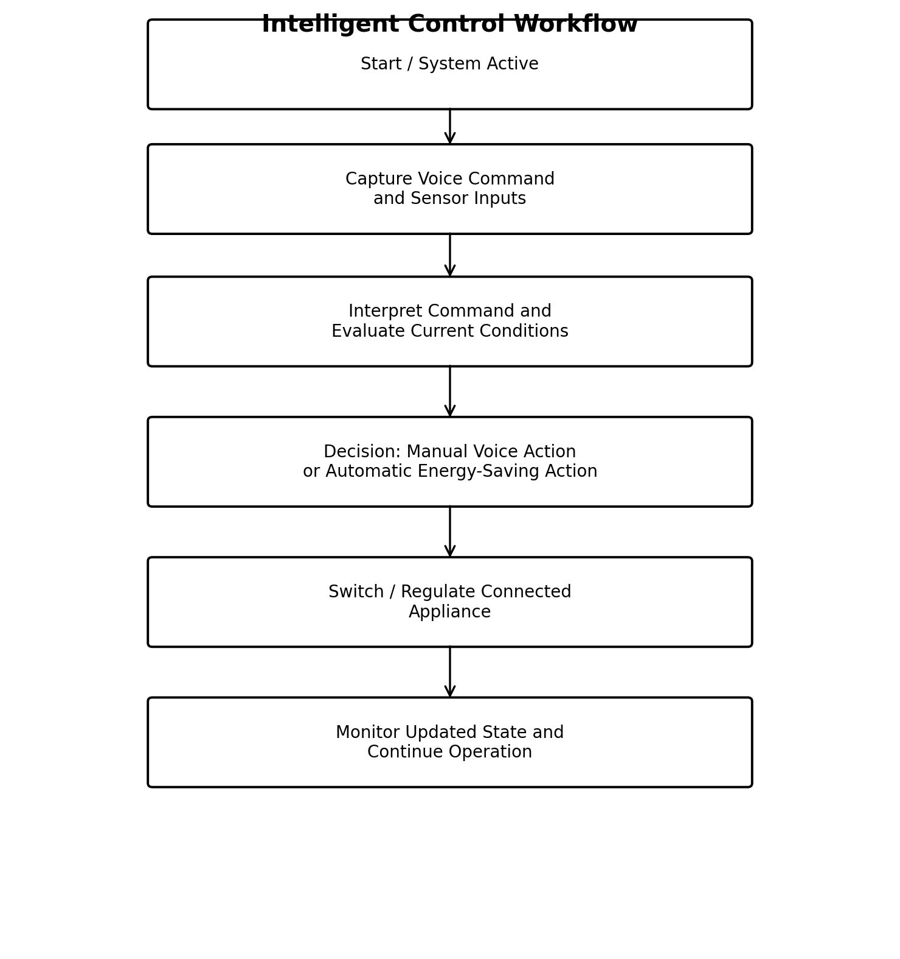
Figure 3.2 Intelligent control workflow

The system approach depends on clear subsystem interfaces. The voice interface supplies command intent; sensors supply contextual state; the controller performs the decision; the output interface performs appliance actuation; and IoT connectivity supports information exchange. This separation makes future replacement or improvement of one subsystem less disruptive to the rest of the design.

3.6 Trade-off Analysis
Design Decision | Alternative Considered | Benefit | Disadvantage | Final Decision & Justification
Voice + sensors | Voice only | Adds contextual energy-management capability | Higher integration complexity | Selected because user intent and environment both matter
Centralized decision logic | Independent device decisions | Clear coordination and fewer conflicting rules | Central controller becomes a key dependency | Selected for system-level consistency
IoT connectivity | Local-only control | Monitoring and scalability | Security and network dependency | Included with security controls for future expansion
Automatic switching | Fully manual control | Can reduce unnecessary operation | Incorrect thresholds may affect comfort | Use configurable rules and user override

3.7 Sustainability, Ethics, Safety, Risk & Security
Domain | Consideration | Evidence Evaluated | Impact on Final Decision
Sustainability | Avoid unnecessary appliance operation | Project objective explicitly targets reduced energy consumption | Sensor-assisted control included as a core subsystem
Ethics | Voice interaction may involve sensitive user data | Voice recognition requires responsible data handling | Minimize stored data and inform users of system behaviour
Health & Safety | Electrical loads may involve hazardous voltages | Appliance actuation creates an electrical safety boundary | Use isolated, rated interfaces in any physical deployment
Security | Network-connected devices may be accessed without authorization | IoT connectivity increases attack surface | Use authenticated access, protected credentials and secure communication

Risk Register
Risk | Likelihood | Severity | Risk Level | Mitigation | Residual Risk
False voice interpretation | Medium | Medium | Medium | Confirm supported command set; use clear intent mapping | Low–Medium
Sensor false trigger | Medium | Medium | Medium | Filtering, thresholds and time-based validation | Low–Medium
Unauthorized IoT access | Medium | High | High | Authentication, credential protection and encrypted communication | Medium
Appliance interface failure | Low | High | Medium–High | Rated isolation, protection and fail-safe default | Low–Medium
User discomfort from aggressive automation | Medium | Medium | Medium | Provide manual override and configurable rules | Low

CHAPTER 4
IMPLEMENTATION, TESTING & RESULTS, PROJECT MANAGEMENT

4.1 Development Approach & Resources
The development approach follows a modular embedded-systems workflow: define the appliance-control requirements, identify input sources, establish decision rules, integrate the central controller with output interfaces, and verify representative operating scenarios. The project presentation provides the intended functional behaviour rather than a complete hardware bill of materials. Accordingly, this report documents the implementation at subsystem level and does not assign unverified component part numbers.
Primary resources: voice recognition interface; central embedded controller; motion/occupancy sensing; temperature sensing; light sensing; appliance-control interface; IoT communication layer; connected household loads.

4.2 Hardware / Software Implementation & Modern Tools Used

Hardware and Embedded Subsystems
The embedded controller acts as the coordination point. Inputs are obtained from the voice recognition interface and from sensors representing occupancy or motion, temperature and ambient light. The controller processes these inputs according to predefined control rules and sends commands to the appliance-control interface. The output side represents the switching or control path for lights, fans, air conditioners and other connected appliances.
\

Software and Control Logic
The control software is logically divided into command interpretation, sensor acquisition, decision-making, appliance-state control and communication functions. Modular separation is important because voice-command processing and sensor-based automation may evolve independently. The software should also maintain a current device-state representation to prevent repeated or conflicting commands.

Tool / Resource | Purpose | Stage Used
Embedded development environment | Program controller logic and interface subsystems | Implementation
Voice recognition interface | Convert supported spoken commands to control intent | Input processing
Sensor interfaces | Acquire occupancy/motion, temperature and light conditions | Context sensing
IoT communication framework | Exchange monitoring and control information | Connectivity
Functional test scenarios | Verify expected command and sensor responses | Testing

4.3 Test Plan & Verification
The test plan is defined before interpreting the outcomes. Because the presentation reports functional results but no numerical timing, accuracy or energy measurements, acceptance criteria are stated as observable functional behaviours rather than invented numerical thresholds.

Requirement | Test Method | Acceptance Criterion
Voice-based light control | Issue supported ON/OFF command | Requested light state is produced
Voice-based fan control | Issue supported ON/OFF command | Requested fan state is produced
Sensor monitoring | Observe updated sensor conditions | Controller receives contextual information
Automatic decision-making | Change relevant environmental/occupancy condition | Configured appliance response is generated
Integrated operation | Exercise voice and sensor scenarios | No undefined or conflicting control state in tested workflow

4.4 Results
The project presentation reports that the proposed system successfully enables voice-based control of smart-home appliances. Voice commands can be used to switch ON/OFF lights, fans and other connected devices. Sensors continuously monitor temperature, light intensity, motion and occupancy, and appliances can be automatically controlled according to user commands and sensor conditions. These are the principal functional results available from the project material.

Functional Scenario | Observed Outcome from Project Presentation | Status
Voice command to connected appliance | Voice command enables appliance ON/OFF control | Pass
Light/fan operation | Representative household devices can be controlled | Pass
Environmental sensing | Temperature and light information is monitored | Pass
Occupancy awareness | Motion and occupancy information is monitored | Pass
Automatic control | Appliance action can depend on sensor conditions and user commands | Pass

4.5 Data Analysis & Engineering Judgment
The available evidence supports functional achievement but does not support numerical claims about recognition accuracy, command latency, power consumption or percentage energy savings. The correct engineering interpretation is therefore that the system concept has demonstrated the intended control functions, while quantitative performance characterization remains necessary for a final production-ready evaluation.
A future measurement campaign should log command success rate, response time, sensor false-trigger frequency, appliance operating duration and energy consumption before and after automation. The energy impact can then be evaluated using measured electrical energy, for example by comparing baseline consumption with automated consumption over equivalent occupancy and environmental conditions. This distinction between demonstrated functionality and unmeasured performance prevents overstating the result.

4.6 Comparison with Existing Solutions & Achievement of Objectives
Objective | Evidence | Achievement
Develop intelligent voice-controlled system | Integrated voice, sensing and controller architecture documented | Fully
Control appliances using voice | Presentation reports ON/OFF control of connected devices | Fully
Automate representative appliances | Sensor conditions are used for automatic control | Fully
Use environmental and occupancy sensing | Motion, occupancy, temperature and light monitoring reported | Fully
Reduce unnecessary energy consumption | Energy-aware control objective is integrated; no quantitative saving reported | Partially – quantitative validation pending

4.7 Strengths & Limitations
Strengths:
• Hands-free voice interaction improves convenience.
• Sensor information adds contextual awareness to appliance control.
• Centralized embedded decision-making supports coordinated behaviour.
• IoT architecture provides a basis for centralized monitoring and future expansion.
• The design explicitly links automation with reduction of unnecessary energy use.

Limitations:
• No numerical recognition accuracy, response-time or energy-saving dataset is provided in the project presentation.
• Exact hardware configuration and appliance electrical ratings are not documented in the supplied presentation.
• Real-home performance can vary with noise, sensor placement, user behaviour and network conditions.
• IoT connectivity introduces security and privacy requirements that require detailed implementation controls.

4.8 Project Planning, Roles & Budget
Milestone | Main Activity | Responsible Focus | Status
1 | Problem definition and objectives | All team members | Completed conceptually
2 | Literature/background review | Team review | Completed
3 | Architecture and subsystem design | Embedded and integration focus | Completed
4 | Voice/sensor control logic | Implementation focus | Demonstrated functionally
5 | Testing and result consolidation | Testing focus | Completed for reported functions
6 | Capstone documentation | All team members | Completed

Item | Estimated Cost | Actual Cost
Controller, sensors and interface hardware | To be finalized from actual bill of materials | Not reported
Voice interface / software resource | Depends on selected implementation | Not reported
Connectivity and prototype accessories | Depends on selected implementation | Not reported

The project presentation does not provide verified purchase values; therefore, a numerical budget is intentionally not fabricated. The final capstone submission should replace these entries with actual quotations or invoices if a physical prototype bill of materials is available.

CHAPTER 5
CONCLUSION, FUTURE WORK AND REFLECTION

5.1 Conclusion
This capstone project addresses the need for a convenient and energy-conscious approach to residential appliance management. The proposed solution integrates voice recognition, sensor monitoring, embedded control and IoT communication into an intelligent smart-home framework. Voice commands provide a simple hands-free mechanism for operating connected appliances, while motion or occupancy, temperature and light information provide contextual inputs for automatic decisions.
The reported functional results show that connected appliances can be controlled through voice commands and that sensor conditions can be used to support automatic appliance operation. The project therefore demonstrates the intended integration of user convenience and sensor-assisted energy management. The main engineering contribution is the coordinated system architecture rather than an isolated component. IoT connectivity enables communication and centralized monitoring, while the sensor layer supports reduction of unnecessary operation. fileciteturn0file0L110-L115
The report also identifies an important boundary of the current evidence: quantitative energy savings and detailed performance metrics have not been supplied in the presentation. Future validation should therefore measure energy consumption, response time, recognition reliability and long-term sensor behaviour before making percentage-based efficiency claims.

5.2 Future Work
• Measure actual energy consumption and quantify savings against a manually controlled baseline.
• Evaluate voice-command recognition under realistic residential noise and multiple-user conditions.
• Introduce configurable user preferences and temporary manual overrides.
• Add secure remote monitoring with authenticated user access and encrypted communication.
• Extend the system with appliance scheduling and predictive occupancy-based control.
• Perform long-duration reliability testing and evaluate sensor placement and false-trigger behaviour.

5.3 Professional Learning & Individual Reflection
New Knowledge Acquired:
• Integration of sensing, human interaction, embedded control and actuation into one system.
• Role of IoT communication in distributed smart-home architectures.
• Importance of distinguishing functional demonstration from quantitative engineering validation.
• Energy-aware automation principles based on occupancy and environmental conditions.

Engineering & Professional Skills Developed:
• System-level requirement analysis and modular design.
• Engineering trade-off evaluation and risk identification.
• Technical documentation and evidence-based reporting.
• Team coordination and division of project responsibilities.
• Critical evaluation of limitations rather than overstating prototype performance.

Individual Reflection – Rushil Vignesh S
The major challenge was viewing the project as an integrated system rather than as separate voice, sensor and IoT features. A key decision was to include connectivity as a supporting layer while keeping the embedded controller responsible for coordinated decisions. The project improved knowledge of IoT-based communication and technical reporting. If repeated, security testing and authenticated remote-control functions would be incorporated earlier in the design cycle.

REFERENCES

- S. Goodwin, Smart Home Automation with Linux and Raspberry Pi, 2nd ed. Berkeley, CA, USA: Apress, 2013, doi: 10.1007/978-1-4302-5888-9.
- A. Bahga and V. Madisetti, Internet of Things: A Hands-On Approach. Hyderabad, India: Universities Press, 2014.
- [3] D. Uckelmann, M. Harrison, and F. Michahelles, Eds., Architecting the Internet of Things. Berlin, Germany: Springer, 2011.
- O. Hersent, D. Boswarthick, and O. Elloumi, The Internet of Things: Key Applications and Protocols, 2nd ed. Chichester, U.K.: Wiley, 2012.
- J. A. Ferreira, J. H. Silva, and coauthors, “Energy-efficient smart home systems: Infrastructure and decision-making process,” Internet of Things, vol. 5, pp. 153–167, 2019, doi: 10.1016/j.iot.2018.12.004.
- M. A. Khan et al., “Smart Home Automation—Use Cases of a Secure and Integrated Voice-Control System,” Systems, vol. 9, no. 4, p. 77, 2021.
- T. George and A. I. Selvakumar, “Smart home energy management systems in India: A socio-economic commitment towards a green future,” Discover Sustainability, vol. 5, art. no. 101, 2024, doi: 10.1007/s43621-024-00295-2.
- H. Xu, L. König, D. Cáliz, et al., “A generic user interface for energy management in smart homes,” Energy Informatics, vol. 1, art. no. 55, 2018, doi: 10.1186/s42162-018-0060-0.
- A. A. Pathare and D. Sethi, “Development of IoT-enabled solutions for renewable energy generation and net-metering control for efficient smart home,” Discover Internet of Things, vol. 4, art. no. 11, 2024.
- U. U. Rehman, P. Faria, L. Gomes, and Z. Vale, “Future of energy management models in smart homes: A systematic literature review of research trends, gaps, and future directions,” Process Integration and Optimization for Sustainability, vol. 9, pp. 1169–1198, 2025.

APPENDICES

Appendix A – Detailed Engineering Calculations
No verified electrical ratings or measured energy data were provided in the project presentation. For a future quantitative evaluation, appliance energy may be calculated as E = P × t, where E is energy, P is average power and t is operating time. Comparative energy reduction can then be expressed as the difference between baseline and automated energy consumption over equivalent test conditions.

Appendix B – Engineering Drawings / System Schematics
The system architecture and control workflow are presented in Figures 3.1 and 3.2. A final hardware schematic should include the exact controller, sensor interfaces, supply ratings, isolation and appliance-control circuitry selected for the physical prototype.

Appendix C – Source Code / Code Repository Information
The supplied project presentation does not include source-code listings or a repository reference. Only essential implementation excerpts should be included in the final report, while the complete source code may be maintained separately in an approved repository.

Appendix D – Datasheets
Datasheets should be attached for the final selected controller, sensors, voice interface, communication module and appliance-control hardware.

Appendix E – Experimental / Raw Data
Future raw data should include timestamped command attempts, command outcomes, sensor readings, appliance states, response times and energy-meter measurements.

Appendix F – Ethics / Institutional Approval
Where voice data or user studies are collected, applicable institutional approval and participant-consent requirements should be documented.

Appendix G – Project Meeting / Progress Records
Meeting minutes, design reviews and progress records may be maintained as supporting evidence for the capstone project.

Appendix H – User / Industry Feedback
User feedback may be collected during future prototype trials to evaluate convenience, clarity of
voice commands, trust in automation and perceived comfort.

Appendix I – Publications / Patents / Competitions / Product Outcomes
No publication, patent or competition outcome is claimed in the supplied project material.

Appendix J – Individual Contribution Evidence
The individual contribution statement on the preliminary pages summarizes the assigned roles of all three team members. Supporting evidence may include design notes, test records, version histories and presentation contributions.

CAPSTONE PROJECT OUTCOME MAPPING SHEET

To be completed by the department/faculty assessor.
Outcome | Evidence / SO Area | Location in This Report
Complex engineering problem formulation | SO1 | Chapter 1 and Chapter 2
Engineering design under constraints | SO2 | Chapter 3
Written / oral technical communication | SO3 | Whole report and viva
Ethics and professional responsibility | SO4 | Section 3.7
Teamwork and leadership | SO5 | Section 4.8 and contribution statement
Experimentation, analysis and engineering judgment | SO6 | Sections 4.3–4.6
Independent acquisition of new knowledge | SO7 | Section 5.3
Standards | SO2 | Section 3.2
Sustainability and societal/environmental impact | SO2 / SO4 | Section 3.7
Risk assessment and mitigation | SO2 / SO4 | Section 3.7
Security considerations | Relevant SO | Section 3.7
Integrated/system-level engineering | SO1 / SO2 | Section 3.5
Project planning and management | SO5 | Section 4.8
Individual contribution | SO1–SO7 | Contribution Statement + Section 4.8

