SAFERTEK BACKEND EXAM

2100030051

B.SRINADH

1. Customers : Information about customers.

2. Products: Information about products.

3. Orders: Information about orders made by customers.

4. OrderItems: Information about items in each order.

Sample Queries

1. List all customers.

1. Find all orders placed in January 2023.

1. Get the details of each order, including the customer name and email

4.List the products purchased in a specific order (e.g., OrderID = 1)

5. Calculate the total amount spent by each customer

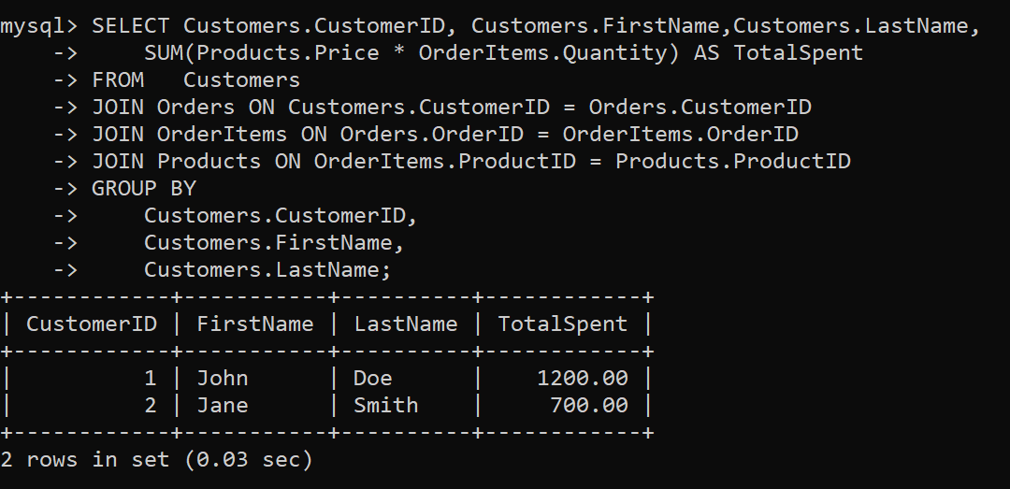

6. Find the most popular product (the one that has been ordered the most).

7. Get the total number of orders and the total sales amount for each month in 2023

8. Find customers who have spent more than $1000

