Members:
Srinadh Kakkera (UFID: 0514-0863)
Neharika Khera (UFID-89500-993)

Graphs and Analysis

For analysis different times of running of different number of Nodes for all the topologies are considered. However in a Rand2D only certain portion of nodes are converging for smaller number of nodes rather than the whole network due to its randomness. So we will discuss both gossip and pushSum for rand2D separately
To simplify the graphing procedure, logarithmic values of times are considered.

NoOfNodes/Topology | Full | Line | 3Dtorus | Honeycomb | RandHoneycomb
100 | 1069 | 5827 | 1403 | 2859 | 1849
200 | 1127 | 11156 | 1627 | 1963 | 1962
300 | 1293 | 13562 | 1462 | 2916 | 1850
400 | 1292 | 15525 | 1745 | 2860 | 1850
500 | 1347 | 17354 | 1743 | 2976 | 1796
600 | 1414 | 27523 | 1627 | 2083 | 1850
700 | 1469 | 28464 | 1574 | 2755 | 2096
800 | 1464 | 40576 | 1522 | 3204 | 2194
900 | 1472 | 38403 | 1548 | 3148 | 2023
1000 | 1528 | 32354 | 1575 | 3376 | 2129

Logarithm of Times:

NoOfNodes/Topology | Full | Line | 3Dtorus | Honeycomb | RandHoneycomb
100 | 3.02897770521 | 3.76544501809 | 3.14705767103 | 3.45621415536 | 3.26693691116
200 | 3.05192391605 | 4.04750850559 | 3.21138755294 | 3.2929202996 | 3.29269900304
300 | 3.11159852488 | 4.13232374004 | 3.16494737262 | 3.46478751965 | 3.2671717284
400 | 3.11126251366 | 4.19103160885 | 3.2417954313 | 3.45636603313 | 3.2671717284
500 | 3.12936759572 | 4.23939959312 | 3.24129738711 | 3.47363292687 | 3.25430633233
600 | 3.15044940946 | 4.43969577013 | 3.21138755294 | 3.31868926995 | 3.2671717284
700 | 3.16702179579 | 4.45429593074 | 3.19700472802 | 3.44012160319 | 3.32139127831
800 | 3.16554107672 | 4.60826923187 | 3.18241465243 | 3.50569250741 | 3.34123662324
900 | 3.16790781 | 4.5843651523 | 3.18977095635 | 3.49803472369 | 3.30599588277
1000 | 3.18412335424 | 4.50992798116 | 3.19728055813 | 3.52840243795 | 3.32817566144

Graph for Gossip Algorithm:
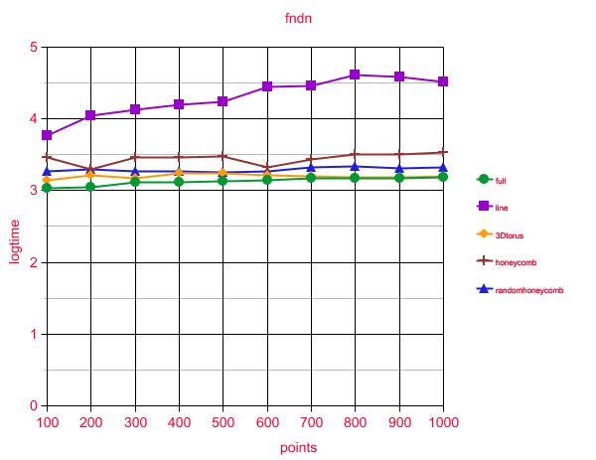

From the graph it is clear that the Line topology takes most time to converge. Of all, a fully connnected network takes the least time.
Interesting Fact
• The interesting fact observed here is that line has at most two neighbors so it takes too long time to get converged as compared to other topologies that is the more the node is connected the better its performance will be.
• By looking at the slope of plots, we can conclude that performance of topologies has less dependency in number of nodes. This is because the gossip is asynchronous .

Times for PushSum:

 | Full | Line | 3Dtorus | Honeycomb | RandHoneycomb
100 | 751 | 4800 | 5778 | 5018 | 1181
200 | 915 | 2934 | 5298 | 14528 | 3883
300 | 1001 | 2889 | 8457 | 12776 | 4012
400 | 1187 | 3360 | 8985 | 20271 | 2514
500 | 1248 | 3787 | 6151 | 18965 | 3734
600 | 1471 | 3461 | 8723 | 21550 | 4161
700 | 1532 | 4105 | 7131 | 22340 | 4020
800 | 1444 | 3519 | 12120 | 24770 | 3640
900 | 1424 | 4224 | 13189 | 16930 | 3276
1000 | 1405 | 3587 | 2871 | 20630 | 3621

Logarthmic values of times for pushsum:

 | Full | Line | 3Dtorus | Honeycomb | RandHoneycomb
100 | 2.8756 | 3.6812 | 3.7617 | 3.7005 | 3.0722
200 | 2.9614 | 3.4674 | 3.7241 | 4.1622 | 3.5891
300 | 3.0004 | 3.4607 | 3.9272 | 4.1063 | 3.6033
400 | 3.0744 | 3.5263 | 3.9535 | 4.3068 | 3.4003
500 | 3.0962 | 3.5782 | 3.7889 | 4.2779 | 3.5721
600 | 3.1676 | 3.5392 | 3.9406 | 4.3334 | 3.6191
700 | 3.1852 | 3.6133 | 3.8531 | 4.3490 | 3.6042
800 | 3.1595 | 3.5464 | 4.0835 | 4.3939 | 3.5611
900 | 3.1535 | 3.6257 | 4.1202 | 4.2286 | 3.5153
1000 | 3.1476 | 3.5547 | 3.4580 | 4.3144 | 3.5588
Graph for PushSum:

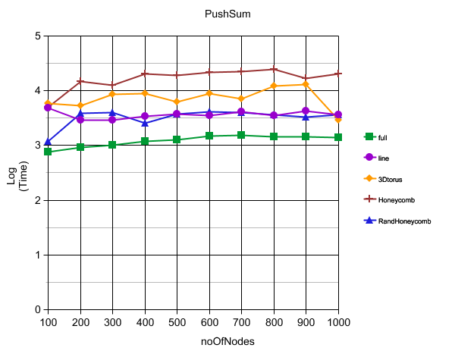
Interesting Fact
• Higher the connectivity of the nodes, better is the performance. This can be easily observed from the graph.

Random2D:

For random2D because of it’s randomness the network converges only for higher number of nodes.
So we consider noNodes above 1000 in intervals of 1000.
 | Gossip | PushSum
1000 | 1754 | 8054
2000 | 2194 | 9740
3000 | 2266 | 10273
4000 | 1925 | 11065
5000 | 2281 | 14638

Logarithmic value of time:

 | Gossip | PushSum
1000 | 3.2440 | 3.9060
2000 | 3.3412 | 3.9885
3000 | 3.3552 | 4.0116
4000 | 3.2844 | 4.0439
5000 | 3.3581 | 4.1654

Graph for Rand2D:
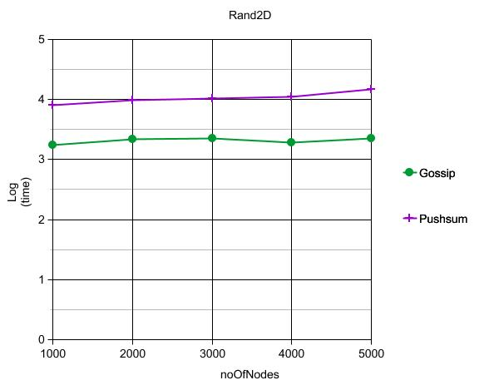

InterestingFact:
- Gossip Algorithm converges faster than PushSum for a rand2D network
- Rand2D converges only for a larger number of Nodes. For lesser number of Nodes only partial number of Nodes converges.

