DevOps Training in Real Time : Phase - I

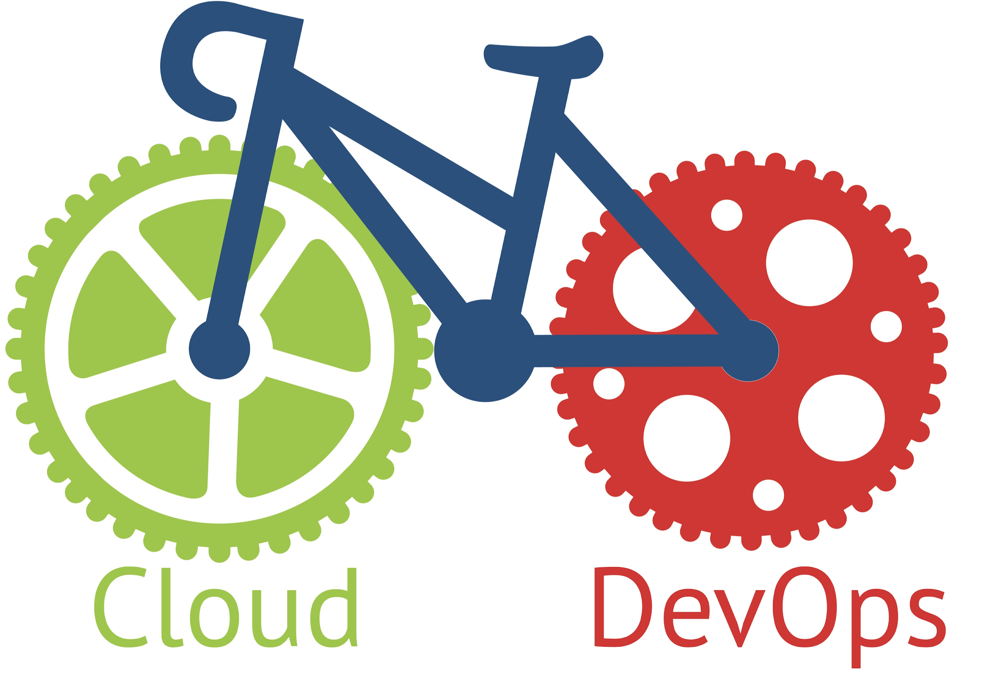

Duration of course: 60 Hours(50 Days)

by SREEHARSHA VEERAPALLI

Training Available in Telugu and English.

[mavrick202@gmail.com](mailto:mavrck202@gmail.com) [sreeharshav@mavricktrainings.com](mailto:sreeharshav@mavricktrainings.com)

Syllabus:

**Module 1:**

* Introduction and use cases of DevOps.
* Understanding DevOps lab infrastructure on AWS.
* Course overview.
* Introduction to Linux Shell Scripting.
* Creating shell scripts for day-to-day activities.
* Understanding IF, WHILE and FOR statements in Shell Scripting.
* Introduction to Powershell Scripting.
* Understanding Noun-Verb usage in Powershell.
* Installing Powershell modules and using them.
* Understanding IF, WHILE and FOR statements in Powershell.
* Creating scripts for regular user management and administration.

**Module 2:**

* Version Controls and its significance
* Introduction to Git version control application
* Git Repositories & GitHub Authentication
* Adding, Committing, Renaming & Deleting files
* GitHub Branches, Merging & Webhooks
* Understanding stash, diff, rebase, fetch, pull, push.
* Overview about Continuous Integration with Jenkins.

**Module 3:**

* Introduction to Infrastructure As A Code.
* Differences between CloudFormation, Azure ARM & Terraform.
* Basics of HashiCorp Terraform
* Configuring Terraform Lab Platform
* Understanding Terraform files
* Terraform Providers, Variables & States
* Configuring Remote state using AWS Simple Storage Service(S3)
* Understanding Terraform Functions.
* Introduction to Packer
* Create AWS AMI using Packer.
* Integration of GitHub, Packer & Terraform with Jenkins.

**Module 4:**

* Introduction to Containers & Docker
* Docker architecture & Docker repositories
* Pull, Create & Upload Docker images
* Using Dockerfile and Docker Compose
* Understanding Docker Networks
* Understanding Docker Volumes
* Creating Docker cluster using Docker Swarm
* Docker Swarm Stacks and Container Placement
* Docker Swarm Node Availability
* Docker Swarm Rolling Updates
* Docker Swarm secrets and Container healthcheck
* Introduction to Kubernetes
* Deploying PODS, Services,Deployments.

**Module 5:**

* Introduction to Ansible
* Differences between Ansible vs Puppet Vs Chef.
* Differences between CloudFormation, Azure ARM & Terraform.
* Configure Ansible Lab Platform.
* Creating & Using Ansible Playbooks
* Understanding & Using Ansible Roles
* Using Ansible Variables & Templates
* Leveraging Ansible Galaxy

**Module 6:**

* Introduction to Puppet
* Puppet Architecture & Puppet components
* Puppet Master & Client Installation & Configuration
* Puppet Classes and Defined Types
* Puppet manifests
* Puppet Modules
* AWS Puppet use cases

**Module 7:**

* Introduction to Jenkins
* Install & Configure Jenkins
* Features & Master-Slave Architecture of Jenkins.
* Configuring Slaves in EC2 and Docker Containers.
* Configure Jenkins Job, RBAC, Pulgins.
* Creating and managing Scripted and Declarative Pipelines.
* Creating multi branch pipelines with Jenkins Blue Ocean.
* Configuring CI/CD Pipeline.
* Integrating Jenkins with AWS, GitHub & Docker.

**Module 8:**

* Introduction to Azure DevOps and Agile terminologies.
* Creating User Stories,Issues, Epics, Kanban Boards.
* Creating Repositories, Importing Code and Branching with Azure DevOps.
* Creating Build Pipelines and Integrating with Azure, AWS Storage.
* Creating and Pushing Docker Images using Azure DevOps.
* Azure DevOps Builds and Artifacts.
* CI/CD with Azure DevOps using Release Pipelines.
* Integrating Terraform with Azure DevOps.
* User Management for Azure DevOps using Azure Active Directory.
* Azure DevOps Custom agent pools & Deployment Groups.