# **AWS: Docker Containers In The Cloud With AWS ECS-Fargate**

Java

# yum provides java

Select the version you want to install.

# yum install java-11-amazon-corretto-11.0.5+10-1.amzn2.x86_64 –y

# export JAVA_HOME=/usr/lib/jvm/java-11-amazon-corretto.x86_64/bin/java

* Git

# yum install git -y

* Maven (optinal,only for maven related jobs )

#cd /opt

#wget <https://www-eu.apache.org/dist/maven/maven-3/3.6.3/binaries/apache-maven-3.6.3-bin.tar.gz>

#sudo tar xzf apache-maven-3.6.3-bin.tar.gz

#sudo ln -s apache-maven-3.6.3 maven

#sudo vi /etc/profile.d/maven.sh

export M2_HOME=/opt/maven

export PATH=${M2_HOME}/bin:${PATH}

#source /etc/profile.d/maven.sh

* Docker

#sudo yum update –y

#sudo amazon-linux-extras install docker

#sudo service docker start

#sudo usermod -a -G docker ec2-user

#sudo chkconfig docker on

### [Install Jenkins](https://www.coachdevops.com/2019/07/install-jenkins-on-redhat-enterprise.html)

#sudo yum install wget –y

**Add Jenkins repository to yum repository**

#sudo wget -O /etc/yum.repos.d/jenkins.repo http://pkg.jenkins-ci.org/redhat/jenkins.repo  
#sudo rpm --import <https://jenkins-ci.org/redhat/jenkins-ci.org.key>

#sudo yum install jenkins –y

**Start Jenkins**  
sudo service jenkins start  
sudo service jenkins status

The manual steps are as follows

1. Create an ECR
2. Push the Docker image to ECR
3. Create a Cluster
4. Create a task-definition
5. Create a alb
6. Create a Setvice

IAM policy

Create IAM user with appropriate permissions; here I am using admin full access.

1. Create ECR

In the ECR service, create a new repository

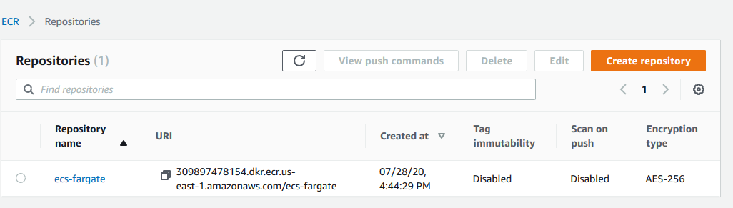

Using view push commands we can send the image to ECR

Note : $(aws ecr get-login --no-include-email --region us-east-1)

Use the above command to login

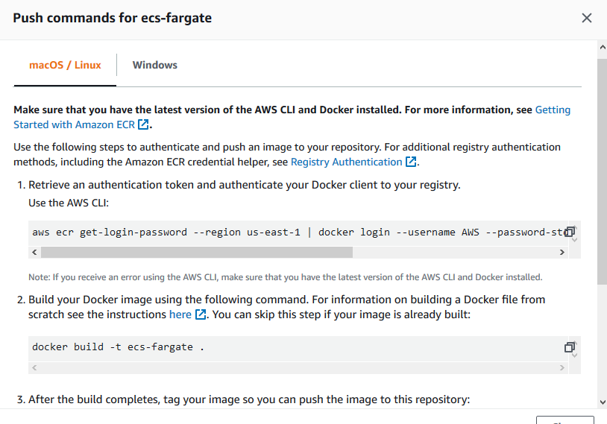

1. Push the Docker image to ECR

Clone the application (we can take any application with working Docker file )

git clone <https://github.com/yeasy/simple-web.git>

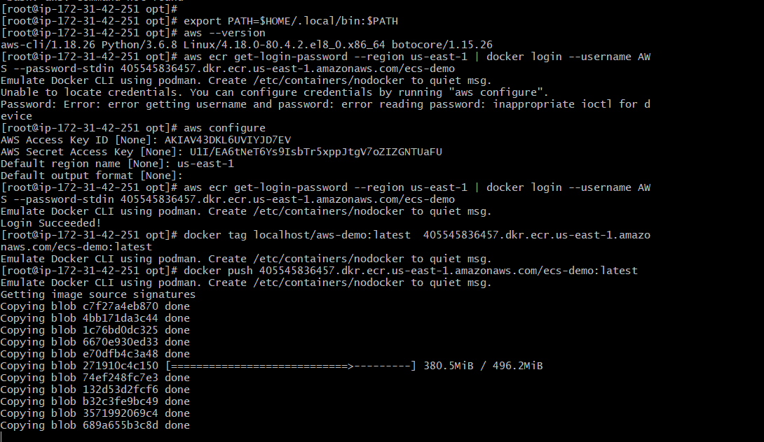

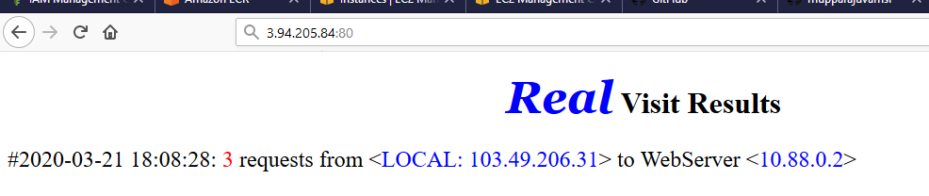

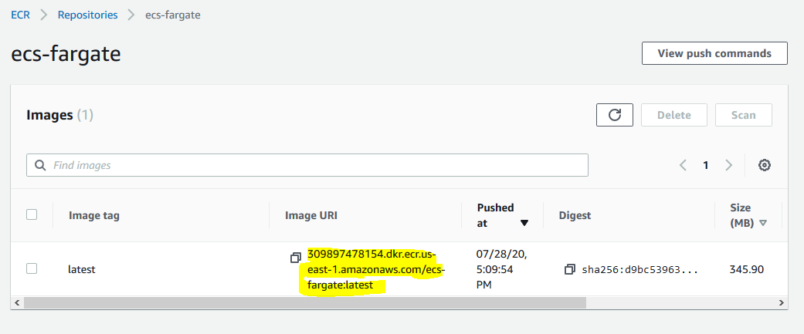

1. Create a Cluster

I used default VPC

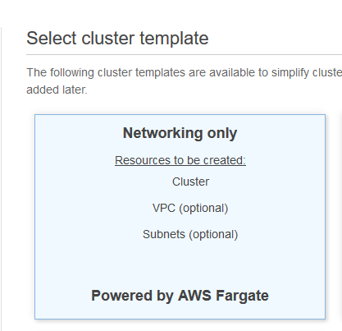

1. create task definition

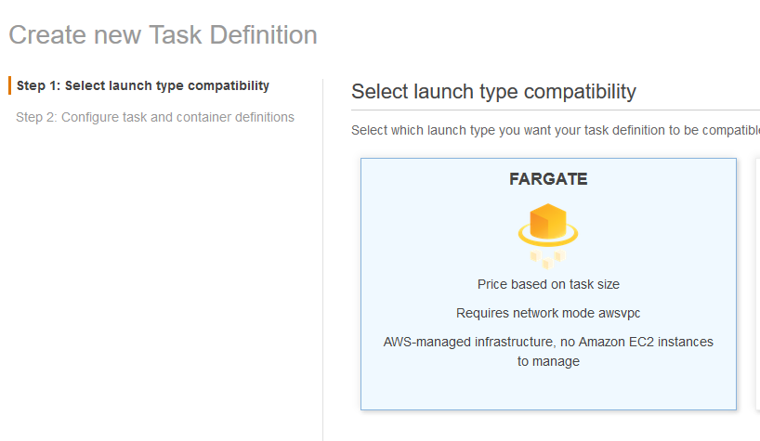

Give task definition name ,it will automatically assigning task role and network mode .

Task size need to selected appropriately and in container section give the image that has been pushed.

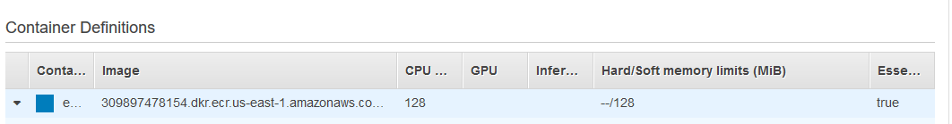

Here we have to select container port in which our application is mapped

My web application will listen to 80 port so selecting container port also 80

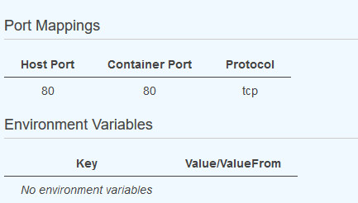

After creating ECR,cluster,taskdefinition we have to create service to maintain the tasks,before creating service we have to create load balancer .

Create a target group with port 80 and target type IP

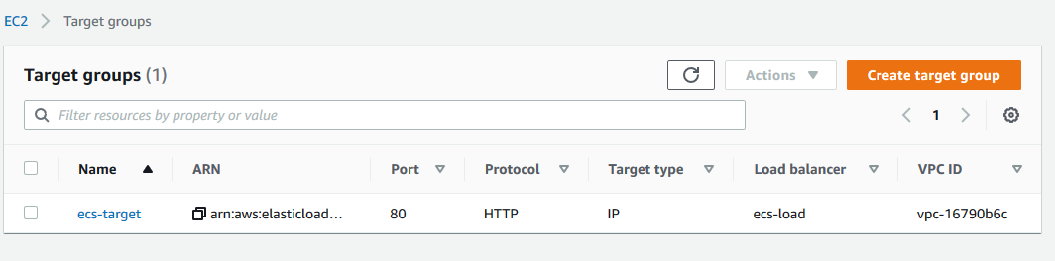

Create a load balancer which listen to the target group crated

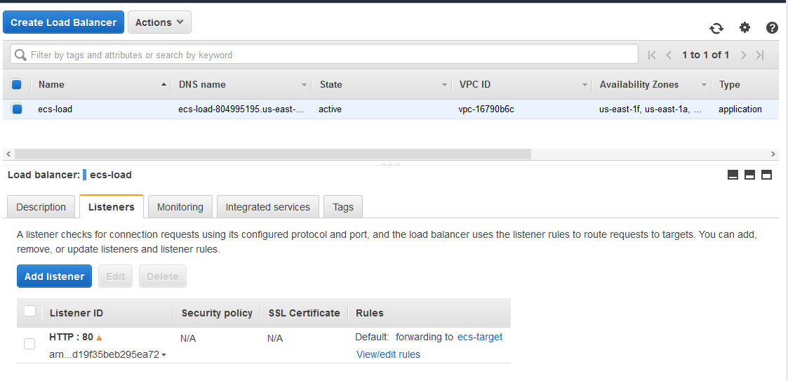

Now create service and select the number of tasks ,load balancer (created one )

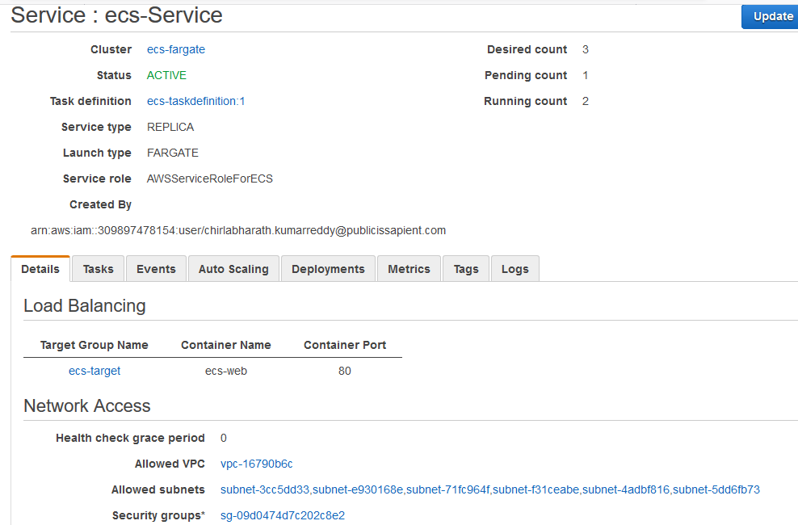

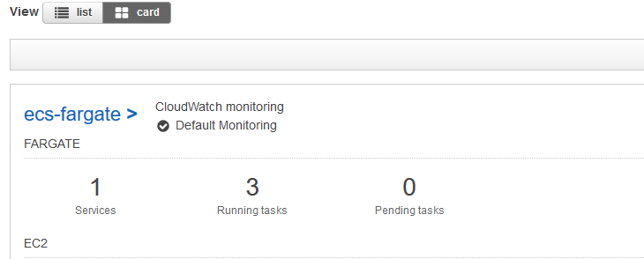

Check the target group is healthy or not ,while creating security groups we need to make sure we opened the correct ports for the application or not .

