EMPLOYEE ATTRITION ANALYSIS PROJECT
Exploratory Data Analysis (EDA) Report
Phase 3: Understanding Patterns & Drivers of Attrition

1. Dataset Shape
The cleaned dataset used for this analysis contains 1,470 employee records across 40 columns (the original 34 cleaned fields plus 6 boolean outlier-flag columns added during the cleaning phase).
Metric | Value
Total Records (Employees) | 1,470
Total Columns | 40 (34 original/cleaned + 6 outlier flags)
Numeric Columns | 26
Categorical Columns | 8
Boolean (Outlier Flag) Columns | 6
Missing Values | 0
Memory Usage | ≈ 399 KB

2. Dataset Information
All 40 columns are fully populated (0 missing values). The dataset combines 26 numeric columns (compensation, tenure, satisfaction scores) and 8 core categorical columns (Department, JobRole, Gender, etc.), plus 6 boolean outlier-indicator columns. Total memory footprint is approximately 399 KB — a small, easily analyzable dataset.

3. Summary Statistics
Key descriptive statistics for the most business-relevant numeric features:
Feature | Mean | Std Dev | Min | Max
Age | 36.9 | 9.1 | 18 | 60
MonthlyIncome ($) | 6,503 | 4,708 | 1,009 | 19,999
DistanceFromHome | 9.2 | 8.1 | 1 | 29
TotalWorkingYears | 11.3 | 7.8 | 0 | 40
YearsAtCompany | 7.0 | 6.1 | 0 | 40
NumCompaniesWorked | 2.7 | 2.5 | 0 | 9
PercentSalaryHike (%) | 15.2 | 3.7 | 11 | 25
Business reading: the average employee is about 37 years old, earns roughly $6,500/month, has worked at ~2-3 companies before this one, and has been with the company for 7 years. The wide standard deviation on income ($4,708) reflects a broad spread from junior to executive pay grades — expected in a company with 5 job levels.

4. Histograms — Distribution Shapes
Histograms show how each numeric variable is distributed across the workforce.
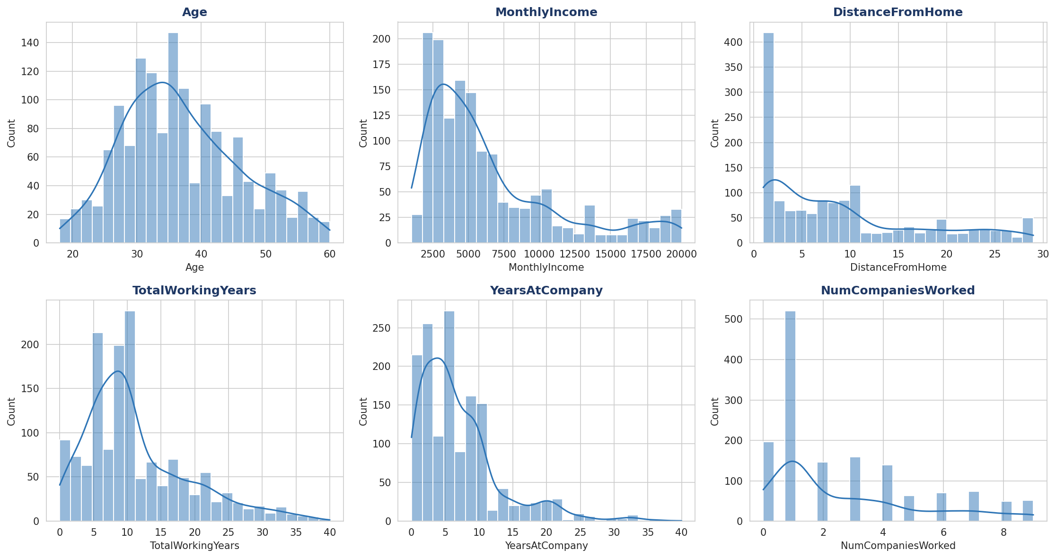
Figure 1: Distribution of Age, Monthly Income, Distance From Home, Total Working Years, Years at Company, and Number of Companies Worked.
Business interpretation: Age is roughly bell-shaped, centered in the early-to-mid 30s — a healthy, experience-balanced workforce. Monthly Income is right-skewed: most employees earn under $8,000/month with a long tail of senior/executive earners, which is normal for a leveled compensation structure. Total Working Years and Years at Company are also right-skewed, showing most employees are early-to-mid career, with a smaller group of long-tenured veterans. Distance From Home skews short, meaning most employees live close to work, but a meaningful minority commute much farther — a group worth watching for commute-related attrition risk.

5. Boxplots — Attrition Comparison
Boxplots compare the spread of key numeric variables between employees who left (Yes) and those who stayed (No).
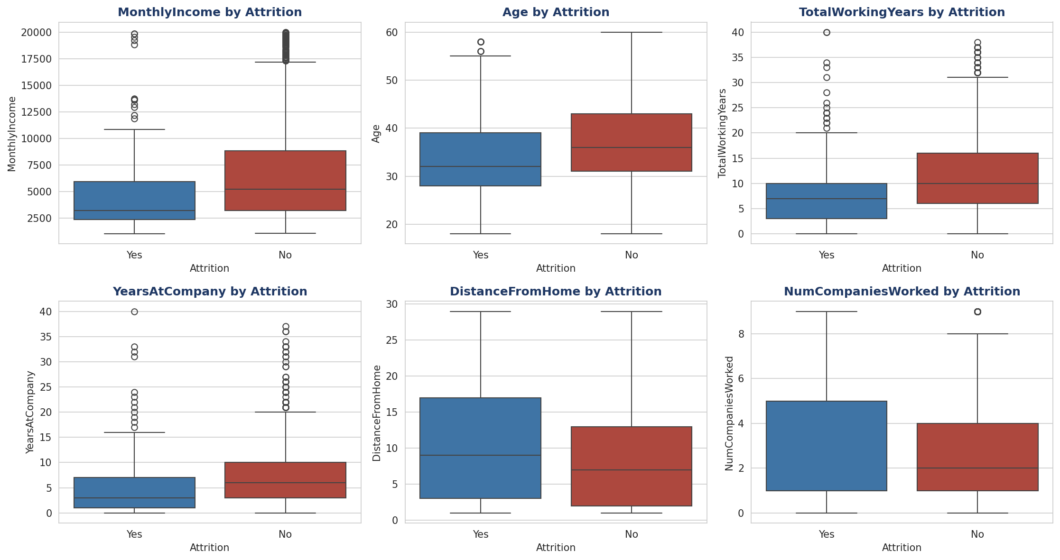
Figure 2: Monthly Income, Age, Total Working Years, Years at Company, Distance From Home, and Number of Companies Worked, split by Attrition.
Business interpretation: Employees who left tend to have visibly lower Monthly Income, are younger, and have fewer Total Working Years and less time at the company than those who stayed — a classic 'early-career flight risk' pattern. Distance From Home is only slightly higher for leavers, suggesting commute distance is a secondary factor. Number of Companies Worked is fairly similar between the two groups, meaning job-hopping history alone isn't a strong standalone differentiator once other factors are considered.

6. Countplots — Categorical Breakdown by Attrition
Countplots show how attrition is distributed across categorical employee segments.
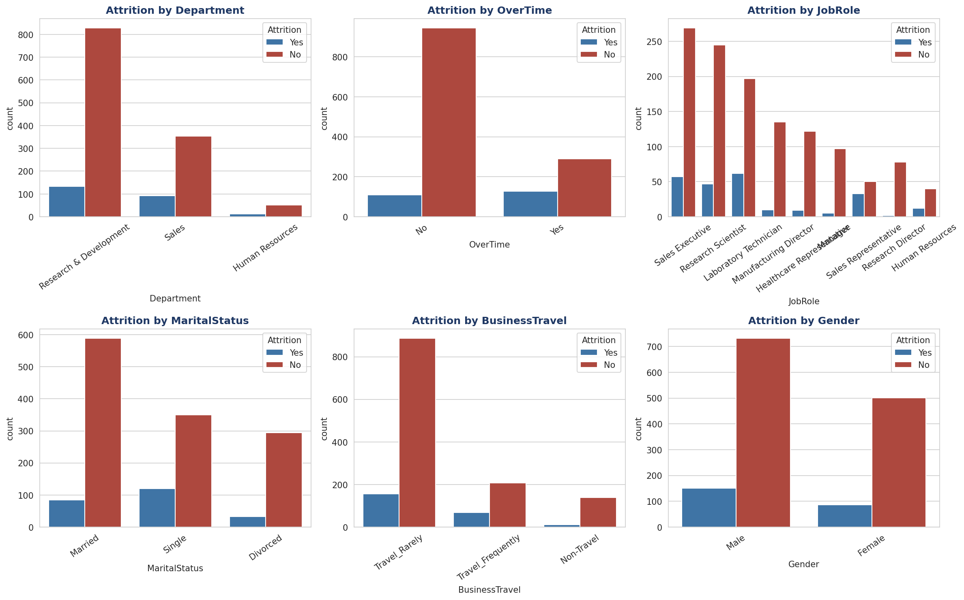
Figure 3: Attrition counts by Department, OverTime, Job Role, Marital Status, Business Travel, and Gender.
Business interpretation: Research & Development has the largest headcount and the most absolute leavers, but Sales shows a higher leaving rate relative to its size. OverTime stands out sharply — employees who work overtime leave far more often than those who don't, making it one of the clearest actionable signals in the dataset. Among job roles, Sales Representatives and Laboratory Technicians show proportionally higher attrition. Single employees leave more often than married or divorced employees, consistent with fewer household ties. Frequent travelers also show elevated attrition versus non-travelers. Gender shows only a small difference between groups.

7. Pie Charts — Workforce Composition
Pie charts are used here only for genuinely low-cardinality splits, where a part-to-whole view is meaningful.
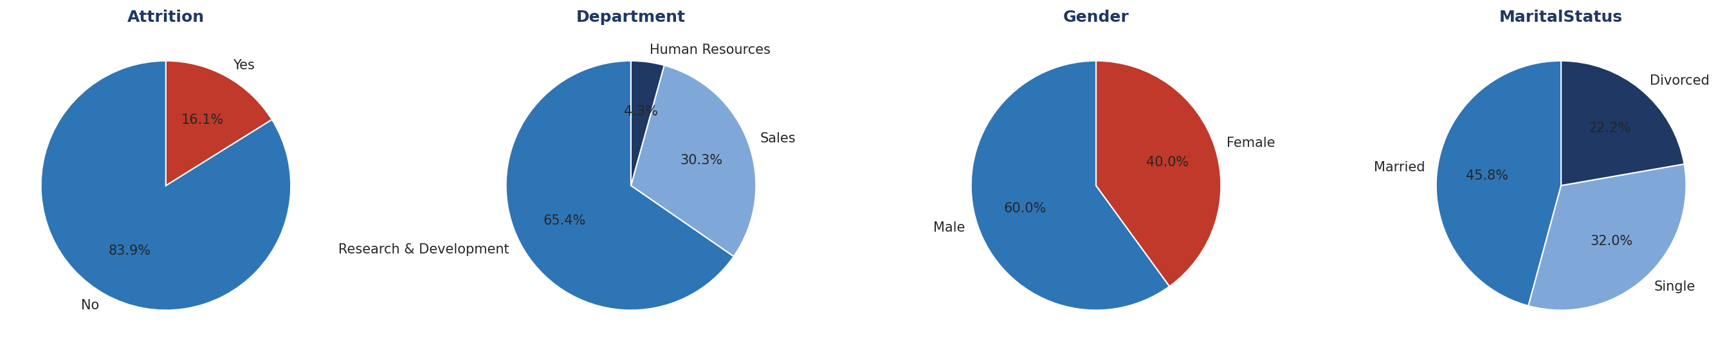
Figure 4: Overall composition of Attrition, Department, Gender, and Marital Status.
Business interpretation: About 1 in 6 employees (16.1%) has left the company — this is the baseline attrition rate against which every segment should be judged. Nearly two-thirds of the workforce sits in Research & Development, so even small percentage shifts there carry large headcount impact. The workforce is roughly 60% male / 40% female, and marital status is fairly evenly split between married, single, and divorced employees, with married employees forming the largest group.

8. Correlation Heatmap
The heatmap shows how strongly every numeric feature relates to every other numeric feature, including the Attrition flag.
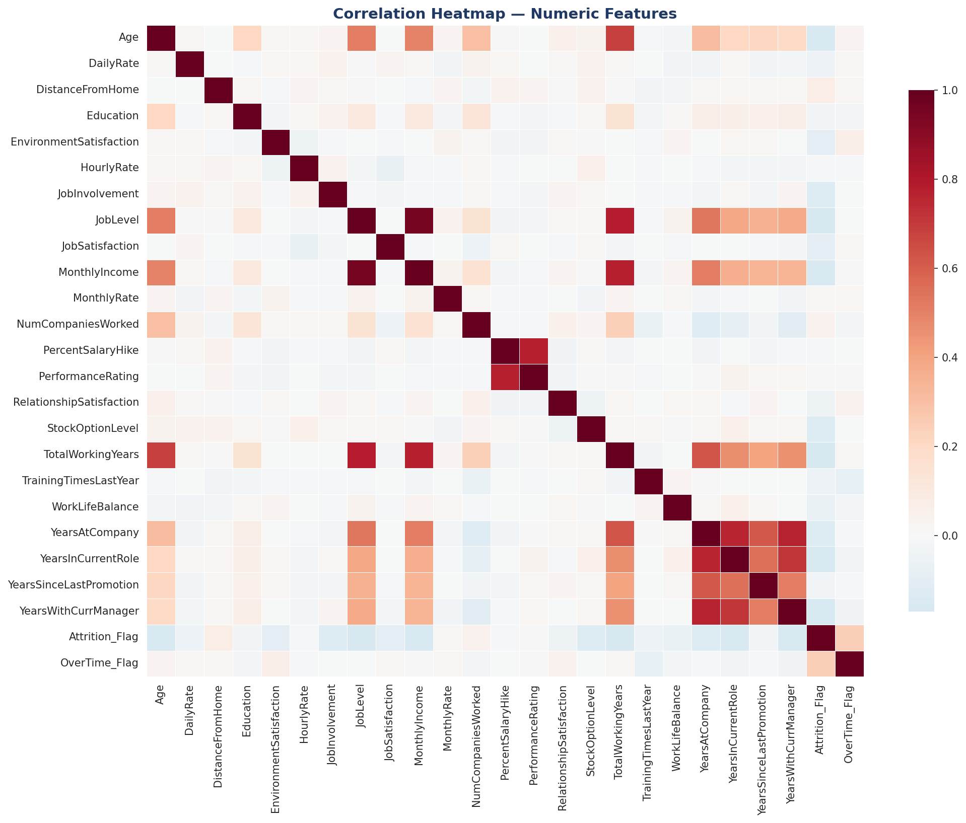
Figure 5: Correlation heatmap across all numeric features (red = positive correlation, blue = negative correlation).
Business interpretation: Several tenure-related fields move together strongly, as expected — Years at Company, Years in Current Role, Years with Current Manager, and Years Since Last Promotion are all highly correlated, essentially describing the same underlying 'career stage' concept. Job Level, Monthly Income, and Total Working Years also cluster together, reflecting a consistent, logical pay-for-experience structure. None of these strong relationships are surprising or indicate a data problem — they confirm the compensation and career-progression system is internally consistent.
Correlations specifically with Attrition (from strongest to weakest):
Feature | Correlation | Business Reading
OverTime | +0.246 | Employees who work overtime are noticeably more likely to leave.
TotalWorkingYears | -0.171 | More total career experience is associated with lower attrition.
JobLevel | -0.169 | Higher job levels (more senior roles) see less attrition.
YearsInCurrentRole | -0.161 | Longer time in the current role correlates with more stability.
MonthlyIncome | -0.160 | Lower earners are somewhat more likely to leave.
Age | -0.159 | Younger employees show a mild tendency toward higher attrition.
YearsWithCurrManager | -0.156 | Longer relationships with a manager correlate with staying longer.
StockOptionLevel | -0.137 | Employees with more equity/stock options are less likely to leave.
No single factor dominates — attrition is driven by a combination of moderate-strength signals rather than one overwhelming cause, which is typical for voluntary turnover and means retention strategy needs to address multiple levers at once.

9. Pairplot — Relationships Among Key Drivers
A pairplot was used (rather than shown for all 26 numeric variables, which would be unreadable) focused on the four numeric features most relevant to attrition: Age, Monthly Income, Total Working Years, and Years at Company.
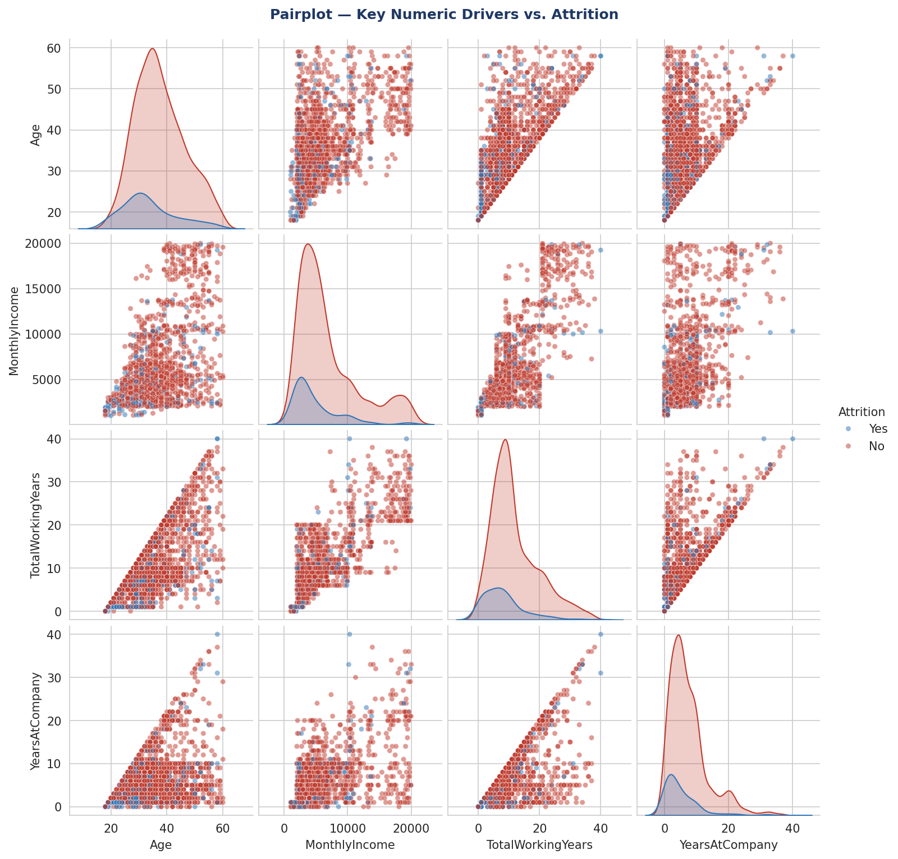
Figure 6: Pairwise relationships between Age, Monthly Income, Total Working Years, and Years at Company, colored by Attrition.
Business interpretation: The diagonal density curves confirm that employees who left (red) skew younger, earn less, and have fewer working years than those who stayed (blue) — visually reinforcing the boxplot findings. The scatter panels show a clear positive relationship between Age, Total Working Years, and Monthly Income (older, more experienced employees earn more, as expected). Attrition cases (red points) cluster in the lower-left regions of these scatter plots — younger, lower-income, less-tenured employees — rather than being scattered randomly, which strengthens confidence that these factors are genuine, combinable attrition signals rather than coincidence.

10. Key Takeaways
- Overall attrition rate is 16.1% — the benchmark for evaluating any segment or policy change.
- OverTime is the single strongest behavioral signal — overtime workers leave at a much higher rate.
- Attrition concentrates in early-career, lower-income, shorter-tenure employees.
- Sales roles and frequent travelers show elevated attrition relative to their size.
- Single employees leave more than married or divorced employees.
- No single variable explains attrition alone — it is a multi-factor pattern, so retention strategy should combine compensation review, workload/overtime management, and targeted support for early-career staff.

11. Full Python EDA Code
The complete script used to generate every statistic and chart in this report:
"""
==============================================================
EMPLOYEE ATTRITION DATASET — EXPLORATORY DATA ANALYSIS (EDA)
==============================================================
Covers: shape, info, summary stats, histograms, boxplots,
countplots, pie charts, correlation heatmap, and pairplot.
Every chart is saved as a PNG for the accompanying report.
==============================================================
"""

import pandas as pd
import numpy as np
import matplotlib
matplotlib.use("Agg")
import matplotlib.pyplot as plt
import seaborn as sns

sns.set_style("whitegrid")
NAVY, ACCENT, RED, GREEN = "#1F3864", "#2E75B6", "#C0392B", "#2E7D32"
PALETTE = [ACCENT, RED]

df = pd.read_csv("employee_attrition_cleaned.csv")

# --------------------------------------------------------------
# 1. DATASET SHAPE
# --------------------------------------------------------------
print("=" * 60)
print("1. DATASET SHAPE")
print("=" * 60)
print(f"Rows: {df.shape[0]} Columns: {df.shape[1]}")

# --------------------------------------------------------------
# 2. DATASET INFORMATION
# --------------------------------------------------------------
print("\n" + "=" * 60)
print("2. DATASET INFO")
print("=" * 60)
df.info()

# --------------------------------------------------------------
# 3. SUMMARY STATISTICS
# --------------------------------------------------------------
print("\n" + "=" * 60)
print("3. SUMMARY STATISTICS (numeric)")
print("=" * 60)
numeric_summary = df.describe().T
print(numeric_summary)

print("\n3b. SUMMARY STATISTICS (categorical)")
categorical_summary = df.describe(include="object").T
print(categorical_summary)

numeric_summary.to_csv("summary_numeric.csv")
categorical_summary.to_csv("summary_categorical.csv")

# --------------------------------------------------------------
# 4. HISTOGRAMS — distribution of key numeric variables
# --------------------------------------------------------------
hist_cols = ["Age", "MonthlyIncome", "DistanceFromHome", "TotalWorkingYears",
"YearsAtCompany", "NumCompaniesWorked"]

fig, axes = plt.subplots(2, 3, figsize=(15, 8))
for ax, col in zip(axes.flatten(), hist_cols):
sns.histplot(df[col], bins=25, kde=True, color=ACCENT, ax=ax)
ax.set_title(col, fontweight="bold", color=NAVY)
plt.tight_layout()
plt.savefig("eda_histograms.png", dpi=150, bbox_inches="tight")
plt.close()

# --------------------------------------------------------------
# 5. BOXPLOTS — numeric variable vs. Attrition
# --------------------------------------------------------------
box_cols = ["MonthlyIncome", "Age", "TotalWorkingYears", "YearsAtCompany",
"DistanceFromHome", "NumCompaniesWorked"]

fig, axes = plt.subplots(2, 3, figsize=(15, 8))
for ax, col in zip(axes.flatten(), box_cols):
sns.boxplot(data=df, x="Attrition", y=col, hue="Attrition",
palette=PALETTE, legend=False, ax=ax)
ax.set_title(f"{col} by Attrition", fontweight="bold", color=NAVY)
plt.tight_layout()
plt.savefig("eda_boxplots.png", dpi=150, bbox_inches="tight")
plt.close()

# --------------------------------------------------------------
# 6. COUNTPLOTS — categorical variable vs. Attrition
# --------------------------------------------------------------
count_cols = ["Department", "OverTime", "JobRole", "MaritalStatus",
"BusinessTravel", "Gender"]

fig, axes = plt.subplots(2, 3, figsize=(16, 10))
for ax, col in zip(axes.flatten(), count_cols):
order = df[col].value_counts().index
sns.countplot(data=df, x=col, hue="Attrition", palette=PALETTE,
order=order, ax=ax)
ax.set_title(f"Attrition by {col}", fontweight="bold", color=NAVY)
ax.tick_params(axis="x", rotation=35)
plt.tight_layout()
plt.savefig("eda_countplots.png", dpi=150, bbox_inches="tight")
plt.close()

# --------------------------------------------------------------
# 7. PIE CHARTS — overall composition (appropriate for
# low-cardinality categorical splits)
# --------------------------------------------------------------
pie_cols = ["Attrition", "Department", "Gender", "MaritalStatus"]

fig, axes = plt.subplots(1, 4, figsize=(18, 4.5))
colors_list = [[ACCENT, RED], [ACCENT, "#7FA8D9", NAVY],
[ACCENT, RED], [ACCENT, "#7FA8D9", NAVY]]
for ax, col, colors in zip(axes, pie_cols, colors_list):
counts = df[col].value_counts()
ax.pie(counts, labels=counts.index, autopct="%1.1f%%",
colors=colors, startangle=90,
wedgeprops={"edgecolor": "white", "linewidth": 1})
ax.set_title(col, fontweight="bold", color=NAVY)
plt.tight_layout()
plt.savefig("eda_piecharts.png", dpi=150, bbox_inches="tight")
plt.close()

# --------------------------------------------------------------
# 8. CORRELATION HEATMAP — numeric feature relationships
# --------------------------------------------------------------
numeric_df = df.select_dtypes(include=np.number).drop(
columns=[c for c in df.columns if c.endswith("_Outlier")] + ["EmployeeNumber"],
errors="ignore"
)
corr = numeric_df.corr()

plt.figure(figsize=(14, 11))
sns.heatmap(corr, cmap="RdBu_r", center=0, annot=False, linewidths=0.4,
cbar_kws={"shrink": 0.8})
plt.title("Correlation Heatmap — Numeric Features", fontweight="bold",
color=NAVY, fontsize=14)
plt.tight_layout()
plt.savefig("eda_heatmap.png", dpi=150, bbox_inches="tight")
plt.close()

# Print top correlations with Attrition_Flag for the report
attr_corr = corr["Attrition_Flag"].drop("Attrition_Flag").sort_values(key=abs, ascending=False)
print("\nTop correlations with Attrition_Flag:")
print(attr_corr.head(10))

# --------------------------------------------------------------
# 9. PAIRPLOT — relationships among the strongest attrition drivers
# --------------------------------------------------------------
pair_cols = ["Age", "MonthlyIncome", "TotalWorkingYears", "YearsAtCompany", "Attrition"]
pp = sns.pairplot(df[pair_cols], hue="Attrition", palette=PALETTE,
diag_kind="kde", plot_kws={"alpha": 0.5, "s": 20})
pp.fig.suptitle("Pairplot — Key Numeric Drivers vs. Attrition", y=1.02,
fontweight="bold", color=NAVY)
pp.savefig("eda_pairplot.png", dpi=150, bbox_inches="tight")
plt.close()

print("\nAll EDA charts saved as PNG files.")
print("EDA complete.")

